Introduction Unit
What was the most serious problem that Elizabeth I faced at the start of her reign ?

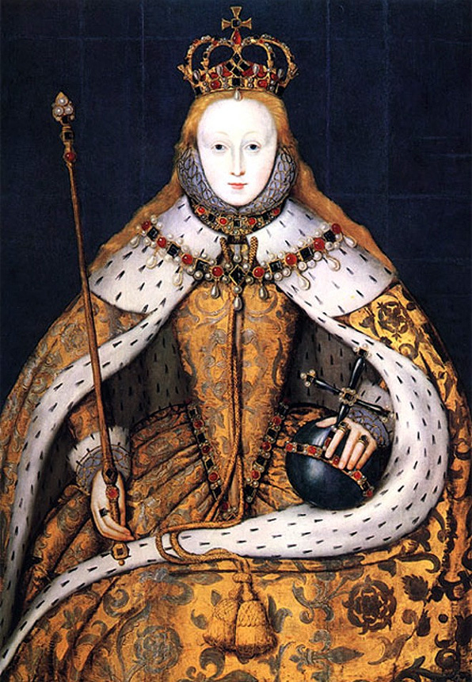

England in 1558 and the legacy of the
Mid Tudor Crisis
The Royal Prerogative and the issue of gender
The New Privy Council
The Religious situation and problems in 1558 including the foreign situation and its impact on religious developments
The 1558 Religious Settlement
• The Acts of Supremacy and Uniformity
• The Royal Injunctions
The financial and economic situation in 1558
Early financial policy

Were Elizabeth’s personal qualities suited to being a Sixteenth Century Monarch ?

Given that this unit of study is asking you about the problems that the Queen faced in 1558, it might seem surprising to start by looking at Elizabeth’s personal qualities.

However, it is important to remember that in Sixteenth Century England the monarch had real political power. In theory Elizabeth I was an autocrat who had to make the all the major decisions herself. She fiercely defended this royal prerogative, and this meant;

- No law could be passed without her consent.
- She could decide when parliament was going to be called, prorogued or closed.
- She could decide who became ministers in her Privy Council.
- She could decide who could attend Court.
- Elizabeth was the centre of the patronage system.
- It was Elizabeth who was responsible for the nature of religious worship in the country.
- It was Elizabeth who could decide if and when England could go to war.

In practice Elizabeth was always short of money, and often had to persuade, bribe, bully and compromise with her subjects. As a result, if we want to analyse the seriousness of problems that faced her, and ask how effectively she addressed them, then we need to know about the Queen’s personal qualities.
Question

- In groups list five qualities you think Elizabeth would require to be an effective monarch. These will be brainstormed on the board.

The same question has been reflected upon by many of her contemporaries and more recently by historians. The following quotations reflect their views of some of her strengths and weaknesses. Read them carefully, and write down next to them what qualities the evidence highlights.
“From Henry and Anne she inherited intelligence, cunning, the capacity to charm and a remarkable strength of will… She was a wily and defensive politician.”

Robert Sloan – The Tudor Years.
A.

“She had been trained in the humanist tradition and she was a learned young woman, even something of a ‘bluestocking’ (intellectual) when she took over the government of the country.”

From A.G.R.Smith – The Emergence of a Nation State.

“She brought her sharp powers of analysis to political process and therefore saw through carelessly constructed arguments”

S J Lee. Elizabeth I

B.

“She is a woman of extreme vanity.”

The Spanish Ambassador, Feria.
C.

“She was no religious fanatic”

From A.G.R.Smith – The Emergence of a Nation State.

D.

“Queen Elizabeth did not attempt to solve problems, she simply avoided them – and then survived long enough for some of them to go away.”

Christopher Haigh – Elizabeth I – A Profile in Power.
E.

“Elizabeth had a cautious and conservative approach to monarchy.”

Robert Sloan – The Tudor Years

“She emerged as queen at the age of twenty five, having grasped the need for both caution and dissimulation” (this means keeping things hidden).

From A.G.R.Smith – The Emergence of a Nation State.

F.

“Two qualities were born within her and were apparent very early in her reign: the ability to choose first- rate advisers and a remarkable gift for winning the devotion of the public.”

Penry Williams “The later Tudors”
comments on Elizabeth political or politic skills.

G.

“The simple truth was that Elizabeth…did not understand key economic ideas like inflation. It was England that paid the price for her ignorance.”

Geoffrey Reagan – Elizabeth I
H.

The higher the evidence is place the more important you consider it to be
The further right, the more that this personal quality that was a advantage to Elizabeth’s monarchy
The further left, the more that this personal quality that was a disadvantage to Elizabeth’s monarchy
An importance graph
Position the letters for the different evidence as you feel most appropriate

Question
- Now compare your graph with your peers. Write two to three paragraphs to explain your decisions.
What was Elizabeth’s inheritance ?
Was the Mid Tudor Crisis ?

Elizabeth I ruled England from 1558 to 1603. This was a forty five year reign which is often regarded as a “Golden Age”. The extent to which this is correct is a matter of debate, and something that we will explore in the coming months. When historians ask such a question, it is often helpful to consider the context of what went before.

It is certainly correct to suggest that the immediate period before Elizabeth’s accession was one that many historians consider to be troubled. Most famously, in 1973, Whitney R.D. Jones wrote of the period as “a Mid Tudor Crisis” and “the epoch of the little Tudors.”

He meant Edward VI (1547 – 1553) and Mary I (1553 – 1558), but this was also the time of Lady Jane Grey (the Nine Day Queen). Jones also included the later years of Henry VIII reign (after the fall of Thomas Cromwell in 1539, after which he increasingly became the syphilitic tyrant of legend). Jones highlights eight problems which he suggests, together, made this crisis for Tudor monarchy. These are shown below;
- Weak rulers (Edward and Mary).
- Economic problems (like inflation).
- Failures in foreign policy (like the loss of Calais).
- Rebellions (like Wyatt’s Rebellion of 1554).
- Problems in religion (The English Reformation and Counter Reformation).
- Factional fighting in Court (Somerset and Northumberland in Edward’s reign).
- Problems in Local Government.
- Problems over the succession (Lady Jane Grey).

Questions
- If Jones’s thesis is correct, which of these issues do you think were the most serious for Elizabeth ? Explain your choice.

- Extension – do any of these problems link together ?

Many contemporaries of this period agreed with Jones’s thesis. For example, consider the quotation below. Then look at the cartoon on Page six.
An extract from a report by Armigail Waad, a Clerk to the Privy Council. It is a summary of the problems her believed face Elizabeth faced when she became queen in 1558.

“The monarchy is not well regarded and the realm (England) is exhausted. The nobility is poor and decayed. There is a lack of good Sea Captains and soldiers. The people are out of order. Justice is not executed. All things are dear. There are religious divisions amongst ourselves. We are at war with Scotland and France. The French King bestrides the realm, having one foot in Calais and the other in Scotland. We have steadfast enmity but no steadfast friendship abroad.”

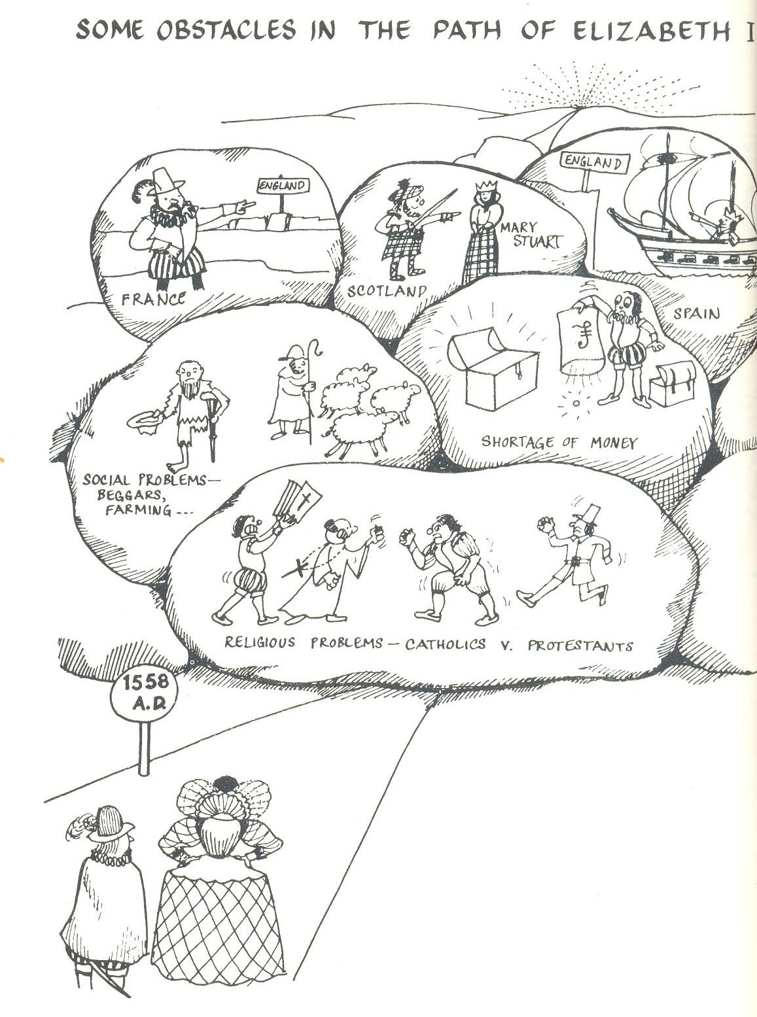

Questions
- List any problems facing Elizabeth, which are shown in the two sources above, but are not in Jones’s thesis.

- Is there any further information in these two sources to support Jones’s idea of a “Mid Tudor Crisis” ?

Today, not all historians agree that there was a Mid Tudor Crisis. Revisionist historians like David Loades would suggest “only in the field of economics is the term crisis appropriate”, whilst most recently, John Matusiak found a middle way between these two views, suggesting they should be viewed as "years of trauma and survival".

Questions
- Write a paragraph to explain what you understand by the term “Mid Tudor Crisis” ?

- Extension - Is there a way that the Mid Tudor Crisis could be said to actually help Elizabeth’s monarchy in 1558 ?

What is clear for us is that in 1558, both England its new monarch faced a series of serious problems after a time of unsettled government. Study the diagram on the following page. We need to;

- Understand the problems she faced and consider the relative importance of them.
- Decide how effectively she dealt with them.
- Understand how they link together.
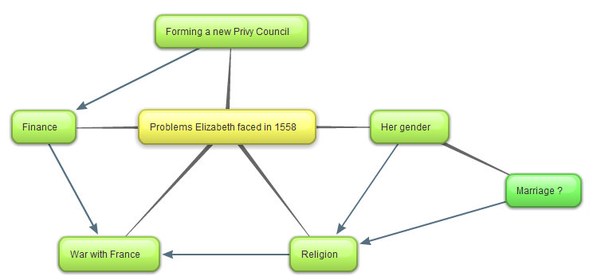
A diagram to show the problems (and how they linked together) that faced Elizabeth in 1558.

Problem One – How would the Queen rule in a
Patriarchal Society ?

Study these three contemporary views on gender and monarchy
“God’s wounds, this it is to serve a base, bastard pissing kitchen woman !”

The Lord Deputy of Ireland talking about his delight in serving his queen, Elizabeth.

“Oh Lord, the Queen is a woman!”

A London woman on seeing Elizabeth for the first time.

“I will have but one mistress and no master”

“My sex cannot diminish my prestige”

Elizabeth (in 1566 and 1603 dealing with the Earl of Leicester and parliament respectively).

Context

When Elizabeth became queen in 1558, there had only ever been two queens who had ruled England in their own right.

- Queen Matilda (sometimes known as Maude) -1141.
- “Bloody” Mary (Elizabeth’s half sister) - 1553 to 1558.

Both reigns were very unpopular, and were seen as failures. As such, there was no precedent for a successful female monarchy. In other words, kingship was exactly that – a job done by men, and Elizabeth’s rule was expected to fail.

What was the view of women at this time and what problems did this create for Elizabeth ?

Quite simply, Tudor England was a patriarchal society. The “Great Chain of Being” meant every person had a fixed place in the social hierarchy. The wife always gained her status in this chain from her husband, the assumption throughout the chain was that women were inferior and needed the tutelage of her man. This was to present Elizabeth with formidable difficulties.

- In 1558 John Knox Scottish reformer (founder of the Scottish Calvinist church) published his First Blast of the Trumpet Against the Monstrous Regiment (rule) of Women. The book was aimed at Mary of Guise and Knox explained that Elizabeth was an exception as she had been made queen by God to restore the Gospel, but it was a reminder of the discomfort many felt at having a female ruler.

- The rule of a woman on her own was seen as unnatural, it was assumed that she would marry; Elizabeth was still young, 25.
- The husband would be expected to the dominant partner and rule as King-consort. Mary Tudor had married Philip II. This had been extremely unpopular; many felt England had become nothing more than a Spanish satellite.

- Her councillors may have felt the need to advise the queen more directly as she was “only” a woman. There is evidence for this letters sent between the Earl of Winchester and William Cecil at the time of the accession.

- War was seen as a man’s job – how could a queen lead a country in a future war ?

- As a woman Elizabeth could not be Head of the Church of England as her father and half brother had been.

In short, at the start of her reign Elizabeth gender made her monarchy look vulnerable, when a key element of being a successful Tudor monarch was the ability to project power and fear.

Task

Now construct a spider diagram to show the problems that Elizabeth’s gender presented to her monarchy. Rank these in order of importance and write a brief paragraph to explain your choices

How effectively did Elizabeth address these problems?

Perhaps one of most remarkable aspects of Elizabeth’s monarchy was that she turned something that was a real problem at the start of her reign into one of its main advantages. In other words, it is possible to argue that Elizabeth’s gender strengthened rather than weakened her rule. This was a good example of her politic skills in action.

- By the 1570s Elizabeth had created a Cult of Gloriana by which the men of England could celebrate the harmony and progress of the Virgin Queen’s rule. She was a woman who presented herself as foregoing earthly pleasures because she was married to England. She once famously referred to "all my husbands, my good people" meaning the English nation.

The image below is typical of the lockets that men wore the show there loyalty and love for Elizabeth (it had previously been the fashion to carry a likeness of your lover in such a locket). No other English monarch before or since has been celebrated thus by their subjects.

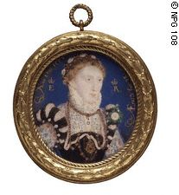
- From the start of Elizabeth’s reign, she used her gender as a political tool. For example, to call on an extra degree of loyalty she would make people aware of her vulnerability (if she needed to pass a difficult bill through parliament). Also, when Elizabeth did not want to make a decision at Council, she would play the stereotype that women were indecisive. On many occasions this bought her valuable time before making a difficult decision.

- Elizabeth exploited her femininity and pretended to consider marriage to evoke loyalty from her subjects. For example, she wooed her courtiers such as the Earl of Leicester and Walter Raleigh. She did the same on the European scene. For example, her last courtship, ended in 1581 when she was aged 48, was with François, Duke of Anjou, 22 years her junior.

- Elizabeth overcame the issue of religion, by taking the title the Supreme Governor of the Church of England (see the later notes of the 1559 Religious Settlement). This was typical of Elizabeth’s ability to find a middle way. Francis Yates argues that Elizabeth’s image as the Virgin Queen helped many moderate Catholics accept the move away from worship of the Virgin Mary. If this is the case then, then Elizabeth gender was turned to her advantage.

- As the image and quotation below show, Elizabeth also used her gender to assist her as a war leader.
The Armada Portrait - 1588

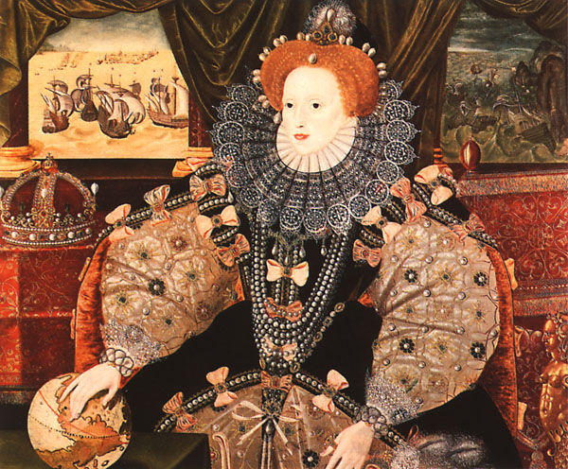
“I know I have the body but of a weak and feeble woman, but I have the heart and stomach of a king, and of a King of England too, and think foul scorn that Parma or Spain, or any Prince of Europe should dare to invade the borders of my realm.”

Elizabeth’s famous Tilbury Speech - 1588

Questions
- Return to your spider diagram to show the problems that Elizabeth’s gender presented to her monarchy. Write two paragraphs to explain how successfully did Elizabeth neutralise the problems that her gender presented for her monarchy up to 1563 ?
- Now write two paragraphs to explain how Elizabeth actually used her gender as a tool of government after 1563 (you may use these in a Unit Two answer, but not a Unit One answer as this stops at 1563).

Problem Two – How could Elizabeth create an effective system of government ?

One of Elizabeth’s initial tasks was to select the ministers and style of her Privy Council. As M Tillman correctly suggests the Privy Council was the “select ruling board of the realm”, and as such these decisions really mattered. This would be a clear indication of her religious aims and an important task in securing good advice. It would be very hard for Elizabeth to be a strong and successful monarch without an effective Privy Council.

Early reforms to the Privy Council

The Privy Council rose in importance right from the start of Elizabeth’s reign. In part this can be best understood by considering how Elizabeth reformed its membership.

Under Mary the Council had grown in size to over forty. Elizabeth preferred the Cromwellian model (ie after the ideas of Thomas Cromwell – Henry VIII’s famous minister) of a smaller Council, famously once stating that “a multitude doth make rather discord and confusion rather than good council”. As a result the 1559 Privy Council started as a group of 20, but quickly became reduced to 18 with the loss of the Marian ministers Heath and Cheney. Moreover, an “inner ring” (J Guy) of regular attendees developed. Elizabeth also increased the frequency of meetings, and occasionally chaired meetings herself.

Who was in Elizabeth’s initial Privy Council ?

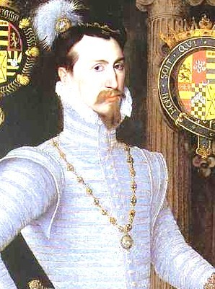
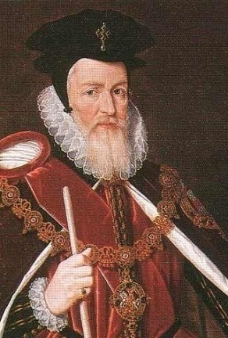
Sir William Cecil (left) was Elizabeth’s first Secretary of State. He had been the overseer of her estates whilst she was Princess Elizabeth, and had been secretary during Edward VI’s reign. He was a moderate Protestant. He is rightly seen as one of the greatest political figures of the Tudor age. W MacCaffrey describes him as “the dynamo which kept...government running smoothly and effectively” whilst S J Lee writes that “he brought to administration an attention to detail and accuracy ...he was...adept at solving problems”. He was an excellent appointment, and in the first two years of her reign he helped to draft the 1559 Religious Settlement and smash the Auld Alliance between France and Scotland with the 1560 Treaty of Edinburgh.

Elizabeth also appointed Robert Dudley (the Earl of Leicester from 1564 right) to the Council in 1562. This provided a factional check to William Cecil dominating government completely. At the start of the reign he was a serious marriage candidate. He was another Protestant. Elizabeth also appointed protestant administrators who had served under Edward VI, such as Sir Francis Knollys, William Parr, and Sir Edward Rogers.

Elizabeth’s first Privy Council should however been seen as a compromise. Indeed it did still include some magnates, although their influence quickly began to decline. The most important of them was her first Lord Treasurer, the very able Marquis of Winchester. He alone of the magnates was a regular member of the inner ring. Elizabeth’s first Council even initially had Catholics like Heath and Cheney. However, as Elizabeth established herself they soon fell away from power.

Hence Elizabeth’s first Privy Council was something of a triumph. It was an effective mixture of efficient experienced politicians, many who had served under Edward and were Protestant and political heavy-weight Catholic peers from Mary’s reign that could not be ignored. Moreover, Elizabeth reformed the Privy Council to make it the centre

Questions

- Explain why it was important for Elizabeth to pick and run an effective Privy Council.
- How successful was Elizabeth’s first Privy Council ?
Problem 3 – The Marian Debt

When historians consider Elizabeth’s reign as a whole, her failure to undertake financial reforms at a time of inflation is often held up as a major criticism. R Sloan for example writes of her financial legacy as “a poisoned chalice”...”in which Elizabeth’s cautious and short sighted approach to government proved most damaging.” The validity of this statement is fully considered in Unit 5. However, here we need to see what financial problems Mary left behind her in 1558, and analysis Elizabeth’s response.

Mary left one financial problem behind her. When she died in 1558 England was allied with Spain, and at war with France. Then, as now war was incredibly expensive, and as such, despite her updating of the tax records, Mary left a debt of £227,000.

Elizabeth had to two possible ways to deal with this problem. She could have either increased the revenue coming into the Exchequer, or she could have reduced the expenditure coming going out. As the diagrams below shows, Elizabeth chose the latter option.

Expenditure going out

The
Marian
Exchequer
Revenue coming in

Because Expenditure is >er than Revenue = Growing debt

Less expenditure going out
The
Early Elizabethan
Exchequer
Similiar revenue coming in

Because Revenue is >er than Expenditure = Annual surplus and debt paid off
By 1585 (the start of the Spanish War) the Crown had a cash reserve of £300,000

The diagram below shows how Elizabeth and the Marquis of Winchester (her first Lord Treasurer) made these savings.

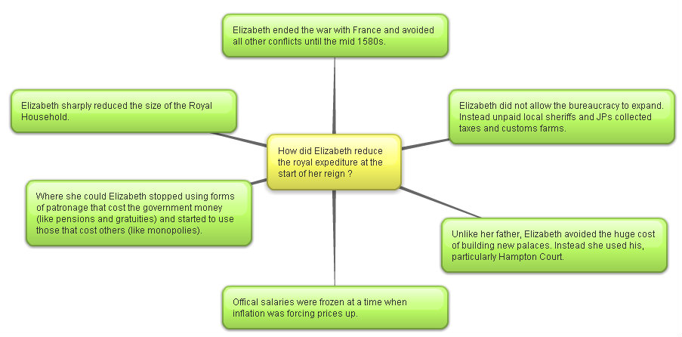

This looks like a remarkable achievement for the young monarch. However, it was not a complete success.

- Some historians argue that Elizabeth failure to introduce reforms to increase revenue in this period would be a long term problem for her when she need to spend a lot of money fighting the Spanish in the period 1585 to 1604.

- Also, her dependency on unpaid local government officials to collect her taxes and customs was inefficient and open to corruption. In other words, this could have been a false saving that cost the Crown more than it saved.

Questions

- Write two paragraphs to explain what financial problem Elizabeth faced in 1558, and consider how effectively she dealt with it.
- How valid do you consider the criticisms to be of Elizabeth’s early financial policy ?
- Study the diagram below. Label it with the Achievements of Elizabeth’s early financial policy and Failures of Elizabeth’s early financial policy as you think most appropriate (remember the best argument will be the weightiest). Explain your decision.

Now label the see saw and explain your choice in the box below

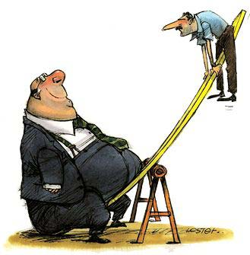

......................................................................................................................................................................................................................................................................................................................................................................................................................................................................................................................................................................................................................................................................................................................................................................................................................................................................................................................................................................................................................................................................................................................................................................................................................................................................................................................................................................................................................................................................................................................................................................................................................................................................................................................................................................................................................................................................................................................................................................................................................................................................................................................................................................................................................................................................................................................................................................................................................................................................................................................................................................................................................................................................................................................................................................................................................................................................................................................................................................................................................................................................................................................................................................................

Problem 4 - What foreign policy should Elizabeth follow ?

Whilst we need to know about all the problems that Elizabeth faced at the start of her reign before we can decide which was the most important, it is possible to argue that determining what foreign policy she would follow was a particularly urgent issue. This was because of the situation that she inherited from Mary.

Task
Study the scanned map of Europe in 1550 below. In groups list as many differences as you can identify between this and a modern map of Europe. These will be discussed in class.
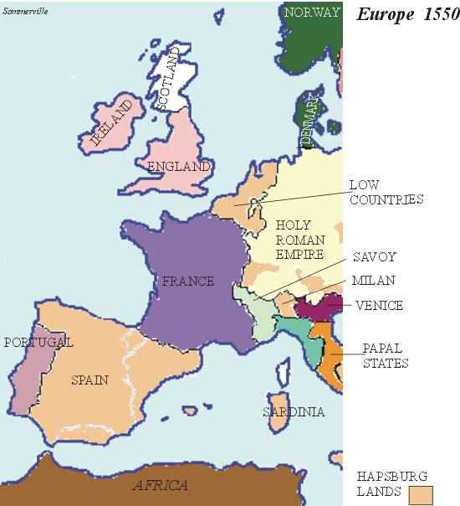

The situation that faced Elizabeth in 1558

- It is important to remember that in 1558 England was only a second rate European power. The two great states of Europe were Valois France and Habsburg Spain. They were at war, and England was tied into an unpopular alliance with Phillip II of Spain through marriage. England was at was therefore at war with France. Cardinal Pole ignominiously described it as “a bone between two dogs”.
- This was very unpopular in England. It had led to the loss of Calais (England’s last possessions in mainland France) and increased taxation (the Marian book of rates). There was great pressure to end the war and follow an independent foreign policy.
- To do so however also had very real dangers. It would break the Spanish alliance that had been the usual Tudor policy since Henry VII’s time. This was a particular problem for English trade it was dependent on selling its wool to the Antwerp cloth markets. Also, both Valois France and Habsburg Spain were Catholic, and the new Elizabethan regime was Protestant. Would an end to the Habsburg – Valois war lead to a Catholic alliance (crusade ?) against Europe’s newest and most powerful Protestant state. The situation was complicated by the Auld Alliance. This was the traditional friendship between Scotland and France (remember that Scotland was an independent country). There were French troops in Scotland, and therefore England’s northern border was not secure. Mary, Queen of Scots was married the Francis II, the heir to the French throne. To make Elizabeth’s situation even more serious, the Catholic Mary, Queen of Scots was Elizabeth’s cousin and heir to the English throne.

Questions

- Why did Cardinal Pole describe England as “a bone between two dogs” in 1558 ?
- List as many problems as you can that faced Elizabeth in the field of foreign affairs when she came to the throne.
- Rank these in order of importance. Write a paragraph to explain your decisions.

Elizabeth thus had five foreign policy aims at the start of her reign

- To secure England’s borders.
(Yellow)
- To ensure that there was not an alliance between Catholic Spain and France against Protestant England.
(Blue)
- To end the war with France which could not be afforded, and avoid future conflict if possible.
(Magenta)
- To reassert England as an independent nation with an independent foreign policy. This included not being dependent on Habsburg Antwerp for trade.
(Green)
- To regain Calais.
(Red)

- Rank these foreign policy aims in order of importance. Write a paragraph to explain your choice.

Extension – do any of these aims link together or contradict each other ?
If so, which ones and why ?

The following page considers the key events in the period 1558 – 1565
You should also read pp112 – 120 in Elizabeth I : Meeting the Challenge – John Warren

A table of key events 1558 – 1564 in the three main theatres of foreign policy
Shading corresponds to policy aims on the previous page

Year | Spain | France | Scotland
1558 | Mary is married to Phillip II of Spain and England is allied to the Habsburgs. She is at war with France | Loss of Calais – Mary Tudor famously declares "When I am dead, you will find Calais lying on my heart" | Mary Stuart (Queen of Scots) is married to Francis II – Heir to the French throne.
Nov - Death of Mary
Accession of Elizabeth
1559 | Phillip II offers to marry Elizabeth and maintain the Spanish alliance. Elizabeth refuses. Relations with Spain quickly cool. | The Treaty of Cateau –Cambresis was signed ending the war with France. Calais is effectively lost. Francis II becomes king of France - the possibility of Spanish French anti-English crusade rises. | The Protestant Reformation sweeps through the borders and lowlands of Scotland. In 1559 the Lords of the Congregation suspend the rule of Mary De Guise (Mary Stuart’s mother). French troops sent to restore her rule.
1560 |  | Death of Francis II – replaced with Charles IX. There is growing tension between the Catholics and Protestants (the Huguenots were Calvinist).  The possibility of Spanish French anti-English crusade falls. | William Cecil convinces Elizabeth to send naval and military support to the Protestant rebels (by the Treaty of Berwick). They are successful and French and English troops are withdrawn by the Treaty of Edinburgh. The Auld Alliance is smashed.
1561 | The Spanish are displeased by marriage negotiations between Elizabeth and the Protestant Eric of Sweden. |  | Mary Stuart returns to Scotland.
1562 | John Hawkins’ first voyage to the Spanish West Indies. The first step to developing English trade beyond its traditional markets (like Antwerp). | The French Wars of Religion break out. England sends assistance to the Huguenots by the Treaty of Hampton Court. The Earl of Warwick seizes Le Havre a negotiating chip for the return of Calais. The French unite to force the English out. | Elizabeth plans to meet Mary Stuart at York. She cancels at the last minute. The two never meet.
1563 |  | The English surrender Le Havre.
1564 | John Hawkins’ second voyage to the West Indies. | War with France ends in the complete expulsion of English influence from France. The Treaty of Troyes ensures that Calais is lost forever.
1565 to  1572 | The first tensions start to rise in English – Spanish relations over increased activity from English privateers. By 1568 John Hawkins blockades San Juan de Ulua. By 1569 trade is suspended between the two countries. In 1570 the Pope excommunicates Elizabeth. | Relations with France stabilise culminating in the 1572 Treaty of Blois. | Mary married Lord Darnley in 1565, only surviving male descendant of the Tudor line. This marriage led to the birth of James. Hence strengthening her claim to the English throne. By 1567 she is forced to take refuge in England. By 1570 there is an English army garrisoned in Scotland.
Questions

- Consider my colour coding above. Have I got it correct ? Could any events be coloured differently ? If so why ?
- Draw up two lists – Successes in Foreign Policy 1558 to 1564 and Failures in Foreign Policy 1558 to 1564. Discuss your lists with another student.
- Use your answers to question 21 to label the see saw. Explain your choice in the box below.

A see saw diagram to show how successful Elizabeth’s foreign policy was in the period 1558 - 1564

........................................................................................................................................................................................................................................................................................................................................................................................................................................................................................................................................................................................................................................................................................................................................................................................................................................................................................................................................................................................................................................................................................................................................................................................................................................................................................................................................................................................................................................................................................................................................................................................................................................................................................................................................................................................................................................................................................................................................................................................................................................................................................................................................................................................................................................................................................................................................................................................................................................................................................................................................................................................................................................................................................................................................................................................................................................................................................................................................................................................................................................................................................................................................................................................................................................................................................................................................................................................................................................................................................................................................................................................................................................................................................................................................................................................................................................................................................................................................................................................................................................................................................................................................................................

Problem 5 - What Religious Settlement Settlement should Elizabeth chose ?

Study the map and diagram below. The map shows the different types of religious worship there were in Europe by the early 1560s. You should note that Anglican worship was the English form of Protestantism. The diagram represents the
Task
What observations do you make ? Why would we expect religion to be a major problem for Elizabeth.
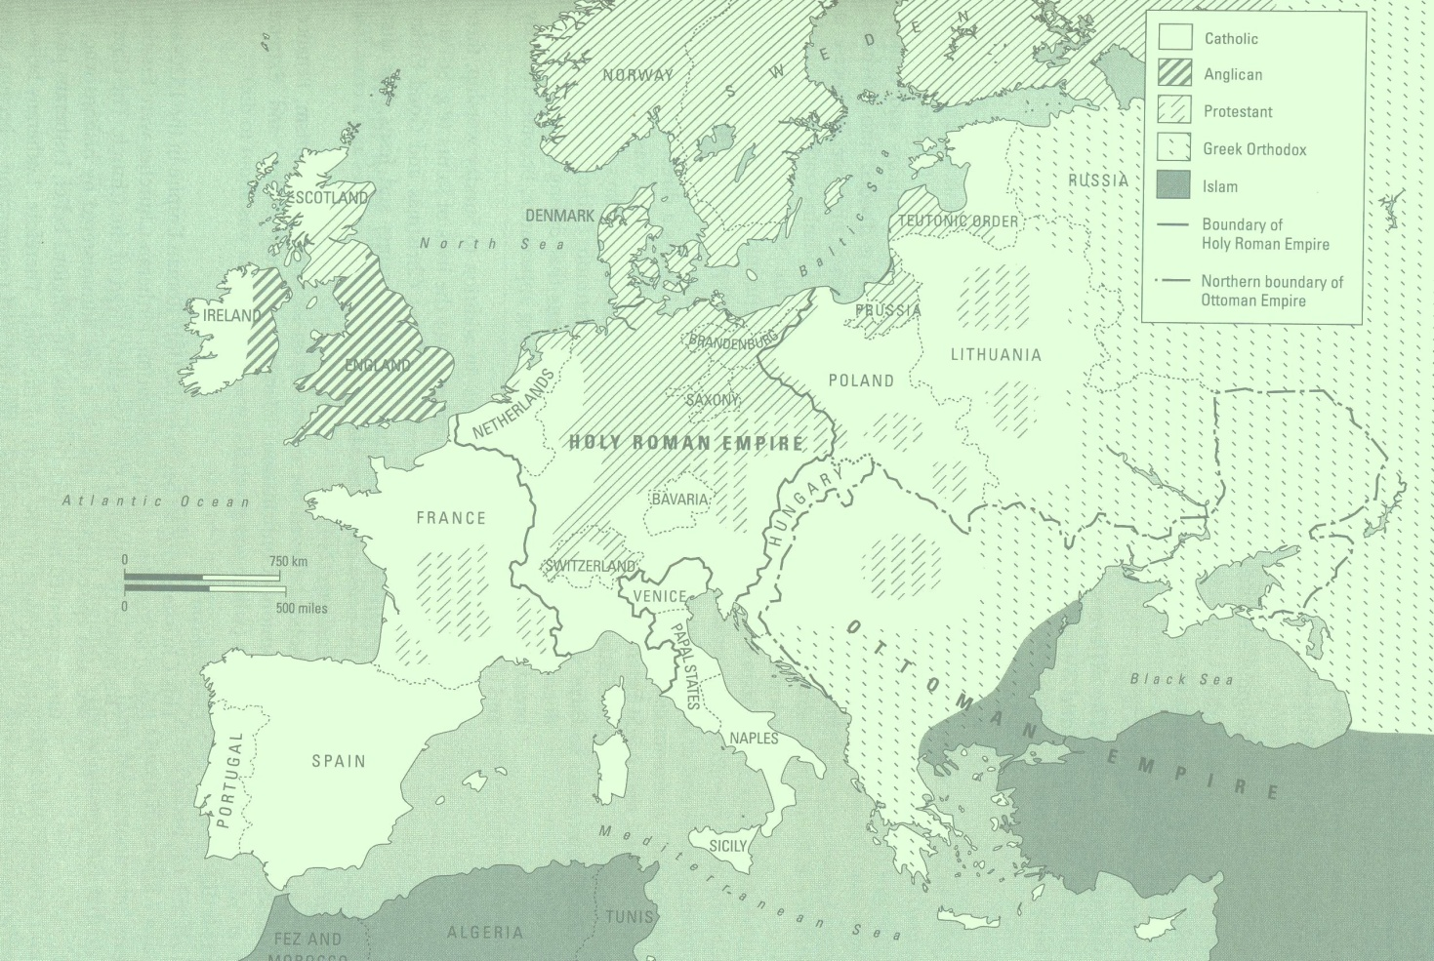

A diagram to show the religious divide in England in 1558

Protestantism Catholicism
Strongest in the South, East and London Strongest in the North, Ireland and Wales
Perhaps a small majority Perhaps a large minority

Roman Catholics supported Mary’s restoration of links with the Pope and Rome
The Puritans
Extreme Protestants

In other words Elizabeth inherited a religiously divided realm at a time when religious wars were raging throughout mainland Europe.

What did Elizabeth believe
It is actually rather difficult to answer this question.

I have no desire to make windows into mens souls
There is only one Jesus Christ and all the rest is a dispute over trifles…”
Her own beliefs…
- Elizabeth’s own background i.e. daughter of Anne Boleyn, product of the break from Rome and raised by Catherine Parr as well as the sympathies of her mainly Protestant Councillors made a Protestant settlement most likely.
- Early signs of her faith. Suspended the heresy laws in December 1558 and released those awaiting trial for heresy, on Christmas day 1558 she ordered that the Host should not be elevated during the mass (elevation suggested the real presence), at the opening of parliament 1559 she told monks from Westminster Abbey and lighted candles to get away.

Religion in Elizabeth’s Kingdom in 1558

Important Events in the passing of the Acts of Uniformity and Supremacy.
- Feb 1559 Bill introduced into parliament. Would have made Elizabeth head of the church and provided for a Protestant form of worship
- Passed Commons. But the Lords forced the changes in worship to be removed and refused to accept the royal supremacy.
- Parliament breaks for a recess over Easter.
- Disputation (debate) is held in Westminster Abbey. Two Catholic bishops were arrested and charged with disobedience to common authority.
- The reconvened Parliament had two bills, the Act of Supremacy and Act of Uniformity introduced to it.
- Act of Supremacy- made Elizabeth Supreme Governor instead of Supreme head of the Church. In practice she had as much power over the church as her predecessors. Easily passed through the House of Commons and opposed by all the Catholic bishops in the Lords and one layman.
- Act of Uniformity- Modelled on the second Edwardian Prayer Book (1552). As a compromise to Catholics used the wording of the Communion from the 1549 and 1552 Edwardian Prayer Book leaving the issue of real presence in memorial open. Prayer Book to be used in all churches, fines for those not attending church on a Sunday, and ornaments rubric left clerical dress and church decoration up to the monarch. Relatively easy passage through Commons but opposed by 9 bishops and 9 temporal Lords in the Lords. Had the 2 detained bishops and 2 members of the clergy not absent been present the Act would have been defeated.
- Act of the First Fruit and Tenths. Allowed for the transfer of property owned by the church to the monarch. The few monasteries Mary had restored were dissolved and property went to the monarch.
- The Thirty Nine Articles of Faith, 1563-71. Elizabeth used convocation (church government, meeting of the bishops) to produce the final statement of church beliefs. Set out clearly the belief in predestination. The articles were firmly based on the 42 Articles from 1552.
- Of the Marian clergy all of the bishops except 1 left the church, 400 ordinary members of the clergy were deprived or resigned between 1559 and 1664. The great majority of ordinary clergy conformed.
- Matthew Parker was appointed Archbishop of Canterbury and the Marian exiles took up the positions left by the Marian bishops.
- Royal Injunctions. The main details of the church were covered by the Acts of Supremacy and Uniformity. The Royal Injunctions were drafted later in 1559 to deal with matters that had not been covered. E.g. clergy might marry with the approval of 2 JPs and their bishop, clergy had to wear the surplice (the white Tunic that had been worn by Catholic clergy), altars could be replaced by Communion tables if the minister wanted.
- The Visitations. Took place in the summer and winter of 1559 to enforce the Royal Injunctions. As a result many churches were changed to the plainness of Edward’s day although were Catholic sympathy was strong this process took a lot longer.

How settling was the settlement?
- Cast as the Godly saviour (in contrast to Mary and the burning of heretics).
- However Elizabeth not a Godly reforming monarch, conservative.
- More concerned about the Supremacy rather than theology.
- Marian exiles fill the empty bishoprics and her councillors are those of Edward’s reign, these men see the settlement as the beginning and set them in conflict with the queen.
- Therefore had created a settlement which left many unsatisfied, even in her own government
- Elizabeth regarded the settlement as final and any attempt to bring changes as a challenge to her authority.

The traditional view of Elizabeth’s 1559 Settlement

Protestantism The Settlement Catholicism

Roman Catholics supported Mary’s restoration of links with the Pope and Rome
The Puritans
Extreme Protestants

The settlement was unquestionably a Protestant one. However there were concessions to the Catholics. Eg the wearing of vestments and the singing of hymns. It was designed to include to moderate Catholics.
Compulsary Reading

Dicken and Fellows – p164 – 171 / 192- 198 / 216 - 219

Further Reading

There are copies of these book (and lots of others on Elizabeth) in the school library

The Later Tudors – P Williams
Chapter VII - The establishment of Elizabethan rule

The Emergence of a Nation State –AGR Smith
Chapter XII – The establishment of the Elizabethan Regime
Or online you could click onto the following site

An excellent site from JP Somerville

http://faculty.history.wisc.edu/sommerville/361/361-14.htm#early%20years
Essays

TITLE:
June 2009
How serious were the problems Elizabeth I faced in 1558?
Examiner Guidance

Elizabeth’s position in 1558 was very vulnerable. She was not seen as the legitimate ruler by Catholics both at home and overseas. As a result Mary Queen of Scots was seen by many as the rightful ruler and her links with France further weakened Elizabeth’s position. England was also at war with France in 1558 and this added to the danger and was made worse when Spain made peace with France as this isolated England and left them open to the possibility of a Catholic crusade. However, this problem should not be exaggerated as it was unlikely that Philip would help to put a pro-French ruler on the throne of England. Philip even offered his hand in marriage to Elizabeth, so provided she did not alienate him her position was more secure. It was possible that there might be a Catholic rebellion at home, but without foreign leadership this was less likely and the Papacy failed to give a lead, hoping that Elizabeth might rejoin the catholic fold. It was expected that Elizabeth would marry and that raised a number of issues over the choice, foreign influence and faction if she chose to marry an Englishman. However, she was also able to use the prospect of marriage as a tool to strengthen her position and buy time to secure her position at the start of her reign. The problem of the succession was crucial and parliament asked her in 1559 to name a successor. She also had to overcome the prejudices against female rulers following the reign of Mary, which had been reinforced by the disasters of the latter years of her reign. She also had to overcome the popular stereotype of women, which emphasised their physical, emotional and intellectual inferiority to men. There were social and economic problems to be dealt with in the aftermath of Mary’s reign. The reign also began with war against France and this created major financial problems.

Examiner Report

At the lower end candidates either described the problems that Elizabeth faced without assessing their seriousness or indulged in speculation about the seriousness without factual support for their ideas.

There were also some candidates who went well beyond 1558 in consideration of the problems. Many chose to emphasise the seriousness of the problems created by the make-up of the Privy Council in 1558 and by addressing this first and at length gave the impression that this was the most serious issue despite being unable to supply any supporting evidence to substantiate it.

There were a number of candidates who mishandled the loss of Calais and suggested that it meant that England was under imminent threat of invasion, even suggesting ‘All invasions came through Calais.’ There were other answers which did not see religion as a problem and argued that England was willing to embrace Protestantism and was simply waiting for Elizabeth to come to the throne.

Key Words and Phrase:

Key issues to be discussed:

Linking and Relative Importance:

Line of Argument
 | Argument | Evidence deployed

Introduction

Tie the question to the factors

1

2

3

4

5

Conclusion

Direct answer to the question

Student

Concerns
January 2012
How successful was Elizabeth I in dealing with the problems she faced between 1558 and the end of 1563 ?

TITLE:
January 2012
How successful was Elizabeth I in dealing with the problems she faced between 1558 and the end of 1563 ?

Examiner Guidance

At the higher levels candidates should focus on the question of ‘how successful’ and not simply list examples of success and failure. Candidates might start by identifying the problems that Elizabeth faced and then go on to assess how successfully she dealt with them.

There are a range of issues that candidates might consider, but what matters is the quality of analysis. Candidates might consider the religious problem and argue that given the divided state of the nation Elizabeth did remarkably well to keep outward religious harmony with the settlement, others might suggest that she disappointed both Protestants and Catholics by the moderate nature of the settlement. It is likely that the issue of her legitimacy will feature in many answers and given the possible challenges to her position she was successful as she was able to avoid rebellion and unrest and secure the throne.

This might be linked to foreign relations. England was at war with France and Elizabeth successfully ended that, even if it meant recognising the loss of Calais; the war had been a drain on resources. Under Mary, England had been a close ally of Spain and Elizabeth was able to keep relations with Spain friendly at the start of the period. This was particularly successful as it made it less likely that France would invade in support of Mary Stuart. Elizabeth was also careful not to dismiss Philip’s marriage proposal too quickly. It might also be argued that Elizabeth dealt successfully with relations with Scotland, which could have been difficult given the ‘Auld Alliance’ and claim of Mary Stuart. Under pressure from her councillors she supported the Protestant Lords and this began the decline of French influence in the kingdom and would help to secure the northern border. Candidates might also consider the issue of faction and the composition of the Council. Under Mary this had become large, but Elizabeth reduced its size and made it more efficient, but at the same time included known Catholics, like Norfolk, provided they remained loyal. Some might also consider the financial inheritance, which was improved with the ending of the war.

Examiner’s Report

There were a significant number of candidates who described the problems that Elizabeth faced and did not address the issue of her success in dealing with them. There were also a number of candidates who went well beyond the dates in the question, some producing surveys of the whole reign, and they did not receive credit for the material. The most common feature was spending too long describing the problems and not enough time assessing whether Elizabeth was successful in dealing with it. Most candidates were aware of the range of difficulties she faced and were able to consider a range of issues, usually including foreign policy, religion, finance, government, and marriage and the succession. In places, some of the knowledge was quite generalised, particularly over foreign policy and religion. In dealing with foreign policy, knowledge of the peace with France was often lacking and details of the religious settlement were also absent when discussing the success of her religious policy.

Key Words and Phrase:

Key issues to be discussed:

Linking and Relative Importance:

Line of Argument
 | Argument | Evidence deployed

Introduction

Tie the question to the factors

1

2

3

4

5

Conclusion

Direct answer to the question

Student

Concerns

