What were the roles of the House of Commons and House of Lords in the Elizabethan system of Government?
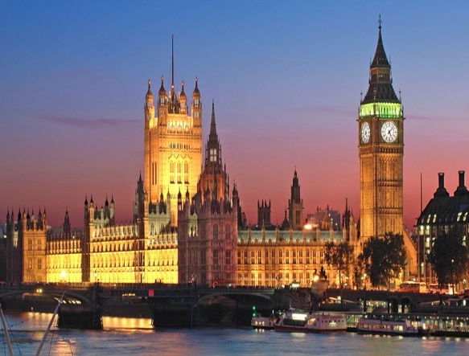
On first consideration there are obvious similarities between Parliament in 1558 and Parliament today.

- It is in the same place – Westminster (shown above left).
- It passes laws.
- There are two chambers (it is bi-cameral).
  - The House of Lords – The Upper House (unelected, housing bishops, aristocrats and lords)
  - The House of Commons (shown below left) – The Lower House (elected to represent the rest of the nation state)
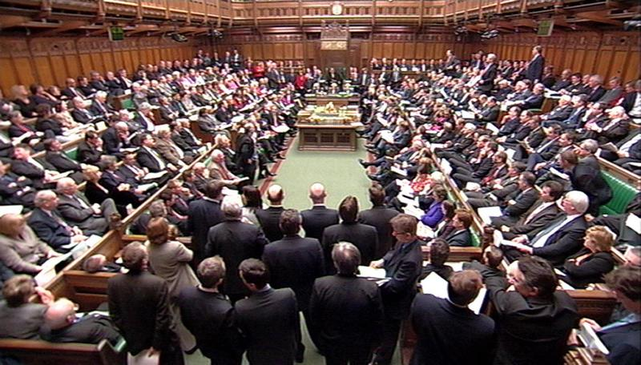
However, the differences are much more importance.

When we think of the Houses of Parliament today we think of it as the centre of our democratic system of government. The government’s legitimacy (or right to rule) comes from its ability to command a majority in the House of Commons. This in turn comes from the seats it gained at the last General Election.

This was not the case In Elizabeth’s time. Elizabeth’s government gained its legitimacy from the idea of the Divine Right of Kings (see Unit Two notes). Elizabeth took the idea of the Royal Prerogative very seriously, and thus was very concerned how Parliament had grown in power in the twenty-five years before 1558. M.Graves argues that the weak leadership of the so called “Mid Tudor Crisis” had seen Parliament take responsibility for “the highest matters of state, altered religion...encroached on property rights...and legislated on all aspects of the Commonweal” For Elizabeth, this was unacceptable. She, like her father before her, believed that Parliament should be limited to three roles;

- To grant the money her government needed when it was required (this is sometimes known as supply or subsidy).
- To pass laws the government wanted it to. To pass laws is sometimes known as to legislate; hence Parliament was the legislative body. It is worth noting here that Elizabeth could pass laws without Parliament by issuing a Royal Proclamation.
- To be a “point of contact” (G.R.Elton) between the government and the people. It could provide advice on Matters of Commonweal, and if asked, Matters of State (see later notes on Parliamentary Privileges).

For Elizabeth therefore it was the monarch, not Parliament that decided policy.

There are other important differences that we should be aware of as well at this stage;

- There was no Prime Minister or political parties as we know them.
- Although there were elections for the lower house, the MP needed the support of important people in their locality. Moreover, elections were often rigged and only men with a certain annual income could vote.
- It was up to Elizabeth when Parliament was called and when it was prorogued (closed).
- Elizabeth’s parliaments were controlled for her by her councillors. Principally by William Cecil, and then, less successfully, by his son Robert Cecil.
Year | Date | Key Issues
1559 | 25 Jan - 8 May | - 1559 Religious Settlement.  - Start of reign supplies granted.
1563-1567 | 1st - 12 Jan - 10 April 1563  2nd - 30 Sept 1566 - 2 Jan 1567 | - Pressure on Elizabeth over the succession.  - Supplies required for foreign policy v the Auld Alliance.
1571 | 2 April-29 May | - Rising fear of Catholicism after the Northern Rising and the excommunication of Elizabeth by the Pope.  - No supplies requested.
1572-1581 | 1st - 8 May - 30 June 1572  2nd - 8 Feb -15 March 1576 | - Peace time supplies requested.
1584-5 | 1st - 16 Jan - 18 Mar 1581  2nd - 23 Nov 1584 - 23 Mar 1587 | - Concerns over the Queen’s safety.  - William of Orange assassinated.  - Babington Plot v Elizabeth.
1586 -7 | 29 Oct 1586 - 23 March 1585 | - The fate of Mary, Queen of Scots.
1589 | 4 February - 29 March | - Supplies required to finance the Spanish War.
1593 | 19 Feb - 10 April | - Supplies required to finance the Spanish War.
1597-8 | 24 Oct 1597 - 9 Feb 1598 | - Supplies required to finance the Spanish War.
1601 | 17 Oct 1601- 19 Dec 1601 | - Supplies required to finance the Spanish War.  - Monopolies Crisis.
Session dates for Elizabeth’s Parliaments
This is a reference table - you do not need to know these dates
Some statistics you may like to use when you write;

- Elizabeth only called ten Parliaments (thirteen sessions) in a 45 year reign.
- This was a lot less than the twenty six sessions in the thirty years before 1558.
- An average of 3 years passed between sessions.
- There was no parliament at all in 26 years of Elizabeth’s reign.
- Elizabeth preferred short sessions that granted money.
- Only 10 percent of MPs ever spoke in debates and only 47 percent of MPs voted.
- MPs did become more educated in Elizabeth’s reign. In 1563 only 26 percent of MPs had legal training. By 1593, this figure had risen to 44 percent. This of course meant that they were more able to questions bills.
- Elizabeth’s parliaments averaged 33 acts per session. More than any other Tudor monarch.
- Out of the 34 times that Elizabeth used her Royal Veto to stop bills passing into law, only 5 were Matters of State. The others were because the legislation was poorly worded or not in the public interest.
The Historical Debate
How far did Elizabeth’s relations with parliament change?
Was co-operation or conflict the dominant theme of Elizabeth’s relationship with her parliaments?
What Is A Historical Debate?

Until this point the study of history has really been a quest to find out what happened in the past. The study of Elizabethan parliaments however is the first time that you will come across the idea of historiography – or historical debates. This is where historians look at the same topics and evidence, and draw different interpretations. This could be because of differing politics, methodology or because they are asking different questions. For example, next year you will look at differing arguments in Russian history. There is a very famous historical debate over the nature of Elizabeth’s relationship with her parliaments. Was co-operation or conflict the dominant theme? The arguments are set out below...

The Neale Thesis - Orthodoxy
Conflict is the dominant theme of Elizabeth’s relationship with her Parliaments

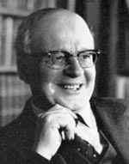
- J.E Neale produced a series of books of the topic. In 1949 he wrote “The Elizabethan House of Commons” and then in the 1950s a two-volume text entitled “Elizabeth I and her Parliaments”.
- These argued that Elizabeth’s relationship with her parliaments was dominated by conflict.
- In particular, Neale argued that Elizabeth’s reign saw the rise of an independent and increasingly university educated gentry in the House of Commons. Against them was the monarchy, supported by the House of Lords.
- The central issue for the opposition in the House of Commons was religion. They were extreme Protestants – Puritans. When they had to choose, they put their religion above their loyalty to the Queen.
- Neale argued that there was an organised group. He referred to a 1566 pamphlet that named 43 MPs. They called themselves “our choir”, and thus Neale labelled them “the Puritan Choir”. For Neale, “the men of 1566 deserve a place pre-eminent in our country’s parliamentary history”.
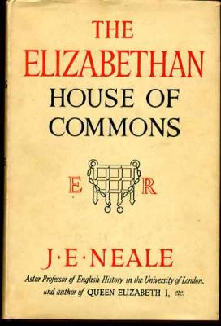
- Neale continued that this was “an opposition group in a significantly new sense: one with a positive programme...the fulfilment of its Protestant destiny”. They thus deliberately planned confrontations with Elizabeth.
- He believed that the House of Commons used its control over finances (subsidies) as weapons to try to get Elizabeth to do what it wanted. The 1566 Parliament was the best example of this. Neale argued that they “made supplies depend on the redress of grievances”.
- Neale had a tendency to look at History with hindsight. His search for trends of progress meant that he saw this conflict as the origin of English Civil War in the 1640s. As a result, Neale also focused on key individuals, such as Peter Wentworth, and compared them to leaders of the Parliamentarians in the 1640s such as John Pym.

Revisionism – led by G.R.Elton
Co-operation is the dominant theme of Elizabeth’s relationship with her Parliaments

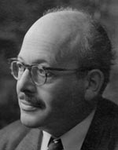

- In 1986 G.R. Elton, a former tutee of Neale, challenged his ideas in ”The Parliaments of England 1559 – 1581”. He argued that co-operation was the dominant theme of Elizabeth’s relationship with her parliaments.
- For Elton “all talk of the rise of Parliament as an institution, or worse, the rise of the House of Commons into political prominence, is balderdash”.
- Elton took this view because he focused on different questions. He accepted that there were clashes, but saw these as isolated incidents.
- Elton rejected the idea of Elizabeth’s House of Commons being the forefather of the leaders of the Parliamentarians in the 1640s.
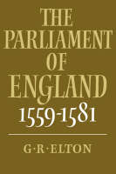
- For Elton it was more important to look at Parliament’s legislative achievements. This meant the laws it passed. He argued that Parliament loyally raised money for the Queen, passed her bills, and was particularly effective on local matters. How else could her parliaments average 33 acts per session?
- For Elton the House of Lords remained the most powerful of the two Houses of Parliament not least because of its social pre-eminence.
- Elton rejected the idea that Puritainism was a progressive political force, and even questioned the existence of the Choir itself. He pointed out that some “members” had Catholic leanings. Others were councillors! It seems today that the the 1566 pamphlet was a satire attacking the members of a parliamentary committee. It is however still unclear why it was produced.
- More recent historians like C.Haigh and M.Graves (sometimes called post-revisionsists) accept Elton’s revision. For example Graves states “the revisionists have convincingly rejected the notion that the Commons political muscle and Commons centred opposition to royal government increased”. He continues that “they have also restored to a prominent place the House of Lords”. For these post revisionists, where there was opposition in the House of Commons, it was usually created by Elizabeth’s own councillors, who were trying to use Parliament to put pressure on the Queen.

Trap to avoid
Remember our mark scheme requires you to write factor-based essays with linking and relative importance. To understand this unit, we need to know the historical debate. However, it should only be used to tie the question that you are given to the factors that you are going to write about (ie in your introduction). Do not just regurgitate this debate because it makes you sound clever. That will not be answering the question set.

The way forward
To answer this topic for our mark scheme we need to explore the factors that make up Neale’s argument (and thus Elton’s revision).
Students tend to do very well on this unit because it lends itself to the higher order analysis skills of linking and relative importance (see the overview diagram below).

Issues (factors) to consider when deciding whether co-operation or conflict was the dominant theme of Elizabeth’s relationship with her parliaments

Religion

The underpinning factor?
For Neale this linked because the Puritan Choir wanted Free Speech to speak on Matters of State...
For Neale this linked because the Puritan Choir wanted to ensure a Protestant heir to throne...

Parliamentary Privileges

(Including Free Speech)
Marriage
&
Succession (including Mary, Queen of Scots)

Monopolies

The best claim to opposition to Elizabeth – but no direct link to Religion

Evidence for conflict

This is the central plank of the Orthodox argument. Elizabeth’s reign saw the rise in the House of Commons of “the Puritan Choir”. This was “an opposition group in a significantly new sense: one with a positive programme...the fulfilment of its Protestant destiny”. This meant that it was an organised opposition which devised parliamentary strategies and coordinated its activities.

- Neale believed that the Puritan Choir forced Elizabeth into a more extreme Protestant settlement than she had intended in 1559 (they argue she wanted a settlement like her father’s).
- Neale referred to a 1566 pamphlet that named 43 MPs. They called themselves “our choir”, and thus Neale labelled them “the Puritan Choir”. They consistently forced Elizabeth to defend the Settlement after its passage.
- As such, Elizabeth’s Royal Prerogative was repeatedly challenged on the issue of religion. This meant that in 1566, 1571, 1572, 1586 and 1593 Elizabeth had to crush Protestant bills.
- In 1571 William Strickland actually proposed a reformed Prayer Book. Elizabeth excluded him from the House, but then was forced to back down and readmit him.
- In 1587 Elizabeth had to send Anthony Cope and his Presbyterian supporters to the Tower.

Religion Religion

Evidence for cooperation

- Revisionists like S.Doran argue that Elizabeth believed in Edwardian doctrinal Protestantism – ie as the daughter of Anne Boleyn she actually wanted a more Protestant Settlement than she got. She was stopped by Catholic opposition in the House of Lords. It was the Catholic Bishop Scot of Chester who said “for matters of religion, I do not think...(Parliament)...should meddle”. By contrast, Protestants in the House of Commons were “part of a government plan to restore English worship to the standard of 1552” (N.Jones).
- Elizabeth’s authority on Religion was never seriously challenged in the House of Commons. It is noteworthy that the entire so-called Puritan Choir accepted the Act of Supremacy’s assertion that Elizabeth was “the only Supreme Governor...in all things spiritual or ecclesiastical”. By contrast only one bishop in the House of Lords would agree to it. They all had to be replaced.
- N.Jones also questions the organised nature of the Puritan Choir in his 1982 book “Faith by Statute”. He points out there is no evidence that they were “a cohesive Puritan Pressure group”. M.Graves supports this, stressing that it was the Commons itself that pushed for Cope to be sent to the Tower.

The Issue of religion
Where does the weight of the evidence lie?

Best Evidence for Conflict Best Evidence for Co-operation
...............................................................................................................................................................................................................................................................................................................................................................................................................................................................................................................................................................................................................................................................................................................................
......................................................................................................................................................................................................................................................................................................................................................................................................................................................................................................................................................................................................................................................

Now label the see saw and explain your choice in the box below

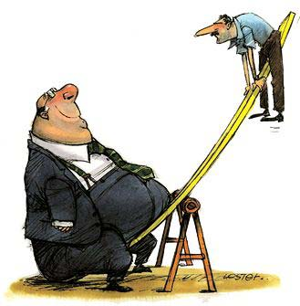

...................................................................................................................................................................................................................................................................................................................................................................................................................................................................................................................................................................................................................................................................................................................................................................................................................................................................................................................................................................................................................................................................................................................................................................................................

For Orthodox historians like J.E.Neale the intertwined issues of the Marriage, Succession and the fate of Mary, Queen of Scots came second only to the 1559 Religious Settlement in importance. In fact it came from the desire to secure Protestant England beyond Elizabeth’s reign. Matters came to the fore in the second parliament (1563 – 1567). Elizabeth had almost died of Smallpox in 1562, and had she done so, then her Catholic cousin, Mary Guise (Queen of Scots) would have been the heir to the throne.

- Neale argued that an organised campaign, led by the university educated Peter Wentworth pressured the Queen to marry to secure a Protestant heir to the throne. For Neale they “employed such arts of opposition and displayed so resolute a spirit that no House of Commons before their time could furnish the like”.
- They did this by linking their concerns to Elizabeth’s need for money. As Neale put it, “there can be little doubt that making supplies depend on the redress of grievances was the deliberate and concerted policy”.
- Elizabeth was forced to promise that she would “marry as soon as I can conveniently” She is also meant to have privately added that it was a strange thing “that the foot should direct the head in such a weighty matter”.
- The House of Commons would not be intimidated however, and continued to push for a direct answer. This forced Elizabeth to issue an express commandment to the House of Commons to stop discussing the topic. This in turn provoked Wentworth’s defence of liberty speech. Elizabeth was so angry that she prorogued the parliament “to be rid of an intolerable House of Commons.”
- For Orthodox historians the issue was not confined to the second parliament. As Elizabeth passed child bearing age it evolved into pressure to execute Mary and name a Protestant successor.
Marriage and Succession

Revisionists would certainly acknowledge that “the succession was an issue which agitated members throughout the reign” (Sloan). However, as always, context is very important.

- Elizabeth was forced to remind the Commons that she was their “anointed Queen...(who)...will never be by violence constrained to do anything”. However this was the point. Elizabeth never married and never named a successor. Moreover it was Elizabeth herself who twice asked Parliament (in 1572 and 1586) to discuss the fate of Mary Guise so it could take the blame. The campaign for her execution was led by two councillors, Croft and Knolly.
- The desire for Elizabeth to marry was not confined to the will of any Puritan Choir. Rather, it was widespread in a nation that craved political and religious stability. Recent work by C.Haigh has shown that Councillors used the Commons to pressure the Queen on the matter. In other words, the Commons was used again. Indeed it was Cecil himself who led the delegation to the Queen and worded their request to name her successor.
- Finally Alsop argues that “the connection between supply and succession was not as substantial as Sir John Neale suggests”. In other words the Commons did not use its financial muscle to blackmail Elizabeth. The Queen was never denied supply, and it was her choice to accept a reduced sum (of extra taxation) in 1566.

The Issues of Marriage, Succession and the fate of Mary
Where does the weight of the evidence lie ?

Best Evidence for Conflict Best Evidence for Co-operation
....................................................................................................................................................................................................................................................................................................................................................................................................................................................................................................................................................................................................................................................................................................................................................................
......................................................................................................................................................................................................................................................................................................................................................................................................................................................................................................................................................................................................................................................

Now label the see saw and explain your choice in the box below

...................................................................................................................................................................................................................................................................................................................................................................................................................................................................................................................................................................................................................................................................................................................................................................................................................................................................................................................................................................................................................................................................................................................................................................................................

Parliamentary Privileges

For Orthodox thinkers, Elizabeth’s reign saw the rise of a wealthier, more educated and thus independent House of Commons. This was what R.H. Tawney called “The Rise of the Gentry”. This led to the Elizabethan House of Commons becoming increasingly aware of their parliamentary privileges. This meant the rights that they enjoyed because they were MPs. These included freedom from arrest and libel. However, the most controversial was the freedom of speech (remember the distinction that Elizabeth made between Matters of State and Matters of Commonweal – see page 10). Did the Puritan Choir want freedom of Speech to push their religious views? For Neale the answer was yes, and moreover this was the beginning of a conflict with the Crown which would end in the Civil War in the 1640s.

- For Neale, men like the Wentworth brothers, inspired by the earlier writings of Thomas More, pushed for freedom of speech. In 1576 Peter Wentworth famously argued that “there is nothing so necessary for the preservation of the prince and state as free speech and without, it is a scorn and mockery to call it a Parliament House, for in truth it is none but a very school of flattery and dissimulation”.
- Wentworth was sent to the Tower for four weeks.
- Neale argued that whilst Elizabeth was “justified constitutionally” in the distinctions she made (page 10 again) “constitutional niceties make little effect in passionate revolutionary times”.

For Revisionists, the idea of an organised and self-aware opposition is not justified. Rather,
- A.G.R.Smith argues that Peter Wentworth was “ a maverick” whose “views on free speech were well ahead of their time”. M.Graves goes further, describing him as “little more than a parliamentary nuisance”.
- The link to the origins of the English Civil War is thus both overstated and unhelpful.
- Indeed, the key evidence here is that it was his fellow MPs who expelled him from the Commons and imprisoned in the Tower for four weeks. In other words, Wentworth’s demands for freedom of speech were certainly not representative of his peers.

The Difference between Matters of State and Matters of Commonweal
Matters of State

For Elizabeth discussion on Matters of State could only happen in Parliament if the Monarch requested it.

The list below is some of the more significant Matters of State.

- Religion
- Marriage
- Succession
- Foreign Policy
- Monopolies
- Purveyance

Only twice, 1572 and 1586 was Parliament asked to discuss a Matter of State. Both times it was the issue of Mary, Queen of Scots

Matters of Commonweal

These were topics that Parliament could initiate discussion on without asking Elizabeth.

The list below is some of the more significant Matters of Commonweal.

- Local Matters
- Private Bills
- National Social Matters
- National Economic Matters

These final two topics sometimes overlapped. – EG the 1597 and 1601 Poor Laws. These were seen as very important matters, so even here Royal assent would still be required.

The Issue of Parliamentary Privileges
Where does the weight of the evidence lie ?

Best Evidence for Conflict Best Evidence for Cooperation
..................................................................................................................................................................................................................................................................................................................................................................................................................................................................................................................................................................................................................................................................................................................................................
......................................................................................................................................................................................................................................................................................................................................................................................................................................................................................................................................................................................................................................................

Now label the see saw and explain your choice in the box below

...................................................................................................................................................................................................................................................................................................................................................................................................................................................................................................................................................................................................................................................................................................................................................................................................................................................................................................................................................................................................................................................................................................................................................................................................

Finances and Monopolies
The Tudor system of government said that in the monarch’s first parliament they should be granted a subsidy round. Thereafter, in ordinary times the government should be financed by customs revenues and rents from the Crown’s own land rentals. Extra subsidies could only be requested in extra-ordinary times (such as war). Reference to the table on page 3 shows that this convention was pushed to its limit by Elizabeth.
- Neale argued that in 1566, 1571, 1585, 1587 and 1601 Parliament linked Elizabeth’s need for extra subsidies to their own political agenda.
- In 1587 for example, the Commons offered Elizabeth extra funds in return for taking sovereignty of the Low Countries (and thus tying England to supporting the Protestant rebels against Spain).
- At times the Commons had to fight bitterly (in 1589 and 1593 for example) to defend its sole right to initiate votes of money. In 1593, William Cecil had to use the more placid House of Lords to launch an additional subsidy request. On seeing the bill the usually loyal Sir Francis Bacon famously replied that “gentlemen must sell their plate and famers their brass pots ere this will be paid”.
- The biggest crisis came in 1601, when Elizabeth and Robert Cecil lost control of Parliament. The unpopularity of Robert Cecil and the ongoing war with Spain were problems. However, the real cause was Elizabeth’s continued use of monopolies as a free form of patronage. Monopolies were a “royal patent for the sole right of exporting, importing, manufacturing, or distributing some particular article” (S. Atkins) – Elizabeth rewarded men for loyal service with them Thus Raleigh had a monopoly on tavern licences, and the Earl of Essex had a monopoly on the import of sweet wines. Monopolies were often abused, and were hated.
- In the 1601 Parliament a list of the monopolies created since 1597 was read out, and caused one MP, William Hakewill, to interrupt, "Is not bread there?" and to then add, "If order be not taken for these, bread will be there before the next Parliament." Another MP dubbed the monopolists the "bloodsuckers of the commonwealth." Robert Cecil dammed the behaviour as “more fit for a grammar school than a parliament house”.
- Elizabeth finally gave in, and had to address Parliament personally, giving her famous Golden Speech. She then cancelled 12 monopolies overnight, halted others in the works, and made monopolists answerable to the common law courts. She had clearly been forced to back down on a Matter of State.

Revisionists would agree that the 1601 Monopolies Crisis was an example of conflict between Elizabeth and the Commons – indeed it is for them the best example of conflict in the 45-year reign. However,
- It is important to note that the Commons never withheld funds from Elizabeth.
- Indeed, Elizabeth became the first monarch in English history to be awarded multiple subsidies. In 1589 and 1593 Elizabeth was offered double subsidy rounds. In 1597 she was awarded a triple subsidy round, and in 1601, after the Monopolies Crisis and the Golden Speech Elizabeth was awarded a quadruple subsidy. These were hardly the actions of a self confident and independent House of Commons.
- Revisionists would also argue that the Commons offer of funds in return for taking sovereignty of the Low Countries was for extra funds. It never threatened to withhold monies – an important distinction.
- Perhaps most importantly of all, the conflict over monopolies was real, but it was not part of the rise of the Puritan Choir. Rather, it was motivated by frustration and self-interest after more than a decade of fighting Spain.

The Issue of Finances and Monopolies
Where does the weight of the evidence lie ?

Best Evidence for Conflict Best Evidence for Cooperation
........................................................................................................................................................................................................................................................................................................................................................................................................................................................................................................................................................................................................................................................................................................
...............................................................................................................................................................................................................................................................................................................................................................................................................................................................................................................................................................................................................................................................................................................................

Now label the see saw and explain your choice in the box below

...................................................................................................................................................................................................................................................................................................................................................................................................................................................................................................................................................................................................................................................................................................................................................................................................................................................................................................................................................................................................................................................................................................................................................................................................

What tactics did Elizabeth use to help her control Parliament?
You should also be aware of the tactics that Elizabeth used to control Parliament

Further Reading

There are copies of these book (and lots of others on Elizabeth) in the school library

The Tudor Years – Ed R Sloan
Chapter XI – Elizabeth and Parliament – R Sloan

The Emergence of A Nation State –AGR Smith
Chapter XV – Elizabeth and her Parliaments

The Reign of Elizabeth I – SJ Lee
Chapter 2 – Elizabeth and Parliament

Elizabeth I – Profiles In Power – C Haigh
Chapter VI – The Queen and the Parliament

Or online you could click onto the following sites

Some excellent articles on History Today

http://www.historytoday.com/re-foster/conflicts-and-loyalties-parliaments-elizabeth-i

https://www.historytoday.com/archive/faction-reign-elizabeth-i

Something a bit higher from Tudors.org

http://www.tudors.org/asa2-level/52-parliament-and-prerogative-in-the-reign-of-elizabeth.html

