Finance

When historians consider Elizabeth’s reign as a whole, her financial and Irish policies are usually the areas which attract most criticism. R Sloan for example is typical when he writes of her financial legacy as “a poisoned chalice”...”in which Elizabeth’s cautious and short sighted approach to government proved most damaging.”

The problem with this approach is that is rather generalised. Reference to Figure 1 below reflects this. In reality, Elizabeth faced a series of interlinked financial problems, and the quality of her response to them varied. Our task is to consider their relative seriousness, and analyse how successfully the regime met these challenges.

Figure 1 – a diagram to show the interlinked financial problems that the Elizabethan regime faced. The problems shaded yellow (1 and 4) are sometimes presented as successfully handled, whilst the turquoise problems (2 and 3) are often protrayed as failures. You will need to decide if you agree with this.

Problem 1 – The Marian financial inheritance

In recent years there has been a lot of revisionist work done on Mid Tudor government. As part of this, the financial reputations of Mary I and Edward VI (especially the protectorate of Northumberland) have been more positively appraised. DM Palliser reflects this when he states “fortunately for Elizabeth both Northumberland and Mary kept the realm generally at peace and managed, with the aid of Lord Treasurer Winchester, to reduce expenditure and to increase income”. The latter point is particularly noteworthy as Winchester took the important but unpopular decision to update the national tax records. These were to be the Marian Book of Rates, subsequently used by Elizabeth throughout her reign. They increased the Crown’s annual income from £29,000 per annum in 1556 to £83,000 in 1557.

These are valid points, but when Mary died in 1558 England was at war, allied with Spain, against France and Scotland. This added a serious debt and an expenditure problem to the spike in inflation she had inherited from the debasement of Henry VIII and Edward VI. The basic problem was that then, as now, war is expensive. Hence, despite updating the tax records, Mary left a debt of £227,000. Worse still £106,000 of this was owed to the Antwerp exchange at 14% interest per annum. This was close to usury. As Sir Walter Mildmay would later tell the House of Commons, England in 1558 was “grievously afflicted with debts; the burden of which...can not be remembered without grief”.

Elizabeth had two possible ways to deal with this problem. She could have either increased the revenue coming into the Exchequer, or she could have reduced the expenditure going out. As the Figure 2 below shows, Elizabeth chose the latter option.

Figure 2. A diagrammatic representation comparing the Marian and early Elizabethan exchequer.

Expenditure going out

The
Marian
Exchequer
Revenue coming in

Because Expenditure is >er than Revenue = Growing debt - (in the red)
The
Early Elizabethan
Exchequer
Less expenditure going out
Similiar revenue coming in

Because Revenue is >er than Expenditure = Annual surplus and debt paid off
By 1585 the Crown had a cash reserve of £300,000 (in the black)
Figure 3. A diagram to show how Elizabeth and the Marquis of Winchester (her Lord Treasurer until 1572) made these savings.

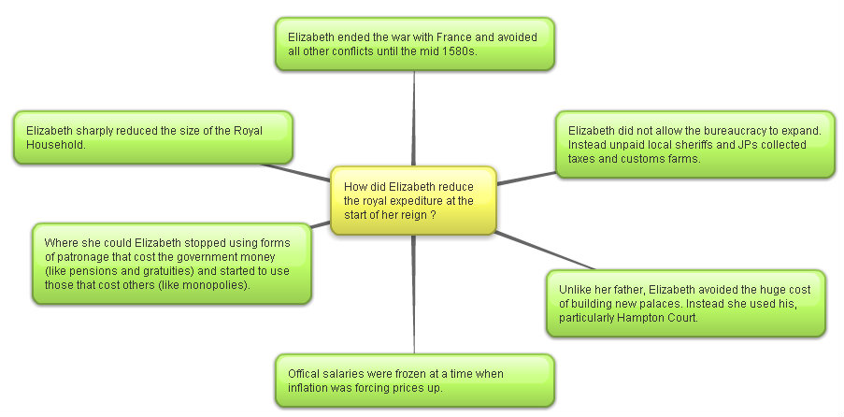

By reducing expenditure Elizabeth ensured that, unlike France and Spain, England did not go bankrupt in the 1570s. As Mildmay continued in his speech to the House of Commons on the matter, “her majesty hath most carefully delivered this country from a great and weighty debt”. Indeed, England was debt free by 1574, and by the outbreak of war with Spain in 1585 the Treasury actually held a cash reserve of £300,000. Her contemporary biographer William Camden, writing shortly after her death described this as her “greatest glory”.

Moreover, historians have united to praise the achievement. C Russell reflects on her “heroic decision to live within the royal income” whilst AGR Smith is uncharacteristically emotive when he writes “it was largely due to the personal and unremitting vigilance of the Queen that England escaped financial disaster.”

Question

- Write a paragraph to explain how Elizabeth addressed the problems of debt and expenditure when she came to the throne.

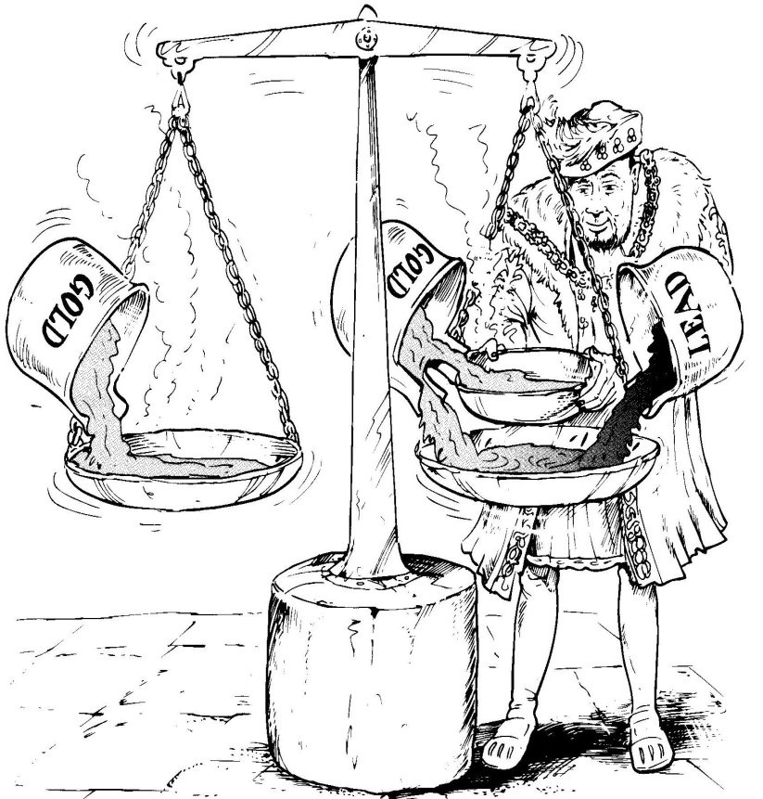
Perhaps even more impressive was Elizabeth’s attempt to deal with the problem of inflation in 1560. As we will see, the causes of Tudor inflation were varied, and in the 1590s the regime really struggled to contain it. However, the spike in prices in the 1550s was thought to be overwhelmingly caused by debasement of the coinage in 1544, and again in 1551. As John Hales wrote in 1581, “immediately after the baseness of our coin in the time of King Henry the prices of all things went up”. Here Elizabeth was very fortunate to be advised by the far-sighted Sir John Gresham who argued that “your Highness hath no other way,
Figure 4 – Cartoon representation of debasement (B Mervyn)
but when time and opportunity
serveth, to bring your money into fine”.

Elizabeth did this within the first year of her reign. The reform involved bringing in all the debased coins and re-issuing new ones with the proper amount of precious metal. This reduced the Crown’s expenditure in the short term, but it also had the desired effect of slowing inflation in the 1560s and 1570s. As DM Palliser comments “her revaluation did much for England’s international standing...it...was also a domestic success, if judged by its effectiveness and permanence”. The truth of this can be seen on Elizabeth’s tomb, which cites this relaunch of English coinage equal to the 1559 religious settlement and the defeat of the armada, as her greatest achievements.

Question

- Write a paragraph to explain how Elizabeth addressed the problems of inflation at the start of her reign. How successful was she ?

However, a bit of context is needed here. This looks like a remarkable achievement for the young monarch, but, it was not a complete success. As R Sloan suggests, this “superficial account disguises some less palatable realities”. In particular, the start of Elizabeth’s reign saw some missed opportunities.

- Some historians argue that Elizabeth’s early failure to introduce reforms to the system of revenue collection at this time would create long term problems for her. C Haigh for example argues that reducing expenditure rather than increasing income in the 1550s created “a hand to mouth existence” which”had worked well only because it had not been tested. From 1585 it was”. This refers to her need to spend a lot of money to fight the Spanish after this date. She did not have the capcity to increase her ordinary income, and was thus forced to use the damaging extraordinary methods.

- Sir John Gresham also wanted to remove the practice of usury (the act of lending money at an unreasonably high rate of interest) in 1561. This was eventually introduced via the 1571 Act against Usury, which stated that “any lending upon a loan above the rate of ten pounds for the hundred for one year” shall render that loan “utterly void”. In other words no loan could charge interst above 10% per annum. Had this been introduced in 1561, the Elizabeth could have broken free form the Antwerp money lenders much quicker than she actually did. It is was William Cecil that stopped the Queen, “resisting as usual any fundamental financial reform” (C Read).

Question

- How valid do you consider the criticisms to be of Elizabeth’s early financial policy ? Explain your answer.

Question

- Now study the diagram below. Label it with the Achievements of Elizabeth’s early financial policy and Failures of Elizabeth’s early financial policy as you think most appropriate (remember the best argument will be the weightiest). Explain your decision.

An analysis of the achievements and failures of Elizabeth’s early financial policy
Now label the see saw and explain your choice in the box below

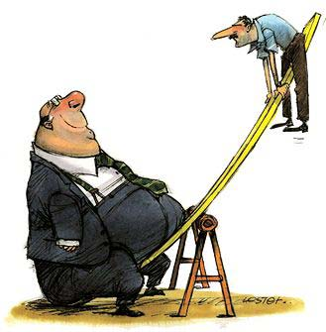

......................................................................................................................................................................................................................................................................................................................................................................................................................................................................................................................................................................................................................................................................................................................................................................................................................................................................................................................................................................................................................................................................................................................................................................................................................................................................................................................................................................................................................................................................................................................................................................................................................................................................................................................................................................................................................................................................................................................................................................................................................................................................................................................................................................................................................................................................................................................................................................................................................................................................................................................................................................................................................................................................................................................................................................................................................................................................................................................................................................................................................................................................................................................................................................................

Problems 2 and 3 – Inflation and the failed Elizabethan response

Figure 5 – A diagrammatic representation of the causes of inflation in Elizabeth’s reign.

From the Black Death in the 1340s, to the Wars of the Roses in the1460s prices did not increase in England. For the next two hundred years they rose continually, albeit at different rates. In Elizabeth’s reign prices rose 75% from 1558 to 1603, with two peaks – the 1550s and the 1590s – the latter of which Andrew Pickering describes “close to hyper-inflation”. Context is important here. It is not just that inflation occurred throughout the Early Modern period of English history, it was, as G Reagan suggests “a pan European phenomenon”. In fact other countries suffered much swifter rises in prices.

Monetary causes of Inflation

- Debasement was unquestionably an important early cause of inflation. However, after Elizabeth revalued the coinage in December 1560, she then did not allow any fresh debasement to occur. It was therefore not a key cause of the inflation spike in the 1590s.

- Elizabeth’s reign saw the continued Habsburg importation of silver from places like the Spanish mines in Potosi in Peru. G Woodward convincingly argues however that “the impact on England appears to have been negligible” as the “Anglo-Spanish wars kept the volume of trade between England and the continent to a minimum”.
Non Monetary causes of Inflation

- Population increase was the most enduring, and perhaps the most important cause of Elizabethan inflation. As Figure 6 below shows, after the terrible influenza outbreak of the early 1560s, England’s population quickly rose from 3 million in 1561 to 4.1 million in 1601. This meant more mouths to feed, and thus higher grain prices. Figure 7 can be partly understood in these terms. For RB Outhwaite this reason “looks to be by far the most important influence on prices”. However, it is noteworthy that he continues that “we must avoid making population pressure do all the work”. In other words, no one reason can, on its own, explain Elizabethan inflation.

Figure 6 – Population change in Elizabethan England.

Figure 7 – The rising price of grain in Elizabethan England.

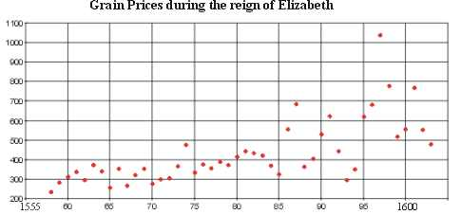

- Problems in agriculture were also important. At the time many blamed the process of enclosure for the problems that they faced. One preacher famously described those who enclosed as “cormorants, greedy gulls...and men without conscience...who...leave nothing for others”. In the context of rising food prices, enclosure often meant the converting of arable open fields into closed fields for pasture (sheep farming). This in turn meant that at the very time that there were more mouths to feed, there was less land under tillage. Elizabeth’s government certainly saw this as a matter of concern, and tried to legislate. In 1563 they passed the Act for the Maintaining of Tillage. This was followed up by the 1598 Statues against Conversions to Pasture and the Engrossing of Farms. Both tried to ensure that no further land would be converted to pasture.

Today, we consider enclosure to be less important. As B Mervyn states “by the end of Elizabeth’s reign the total area enclosed, even in the worst affected regions, was less than nine per cent”. In other words, the overwhelming majority of farmland was not taken out of arable production. This argument becomes even stronger when one considers that some enclosed fields continued to be used for growing crops. Further, Elizabeth’s reign also saw the extension of the amount of land under cultivation. Clearly enclosure’s importance has been overstated. We now think that is because historians have been drawn to the topic because of the strong political reaction to the rare forced enclosures. For example, in Mary’s reign, Kett’s Rebellion (1549) in Norfolk complained about “the overgrazing of the commons by greedy landlords...and...rising rents”.

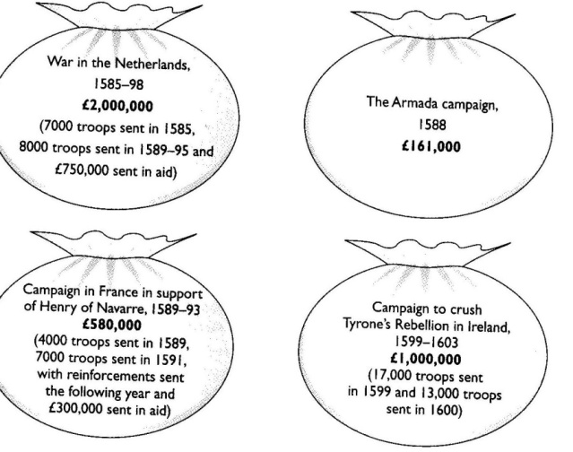
- Consideration of Figure 7 does however suggest a more important short term cause of rising grain prices. Throughout Elizabeth’s reign there were strings of excellent harvest. However, where there were bad harvests, such as in 1594 – 1597 grain prices quickly inflated through the process of supply and demand. There was actually famine in the North West in this period; however, even then, it was enclosure that was commonly blamed. In 1596 for example there were enclosure riots.

- Finally another important short term cause of inflation was the increased expenditure of the government in the Spanish war (1585 – 1604). Reference to figure 8 shows that Elizabeth raised and spent over £4million financing the war. This level of expenditure was obviously inflationary, even allowing for the Crown’s use of purveyance. A further point to make here is that Elizabeth was increasingly forced to use extraordinary forms of finance such as multiple subsidy rounds and monopolies.
Figure 8 – The cost of the Spanish War – B Mervyn

Question

- Reread pages 10 to 12. Now complete the tasks below.
- Which three causes of inflation in Elizabethan England do you consider to be most important ?
- Explain your decisions
- Do any of these reasons link together ? Explain your decisions.

......................................................................................................................................................................................................................................................................................................................................................................................................................................................................................................................................................................................................................................................................................................................................................................................................................................................................................................................................................................................................................................................................................................................................................................................................................................................................................................................................................................................................................................................................................................................................................................................................................................................................................................................................................................................................................................................................................................................................................................................................................................................................................................................................................................................................................................................................................................................................................................................................................................................................................................................................................................................................................................................................................................................................................................................................................................................................................................................................................................................................................................................................................................................................................................................

......................................................................................................................................................................................................................................................................................................................................................................................................................................................................................................................................................................................................................................................................................................................................................................................................................................................................................................................................................................................................................................................................................................................................................................................................................................................................................................................................................................................................................................................................................................................................................................................................................................................................................................................................................................................................................................................................................................................................................................................................................................................................................................................................................................................................................................................................................................................................................................................................................................................................................................................................................................................................................................................................................................................................................................................................................................................................................................................................................................................................................................................................................................................................................................................

What were the effects of inflation ?
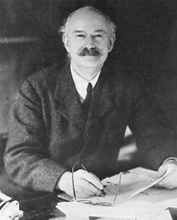
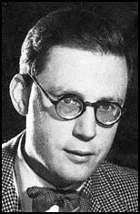
In 1941 RH Tawney (top) argued that inflation changed the balance of power in Elizabethan society. In his famous work “The rise of the Gentry” he suggested the inflation led to “a substantial net swing of capital and income from the aristocracy to the gentry”. In 1953 Hugh Trevor Roper (bottom) challenged this in his work “The Gentry 1540 – 1640”. He suggested that the landed gentry were actually unskilled in managing their estates, and thus suffered from falling rent rolls.
Figure 9 – A diagrammatic representation of the classes in the countryside of Elizabethan England. Below the great landed families of the aristocracy were the gentry. The gentry can be considered those who had more land than they could farm themselves. Yeomen tended to be independent farmers with freeholds to the value of 40 shillings, whilst the husbandmen held small amounts of land by tenure. Labourers were usually landless and paid in wages. They made up two thirds of the population.

More recently few historians would argue that no one class in entirety rose or fell because of inflation. However, G Batho has shown that most landowners, be they aristocracy or gentry, managed to increase their incomes. This was because of the higher food prices shown in Figure 7, and competition for land caused by the rising population shown in Figure 6. Even so, certain trends can still be identified.

- As the nation’s principle land owner, the Crown suffered a weakening of its overall position because of price inflation. Many of the tenant farmers on crown land had leases which ranged from twenty to a hundred years. Rents were quickly devalued by inflation and this forced the cash strapped Crown to sell the land they owned. Thus a downward spiral developed. S Atkins, when discussing the impact of inflation in this period, argues that of all the changes it caused the “most momentous was the weakening of the position of the crown”.

- As we have seen, the impact of inflation on the aristocracy depended on the extent to which they were tied to similar long term leases as the Crown. Where they were, then they “lost ground in the face of rising prices.” (Tawney). They would then be forced to sell their land, usually to the gentry, to seek fresh sources of income. However, we now think that that this was not widespread, and some members of the aristocracy actually gained via the practice of rack renting (this was where the rent was increased in difficult times but not reduced when the economic climate improved). Certainly Elizabeth’s reign did not see a large decline in the aristocracy’s numbers. DM Palliser estimates that there were 57 great families in 1558, and 55 in 1603.
- The gentry and to a lesser extent the yeomen and husbandmen generally did do best from inflation. They tended to be those who gained from the existing long term leases, and they were then in a good position to pick up cheap land that the Crown and aristocracy needed to sell in a hurry. We still need to be careful here however as there were important local differences. G Batho argues the group that suffered the most were the Catholic gentry who, from the 1570s, repeatedly got themselves fined as recusants.

- Perhaps the group that was hardest hit by inflation were wage-earning labourers. They were often paid daily rates, but the rising population kept wages down. Those without any land of their own were most at risk, and in the 1596 for example there were food riots in the affluent county of Oxfordshire.

Question

- Reread pages 14 and 15. Write one to two paragraphs to explain if you agree with M Saxon that Elizabethan inflation led to “a polarisation in late Tudor society between the haves and the have nots”.

The Failure to reform the Elizabethan system of finance

Inflation in itself was not necessarily a bad thing for the Elizabethan government. However, the problem came because it exposed the complete failure of the regime to update its system of revenue collection to match the rising prices. Figure 10 below reflects this. For example, Lockyer and O’Sullivan estimate that if customs revenue had kept pace with inflation, then Elizabeth would, by 1603, have been receiving £168,000 per annum rather than the actual figure of well below £100,000.

The problem infected all the main areas of ordinary revenue shown in Figure 11.

Figure 10 – A table to show the failure of ordinary revenue to keep pace with inflation.
Financial Issue | Percentage increase  1558 – 1603
Inflation | 75%
Ordianry income | 50%
Crown rents | 25%

Figure 11. A diagrammatic representation of the Ordinary revenue streams for Elizabethan government.
Rental from Crown lands

Sources of Ordinary Revenue

Wardships
Customs Duties

Fruits of Justice fines

What did the government do wrong ?

After her early successes, TA Morris reflects that “Elizabethan finances settled into a characteristically conservative rut”. He continues that they were marked by “unimaginantive personnel and machinery...and most importantly...static income”.

- Perhaps the biggest area of criticism was that in Elizabeth’s forty five year reign the tax records were never updated. Elizabeth continued to use the Marian Book of Rates from 1556. Obviously each year that this was used, ownership records were less accurate, and revenue fell. Elizabeth and Cecil seemed to have been reluctant to update the records because this would have been politically unpopular. As DM Palliser states, “administrative interia was the price that the government paid for political stability”.

- One of the ways that Elizabeth had reduced expenditure was via the false economy of cutting back on state tax collectors. Instead, Elizabeth used local landowners and self declaration to collect her taxes. This was to prove problematical for effective revenue collection.

  - The tone was set by the Queen herself. She often allowed her favourites to simply keep huge sums. For example the Earl of Leicester owed £35,000 and the Marquis of Winchester (her first Lord Treasurer) was allowed to keep the £34,000 in taxation that he had collected for her on his lands.

  - Worse still the system of self declaration was widely abused. The rich and powerful simply did not honestly declare their incomes. In 1534, there were fifteen nobles who were assessed by Henry VIII as having an annual income over £1,000. By 1571 self regulation under Elizabeth meant that this figure had fallen to nine. By 1601 only one noble admitted to such an income. In 1589, at the height of the Spanish War, William Cecil (her second Lord Treasurer) declared his income as £133, 6s and 8d. It is believed that the actual figure was actually closer to £4,000. As the Council complained, there was a “diminution of men’s values heretofore in their assessments”.

Instead the government tried to control inflation by legislation. This can be seen in Figure 12 below. The Statute Regarding the Export of Corn helped to stop grain prices rises, but elsewhere, they failed to stop inflation. Some measures, like the Act for Maintaining Tillage and the Statute against the Conversions to Pasture attacked enclosure. We now know that this was not a main cause of rising prices so it had little impact. Worse, The Statute of Articiers set a maximum, but not a minimum wage rate. Again, rising wages were not a main cause of inflation. The result was that the former slowed much needed modernisation in the countryside, whilst the latter cushioned the landowner’s classes from inflation by passing the cost onto the labourers.

Figure 12. A table to show economic legislation passed in Elizabeth’s reign (adapted from B Mervyn).
Year | Act | Key Points | Analysis
1563 | Act For Maintaining Tillage  Statute  Of  Artificers | - All land which had been under tillage for four years since 1528 could not be converted to pasture.  - This fixed a maximum (but not a minimum wage). It obliged all unemployed people to seek work. Young men had to accept work as labourers, and young women were expected to go into service. | - Showed the Council’s dislike of rising food prices and enclosure.  - This increased poverty for those with work.
1592-3 | Statute  Regarding the export of Corn | - This banned the export of corn unless the home prices was below twenty shillings a quarter.  - The Act For Maintaining Tillage was repealed. | - This stopped grain exports as a cause of rising food prices.  - This showed the Council’s confusion of the true causes of inflation.
1598 | Statute against the Conversions to Pasture  Statute Against the Emgrossing of Farms. | - These acts were designed to stop further enclosure after the repeal of the 1563 legislation led to a quickening of the process (particularly in the Midlands – for example Staffordshire enclosure caused real distress 1592 – 1594. | - This further U turn again showed how confused the government was on the issue of enclosure.

Question

- Reread the table above and colour code it. Blue = unhelpful in the fight against inflation and yellow = helpful.
- Elizabeth’s government utterly failed to stop inflation.

Write two paragraphs to explain how far you agree with this statement.

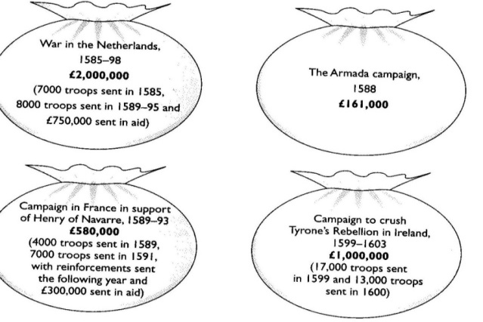
How successful was Elizabeth at financing the Spanish War ?

Reference to Figure 8 (included again here) shows that in the second half of Elizabeth’s reign war meant that the regime had to spend £3.76 million fighting the Spanish. That Elizabeth managed to raise this huge sum should be seen as a remarkable achievement. However, as Figure 13 shows it required increased use of extraordinary revenue sources.
Figure 8 – The cost of the Spanish War (B Mervyn).

Figure 13. A diagrammatic representation comparing the Marian, early and late Elizabethan exchequer.

Expenditure going out
The
Marian
Exchequer
Revenue coming in

Because Expenditure is >er than Revenue = Growing debt - (in the red)
The
Early Elizabethan
Exchequer
Less expenditure going out
Similiar revenue coming in

Because Revenue is >er than Expenditure = Annual surplus and debt paid off
By 1585 the Crown had a cash reserve of £300,000 (in the black)

Increased expenditure going out
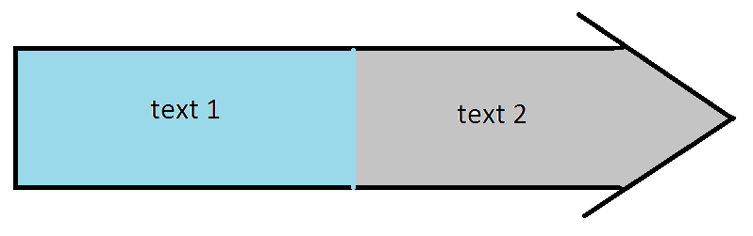
The late
(wartime) Elizabethan
Exchequer
Lack of reform means ordinary revenue remains about the same, and can not meet the cost of war
Increased use of
extraordinary revenue to make up the shortfall

Even with increased use of extraordinary revenue the cost of war means Expenditure is >er than Revenue = Growing debt - (in the red again)

Questions

- Study Figure 13 with care. Write a paragraph to explain what it shows.
- How far does Figure 13 support C Haigh’s argument that the failure to reform finance in the years of peace created “a hand to mouth existence” which”had worked well only because it had not been tested. From 1585 it was”.

Figure 14. A diagrammatic representation of how the government raised extraordinary revenue to finance the Spanish War.

- Monopolies

Because financing the war was so expensive, Elizabeth increasingly used monopolies as a free form of patronage. S. Atkins defines a monopoly as a “royal patent for the sole right of exporting, importing, manufacturing, or distributing some particular article”. This meant that the monopolist could set prices without fear of competition. Unsurprisingly whilst monopolies were popular in Court, (where, for example, Raleigh had a monopoly on tavern licences, and the Earl of Essex had a monopoly on the import of sweet wines) they were hated in the country because they were often abused and damaged the economy.

This resentment was most clearly seen in 1601, when Elizabeth and Robert Cecil lost control of Parliament. When a list of the monopolies created since 1597 was read out, one MP, William Hakewill, interrupted, "Is not bread there?" and to then add, "If order be not taken for these, bread will be there before the next Parliament." Another MP dubbed the monopolists the "bloodsuckers of the commonwealth." Robert Cecil dammed the behaviour as “more fit for a grammar school as a parliament house”. Elizabeth finally gave in, and had to address Parliament personally, giving her famous Golden Speech. She then cancelled twelve monopolies overnight, halted others in the works, and made monopolists answerable to the common law courts.

Thus monopolies caused serious economic and political problems for the government.

- Purveyance

Purveyance was the right of the Court to buy commodities at a price that they themselves set. It was meant to be used only in extraordinary times, such as war. However even before 1585 Elizabeth used purveyance widely (for example when on royal progress). Lockyer and O’Sullivan estimate that it saved the queen £40,000 p/a. It was possible to appeal against the prices set by royal purveyors in the Board of Green Cloth. However, as this was run by the royal household, few claims were successful.

After 1585, the war meant that the government started using purveyance legitimately, but on an even greater scale to purchase the materials needed to fight the Spanish. At times this had a disastrous impact on the economy. A good example here was iron production in the Weald area of Kent. Garrett Mattingley argues that the strength and purity of the metal produced there was central to the English defeating the Spanish (as it allowed the cannon on their ships to work in rollers and thus they could be fired three times faster than the Spanish cannon). Indeed, the Crown did actually own a couple of foundries in the area. However, the war meant that Weald iron was in great demand, and the Crown’s purveyors were sent to fix the purchase price. The problem was that they set it so low that a number of foundries went out of business.

At the same time local areas were increasingly expected to raise their own taxes to pay for fortifications and militia, whilst ship money was extended to inland counties. Thus, just like monopolies, purveyance and increased local taxation did political damage to the government because it was seen as greedy and exploitative. Perhaps more importantly, purveyance distorted the economy, and in extreme cases, forced businesses to close down.

- Forced Loans

As costs of war rose Elizabeth was increasingly forced to resort to borrowing. The corporation of London lent her £200,000, but she also levied forced loans on her richer subjects. Lockyer and O’Sullivan estimate that this raised a further £330,000. Below is a typical Privy Seal for a forced loan from 1589.

...the intended invasion of this realm, upon the great preparations made by the King of Spain...means we need...loving subjects to furnish us by way of a loan. Wherefore we require you to pay the sum of £25.

Forced loans did little damage to the economy; however they made the Privy Council in particular unpopular with those receiving the orders to pay up.
- Selling of Crown lands

In an attempt to raise quick money, and to avoid increased taxation or forced loans, Elizabeth allowed the selling of over £600,000 of Crown lands to raise revenue. This had the advantage of being popular, but it was very short-sighted. It greatly undermined the future financial independence of the monarchy, as future monarchs would not get the rent from this land. As such, they would have to increasingly depend on Parliament. As R Sloan suggests, it was “a poisoned chalice” for the early Stuart monarchs.

- Multiple Subsidies

By far the bulk of this increased revenue (estimated at £2.5 million) came from extra supply from Parliament. Elizabeth became the first monarch in English history to be awarded multiple subsidies by the House of Commons. This was necessary because she had failed to update the Marian Book of Rates, but even so, in 1589 and 1593 Elizabeth was offered double subsidy rounds. In 1597 she was awarded a triple subsidy round, and in 1601, after the Monopolies Crisis and the Golden Speech, Elizabeth was awarded a quadruple subsidy.

The problem with this was that this was again unpopular and, as suggested, it increased the monarch’s dependence on Parliament. This was not really an issue in Elizabeth’s reign, but as Sloan continued, “Elizabeth’s success in papering over the cracks without major innovation created the mistaken impression that the Stuarts sought new taxes for selfish or dangerous purposes”.

Question

- Reread pages 18 to 21. In 1603, after 18 years of war against Spain Elizabeth only left a debt of £350,000. Write a paragraph to explain your answers for each of the following questions.

    - What is the best argument that this was a success ?
    - What is the best argument that it was a failure ?
    - Now complete the ranking task on the following page. Do any of these methods of raising finace link together ?

An analysis to contrast the achievements and failures of Elizabeth’s attempt to finance to Spanish War 1585 – 1603

Now label the see saw and explain your choice in the box below
(remember the heavier argument is the better argument)

......................................................................................................................................................................................................................................................................................................................................................................................................................................................................................................................................................................................................................................................................................................................................................................................................................................................................................................................................................................................................................................................................................................................................................................................................................................................................................................................................................................................................................................................................................................................................................................................................................................................................................................................................................................................................................................................................................................................................................................................................................................................................................................................................................................................................................................................................................................................................................................................................................................................................................................................................................................................................................................................................................................................................................................................................................................................................................................................................................................................................................................................................................................................................................................................

......................................................................................................................................................................................................................................................................................................................................................................................................................................................................................................................................................................................................................................................................................................................................................................................................................................................................................................................................................................................................................................................................................................................................................................................................................................................................................................................................................................................................................................................................................................................................................................................................................................................................................................................................................................................................................................................................................................................................................................................................................................................................................................................................................................................................................................................................................................................................................................................................................................................................................................................................................................................................................................................................................................................................................................................................................................................................................................................................................................................................................................................................................................................................................................................

Question

- Revisit Figure i on Page 4. What are the three most serious financial problems that Elizabeth faces in her reign ? Explain your decision below, and then explain any links between them. Then complete the table on the following page.

......................................................................................................................................................................................................................................................................................................................................................................................................................................................................................................................................................................................................................................................................................................................................................................................................................................................................................................................................................................................................................................................................................................................................................................................................................................................................................................................................................................................................................................................................................................................................................................................................................................................................................................................................................................................................................................................................................................................................................................................................................................................................................................................................................................................................................................................................................................................................................................................................................................................................................................................................................................................................................................................................................................................................................................................................................................................................................................................................................................................................................................................................................................................................................................................

......................................................................................................................................................................................................................................................................................................................................................................................................................................................................................................................................................................................................................................................................................................................................................................................................................................................................................................................................................................................................................................................................................................................................................................................................................................................................................................................................................................................................................................................................................................................................................................................................................................................................................................................................................................................................................................................................................................................................................................................................................................................................................................................................................................................................................................................................................................................................................................................................................................................................................................................................................................................................................................................................................................................................................................................................................................................................................................................................................................................................................................................................................................................................................................................

Factor to show success | Examples | Factor to balance | Examples
Increased sources of revenue |  | Although revenue increased the methods were short term and didn’t keep up with inflation
Judgement on this issue (dominant theme):

Decreased expenditure |  | Methods used to decrease expenditure unpopular and caused unrest
Judgement on this issue (dominant theme):

Collected large subsidies |  | Failed to reform taxation system and allowed corruption
Judgement on this issue (dominant theme):

Improved financial admin’ |  | Cecil wasn’t the right man for the job
Judgement on this issue (dominant theme):

OVERALL judgement – how successfully did Elizabeth handle her finances including thoughts on relative importance and linking:

January 2010
“Inflation was the most serious financial problem facing Elizabeth I and her government”
Now attempt to complete the questions planning exercises.

How far do you agree ?

Examiner Guidance

No set answer is looked for but candidates will need to address the question.

There is a range of financial problems that candidates can consider, but they must give due attention to the named factor, even if they argue that it was not the most important. Inflation had a major impact on crown revenue and impacted on the cost of warfare, which would be a major item of expenditure at the end of the period. Inflation also had an impact on taxation returns, although some may suggest that it was Elizabeth’s failure to update assessments that was the bigger problem. Some may consider the problem of crown expenditure and selling of crown lands, others may look at customs or monopolies as issues.

Examiner Report

Most candidates were able to discuss a range of financial problems, although the degree of detail and precise support varied considerably.

There was usually a reasonable understanding of inflation, re-coinage was mentioned, but knowledge of earlier policies was thin and frequently inaccurate. Many answers argued that the cost of war was the most serious financial problem and were usually able to support this view with reference to the cost of the Spanish conflict and how it contributed to the debt Elizabeth left. The question of the taxation system was often well explained and the problems this created was often supported by reference to Cecil’s self-assessment for the subsidy. This was the ideal opportunity to link inflation and the problems of the tax system, but few seized the chance.

Key Words and Phrase:

Key issues to be discussed:

Linking and Relative Importance:

Line of Argument
 | Argument | Evidence deployed

Introduction
Tie the question to the factors

1

2

3

4

5

Conclusion

Direct answer to the question

Student

Concerns

