Student work booklet
OCR -Y107
Later Tudors - Elizabeth notes

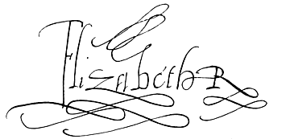
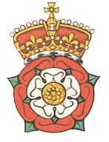

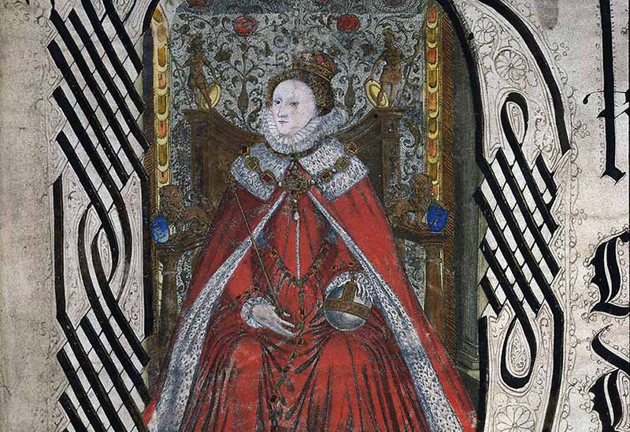
www.heathenhistory.co.uk
Section | Page | Topic
A | 2 | Personal Learning Checklist  Generic mark scheme / connectives  Past questions
B | 10 | Introduction Unit
C | 34 | Unit 1  The nature of the Elizabethan monarchy, government and parliament.
D | 98 | Unit 2  Elizabeth and religion
E | 131 | Unit 3  Elizabeth’s management of financial, economic and social affairs.
Sections

Section A
Personal Learning Checklist
Skills
KEY: Red = with difficulty Amber = not sure Green = yes

Essay skills (Elizabeth)  I can; | Red | Amber | Green | To address this before the exam I will:-
- Identify the key terms in the question, and use them in my answer.
- Identify the appropriate points/themes/ideas required in planning my line of argument.
- Produce a focused opening paragraph.
- Avoid irrelevance and description.
- Make links between my reasons and factors
- Compare the relative importance of these different reasons and factors in the bod of my essay.
- Write analytically about the issues.
- Develop my analysis with detailed and specific hard evidence.
- Communicate clearly and with confidence (RWC)
- Reach a supported judgement in a sustained conclusion.

Independent Study Skills  I have; | Red | Amber | Green | To address this before the exam I will:-
- The ability to read and note effectively
- The confidence to ask as well as to answer questions
- The ability to keep organised notes
Content

Introduction:  This introduction unit takes content from topics 1,2 and 3. | Red | Amber | Green | To address this before the exam I will:-
England in 1558 and the legacy of the
Mid Tudor Crisis
The Royal Prerogative and the issue of gender
The New Privy Council
The Religious situation and problems in 1558 including the foreign situation and its impact on religious developments
The 1558 Religious Settlement
• The Acts of Supremacy and Uniformity
• The Royal Injunctions
The financial and economic situation in 1558
Early financial policy

Sample questions
- How successfully did Elizabeth I deal with the problems she faced in 1558?
- How serious were the problems that Elizabeth I faced in the period 1558 –64?
- “Her gender was the most serious problem that Elizabeth faced at the start of her reign”. Discuss.

Topic 1:  The nature of the Elizabethan monarchy, government and parliament. | Red | Amber | Green | To address this before the exam I will:-
The role of the monarch
The role of the Privy Council
The role of the Court
The role of ministers (especially William Cecil)
Elizabeth’s use and management of faction
The role of gender
The roles of the houses of Commons and Lords
The historical debate – Puritan Choir ?
The attitudes of Elizabeth, the Privy Council and Parliament to the issues of;
- Religion
- Marriage and succession
- Parliamentary privilege
- Monopolies and finance
The impact of marriage and succession on domestic and foreign affairs
The impact of Mary, Queen of Scots and James
Sample questions

Government

- “The Court was the most important element of the Elizabethan system of government”. Discuss.
- “The Council was the most important body in the Elizabethan system of government”. Discuss.
- “It was Elizabeth who ruled England.” A.L. Rowse. Discuss the validity of this view of the Elizabethan system of government.
- Assess the role of Elizabeth’s ministers in the government of England.
- How successfully did Elizabeth I manage factional struggles in Court and Council?
- “The issue of the succession was never a serious problem for Elizabeth”. Discuss.
- How serious for Elizabeth was the presence of Mary, Queen of Scots in England from 1568?
- How effective was the Elizabethan system of government?

Parliaments

- Was co-operation or conflict the dominant theme of Elizabeth’s relationship with her parliaments?
- How far do you agree that parliamentary privileges were the most serious cause of conflict between Elizabeth and her parliaments?
- How successful were Elizabeth I and her ministers at managing parliament?
- How convincing is the claim that parliament became more powerful in Elizabeth’s reign?
- Which was more important in Elizabeth’s reign, the House of Commons or the House of Lords?

Topic 2:  Elizabeth and religion | Red | Amber | Green | To address this before the exam I will:-
Elizabeth’s religious inheritance / her beliefs
The 1559 Religious Settlement
- The Act of Supremacy
- The Act of Uniformity
- The Royal Injuctions
The Puritan challenge
- Aims and support
- Influence of Puritan leaders
- Attempts to change the church
- MPs tactics
- Separatism
- The attitude of Elizabeth’s archbishops
The Elizabethan Archbishops of Canterbury
The Catholic threat
- “Survivalism” pre-1568
- Why did it increase after 1568 ?
- Government reaction
- The Northern Rebellion (1569)
- Papal excommunication (1570)
- Mary, Queen of Scots
- Seminary priests
- Douai Priests and Jesuits.
- The problems facing Catholics
1558 – 1589
Comparison between the Catholic and Puritan threats.

Sample questions

- To what extent was the 1559 Religious Settlement a compromise that satisfied no one?
- “The 1559 Religious Settlement was a Protestant victory”. Discuss.
- How serious was the Catholic challenge to Elizabeth and her Church?
- Assess the reasons why Elizabeth was more concerned by the Catholic challenge after 1570 than before.
- How successful was Elizabeth’s religious policy?
- Which was a more serious challenge to Elizabeth’s religious policy – Catholicism or Puritanism?
- How serious was the Puritan challenge to the Elizabethan Church?
- How successful was Elizabeth’s policy towards Puritanism?
- How effective were Elizabeth’s archbishops at enforcing religious conformity?

Topic 3:  Elizabeth’s management of financial, economic and social affairs. | Red | Amber | Green | To address this before the exam I will:-
The financial and economic situation in 1558
Sources of Crown income
The problem of inflation
The Methods of raising finance
- Ordinary revenue
- Parliamentary taxation
Methods of reducing financial costs and financial administration
The impact of war
Overseas trade
Significance of slavery
The Monopolies
The Statute of Artificers
Poverty and the poor law

Sample questions

Finance

- How successfully did Elizabeth deal with her financial problems?
- How serious were the financial problems that Elizabeth faced?
- “The demands of war were the most serious financial problems that Elizabeth faced”. Discuss.
- Assess the causes of inflation in Elizabeth’s reign.
- “It was only the demands of war that created financial problems for Elizabeth in the period 1580 – 1603”. How far do you agree?

Economics and trade

- How serious were the economic problems in the Elizabethan period?
- “Enclosure was the most serious economic problem that Elizabethan England faced”. Discuss.
- How successfully was English overseas trade developed during the reign of Elizabeth?
- “The development of the slave trade was the most area of expansion in trade in the Elizabethan period”. How far do you agree?

Finance and economics

- How serious were the financial and economic problems that Elizabethan England faced?
- “Elizabeth achieved more in financial matter than in economic or trade policy”. Discuss.

Social matters

- How successfully did the Elizabethans deal with the problems of poverty and vagrancy?
- “Elizabeth and her government dealt ore effectively with vagrancy than poverty”. Discuss.

Topic 4:  The Elizabethan later years | Red | Amber | Green | To address this before the exam I will:-
The significance of the Spanish War
Armada as “Zenith”
1585 – 1604
The defence of the royal prerogative
Relations with Parliament – the monopolies crisis
Economic and social problems
- Harvests and rising prices
- Local unrest
- Food riots
- Oxfordshire Rising
- Irish Rebellion
- Essex’s Rebellion
Elizabeth’s reputation 1588 - 1603

Sample questions

- “Rebellion was the most serious problem for Elizabeth I and her government faced in the period 1588 – 1603”. Discuss.
- To what extent did the popularity of Elizabeth and her government decline in the years after 1588?
- To what extent did the effectiveness of the Elizabethan regime decline after 1588?
- How far do you agree that the effectiveness and popularity of the Elizabethan government decline after 1588?
- How powerful was Elizabeth at the end of her reign?
- How successfully did Elizabeth I defend the Royal Prerogative at the end of her reign?
- “The most important impact of the war with Spain was financial”. How far do you agree?
- How serious a threat to Elizabeth were the social and economic problems in the 1590s?
- “Elizabeth died unloved and unlamented…and it was partly her own fault”. C Haigh. How far do you agree?

Mark Scheme
Three Top Tips
- You must form a line of argument around the key terms in the question.
- When comparing and link factors make sure that your opinions are justified (and not just assertions)
- The examiners expect to you to be able to deploy detailed hard and contemporary evidence in your paragraphs.

Generic mark scheme and helpful connectives

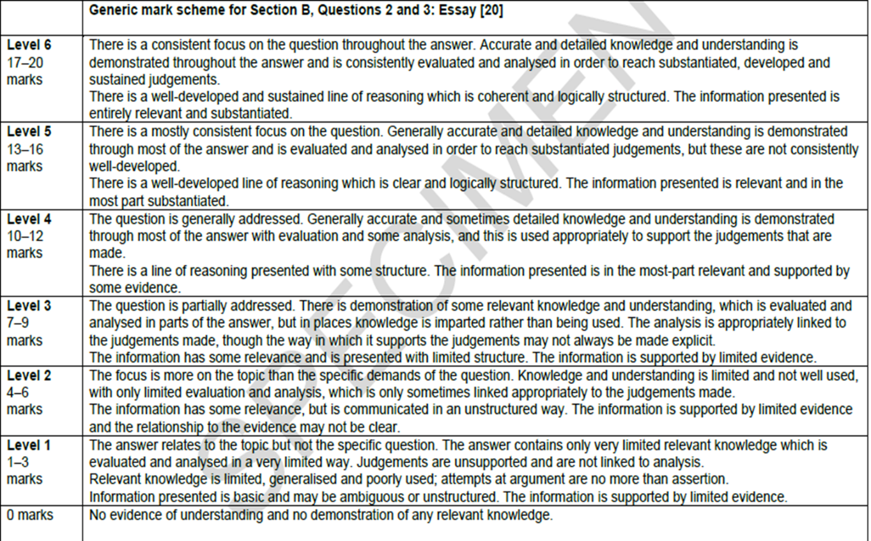
E
D
C
B
A

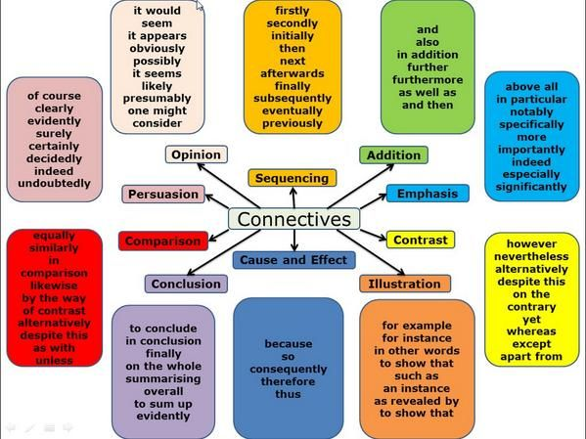

Past Questions
Topic One – government and parliament
Topic Two – religion
Topic Three – finances, economics and social matters
Topic Four – the later years
- Questions crossing the topic areas
Sample Paper
- How effectively did Elizabeth I deal with the problems that she faced in 1558.
- “The Puritan threat was never serious”. How far do you agree?
2017
- Assess the impact of the issues of marriage and succession on domestic affairs in the period from 1558 to 1603.
- ‘The cost of war was the most important cause of Elizabeth’s financial problems.’ How far do you agree?
2018
- To what extent did the religious settlement of 1558–1559 achieve Elizabeth’s aims?
- ‘Elizabeth’s power was seriously threatened in the period from 1588 to 1603.’ How far do you agree?
2019
- How serious was the Catholic threat in the period 1558 to 1589?
- “Unrest and rebellion never seriously threatened Elizabeth I in the period after 1588” How far do you agree?

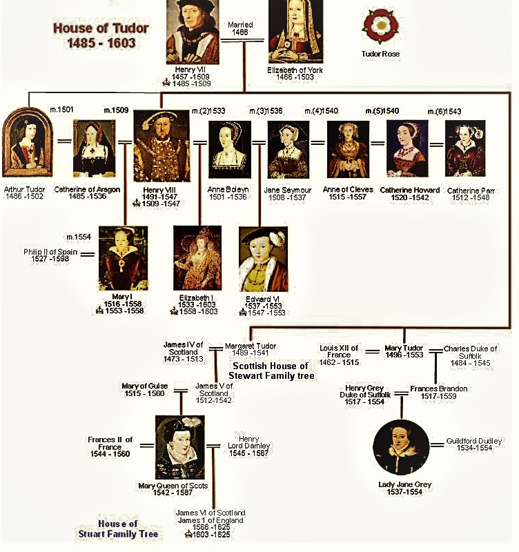

Tudor Family Tree

Section B
How successfully did Elizabeth I deal with the problems she faced in 1558?

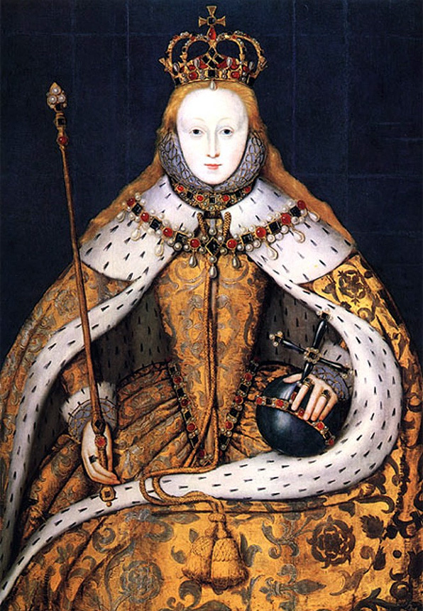

Were Elizabeth’s personal qualities suited to being a Sixteenth Century Monarch?

Given that this unit of study is asking you about the problems that the Queen faced in 1558, it might seem surprising to start by looking at Elizabeth’s personal qualities.

However, it is important to remember that in Sixteenth Century England the monarch had real political power. In theory Elizabeth I was an autocrat who had to make the all the major decisions herself. She fiercely defended this royal prerogative, and this meant;

- No law could be passed without her consent.
- She could decide when parliament was going to be called, prorogued or closed.
- She could decide who became ministers in her Privy Council.
- She could decide who could attend Court.
- Elizabeth was the centre of the patronage system.
- It was Elizabeth who was responsible for the nature of religious worship in the country.
- It was Elizabeth who could decide if and when England could go to war.

In practice Elizabeth was always short of money, and often had to persuade, bribe, bully and compromise with her subjects. As a result, if we want to analyse the seriousness of problems that faced her, and ask how effectively she addressed them, then we need to know about the Queen’s personal qualities.

Question

- List five qualities you think Elizabeth would require to be an effective monarch. These will be brainstormed on the board.

Skills Elizabeth required to be an effective autocrat

The same question has been reflected upon by many of her contemporaries and more recently by historians. The following quotations reflect their views of some of her strengths and weaknesses. Read them carefully, and write down next to them what qualities the evidence highlights.

A.
“From Henry and Anne she inherited intelligence, cunning, the capacity to charm and a remarkable strength of will… She was a wily and defensive politician.”

Robert Sloan – The Tudor Years.

“She had been trained in the humanist tradition and she was a learned young woman, even something of a ‘bluestocking’ (intellectual) when she took over the government of the country.”

From A.G.R.Smith – The Emergence of a Nation State.

“She brought her sharp powers of analysis to political process and therefore saw through carelessly constructed arguments”

S J Lee. Elizabeth I

B.

“She is a woman of extreme vanity.”

The Spanish Ambassador, Feria.

C.

“She was no religious fanatic”
From A.G.R.Smith – The Emergence of a Nation State.
D.

E.
“Queen Elizabeth did not attempt to solve problems, she simply avoided them – and then survived long enough for some of them to go away.”
Christopher Haigh – Elizabeth I – A Profile in Power.

“Elizabeth had a cautious and conservative approach to monarchy.”

Robert Sloan – The Tudor Years

“She emerged as queen at the age of twenty-five, having grasped the need for both caution and dissimulation” (this means keeping things hidden).

From A.G.R.Smith – The Emergence of a Nation State.

F.

“Two qualities were born within her and were apparent very early in her reign: the ability to choose first- rate advisers and a remarkable gift for winning the devotion of the public.”

Penry Williams “The later Tudors”
comments on Elizabeth political or politic skills.

G.

H.

“The simple truth was that Elizabeth…did not understand key economic ideas like inflation. It was England that paid the price for her ignorance.”
Geoffrey Reagan – Elizabeth I

The higher the evidence is placed the more important you consider it to be
The further left, the more that this personal quality that was a disadvantage to Elizabeth’s monarchy
The further right, the more that this personal quality that was an advantage to Elizabeth’s monarchy
An importance graph
Position the letters for the different evidence as you feel most appropriate

Question
- Write a paragraph to explain your decisions.

What was Elizabeth’s inheritance?
Was the Mid Tudor Crisis?

Elizabeth I ruled England from 1558 to 1603. This was a forty-five year reign which is often regarded as a “Golden Age”. The extent to which this is correct is a matter of debate, and something that we will explore. When historians ask such a question, it is often helpful to consider the context of what went before.

It is certainly correct to suggest that the immediate period before Elizabeth’s accession was one that many historians consider to be troubled. Most famously, in 1973, Whitney R.D. Jones wrote of the period as “a Mid Tudor Crisis” and “the epoch of the little Tudors.” He meant Edward VI (1547 – 1553) and Mary I (1553 – 1558), but this was also the time of Lady Jane Grey (the Nine Day Queen). Jones also included the later years of Henry VIII reign (after the fall of Thomas Cromwell in 1539, after which he increasingly became the syphilitic tyrant of legend). Jones highlights eight problems which he suggests, together, made this crisis for Tudor monarchy. These are shown below;
- Weak rulers (Edward and Mary).
- Economic problems (like inflation).
- Failures in foreign policy (like the loss of Calais).
- Rebellions (like Wyatt’s Rebellion of 1554).
- Problems in religion (The English Reformation and Counter Reformation).
- Factional fighting in Court (Somerset and Northumberland in Edward’s reign).
- Problems in Local Government.
- Problems over the succession (Lady Jane Grey).

Questions
- What do you understand by the term the Mid Tudor Crisis? If Jones’s thesis is correct, which of these issues do you think were the most serious for Elizabeth? Explain your choice.

Extension – do any of these problems link together? Write a paragraph to justify your ideas.

Many contemporaries of this period agreed with Jones’s thesis. For example, consider the quotation below. Then look at the cartoon on Page fifteen.
An extract from a report by Armigail Waad, a Clerk to the Privy Council. It is a summary of the problems her believed face Elizabeth faced when she became queen in 1558.
“The monarchy is not well regarded and the realm (England) is exhausted. The nobility is poor and decayed. There is a lack of good Sea Captains and soldiers. The people are out of order. Justice is not executed. All things are dear. There are religious divisions amongst ourselves. We are at war with Scotland and France. The French King bestrides the realm, having one foot in Calais and the other in Scotland. We have steadfast enmity but no steadfast friendship abroad.”

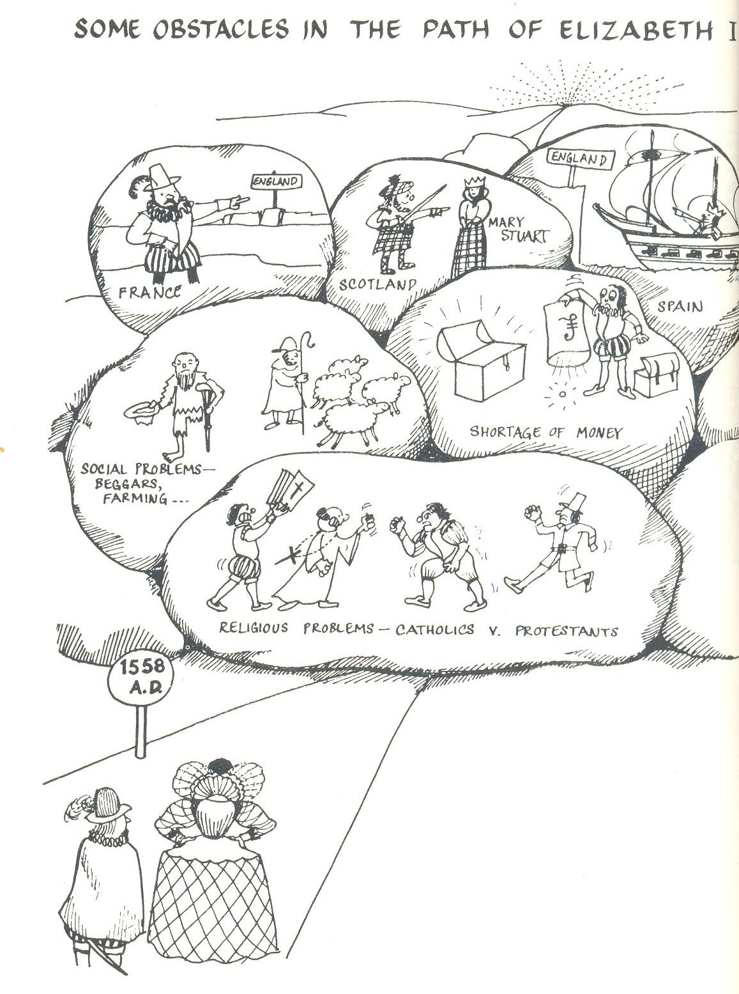

Today, not all historians agree that there was a Mid Tudor Crisis. Revisionist historians like David Loades would suggest “only in the field of economics is the term crisis appropriate”, whilst most recently, John Matusiak found a middle way between these two views, suggesting they should be viewed as "years of trauma and survival".

Questions

- Is there a way that the Mid Tudor Crisis could be said to actually help Elizabeth’s monarchy in 1558?

What is clear for us is that in 1558, both England its new monarch faced a series of serious problems after a time of unsettled government. Study the diagram on the following page. We need to;

- Understand the problems she faced and consider the relative importance of them.
- Decide how effectively she dealt with them.
- Understand how they link together.
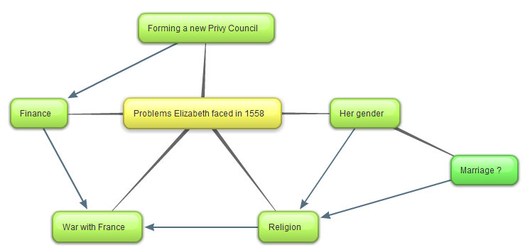
A diagram to show the problems (and how they linked together) that faced Elizabeth in 1558.

Problem One – How would the Queen rule in a
Patriarchal Society?

Study these three contemporary views on gender and monarchy
“God’s wounds, this it is to serve a base, bastard pissing kitchen woman!”
The Lord Deputy of Ireland talking about his delight in serving his queen, Elizabeth.

“Oh Lord, the Queen is a woman!”
A London woman on seeing Elizabeth for the first time.

“I will have but one mistress and no master”
“My sex cannot diminish my prestige”
Elizabeth (in 1566 and 1603 dealing with the Earl of Leicester and parliament respectively).

Context

When Elizabeth became queen in 1558, there had only ever been two queens who had ruled England in their own right.

- Queen Matilda (sometimes known as Maude) -1141.
- “Bloody” Mary (Elizabeth’s half-sister) - 1553 to 1558.

Both reigns were very unpopular, and were seen as failures. As such, there was no precedent for a successful female monarchy. In other words, kingship was exactly that – a job done by men, and Elizabeth’s rule was expected to fail.

What was the view of women at this time and what problems did this create for Elizabeth ?

Quite simply, Tudor England was a patriarchal society. The “Great Chain of Being” meant every person had a fixed place in the social hierarchy. The wife always gained her status in this chain from her husband, the assumption throughout the chain was that women were inferior and needed the tutelage of her man. This was to present Elizabeth with formidable difficulties.

- In 1558 John Knox Scottish reformer (founder of the Scottish Calvinist church) published his First Blast of the Trumpet Against the Monstrous Regiment (rule) of Women. The book was aimed at Mary of Guise and Knox explained that Elizabeth was an exception as she had been made queen by God to restore the Gospel, but it was a reminder of the discomfort many felt at having a female ruler.

- The rule of a woman on her own was seen as unnatural, it was assumed that she would marry; Elizabeth was still young, 25.
- The husband would be expected to the dominant partner and rule as King-consort. Mary Tudor had married Philip II. This had been extremely unpopular; many felt England had become nothing more than a Spanish satellite.
- Her councillors may have felt the need to advise the queen more directly as she was “only” a woman. There is evidence for this in letters sent between the Earl of Winchester and William Cecil at the time of the accession.
- War was seen as a man’s job – how could a queen lead a country in a future war?
- As a woman Elizabeth could not be Head of the Church of England as her father and half-brother had been.

In short, at the start of her reign Elizabeth gender made her monarchy look vulnerable, when a key element of being a successful Tudor monarch was the ability to project power and fear.

Task

Now construct a spider diagram to show the problems that Elizabeth’s gender presented to her monarchy. Rank these in order of importance and write a brief paragraph to explain your choices

How effectively did Elizabeth address these problems?

Perhaps one of most remarkable aspects of Elizabeth’s monarchy was that she turned something that was a real problem at the start of her reign into one of its main advantages. In other words, it is possible to argue that Elizabeth’s gender strengthened rather than weakened her rule. This was a good example of her politic skills in action.

- By the 1570s Elizabeth had created a Cult of Gloriana by which the men of England could celebrate the harmony and progress of the Virgin Queen’s rule. She was a woman who presented herself as foregoing earthly pleasures because she was married to England. She once famously referred to "all my husbands, my good people" meaning the English nation.

The image below is typical of the lockets that men wore the show their loyalty and love for Elizabeth (it had previously been the fashion to carry a likeness of your lover in such a locket). No other English monarch before or since has been celebrated thus by their subjects.

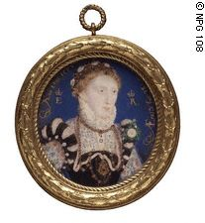
- From the start of Elizabeth’s reign, she used her gender as a political tool. For example, to call on an extra degree of loyalty she would make people aware of her vulnerability (if she needed to pass a difficult bill through parliament). Also, when Elizabeth did not want to make a decision at Council, she would play the stereotype that women were indecisive. On many occasions this bought her valuable time before making a difficult decision.

- Elizabeth exploited her femininity and pretended to consider marriage to evoke loyalty from her subjects. For example, she wooed her courtiers such as the Earl of Leicester and Walter Raleigh. She did the same on the European scene. For example, her last courtship, ended in 1581 when she was aged 48, was with François, Duke of Anjou, 22 years her junior.

- Elizabeth overcame the issue of religion, by taking the title the Supreme Governor of the Church of England (see the later notes of the 1559 Religious Settlement). This was typical of Elizabeth’s ability to find a middle way. Francis Yates argues that Elizabeth’s image as the Virgin Queen helped many moderate Catholics accept the move away from worship of the Virgin Mary. If this is the case then, then Elizabeth gender was turned to her advantage.

- As the image and quotation below show, Elizabeth also used her gender to assist her as a war leader.
The Armada Portrait - 1588

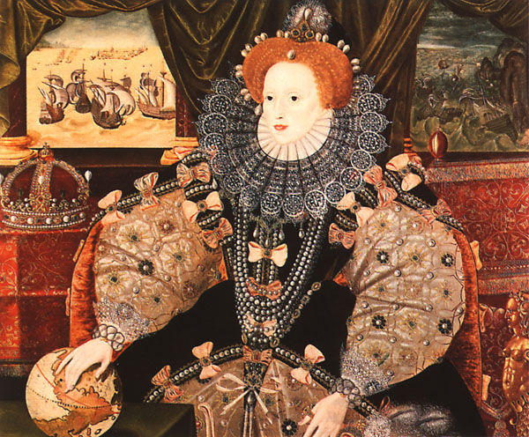
“I know I have the body but of a weak and feeble woman, but I have the heart and stomach of a king, and of a King of England too, and think foul scorn that Parma or Spain, or any Prince of Europe should dare to invade the borders of my realm.”

Elizabeth’s famous Tilbury Speech - 1588

Questions

- Write a paragraph to explain how Elizabeth not only neutralised gender as a problem, but actually turned it into an effective tool of government after 1563.

Two – How could Elizabeth create an effective system of government?

One of Elizabeth’s initial tasks was to select the ministers and style of her Privy Council. As M Tillman correctly suggests the Privy Council was the “select ruling board of the realm”, and as such these decisions really mattered. This would be a clear indication of her religious aims and an important task in securing good advice. It would be very hard for Elizabeth to be a strong and successful monarch without an effective Privy Council.

Early reforms to the Privy Council

The Privy Council rose in importance right from the start of Elizabeth’s reign. In part this can be best understood by considering how Elizabeth reformed its membership.

Under Mary the Council had grown in size to over forty. Elizabeth preferred the Cromwellian model (ie after the ideas of Thomas Cromwell – Henry VIII’s famous minister) of a smaller Council, famously once stating that “a multitude doth make rather discord and confusion rather than good council”. As a result, the 1559 Privy Council started as a group of 20, but quickly became reduced to 18 with the loss of the Marian ministers Heath and Cheney. Moreover, an “inner ring” (J Guy) of regular attendees developed. Elizabeth also increased the frequency of meetings, and occasionally chaired meetings herself.

Who was in Elizabeth’s initial Privy Council?

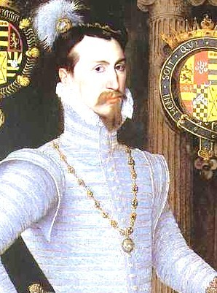
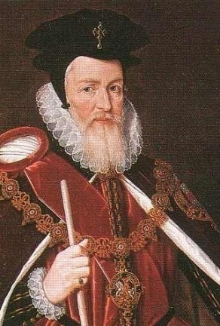
Sir William Cecil (left) was Elizabeth’s first Secretary of State. He had been the overseer of her estates whilst she was Princess Elizabeth, and he had been secretary during Edward VI’s reign. He was a moderate Protestant, and ten years older than Elizabeth, he was already “an experienced politico” (J Guy). However, his power came from his abilities. He is rightly seen as one of the greatest political figures of the Tudor age. W MacCaffrey describes him as “the dynamo which kept...government running smoothly and effectively” whilst S J Lee writes that “he brought to administration an attention to detail and accuracy ...he was...adept at solving problems”. Indeed, Richard Rex considers him “the most organised politician of the Sixteenth Century”, and this meant that he usually won out in factional struggles. He was an excellent appointment, and in the first two years of her reign he helped to draft the 1559 Religious Settlement and smash the Auld Alliance between France and Scotland with the 1560 Treaty of Edinburgh.

Elizabeth also appointed Robert Dudley (the Earl of Leicester from 1564 right) to the Council in 1562. This provided a factional check to William Cecil dominating government completely. At the start of the reign he was a serious marriage candidate. He was another Protestant. Elizabeth also appointed protestant administrators who had served under Edward VI, such as Sir Francis Knollys, William Parr, and Sir Edward Rogers.

Elizabeth’s first Privy Council should however be seen as a compromise. Indeed, it did still include some magnates, although their influence quickly began to decline. The most important of them was her first Lord Treasurer, the very able Marquis of Winchester. He alone of the magnates was a regular member of the inner ring. Elizabeth’s first Council even initially had Catholics like Heath and Cheney. However, as Elizabeth established herself, they soon fell away from power.

Hence Elizabeth’s first Privy Council was something of a triumph. It was an effective mixture of efficient experienced politicians, many who had served under Edward and were Protestant and political heavy-weight Catholic peers from Mary’s reign that could not be ignored. Moreover, Elizabeth reformed the Privy Council to make it the centre

Questions

- Explain why it was important for Elizabeth to pick and run an effective Privy Council.
- How successful was Elizabeth’s first Privy Council?

Problem 3 - What Religious Settlement should Elizabeth chose ?

Study the map and diagrams below. The map shows the different types of religious worship there were in Europe by the early 1560s. You should note that Anglican worship was the English form of Protestantism.

- What observations do you make? Why would we expect religion to be a major problem for Elizabeth? Write two paragraphs.
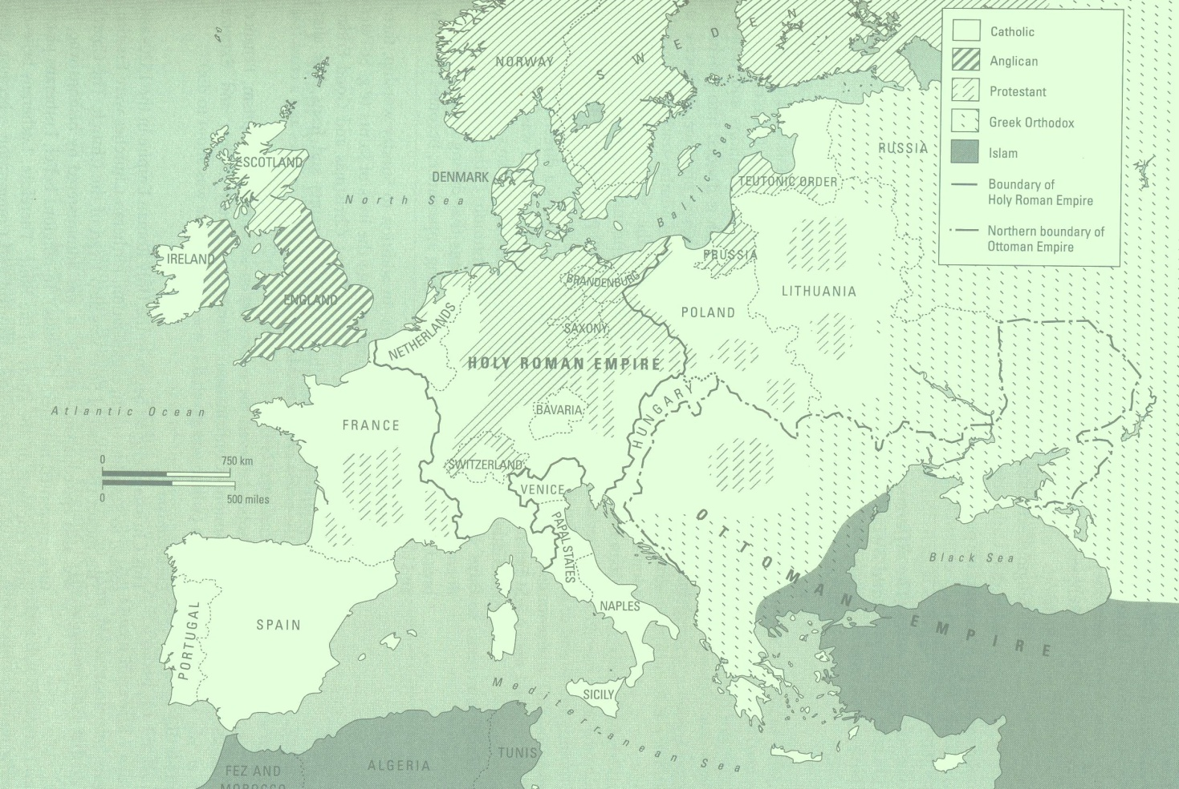

A diagram to show the religious divide in England in 1558

Protestantism Catholicism
CATHOLICS

Strongest in the North, Ireland and Wales - Perhaps a large minority.

PROTESTANTS
Strongest in the South, East and London – perhaps a small majority.

Roman Catholics supported Mary’s restoration of links with the Pope and Rome
The Puritans
Extreme Protestants

A cartoon to show the different religions of the Tudor monarchs
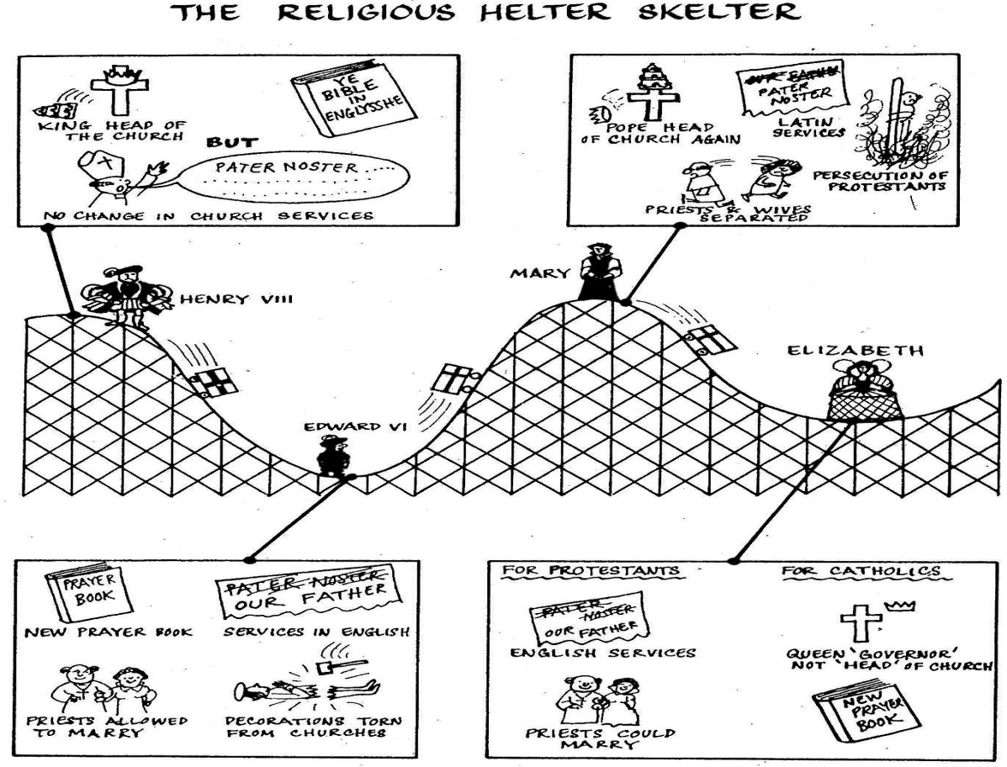
In other words, Elizabeth inherited a religiously divided realm at a time when religious wars were raging throughout mainland Europe.

An introduction to the main differences between Catholic and Protestant churches

A typical Catholic Church

A typical Protestant church

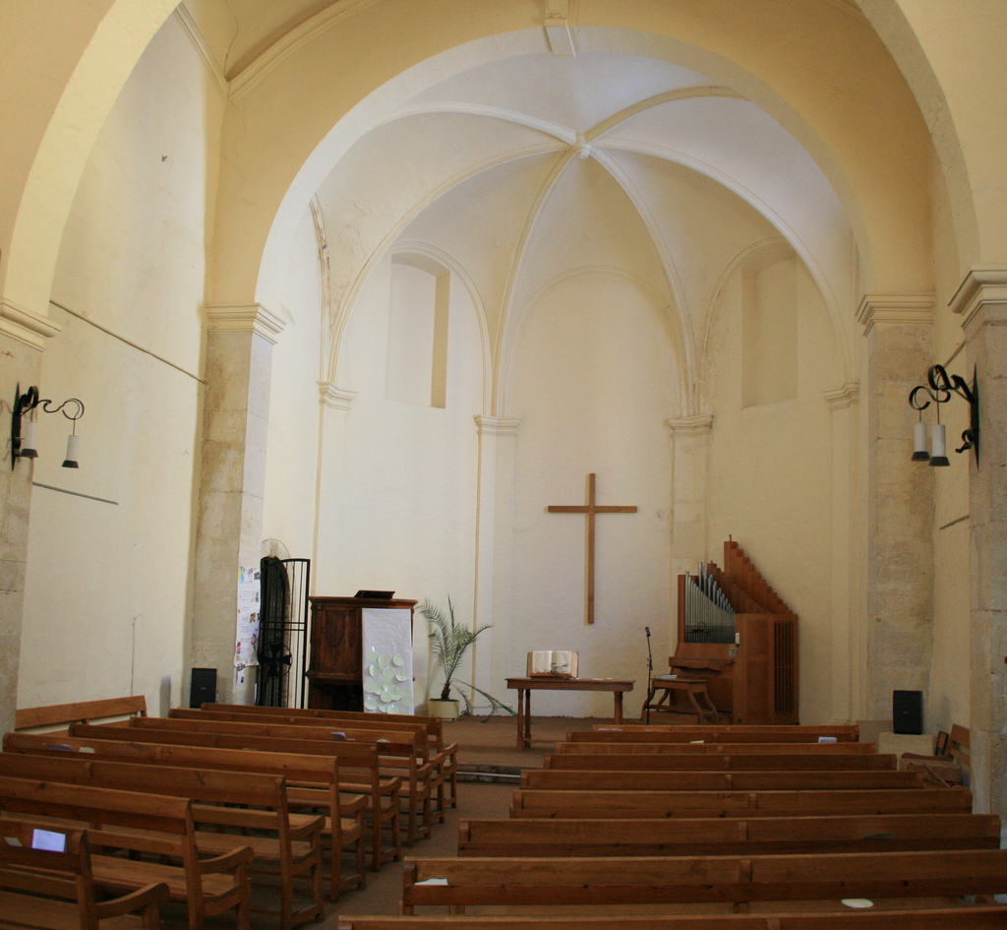

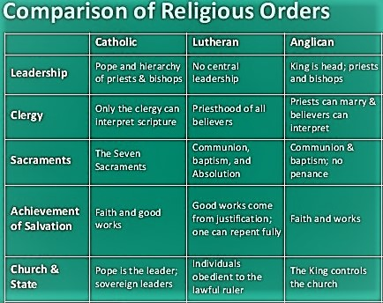

What did Elizabeth believe?

It is actually rather difficult to answer this question. She is once meant to have said:

“I have no desire to make windows into men’s souls There is only one Jesus Christ and all the rest is a dispute over trifles…”

Some further clues can be found I her background and early actions…

Elizabeth’s own background i.e. she was the daughter of Anne Boleyn, product of the break from Rome and raised by Catherine Parr as well as the sympathies of her mainly Protestant Councillors made a Protestant settlement most likely.

Early signs of her faith. Suspended the heresy laws in December 1558 and released those awaiting trial for heresy, on Christmas day 1558 she ordered that the Host should not be elevated during the mass (elevation suggested the real presence), at the opening of parliament 1559 she told monks from Westminster Abbey and lighted candles to get away.

What did Elizabeth do?
Consider her 1559 Religious Settlement shown below (from B Mervyn)
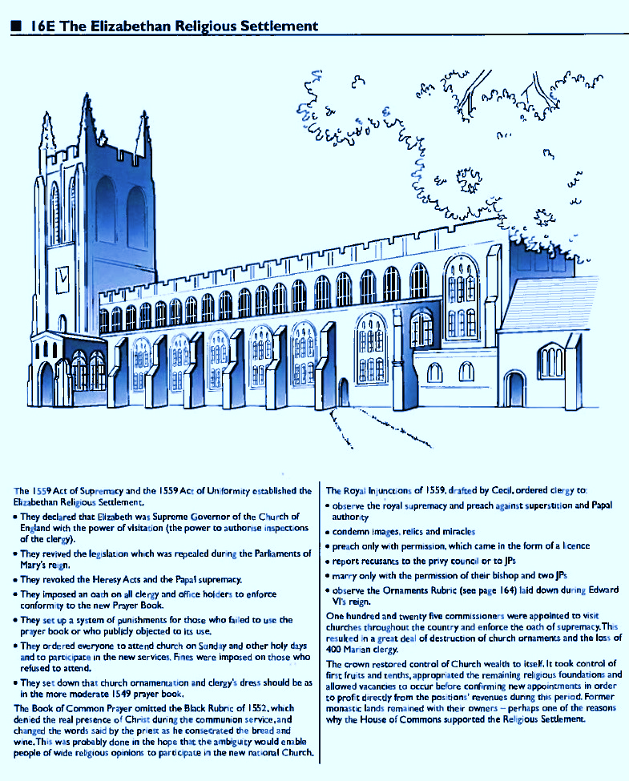

Important Events in the passing of the Acts of Uniformity and Supremacy.

In February 1559 Bill introduced into parliament. Would have made Elizabeth head of the church and provided for a Protestant form of worship Passed Commons. But the Lords forced the changes in worship to be removed and refused to accept the royal supremacy. Parliament breaks for a recess over Easter. Disputation (debate) is held in Westminster Abbey. Two Catholic bishops were arrested and charged with disobedience to common authority. The reconvened Parliament had two bills, the Act of Supremacy and Act of Uniformity introduced to it.

- Act of Supremacy- made Elizabeth Supreme Governor instead of Supreme head of the Church. In practice she had as much power over the church as her predecessors. Easily passed through the House of Commons and opposed by all the Catholic bishops in the Lords and one layman.
- Act of Uniformity- Modelled on the second Edwardian Prayer Book (1552). As a compromise to Catholics used the wording of the Communion from the 1549 and 1552 Edwardian Prayer Book leaving the issue of real presence in memorial open. Prayer Book to be used in all churches, fines for those not attending church on a Sunday, and ornaments rubric left clerical dress and church decoration up to the monarch. Relatively easy passage through Commons but opposed by 9 bishops and 9 temporal Lords in the Lords. Had the 2 detained bishops and 2 members of the clergy not absent been present the Act would have been defeated.
- Act of the First Fruit and Tenths. Allowed for the transfer of property owned by the church to the monarch. The few monasteries Mary had restored were dissolved and property went to the monarch.
- The Thirty-Nine Articles of Faith, 1563-71. Elizabeth used convocation (church government, meeting of the bishops) to produce the final statement of church beliefs. Set out clearly the belief in predestination. The articles were firmly based on the 42 Articles from 1552.
- Of the Marian clergy all of the bishops except 1 left the church, 400 ordinary members of the clergy were deprived or resigned between 1559 and 1664. The great majority of ordinary clergy conformed.
- Matthew Parker was appointed Archbishop of Canterbury and the Marian exiles took up the positions left by the Marian bishops.
- Royal Injunctions. The main details of the church were covered by the Acts of Supremacy and Uniformity. The Royal Injunctions were drafted later in 1559 to deal with matters that had not been covered. E.g. clergy might marry with the approval of 2 JPs and their bishop, clergy had to wear the surplice (the white Tunic that had been worn by Catholic clergy), altars could be replaced by Communion tables if the minister wanted.
- The Visitations. Took place in the summer and winter of 1559 to enforce the Royal Injunctions. As a result, many churches were changed to the plainness of Edward’s day although were Catholic sympathy was strong this process took a lot longer.

How settling was the settlement?

- Cast as the Godly saviour (in contrast to Mary and the burning of heretics).
- However, Elizabeth not a Godly reforming monarch, conservative more concerned about the Supremacy rather than theology.
- Marian exiles fill the empty bishoprics and her councillors are those of Edward’s reign, these men see the settlement as the beginning and set them in conflict with the queen.
- Therefore, had created a settlement which left many unsatisfied, even in her own government
- Elizabeth regarded the settlement as final and any attempt to bring changes as a challenge to her authority.

A view of Elizabeth’s 1559 Settlement

Protestantism The Settlement Catholicism

Roman Catholics supported Mary’s restoration of links with the Pope and Rome
The Puritans
Extreme Protestants

The settlement was unquestionably a Protestant one. However, there were concessions to the Catholics. Eg, the wearing of vestments and the singing of hymns. It was designed to include to moderate Catholics.

- How successful was Elizabeth’s early religious policy? Write two paragraphs in your answer.

Problem 4 – The Marian Debt

When historians consider Elizabeth’s reign as a whole, her failure to undertake financial reforms at a time of inflation is often held up as a major criticism. R Sloan for example writes of her financial legacy as “a poisoned chalice”...”in which Elizabeth’s cautious and short sighted approach to government proved most damaging.” The validity of this statement is fully considered in Unit 5. However, here we need to see what financial problems Mary left behind her in 1558, and analysis Elizabeth’s response.

Mary left one financial problem behind her. When she died in 1558 England was allied with Spain, and at war with France. Then, as now war was incredibly expensive, and as such, despite her updating of the tax records, Mary left a debt of £227,000.

Elizabeth had to two possible ways to deal with this problem. She could have either increased the revenue coming into the Exchequer, or she could have reduced the expenditure coming going out. As the diagrams below shows, Elizabeth chose the latter option.

A diagrammatic representation comparing the Marian, early and late Elizabethan exchequer.

Expenditure going out
The
Marian
Exchequer
Revenue coming in

Because Expenditure is >er than Revenue = Growing debt - (in the red)
Similar revenue coming in
The
Early Elizabethan
Exchequer
Less expenditure going out

Because Revenue is >er than Expenditure = annual surplus and debt paid off
By 1585 (the start of the Spanish War) the Crown had a cash reserve of £300,000

The diagram below shows how Elizabeth and the Marquis of Winchester (her first Lord Treasurer) made these savings.

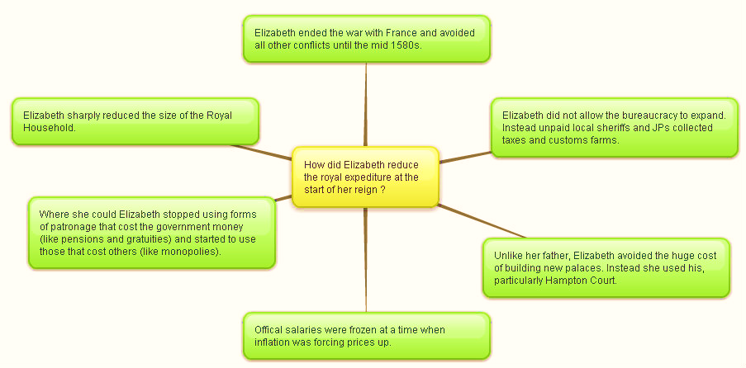

This looks like a remarkable achievement for the young monarch. However, it was not a complete success.

- Some historians argue that Elizabeth failure to introduce reforms to increase revenue in this period would be a long-term problem for her when she need to spend a lot of money fighting the Spanish in the period 1585 to 1604.

- Also, her dependency on unpaid local government officials to collect her taxes and customs was inefficient and open to corruption. In other words, this could have been a false saving that cost the Crown more than it saved.

Questions

- Write a paragraph to explain what financial problem Elizabeth faced in 1558, and consider how effectively she dealt with it.
- Study the diagram below. Label it with the Achievements of Elizabeth’s early financial policy and Failures of Elizabeth’s early financial policy as you think most appropriate (remember the best argument will be the weightiest). Explain your decision.

Now label the see saw and explain your choice in the box below

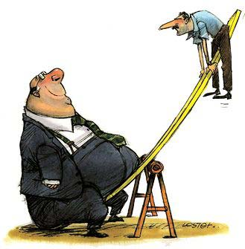

......................................................................................................................................................................................................................................................................................................................................................................................................................................................................................................................................................................................................................................................................................................................................................................................................................................................................................................................................................................................................................................................................................................................................................................................................................................................................................................................................................................................................................................................................................................................................................................................................................................................................................................................................................................................................................................................................................................................................................................................................................................................................................................................................................................................................................................................................................................................................................................................................................................................................................................................................................................................................................................................................................................................................................................................................................................................................................................................................................................................................................................................................................................................................................................................

Essay Planning Task

How effectively did Elizabeth deal with the problems she faced in 1558?

- Study the student-friendly mark scheme and the examiner guidance for this question on the sample paper. Complete the essay plan below.

Think carefully about how you will build your argument.
- What are the key terms in the question? How will you use them?
- What hard evidence will you deploy?
- How will you show judgement (relative importance) in the body of your answer?
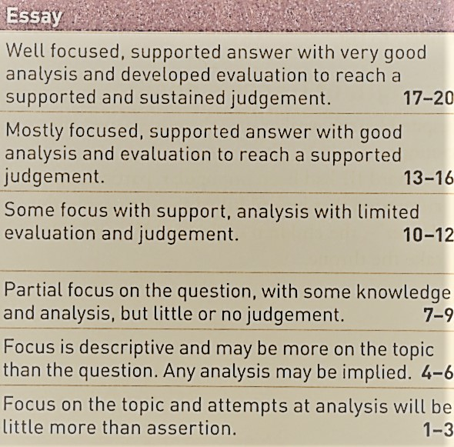
A

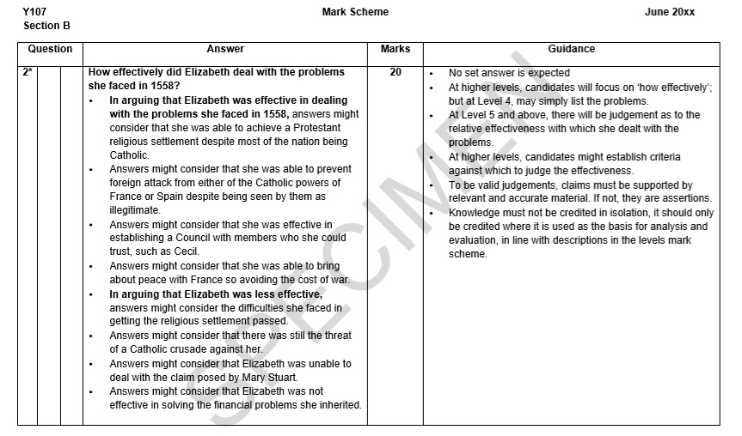
E
C
TITLE:
How effectively did Elizabeth deal with the problems she faced in 1558?
Key Words and Phrase:

Key issues to be discussed:

Linking and Relative Importance:

Line of Argument
 | Argument | Evidence deployed
Introduction

Tie the question to the factors
1

2

3

4

Conclusion

Direct answer to the question

Further Reading

Programme One in David Starkey’s series on Elizabeth – it is on YouTube
https://www.youtube.com/watch?v=VQbvaGl4jrg

I can lend you copies of the following texts

The Later Tudors – P Williams
Chapter VII - The establishment of Elizabethan rule

The Emergence of a Nation State –AGR Smith
Chapter XII – The establishment of the Elizabethan Regime

England and Wales under the Tudors – S Atkins
Chapter XI – T reign of Elizabeth. The first ten years

