Section C
The nature of the Elizabethan monarchy, government and parliament

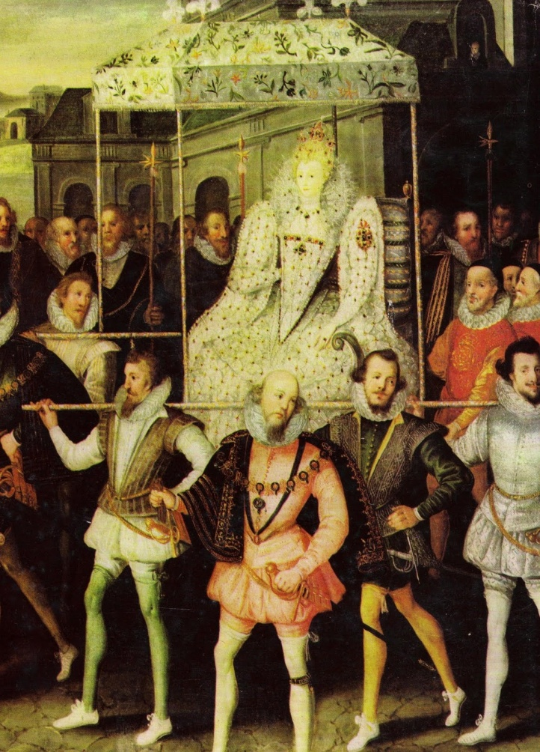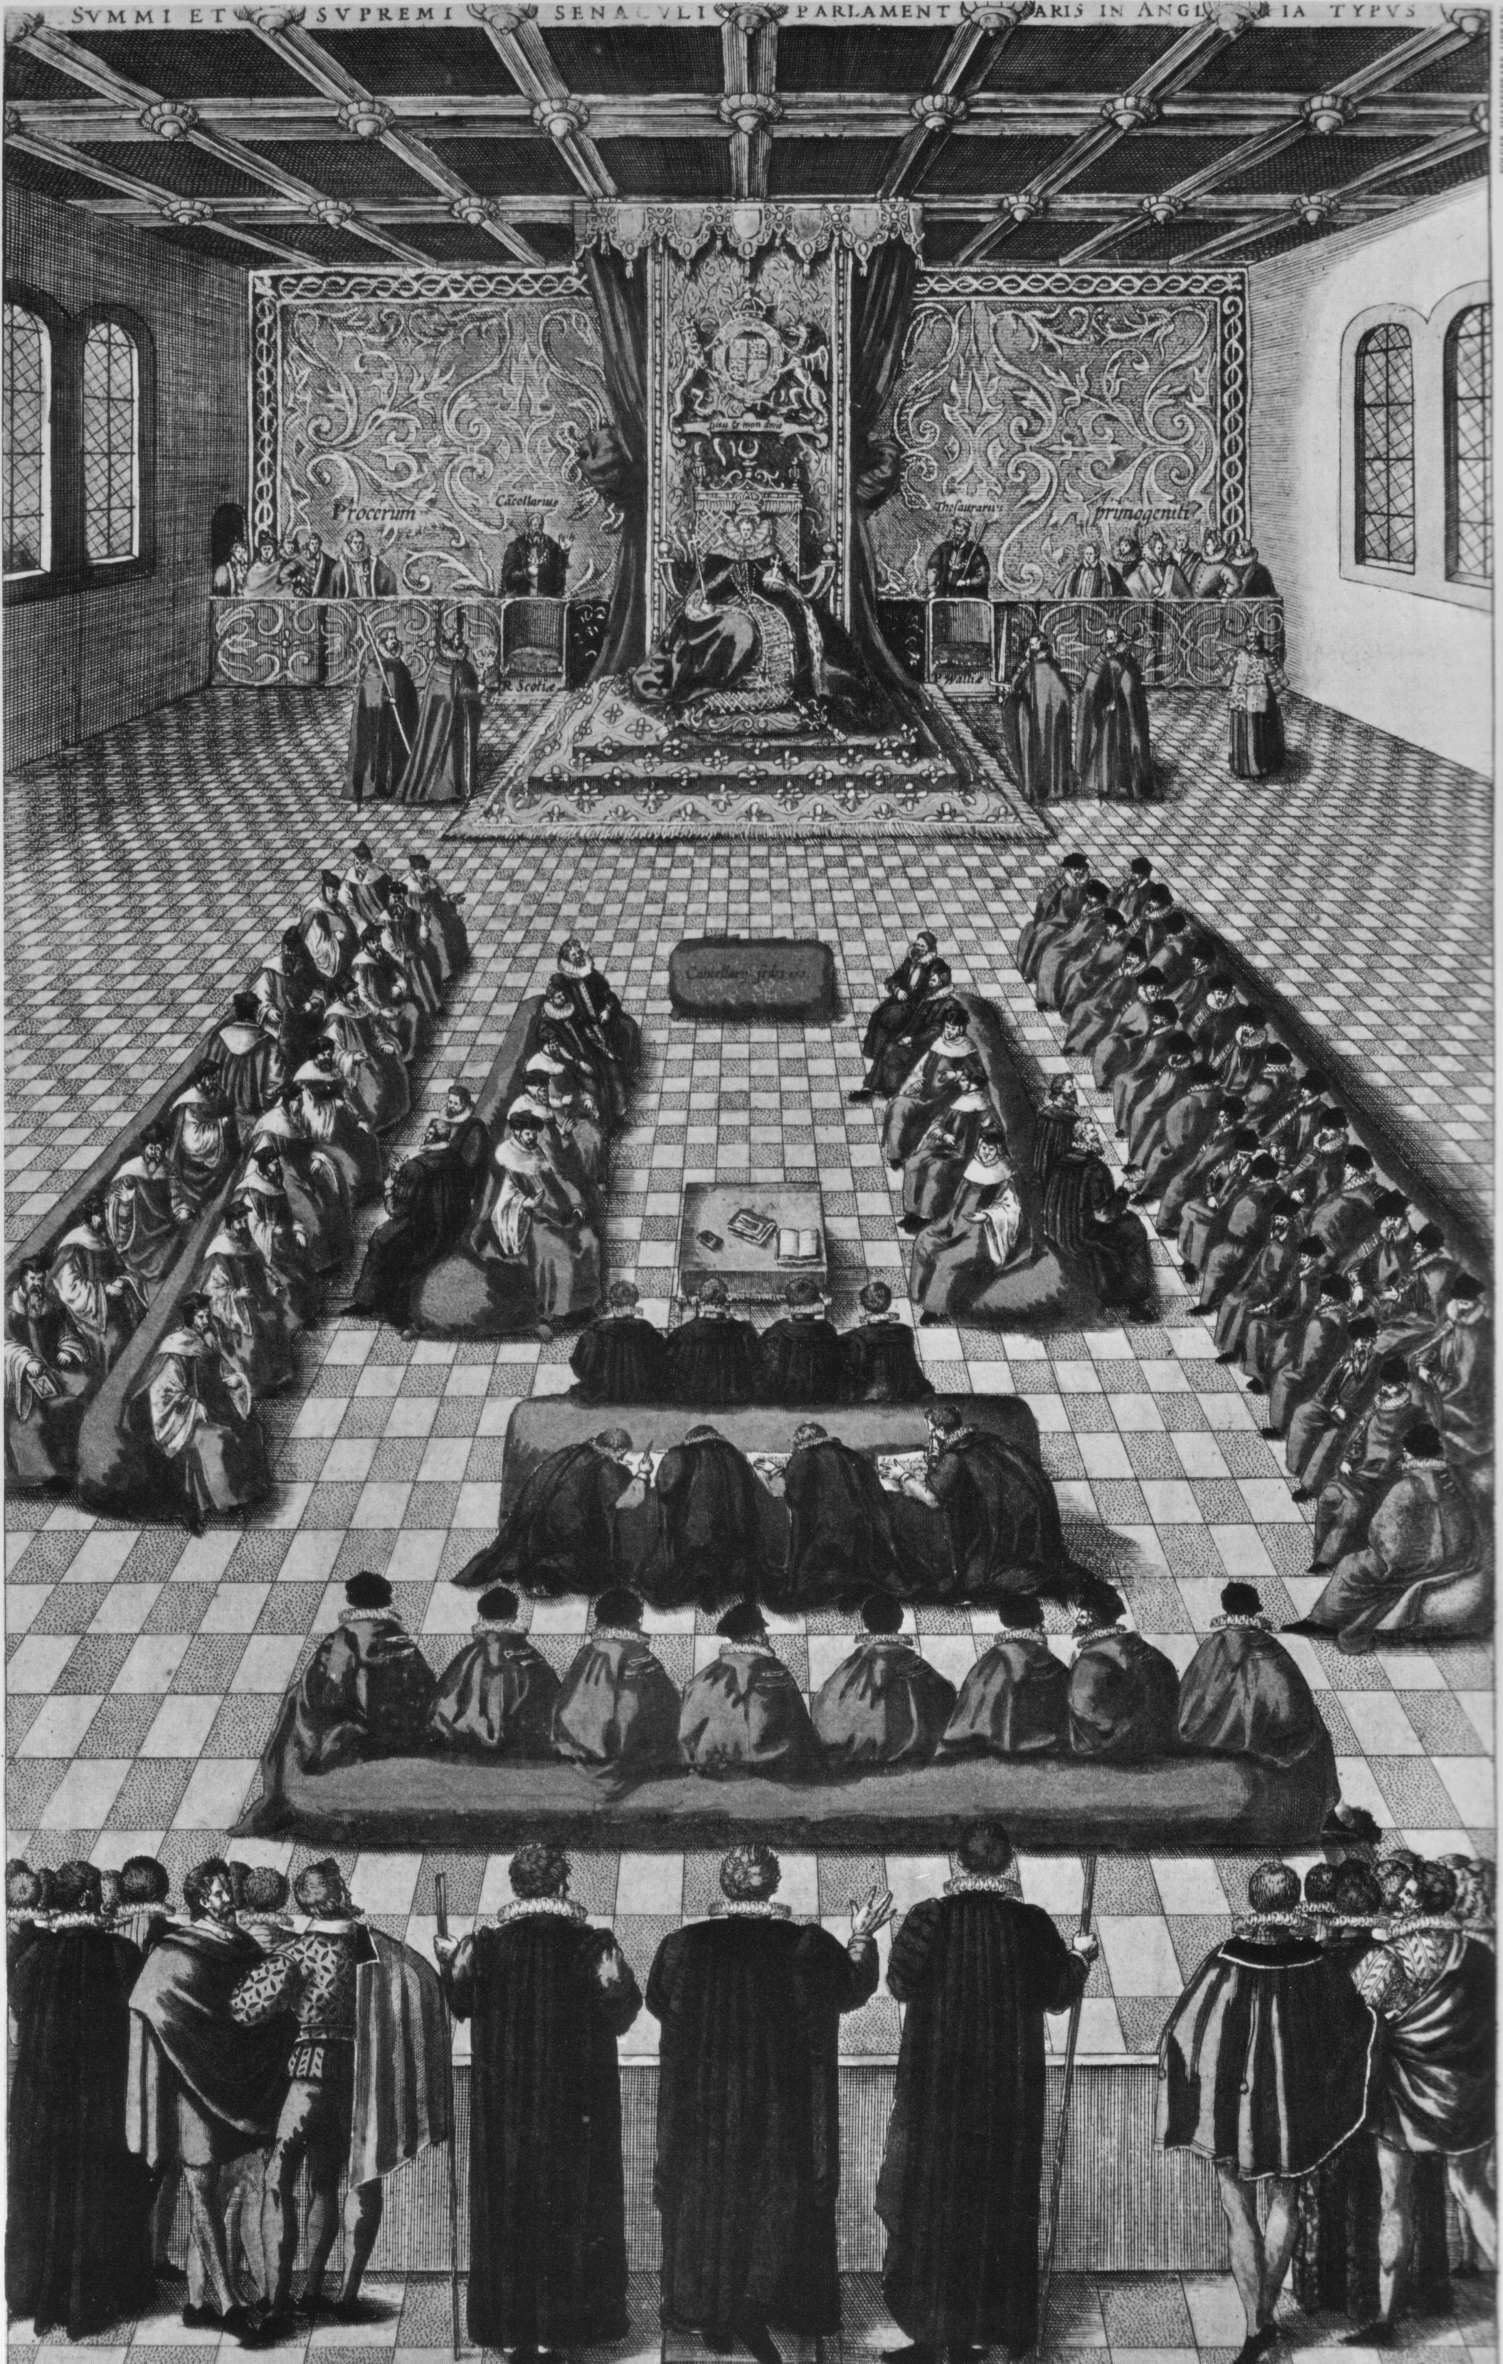

A simplified diagram to show the key bodies in the Elizabethan system of government

The purpose of this page is to introduce the bodies (or bits) of government that you will be studying in Unit Two. By the end of this unit you will be able to produce a much more detailed version of this, and be able to explain how the arrows link them together

Note that a “great man” like William Cecil could be a Privy Councillor, a Courtier and be an MP

The Monarch
- Elizabeth strongly defended the Royal Prerogative
- Directly responsible for all the state departments
- Appointed and dismissed all ministers

The Privy Council
- “The indispensable hub of the entire machinery of government” - R Sloan
- Chief executive and administrative body of central government.

The Court
- The centre of Patronage
- The centre of the Cult of Gloriana
- A place of independent information for the monarch.

Parliament
- The legislative (place where laws were made).
- The place where taxes could be raised..
- “A point of contact” G R Elton (when asked.

An extract from Mirror of Magistrates - 1559
What was the role of the Monarch in the Elizabethan System of Government?

Full little know we wretches what we do
When we presume our princes to resist...

Today, we have a constitutional monarch, Elizabeth II, who is a figurehead ruler with limited actual power. Sixteenth Century England was of course very different. In theory, and often in practice, Elizabeth I was an autocrat who had to make all the major decisions herself. She fiercely defended her royal prerogative, and this meant;

- No law could be passed without her consent.
- She could decide when parliament was going to be called, prorogued or closed.
- She could decide who became ministers in her Privy Council.
- She could decide who could attend Court.
- Elizabeth was the centre of the patronage system.
- It was Elizabeth who was responsible for the nature of religious worship in the country.
- It was Elizabeth who could decide if and when England could go to war.

To disobey Elizabeth was treason, and the penalty for treason was death. If one reflects also upon Elizabeth’s intellect (for example S J Lee writes that she brought her “sharp powers of analysis to political process and therefore saw through carelessly constructed arguments”) and of her political skills (John Guy suggests that “she knew her own mind and her instinct for power was infallible”... continuing that...”she controlled her own policy more than any other Tudor”) then it is easy to conclude that Elizabeth was the government of the realm.

Her contemporary, William Camden certainly believed this, branding her “the famous Empresse Elizabeth” who “had so rare gifts, as when her counsellors had said all they could say, she would frame out a wise counsel beyond all theirs”. Moreover, this is the view that has dominated for much of the Twentieth Century. S T Bindoff wrote of her as a “superb and matchless flower” and continued that “no wiser or mightier ever adorned the English throne”, whilst A L Rowse bluntly stated “it was Elizabeth who ruled England”.

Yet today we understand that it is too simple to suggest that Elizabeth was both in total control, and consistently successful. Elizabeth was always short of money, and had no standing army or civil service to impose her will. She required co-operation and consent from those institutions she ruled through.

The Privy Council above all existed to advise the monarch, but revisionists would argue that this also left it “well placed to manipulate” (C Haigh). Ministers could be disloyal, and Parliament did challenge her Royal Prerogative over matters such as her marriage and monopolies. Elizabeth required Lord Lieutenants and Justices of the Peace in local government to ensure that the centre’s policies were actually carried out in the shires. By the end of her reign the Court had become a “sordid and self-seeking playpen for overgrown and ill-tempered children” (C.Haigh again). Whilst G.Donaldson argues that by the 1590s she “allowed problems to build up”...and as a result the reign ended “in anti-climax, in decline and almost in failure” when faction spun out of control in Essex’s Revolt.

Our task therefore is to compare the relative importance of the differing institutions of the Elizabethan system of government. When we do this we should consider how they link together and how far, if at all, they undermine Elizabeth’s Royal Prerogative. At the end you should ask yourself how far you agree with the statement
“Elizabeth was the focus of an effective system of government”

Questions
- Construct a spider diagram to show the powers of a Tudor monarch in theory.
- What were the main administrative limits to these powers in reality.

R Sloan
What was the role of the Privy Council in the Elizabethan system of government?
“The Council was the indispensable hub of the entire machinery of government.”

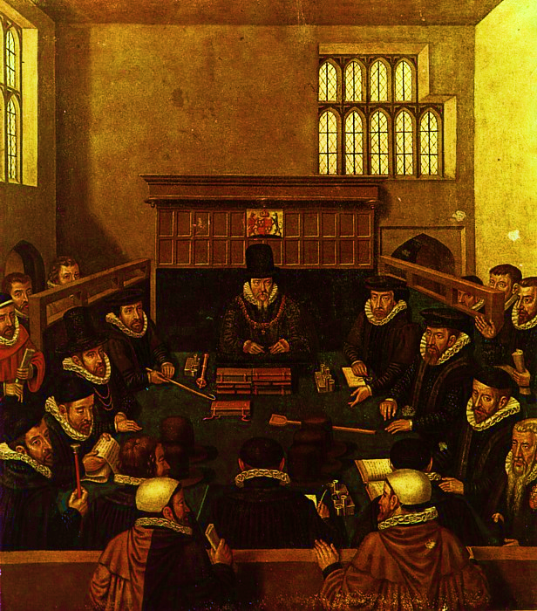

The Privy Council was a regular and formal meeting of Elizabeth’s most important ministers. Sometimes it would be chaired by the Queen herself, but usually it would be chaired in her name by the Secretary of State. To start with under Elizabeth, it met twice a week, most commonly at Greenwich, Westminster or Hampton Court. By the mid-1580s, the Spanish war meant that it was often meeting up to two or three times a day.

Historians often view the Privy Council as very important to central government. M Tillman stresses its executive role, stating that it was the “select ruling board of the realm” whilst John Guy argues that the Privy Council was of great administrative importance. For him, it was the Council that “got things done”. K Randell views the Council as “the most dynamic and powerful element of the central government machinery” whilst S J Lee views this importance in a broader Tudor context, suggesting that “Elizabeth maintained (the Council)... as the single most important institution for decision making and the formation of policy.”

However, just because historians say something is important, this does not necessarily make it so. Study the diagram on the following page (adapted from M Tillman – The Triumph of Elizabeth page 60) and answer the following questions;

Questions
- What were the main executive roles of the Privy Council?
- What were the main administrative roles of the Privy Council?
- Can you see any links between any of its roles?
- From what you already know about Elizabethan England, can we argue that the Privy Council had any significant achievements?

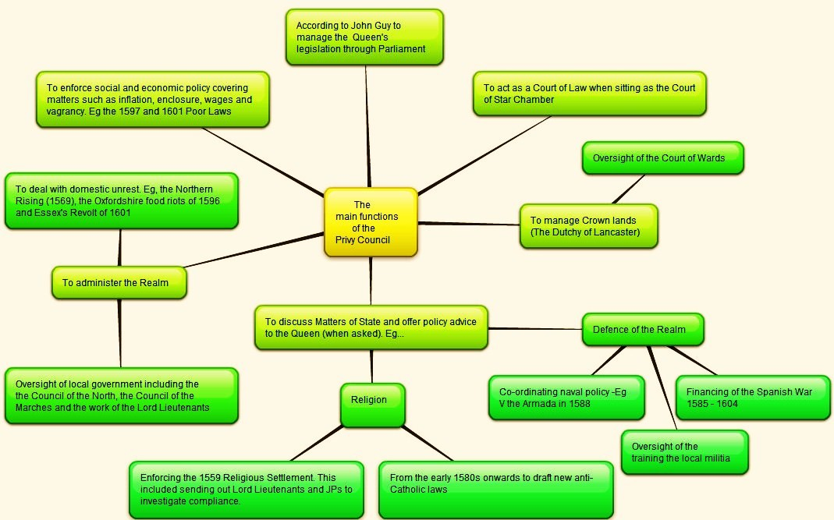

The limitations of the Privy Council in the Elizabethan system of government

There are four major criticisms levelled at the Elizabethan Privy Council.

- Revisionist historians like C Haigh suggest that William Cecil used the Privy Council to force the Queen into policies that she did not want to follow. This “Cecilian manipulation” centred on his control of the information that Elizabeth received. It can be seen most clearly in 1559 when he pressured Elizabeth to support lowland Protestant rebels against Mary, Queen of Scots. Elizabeth was reluctant to support a rebellion against a fellow monarch, so Cecil drafted a memorandum giving an intellectual justification for her intervention. When that did not work, he briefed ambassadors to write to her pressing for the need for immediate action. When Elizabeth still refused to act, Cecil threatened to resign. Only then did she give ground and move troops north of the border. The point here is that this is a long way from William Cecil’s promise to “obey her majesty’s commandment” and suggests that members of the Privy Council did not always act in good faith when advising the Queen, and perhaps at times even dominated her.

- There is an argument that a three-way factional rivalry between William Cecil, the Earl of Leicester and the Earl of Sussex was a real barrier to effective government in the 1560s. Here Elizabeth deserves credit for forcing reconciliation between the Earls of Leicester and Sussex in 1566, and detaching the Earl of Leicester from the anti-Cecil group in 1569. What followed in the 1570s and 1580s was a period of “moderation, consensus and stability” (S J Lee).

- There was a significant decline in the loyalty and effectiveness of the Privy Council in the 1590s as the death of older ministers led to the appointment of less able and less loyal younger ministers. We have already seen how by the 1590s the Privy Council had become “dangerously narrow and weak in its membership” (C Haigh). This came to a head in 1601 with two significant challenges to Elizabeth’s government. The disloyalty led to faction spinning out of control, culminating in Essex’s Revolt. In the same year the ineffective management of parliament by Robert Cecil turned resentment over the abuse of monopolies into a full-blown revolt, which Elizabeth had to snuff out herself. As it was Elizabeth who appointed these ministers perhaps this failure reflects her shortcomings as much as that of the men themselves.

- K Randell describes the Privy Council as a “jack of all trades”. This supports G R Elton’s analysis that it tried to do too much, and was thus perhaps a reflection of Elizabeth’s own personality. He cites one day’s agenda in the 1570s (shown below).
- The House arrest of Lady Stonor (a Catholic)
- Trade with Spain
- A minor land dispute in Guernsey
- A poor man’s complaint against the Bishop of Hereford
- Various matters concerned with recusants
- A report that someone had spoken in favour of the Jesuit Edward Campion
- A land dispute involving the Earls of Northumberland and Bedford
- A merchant’s losses to pirates
- Sir Peter Carew’s debts

On a different occasion it discussed equally trivial matters such as “the cost of a pond in St James’s Park and the alleged use of lewd words by a William Holland of Sussex” (R Sloan). All of this seems a long way from the idea of the Council being a professional body which dealt with business efficiently.

Relative importance of the Privy Council in the Elizabethan system of government

Clearly the Privy Council was an important part of the Elizabethan system of government. However, the question is how important? Moreover, was it more important than the Queen herself?
Task

Study the quotations below and place their letter key on the graph on the following page. You should move them further along the X axis the more that they suggest that the Council was important, and higher up the Y axis to show how far you agree with them.

Now write a couple of paragraphs to explain your graph and aim to deploy evidence to support your view of what the historian has said
Now compare and discuss your conclusions with your peers.

A
M Tillman suggests the Privy Council was the “select ruling board of the realm” .

B
J Guy argues that the Privy Council was of great administrative importance. For him, it was the Council that “got things done”.
C
K Randell views the Council as “the most dynamic and powerful element of the central government machinery”.
D
P Williams takes a different view, suggesting that the Privy Council “could and did reach conclusions upon policy, but the final decision rested with the Queen, who seldom attended meetings and might easily ignore their conclusions”.
ED
AGR Smith goes further “the Queen depended in some small measure upon her councillors for advice, but she alone made the final decisions”.

Finally place the view of her contemporary, William Camden. He knew Elizabeth, but was writing after she had died.

FED
Elizabeth “had so rare gifts, as when her counsellors had said all they could say, she would frame out a wise counsel beyond all theirs”.

An importance graph
This is designed to help you draw your own conclusions about the importance of the Privy Council
I do not agree with this statement
I agree a lot with this statement
The Council was very important
The Council was not important

What was the role of the Court in the Elizabethan System of Government?
Sir Christopher Hatton
“The Queen did fish for men’s souls, and had so sweet a bait that no-one could escape”

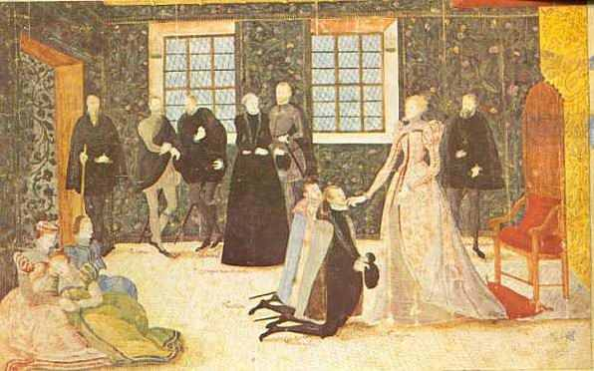

The Household in general and the Court in particular had always been central to the Tudor system of government. Elizabeth’s gender meant that the positions in the Privy Chamber, which P Wright describes as “the cockpit of faction” because of their personal access to the monarch, could no longer be filled by men. As the political nation of England was all male with the exception of the queen, instead the Presence Chamber (shown above) grew in importance. On the next page Paul Hentzer, a visiting Silesian describes his visit to it in 1598.

“In the same hall were a great number of councillors of state and gentlemen who awaited the Queen’s coming...First came barons, earls, knights of the garter...next came the Chancellor, bearing the seals of office in a red silk purse, between two others, one carrying the royal sceptre, the other the sword of state...Next came the Queen very majestic, her face fair but wrinkled, her eyes small yet black and pleasant, her nose a little hooked, her teeth black (from the English habit of too great a use of sugar).

Her air was stately, her manner of speaking mild and obliging. As she went along, she spoke in English, French and Italian. The ladies of the Court followed, very handsome and well-shaped. She was guarded on each side by fifty gentlemen with gilt battle-axes”.

Quoted in T A Morris – “Tudor Government”

Whilst the Court did not have a formal and defined set of functions in the Elizabethan system of government, the remarkable point about the evidence above is that it unwittingly highlights two of the three ways that Elizabeth used the Court to govern England.

- “As she went along she spoke in English, French and Italian”

Elizabeth used the Court as a place to obtain independent information. In theory all correspondence to the Queen needed to pass through the Secretary of State. This gave this person great power over Elizabeth. However, it was the Lord Chamberlain who controlled access to the Queen in Court, and it was usual for foreign ambassadors to attend. Elizabeth was of “a classical scholar, adept in both Latin and Greek”...with...”linguistic skills in French, Italian and Spanish” (S J Lee) and she was able to use this contact to ensure that she was not being fed only one side of an argument.

- “Next came the Queen very majestic...her air was stately”

The Court was used to develop Elizabeth’s Cult of Gloriana. F Yates argues that the idea of the Virgin Queen was initially deliberately fostered in the post-Catholic age to challenge the idea of the Virgin Mary. Perhaps, but elsewhere the Cult was used to “create a credible majestic image for a female monarch” (T A Morris). A good example of this was the Accession Day tilts, which saw jousting in defence of the Queen’s honour. These “ceremonies of adoration” (P Williams) were part of the “intense phase” (S Adams) of the Cult in the 1580s. C Haigh suggests that these pageants were “mass indoctrination of the participants...a constant reinforcement of loyal attitudes” based on an idealist image of womanhood. J Guy suggests that Elizabeth used the Court to “encourage flirtation and ritualised sexuality” with the Monarch as the idealised focus. C Haigh writes of ”the display of majesty”...”where the Queen dressed to impress, and she expected to be admired”. Edmund Spenser wrote the sonnets like “the Faerie Queen” declaring her “a most virtuous and beautiful lady” whilst it became fashionable for her ministers to carry around lockets with her picture in it.

This Cult of Gloriana was also reinforced by Elizabeth’s royal progresses. Each summer the Court would leave an insanitary London and visit the great houses of her courtiers in southern and central England (at their expense). This allowed the Queen to project her majesty on the cheap. Feasts and entertainments were laid on, and it is said that the Earl of Leicester’s water pageant in 1575, which included representations of sea creatures and poems in the Queen’s honour, was the basis of part of Shakespeare’s “A Midsummer Night’s Dream”.

Below is part of an inventory for Elizabeth’s visit to Lord and Lady North in the same progress. It is an insight into the Tudor diet, and the cost of hosting Elizabeth. As Edith Sitwell reflected, “the fields, the air, the rivers, the sea, must have been completely dispeopled”.

- “1,200 manchets, 3,600 cheatbreads,
- 74 hoggesheads of beare (beer), 2 tunnes of ale,
- 1 hoggeshead of vinegar, 24lbs of lard, 430 lbs of butter, 2,522 eggs, 6 Holland chesses.
- 11 oxen, 66 sheep, 17 veales, 7 lambs, 34 pigges, 8 dozen rabbits and hares, 4 stags, 8 gammons of bacon.
- 32 geese, 30 dozen and 2 capon, 6 turkies, 32 swannes, 22 dozen and 9 mallards, 1 crane, 22 bitterns, 12 shovellers, 21 dozen chickens, 125 pigeons, 8 dozen and 10 pewyts, 68 godwyts, 17 gulls, 8 dozen and 11 dottrells, 8 snypts, 29 plovers, 18 redshanks, 22 partridges, 1 pheasant, 27 dozen and 1 quail, 2 curlewes.
- 4 sturgeons, 4 dozen crayefishes, 8 turbots, a cartload and 2 horseloads of oysters, 1 barrel of anchovies, 2 pykes, 2 carps, 4 tenchies, 12 pearches, 400 red herring etc... “.

Quoted in E Sitwell – “The Queen and the Hive”

That the Cult was used in different ways at different times in Elizabeth’s reign can be seen by contrasting the Armada and Sieve Portraits on the next page). It is too easy to belittle the Cult of Gloriana today. However, we should remember how potentially serious a threat to her monarchy Elizabeth’s gender was. Instead, Elizabeth turned this into a tool of government to help her to maintain her control.

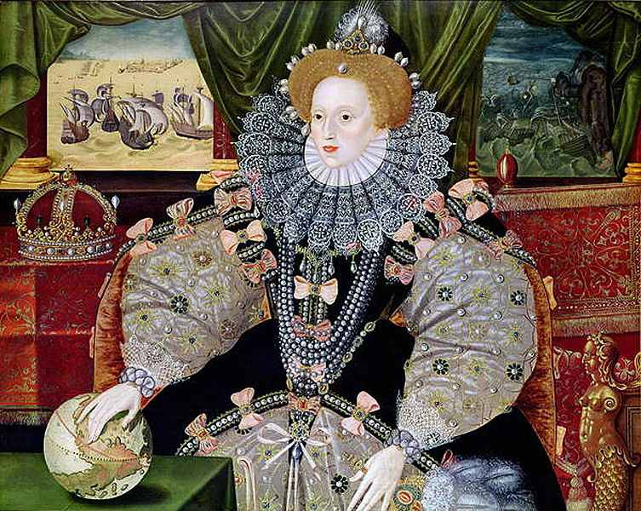
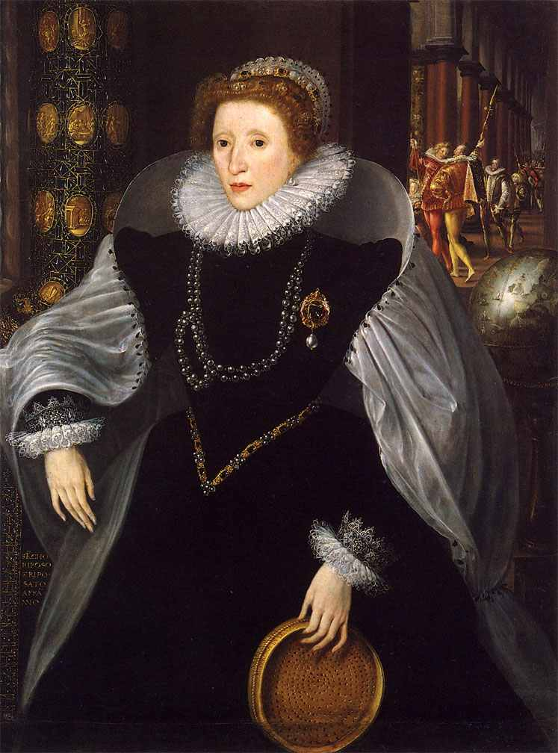
These, and many other Tudor paintings can be seen for free at the National Portrait Gallery.

- Finally, it is worth noting that the Court was the centre of the patronage and faction system. Patronage can be defined as “the disposal of jobs and offices – which were in the gift of the Queen or her leading ministers” (M Tillman). In other words, patronage was the reward the Crown needed to give out to acknowledge the loyalty and service of the political nation. This made the Court “the clearing-house” (C Haigh). W MacCaffrey estimates that there were no more than 2,500 men with political power in Elizabethan England, and estimates that 1,000 of these had directly attended Court at some stage in their life. This represents a considerable proportion, and reflects the importance of this function of the Court.

Patronage underpinned the faction system. “Lesser men attached themselves to courtiers who might secure them offices or grants” indeed...” a courtier’s following in his locality was dependent upon his ability to provide patronage” (C Haigh ). Hence, factions were fluid alliances built around the influence and patronage a great man had. Such factional leaders were thus the “brokers of patronage” (M Tillman) This meant that there was a “never-ending process of competitive jockeying for position” (K Randell).
Types of patronage used by Elizabeth

Financial rewards that cost the Crown
- Pensions, gratuities and annuities
- Wardship of Crown lands

Financial rewards that did not cost the Crown

- Customs Farms
- Monopolies rights

Employment
- Offices in the legal system and the local administration
- Position in the armed forces
- Positions in the Church (bishoprics)

Non-Financial Patronage
- Court honours
- Knighthoods
- Peerages

It is worth noting here that Elizabethan England was a hierarchical society where status was valued above wealth. Elizabeth was very reluctant to grant such honours.

C Haigh argues that, “Elizabeth deliberately politicised her Court, by making courtiers into politicians and politicians into courtiers”. This meant that faction in Court could help Elizabeth control and dominate her Council. Men could thus have influence with Elizabeth in one of two ways. Some were “the male favourite” (S Adams) of the moment. These men tended to rise initially through the Court, and good examples include the Earls of Leicester and Essex, Sir Walter Raleigh (until he got one of Elizabeth’s maids of honour, Elizabeth Throckmorton, pregnant and married her in secret) and that excellent dancer, Sir Christopher Hatton. Others, like William Cecil, Sir Francis Walsingham, Sir Francis Knollys and Sir James Croft were politicians or administrators who had to attend Court to maintain their influence. So important was patronage, that William Cecil even had to appoint his own patronage secretary, to ensure that this work was done properly. There were three great factional rivalries in Elizabeth’s forty-five year reign.

Questions

- Study the two very different portraits of Elizabeth. What messages are they giving about Elizabeth? How did they help Elizabeth govern England?
- Construct a spider-diagram to show the importance of the Court to the Elizabethan system of government.
- Looking back from the 1630s, Robert Nauton, said of Elizabeth that “she ruled much by faction” ...” which she herself both made, upheld and weakened”. How far do you agree? Did patronage and faction do more harm than good?

In the early 1560s
The Earl of Sussex V The Earl of Leicester

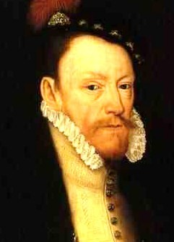v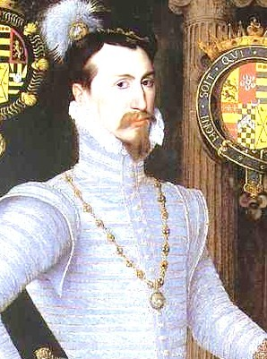

Leicester tried to get Sussex convicted of misconduct over his work in Ireland, whilst Sussex tried to prove that Leicester had murdered his wife. This rivalry really got out of hand. By 1566 the different factions were carrying weapons and wearing their own “party colours” (yellow for Sussex and purple for Leicester). There was even talk of a duel between the two before Elizabeth stepped in to force reconciliation. She forced them to ride through London together. However, at one stage civil war looked possible.

In the late 1560s
William Cecil V The Earl of Leicester
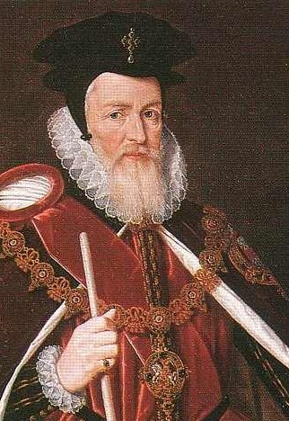v

This factional rivalry really centred on Leicester ambition to marry Elizabeth, and his resentment of William’s Cecil’s influence. Cecil was also keen for Elizabeth to marry, but he was determined that she should marry anyone but Leicester. It was thus perhaps inevitable that the two should clash. Matters reached a peak in the late 1560s, with Leicester trying, and failing to get Cecil dismissed. As Leicester’s marriage suit faded, so did the bad feeling, and recent work by Simon Adams has stressed that the 1570s and 1580s demonstrated a “political homogeneity previously unknown”. He continues that had there been permanent conflict over patronage it would have “gridlocked government”. C Haigh agrees with this view of the 1570s and 1580s, suggesting that they “did not let their rivalries get out of hand, but nor did they ignore opportunities to advance themselves and their followers at the expense of rivals”.

In the late 1590s

Robert Cecil V The Earl of Essex
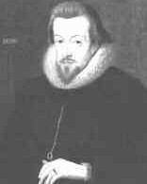v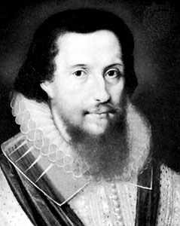

This was by far the most serious factional rivalry of Elizabeth’s reign. C Haigh argues that “factional struggle affected every decision”. Just as Robert Cecil looked to fill his father’s position as the most important politician and administrator in the realm, so Essex looked to replace his stepfather, Leicester, as the Queen’s favourite. Matters came to a head in 1601 when Essex returned without permission from his command of the Queen’s forces in Ireland, and burst into the Queen’s bedchamber. He was convinced, correctly, that Cecil was engineering his downfall. Elizabeth banned him from Court (thus weakening his faction). She also took away his monopoly on sweet wines and put him under house arrest. Essex then launched his doomed revolt (see unit six notes), and ended up being executed. The point here however is that by this stage faction was out of control, and actually caused a revolt against the Queen. Equally, in the last two years of her reign a kind of Regnum Cecilinum replaced it.

How important were the ministers in the Elizabethan System of Government ?

The following pages list the most important ministers in Elizabeth’s government. Study them, and then have a game of Elizabethan Ministers Top Trumps. Then consider which you think are most important. The diagram below from B Mervyn shows the tasks of the different posts.

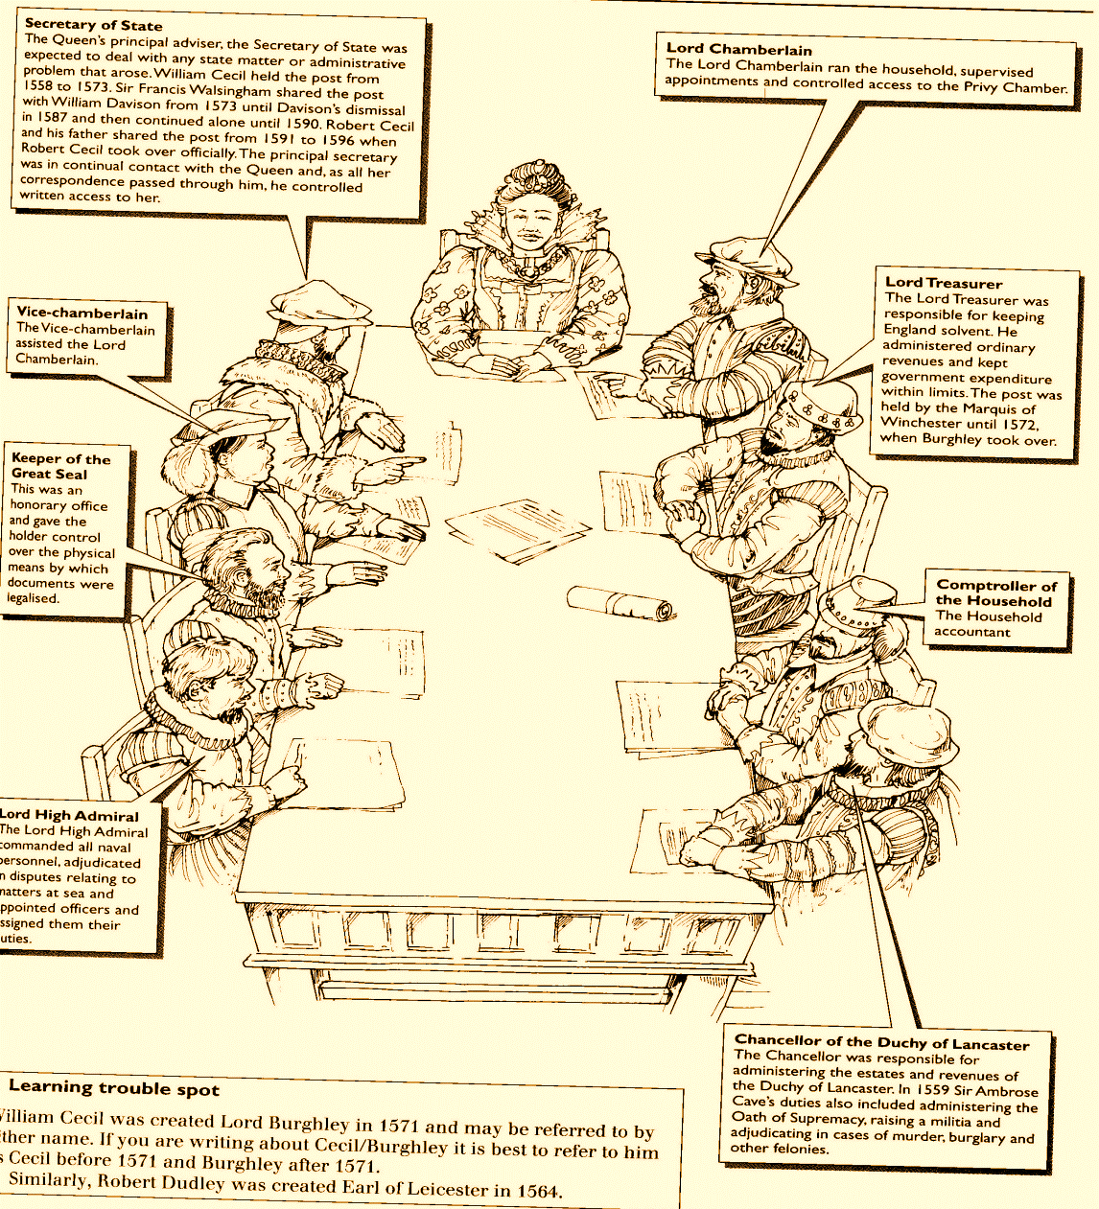

Romance: 0 Cecil was not a favourite or consort to be flirted with. His influence came from his ability alone.
What historians think : +8
MacCaffrey – “the dynamo which kept...government running smoothly and effectively”
Lee – “he brought to administration an attention to detail and accuracy...he was...adept at solving problems”
Haigh has questioned his loyalty writing of “Cecilian manipulation”

Jobs Held : +10 The greatest administrator and politician of the age. ‘58 - Secretary of State ‘61 – Master of the Court of Wards ’72 – Lord Treasurer
Years of Service : 40 Years 1558 – 1598 (his death)
Faction : +8 Had a large faction (incl’ the Earl of Sussex) but tried to avoid overplaying his position).
What Elizabeth Thought : +10 Would not let him retire, even fed him broth herself when he was dying. She knew it was Cecil who drafted the 1559 Religious Settlement, negotiated the Treaty of Edinburgh, and controlled Parliament for her.

William Cecil = Lord Burghley from 1571

- Now refer to page 57 in B Mervyn (on the next page) and the paragraph from Stephen Alford in History Today (2011). Write 150 words to explain the importance of William Cecil to the Elizabethan system of government. Think carefully about building your argument.

- Lead with your strongest argument.
- Build your argument with connectives from page 7.
- Try to interact with the evidence that you deploy.

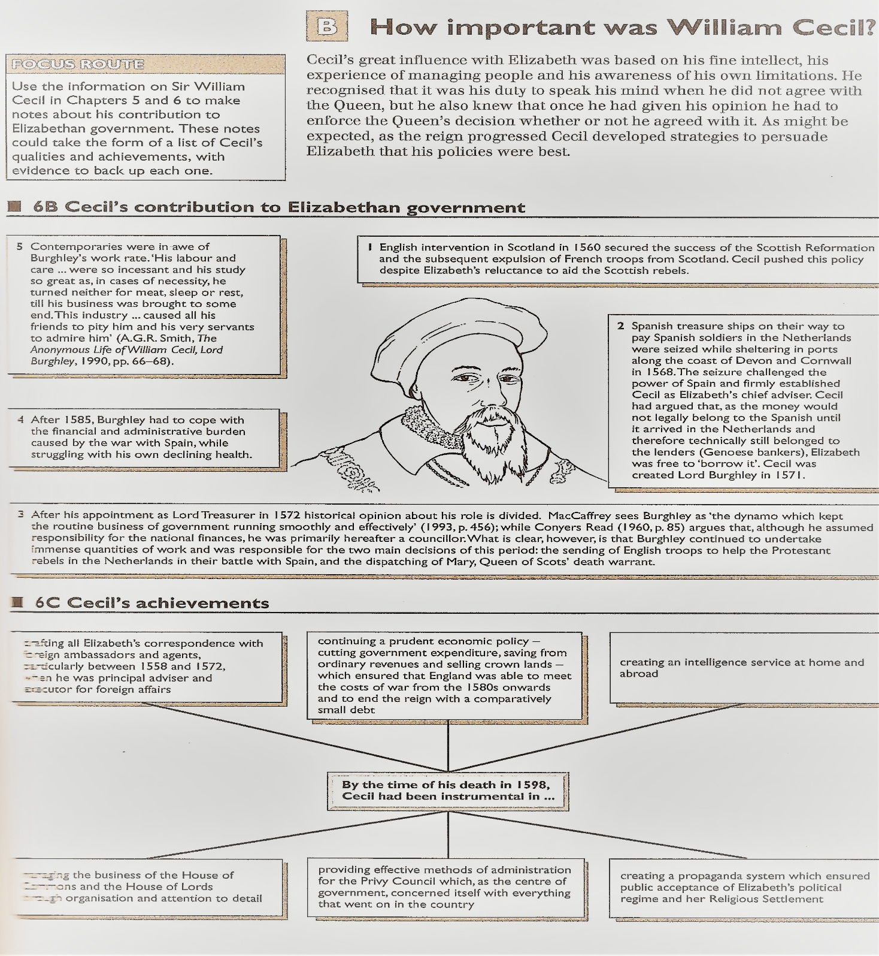

“For the past 20 years historians have looked at him (William Cecil) in fresh ways: at his religion; at his radical position on the politics of the royal succession (where he tried to bounce Elizabeth into making decisions she did not want to make and sought the destruction of the Queen of Scots); and at the dynastic pretensions of his great houses. The boring bureaucrat was a pose; behind the mask was a powerful minister, who could be ruthless in pursuing his political objectives, in securing Protestant religion and the stability of the Tudor state. He was a dynast who trained his son Sir Robert Cecil (1563-1612) for government office. Burghley’s notion of service had little to do with sentiment; his office, as he saw it, was to hold Elizabeth to her God-given duties as queen. At times he was deeply critical of her. As he wrote to Sir Robert in 1595, he was responsible to God first and then the queen, ‘preferring in policy her majesty afore all others on the earth’.”
Stephen Alford
History Today - 2011
What historians think : +2 Lee – “prepared to resort to devious means” and “able and charismatic but, above all...a destabilising influence”
Recent work by S Adams has stressed that his factional rivalry with William Cecil died in the 1570s. This was replaced by co-operation as the international situation grew more serious.

Romance:+8
This was where Leicester’s influence came from. Genuine attraction and the closest Elizabeth came to marriage (in the early 1560s)
What Elizabeth Thought :
+8
Was the closest she ever came to a true lover. Perhaps seriously considered marriage in the early 1560s. However would not let him dominant her, famously said “I will have here but one mistress and no master” when he overstepped the mark.

Faction : +7
Could rival Cecil’s factional power, but rarely won when they clashed.
Robert Dudley Earl of Leicester from 1564

Jobs Held : +2 No major government role ’58 – Master of the Queen’s Horse’62 made a Privy Councillor

Years of Service : 30 Years 1558 – 1588 (his death)

What Elizabeth Thought : +8
Second only William Cecil in ability. That Elizabeth trusted him with both her personal security and the greatest secrets of the realm says much. Lee argues “Walsingham did provide the sort of perspective which the Queen needed “.

Faction : +2 Walsingham kept out of faction if at all possible. But personally close to William Cecil.
Romance: 0
This was not the Walsingham way.
What historians think : +7
Lee – “private, withdrawn and highly organised ...with... a good eye for detail.” He continues that Walsingham was “above reproach as far as loyalty was concerned”
Jobs Held : +8
Elizabeth’s spymaster and leading diplomat. ’69 investigated the Ridolfi Plot, ’70 Ambassador to France / secretly helps the Huguenots. Also deals with the Throckmorton and Babington plots. Builds the most effective internal and external spy network in Europe,

He continues this responsibility even when, in ’73 he became Secretary of State.
Years of Service :
32 Years 1558 – 1590 (his death)

Sir Francis Walsingham

Romance: 0
Like William Cecil more of a father figure.
Jobs Held : +6
Had held positions under Edward VI and Mary (one of the few Protestants to retain influence). Brought experience to the new regime.
‘58.Treasurer of the Queen’s household, ’66 made Chancellor of the Exchequer and auditor of the Duchy of Lancaster,

What Elizabeth Thought : +7
Elizabeth trusted him with her money and was known to have listened to his moderating arguments about taking a harder line with the puritans.
Sir Walter Mildmay

Years of Service : 31 Years 1558 – 1589 (his death)

Faction : +2
Mildmay was close to William Cecil, and brother-in-law to Francis Walsingham. Avoided faction where possible.

What historians think : +5
Often overlooked by historians. However Lee writes of him as “a man of cultivation and of great piety”.

Faction : +4
Most influential in the 1570s and 1580s when faction was at a low ebb. Some rivalry with Raleigh to be the Queen’s favourite in the 1580s.
Sir Christopher Hatton
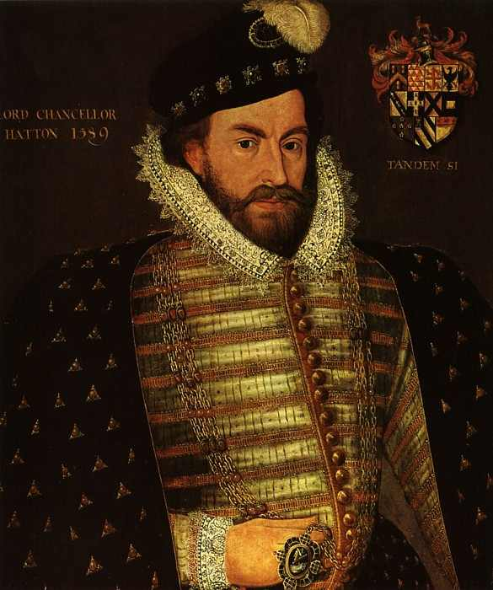

Romance: +6
A great dancer who flirted outrageously with the queen.
What historians think : +5
Like Mildmay sometimes underestimated. However Lee suggests “the key stabilising factor of the reign...the main channel to the legislative.”
What Elizabeth Thought : +7
The one minister who was both a favourite and able.

As Lee puts it “the one servant who seemed to combine the Queen’s affection with her respect”.
Jobs Held : +6
‘58.appointed Vice-Chamberlain and a privy councillor. ’87 Lord Chancellor.

Years of Service : 33 Years 1558 – 1591 (his death)

Years of Service : 14 Years 1581 – 1595 (his fall from grace)

Faction : +4 Played factional rivalry with Hatton and Essex. Not really bright enough to win.

What Elizabeth Thought :
+3 When he returned to Court in 1581 he was very much Elizabeth’s favourite. In 1588 named Virginia after her. Ended up in the tower in 1595 when he got Elizabeth Throckmorton pregnant and then married her in secret.
Romance: +6
“Dashing and flamboyant” (B Mervyn) but made the mistake of looking at a woman other than Elizabeth. After his release from the Tower, he was only a minor figure.

What historians think : +2
R Wernham suggests that his achievements were really as an explorer. He was never even a Privy Councillor. Really a distraction.
Jobs Held : +2
‘85.Captain of the Queen’s Bodyguard ’88 appointed Vice-Admiral of Devon and Cornwall.

Sir Walter Raleigh
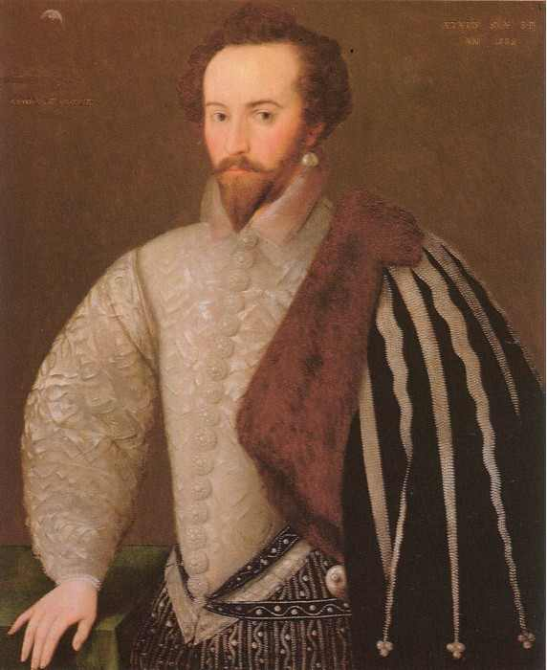

Jobs Held : +2
’93 Became a Privy Councillor. ’97 Led the fleet in the attack on the Spanish fleet at Cadiz. ’99 Appointed to lead the army in Ireland.

What historians think : 0 Lee “It is difficult to say anything positive...a wasted career”. He was “impatient, petulant and ruthless...he...played little direct part in the administrative process”
Romance: +3 Was convinced that he could get Elizabeth to do anything. In reality he was never in control of the aged queen.
Faction : +3
Built a powerful faction but broke the system. This led to his downfall and revolt.
What Elizabeth Thought :
+3

Initially Elizabeth’s relationship was part mother part lover with Essex. After his return from Ireland she understood he had to be broken.
Robert Devereux
Inherited the Earl of Essex in 1577 (aged 10)

Years of Service :
8 Years 1593 – 1601 (his execution)

What Elizabeth Thought :
+5

Elizabeth called him her “pigmy” and he suffered in comparison with his father. Recognised that he was the most able of the new wave, but blamed him for the Monoplies Crisis.
Faction: +10 Helped his great rival, Essex, destroy himself. By 1603 had patronage powers beyond even those of his father.
Robert Cecil

Romance: 0
No chance.
What historians think : +4 Mervyn “His advancement was not rapid. His organisational skills were eventually recognised.” However, he was always an unpopular figure. Some say that this rubbed off on Elizabeth.
Jobs Held : +7
’91 Became a Privy Councillor. ’96 appointed Secretary of State. ’99 Appointed Master of Wards.
Years of Service : 12 Years 1591 – 1603 (her death)

- Now construct a simple spider-diagram showing the eight named minsters. Under each write what you consider to be the most noteworthy point about them. Now rank them 1 to 8 (where 1 = most important).
- Write two paragraphs to explain your decisions.
- Now use a piece of A1 paper to construct your own version of the diagram on Page 37. You should include as much evidence as you can and explain the links between the different parts of the system.
- R Sloan concluded that “while the monarch did not govern alone the other institutions of government existed more to serve than restrict her power” – How far do you agree? Explain your answer.

Further Reading

The Tudor Years – Ed R Sloan
Chapter VIII - The government of England under Elizabeth – R Sloan

The Emergence of A Nation State –AGR Smith
Chapter XIII – The Queen and Her Ministers
Chapter XIV – Patronage and Faction

The Reign of Elizabeth I – SJ Lee
Chapter I – Elizabeth and her government

Elizabeth I – Profiles In Power – C Haigh
Chapter IV – The Queen and the Council
Chapter V – The Queen and the Court

Or online you could click onto the following sites

Something a bit higher from Tudors.org

http://www.tudors.org/asa2-level/57-were-elizabethan-politics-factional.html

Now attempt to complete the questions planning exercises.
Again – there are board plans in the appendices for later reference

January 2010
How important was the Privy Council in the government of England during the reign of Elizabeth ?

TITLE:
January 2010

How important was the Privy Council in the government of England during the reign of Elizabeth?

Examiner Guidance

No set answer is looked for but candidates will need to address the question.

Candidates will need to consider the role of the Privy Council in the government of England, but this should be weighed up against other elements of government in order to reach a judgement about its relative importance. It is likely that many will write in greater depth about the role of parliament and some may be sidetracked in to the debate about parliament. Better answers might also consider local government and the role of JPs etc.

Examiner Report

It was pleasing to see that a topic which has in the past attracted some very weak answers, where knowledge about the Privy Council is, at best, generalised and more frequently confused, did produce some excellent answers this time.

There was evidence of knowledge of both specific individuals and of their relationship with each other and as the Councillors with the Queen. Most answers showed an awareness of the regularity of the Council’s sessions and the Council’s ability to pressurise the Queen. Weaker answers often saw either party accepting the lead of the other as weakness, as if the relationship was entirely oppositional. There were still a few candidates who confused Council and Parliament. The issues of Elizabeth’s marriage and the question of Mary Queen of Scots were the principal examples used to discuss and debate the relationship between Elizabeth and her Council.

Key Words and Phrase:

Key issues to be discussed:

Linking and Relative Importance:

Line of Argument
 | Argument | Evidence deployed

Introduction

Tie the question to the factors

1

2

3

4 (?)

Conclusion

Direct answer to the question

Student

Concerns

TITLE:

Assess the role of Elizabeth I ministers in her government to 1603.

Key Words and Phrase:

Key issues to be discussed:

Linking and Relative Importance:

Line of Argument
 | Argument | Evidence deployed

Introduction

Tie the question to the factors

1

2

3

4

Conclusion

Direct answer to the question

Student

Concerns

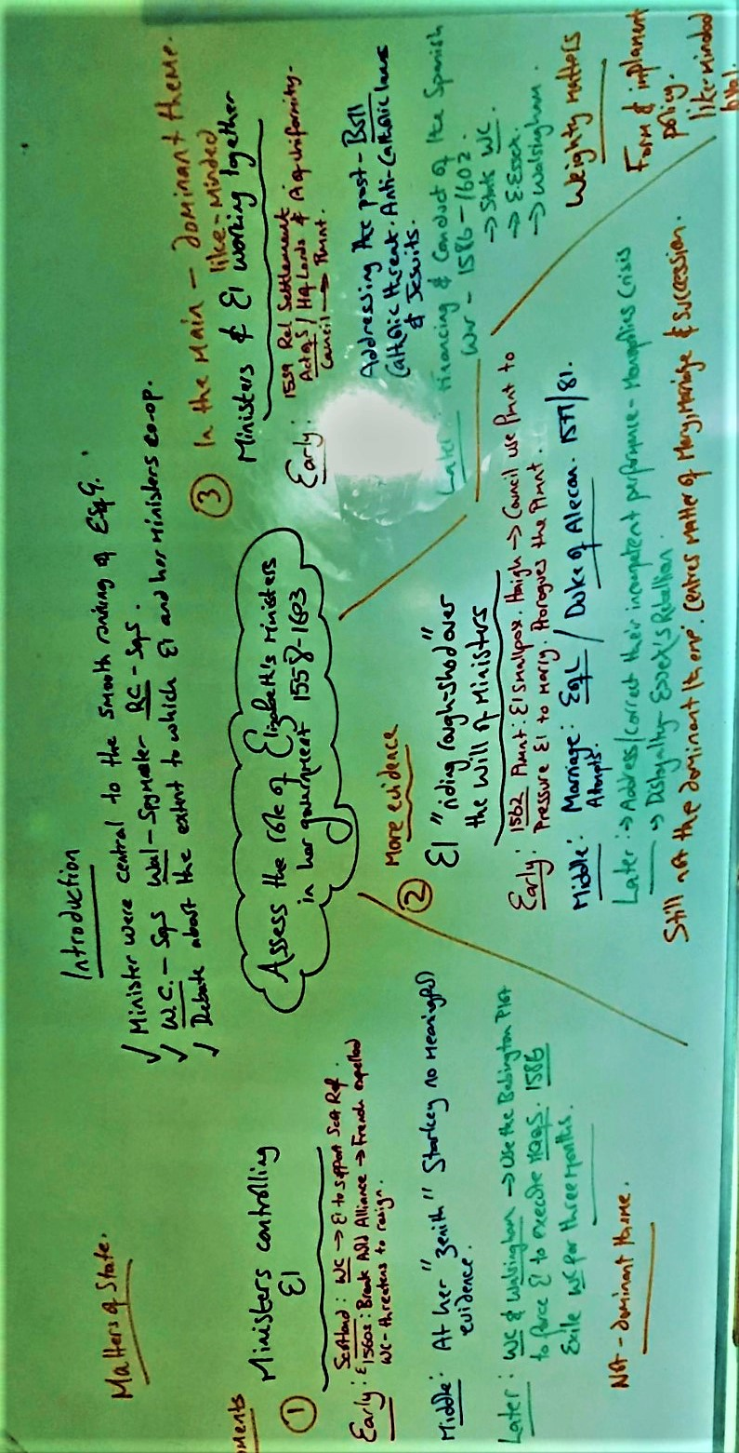
What were the roles of the House of Commons and House of Lords in the Elizabethan system of Government?
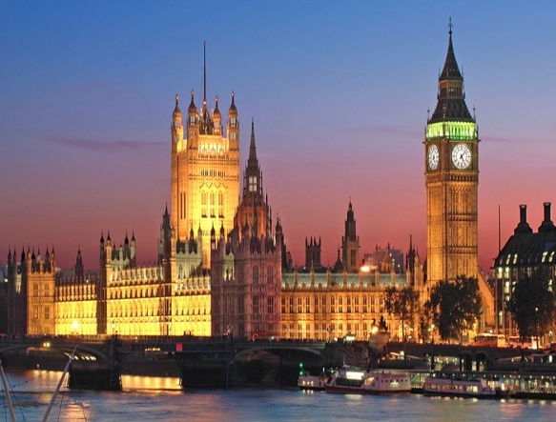
On first consideration there are obvious similarities between Parliament in 1558 and Parliament today.

- It is in the same place – Westminster (shown above left).
- It passes laws.
- There are two chambers (it is bi-cameral).
  - The House of Lords – The Upper House (unelected, housing bishops, aristocrats and lords)
  - The House of Commons (shown below left) – The Lower House (elected to represent the rest of the nation state)
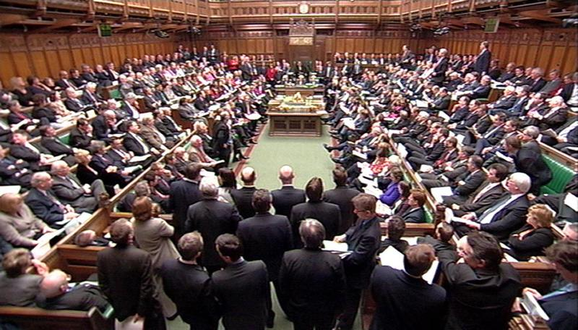
However, the differences are much more importance.

When we think of the Houses of Parliament today we think of it as the centre of our democratic system of government. The government’s legitimacy (or right to rule) comes from its ability to command a majority in the House of Commons. This in turn comes from the seats it gained at the last General Election.

This was not the case In Elizabeth’s time. Elizabeth’s government gained its legitimacy from the idea of the Divine Right of Kings (see Unit Two notes). Elizabeth took the idea of the Royal Prerogative very seriously, and thus was very concerned how Parliament had grown in power in the twenty-five years before 1558. M.Graves argues that the weak leadership of the so called “Mid Tudor Crisis” had seen Parliament take responsibility for “the highest matters of state, altered religion...encroached on property rights...and legislated on all aspects of the Commonweal” For Elizabeth, this was unacceptable. She, like her father before her, believed that Parliament should be limited to three roles;

- To grant the money her government needed when it was required (this is sometimes known as supply or subsidy).
- To pass laws the government wanted it to. To pass laws is sometimes known as to legislate; hence Parliament was the legislative body. It is worth noting here that Elizabeth could pass laws without Parliament by issuing a Royal Proclamation.
- To be a “point of contact” (G.R.Elton) between the government and the people. It could provide advice on Matters of Commonweal, and if asked, Matters of State (see later notes on Parliamentary Privileges).

For Elizabeth therefore it was the monarch, not Parliament that decided policy.

There are other important differences that we should be aware of as well at this stage;

- There was no Prime Minister or political parties as we know them.
- Although there were elections for the lower house, the MP needed the support of important people in their locality. Moreover, elections were often rigged and only men with a certain annual income could vote.
- It was up to Elizabeth when Parliament was called and when it was prorogued (closed).
- Elizabeth’s parliaments were controlled for her by her councillors. Principally by William Cecil, and then, less successfully, by his son Robert Cecil.
Year | Date | Key Issues
1559 | 25 Jan - 8 May | - 1559 Religious Settlement.  - Start of reign supplies granted.
1563-1567 | 1st - 12 Jan - 10 April 1563  2nd - 30 Sept 1566 - 2 Jan 1567 | - Pressure on Elizabeth over the succession.  - Supplies required for foreign policy v the Auld Alliance.
1571 | 2 April-29 May | - Rising fear of Catholicism after the Northern Rising and the excommunication of Elizabeth by the Pope.  - No supplies requested.
1572-1581 | 1st - 8 May - 30 June 1572  2nd - 8 Feb -15 March 1576 | - Peace time supplies requested.
1584-5 | 1st - 16 Jan - 18 Mar 1581  2nd - 23 Nov 1584 - 23 Mar 1587 | - Concerns over the Queen’s safety.  - William of Orange assassinated.  - Babington Plot v Elizabeth.
1586 -7 | 29 Oct 1586 - 23 March 1585 | - The fate of Mary, Queen of Scots.
1589 | 4 February - 29 March | - Supplies required to finance the Spanish War.
1593 | 19 Feb - 10 April | - Supplies required to finance the Spanish War.
1597-8 | 24 Oct 1597 - 9 Feb 1598 | - Supplies required to finance the Spanish War.
1601 | 17 Oct 1601- 19 Dec 1601 | - Supplies required to finance the Spanish War.  - Monopolies Crisis.
Session dates for Elizabeth’s Parliaments
This is a reference table - you do not need to know these dates
Some statistics you may like to use when you write;

- Elizabeth only called ten Parliaments (thirteen sessions) in a 45 year reign.
- This was a lot less than the twenty six sessions in the thirty years before 1558.
- An average of 3 years passed between sessions.
- There was no parliament at all in 26 years of Elizabeth’s reign.
- Elizabeth preferred short sessions that granted money.
- Only 10 percent of MPs ever spoke in debates and only 47 percent of MPs voted.
- MPs did become more educated in Elizabeth’s reign. In 1563 only 26 percent of MPs had legal training. By 1593, this figure had risen to 44 percent. This of course meant that they were more able to questions bills.
- Elizabeth’s parliaments averaged 33 acts per session. More than any other Tudor monarch.
- Out of the 34 times that Elizabeth used her Royal Veto to stop bills passing into law, only 5 were Matters of State. The others were because the legislation was poorly worded or not in the public interest.
The Historical Debate
How far did Elizabeth’s relations with parliament change?
Was co-operation or conflict the dominant theme of Elizabeth’s relationship with her parliaments?
What Is A Historical Debate?

Until this point the study of history has really been a quest to find out what happened in the past. The study of Elizabethan parliaments however is the first time that you will come across the idea of historiography – or historical debates. This is where historians look at the same topics and evidence, and draw different interpretations. This could be because of differing politics, methodology or because they are asking different questions. For example, next year you will look at differing arguments in Russian history. There is a very famous historical debate over the nature of Elizabeth’s relationship with her parliaments. Was co-operation or conflict the dominant theme? The arguments are set out below...

The Neale Thesis - Orthodoxy
Conflict is the dominant theme of Elizabeth’s relationship with her Parliaments

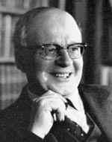
- J.E Neale produced a series of books of the topic. In 1949 he wrote “The Elizabethan House of Commons” and then in the 1950s a two-volume text entitled “Elizabeth I and her Parliaments”.
- These argued that Elizabeth’s relationship with her parliaments was dominated by conflict.
- In particular, Neale argued that Elizabeth’s reign saw the rise of an independent and increasingly university educated gentry in the House of Commons. Against them was the monarchy, supported by the House of Lords.
- The central issue for the opposition in the House of Commons was religion. They were extreme Protestants – Puritans. When they had to choose, they put their religion above their loyalty to the Queen.
- Neale argued that there was an organised group. He referred to a 1566 pamphlet that named 43 MPs. They called themselves “our choir”, and thus Neale labelled them “the Puritan Choir”. For Neale, “the men of 1566 deserve a place pre-eminent in our country’s parliamentary history”.
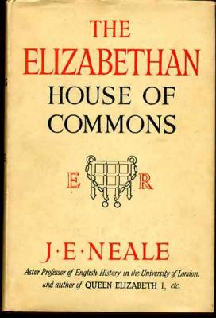
- Neale continued that this was “an opposition group in a significantly new sense: one with a positive programme...the fulfilment of its Protestant destiny”. They thus deliberately planned confrontations with Elizabeth.
- He believed that the House of Commons used its control over finances (subsidies) as weapons to try to get Elizabeth to do what it wanted. The 1566 Parliament was the best example of this. Neale argued that they “made supplies depend on the redress of grievances”.
- Neale had a tendency to look at History with hindsight. His search for trends of progress meant that he saw this conflict as the origin of English Civil War in the 1640s. As a result, Neale also focused on key individuals, such as Peter Wentworth, and compared them to leaders of the Parliamentarians in the 1640s such as John Pym.

Revisionism – led by G.R.Elton
Co-operation is the dominant theme of Elizabeth’s relationship with her Parliaments

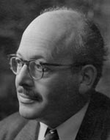

- In 1986 G.R. Elton, a former tutee of Neale, challenged his ideas in ”The Parliaments of England 1559 – 1581”. He argued that co-operation was the dominant theme of Elizabeth’s relationship with her parliaments.
- For Elton “all talk of the rise of Parliament as an institution, or worse, the rise of the House of Commons into political prominence, is balderdash”.
- Elton took this view because he focused on different questions. He accepted that there were clashes, but saw these as isolated incidents.
- Elton rejected the idea of Elizabeth’s House of Commons being the forefather of the leaders of the Parliamentarians in the 1640s.
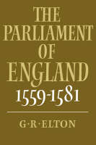
- For Elton it was more important to look at Parliament’s legislative achievements. This meant the laws it passed. He argued that Parliament loyally raised money for the Queen, passed her bills, and was particularly effective on local matters. How else could her parliaments average 33 acts per session?
- For Elton the House of Lords remained the most powerful of the two Houses of Parliament not least because of its social pre-eminence.
- Elton rejected the idea that Puritainism was a progressive political force, and even questioned the existence of the Choir itself. He pointed out that some “members” had Catholic leanings. Others were councillors! It seems today that the the 1566 pamphlet was a satire attacking the members of a parliamentary committee. It is however still unclear why it was produced.
- More recent historians like C.Haigh and M.Graves (sometimes called post-revisionsists) accept Elton’s revision. For example Graves states “the revisionists have convincingly rejected the notion that the Commons political muscle and Commons centred opposition to royal government increased”. He continues that “they have also restored to a prominent place the House of Lords”. For these post revisionists, where there was opposition in the House of Commons, it was usually created by Elizabeth’s own councillors, who were trying to use Parliament to put pressure on the Queen.

Trap to avoid
Remember our mark scheme requires you to write factor-based essays with linking and relative importance. To understand this unit, we need to know the historical debate. However, it should only be used to tie the question that you are given to the factors that you are going to write about (ie in your introduction). Do not just regurgitate this debate because it makes you sound clever. That will not be answering the question set.

The way forward
To answer this topic for our mark scheme we need to explore the factors that make up Neale’s argument (and thus Elton’s revision).
Students tend to do very well on this unit because it lends itself to the higher order analysis skills of linking and relative importance (see the overview diagram below).

Issues (factors) to consider when deciding whether co-operation or conflict was the dominant theme of Elizabeth’s relationship with her parliaments

Religion

The underpinning factor?
For Neale this linked because the Puritan Choir wanted Free Speech to speak on Matters of State...
For Neale this linked because the Puritan Choir wanted to ensure a Protestant heir to throne...

Parliamentary Privileges

(Including Free Speech)
Marriage
&
Succession (including Mary, Queen of Scots)

Monopolies

The best claim to opposition to Elizabeth – but no direct link to Religion

Evidence for conflict

This is the central plank of the Orthodox argument. Elizabeth’s reign saw the rise in the House of Commons of “the Puritan Choir”. This was “an opposition group in a significantly new sense: one with a positive programme...the fulfilment of its Protestant destiny”. This meant that it was an organised opposition which devised parliamentary strategies and coordinated its activities.

- Neale believed that the Puritan Choir forced Elizabeth into a more extreme Protestant settlement than she had intended in 1559 (they argue she wanted a settlement like her father’s).
- Neale referred to a 1566 pamphlet that named 43 MPs. They called themselves “our choir”, and thus Neale labelled them “the Puritan Choir”. They consistently forced Elizabeth to defend the Settlement after its passage.
- As such, Elizabeth’s Royal Prerogative was repeatedly challenged on the issue of religion. This meant that in 1566, 1571, 1572, 1586 and 1593 Elizabeth had to crush Protestant bills.
- In 1571 William Strickland actually proposed a reformed Prayer Book. Elizabeth excluded him from the House, but then was forced to back down and readmit him.
- In 1587 Elizabeth had to send Anthony Cope and his Presbyterian supporters to the Tower.

Religion Religion

Evidence for cooperation

- Revisionists like S.Doran argue that Elizabeth believed in Edwardian doctrinal Protestantism – ie as the daughter of Anne Boleyn she actually wanted a more Protestant Settlement than she got. She was stopped by Catholic opposition in the House of Lords. It was the Catholic Bishop Scot of Chester who said “for matters of religion, I do not think...(Parliament)...should meddle”. By contrast, Protestants in the House of Commons were “part of a government plan to restore English worship to the standard of 1552” (N.Jones).
- Elizabeth’s authority on Religion was never seriously challenged in the House of Commons. It is noteworthy that the entire so-called Puritan Choir accepted the Act of Supremacy’s assertion that Elizabeth was “the only Supreme Governor...in all things spiritual or ecclesiastical”. By contrast only one bishop in the House of Lords would agree to it. They all had to be replaced.
- N.Jones also questions the organised nature of the Puritan Choir in his 1982 book “Faith by Statute”. He points out there is no evidence that they were “a cohesive Puritan Pressure group”. M.Graves supports this, stressing that it was the Commons itself that pushed for Cope to be sent to the Tower.

The Issue of religion
Where does the weight of the evidence lie?

Best Evidence for Conflict Best Evidence for Co-operation
...............................................................................................................................................................................................................................................................................................................................................................................................................................................................................................................................................................................................................................................................................................................................
......................................................................................................................................................................................................................................................................................................................................................................................................................................................................................................................................................................................................................................................

Now label the see saw and explain your choice in the box below

...................................................................................................................................................................................................................................................................................................................................................................................................................................................................................................................................................................................................................................................................................................................................................................................................................................................................................................................................................................................................................................................................................................................................................................................................

For Orthodox historians like J.E.Neale the intertwined issues of the Marriage, Succession and the fate of Mary, Queen of Scots came second only to the 1559 Religious Settlement in importance. In fact it came from the desire to secure Protestant England beyond Elizabeth’s reign. Matters came to the fore in the second parliament (1563 – 1567). Elizabeth had almost died of Smallpox in 1562, and had she done so, then her Catholic cousin, Mary Guise (Queen of Scots) would have been the heir to the throne.

- Neale argued that an organised campaign, led by the university educated Peter Wentworth pressured the Queen to marry to secure a Protestant heir to the throne. For Neale they “employed such arts of opposition and displayed so resolute a spirit that no House of Commons before their time could furnish the like”.
- They did this by linking their concerns to Elizabeth’s need for money. As Neale put it, “there can be little doubt that making supplies depend on the redress of grievances was the deliberate and concerted policy”.
- Elizabeth was forced to promise that she would “marry as soon as I can conveniently” She is also meant to have privately added that it was a strange thing “that the foot should direct the head in such a weighty matter”.
- The House of Commons would not be intimidated however, and continued to push for a direct answer. This forced Elizabeth to issue an express commandment to the House of Commons to stop discussing the topic. This in turn provoked Wentworth’s defence of liberty speech. Elizabeth was so angry that she prorogued the parliament “to be rid of an intolerable House of Commons.”
- For Orthodox historians the issue was not confined to the second parliament. As Elizabeth passed child bearing age it evolved into pressure to execute Mary and name a Protestant successor.
Marriage and Succession

Revisionists would certainly acknowledge that “the succession was an issue which agitated members throughout the reign” (Sloan). However, as always, context is very important.

- Elizabeth was forced to remind the Commons that she was their “anointed Queen...(who)...will never be by violence constrained to do anything”. However this was the point. Elizabeth never married and never named a successor. Moreover it was Elizabeth herself who twice asked Parliament (in 1572 and 1586) to discuss the fate of Mary Guise so it could take the blame. The campaign for her execution was led by two councillors, Croft and Knolly.
- The desire for Elizabeth to marry was not confined to the will of any Puritan Choir. Rather, it was widespread in a nation that craved political and religious stability. Recent work by C.Haigh has shown that Councillors used the Commons to pressure the Queen on the matter. In other words, the Commons was used again. Indeed it was Cecil himself who led the delegation to the Queen and worded their request to name her successor.
- Finally Alsop argues that “the connection between supply and succession was not as substantial as Sir John Neale suggests”. In other words the Commons did not use its financial muscle to blackmail Elizabeth. The Queen was never denied supply, and it was her choice to accept a reduced sum (of extra taxation) in 1566.

The Issues of Marriage, Succession and the fate of Mary
Where does the weight of the evidence lie ?

Best Evidence for Conflict Best Evidence for Co-operation
....................................................................................................................................................................................................................................................................................................................................................................................................................................................................................................................................................................................................................................................................................................................................................................
......................................................................................................................................................................................................................................................................................................................................................................................................................................................................................................................................................................................................................................................

Now label the see saw and explain your choice in the box below

...................................................................................................................................................................................................................................................................................................................................................................................................................................................................................................................................................................................................................................................................................................................................................................................................................................................................................................................................................................................................................................................................................................................................................................................................

Parliamentary Privileges

For Orthodox thinkers, Elizabeth’s reign saw the rise of a wealthier, more educated and thus independent House of Commons. This was what R.H. Tawney called “The Rise of the Gentry”. This led to the Elizabethan House of Commons becoming increasingly aware of their parliamentary privileges. This meant the rights that they enjoyed because they were MPs. These included freedom from arrest and libel. However, the most controversial was the freedom of speech (remember the distinction that Elizabeth made between Matters of State and Matters of Commonweal – see page 10). Did the Puritan Choir want freedom of Speech to push their religious views? For Neale the answer was yes, and moreover this was the beginning of a conflict with the Crown which would end in the Civil War in the 1640s.

- For Neale, men like the Wentworth brothers, inspired by the earlier writings of Thomas More, pushed for freedom of speech. In 1576 Peter Wentworth famously argued that “there is nothing so necessary for the preservation of the prince and state as free speech and without, it is a scorn and mockery to call it a Parliament House, for in truth it is none but a very school of flattery and dissimulation”.
- Wentworth was sent to the Tower for four weeks.
- Neale argued that whilst Elizabeth was “justified constitutionally” in the distinctions she made (page 10 again) “constitutional niceties make little effect in passionate revolutionary times”.

For Revisionists, the idea of an organised and self-aware opposition is not justified. Rather,
- A.G.R.Smith argues that Peter Wentworth was “ a maverick” whose “views on free speech were well ahead of their time”. M.Graves goes further, describing him as “little more than a parliamentary nuisance”.
- The link to the origins of the English Civil War is thus both overstated and unhelpful.
- Indeed, the key evidence here is that it was his fellow MPs who expelled him from the Commons and imprisoned in the Tower for four weeks. In other words, Wentworth’s demands for freedom of speech were certainly not representative of his peers.

The Difference between Matters of State and Matters of Commonweal
Matters of State

For Elizabeth discussion on Matters of State could only happen in Parliament if the Monarch requested it.

The list below is some of the more significant Matters of State.

- Religion
- Marriage
- Succession
- Foreign Policy
- Monopolies
- Purveyance

Only twice, 1572 and 1586 was Parliament asked to discuss a Matter of State. Both times it was the issue of Mary, Queen of Scots

Matters of Commonweal

These were topics that Parliament could initiate discussion on without asking Elizabeth.

The list below is some of the more significant Matters of Commonweal.

- Local Matters
- Private Bills
- National Social Matters
- National Economic Matters

These final two topics sometimes overlapped. – EG the 1597 and 1601 Poor Laws. These were seen as very important matters, so even here Royal assent would still be required.

The Issue of Parliamentary Privileges
Where does the weight of the evidence lie ?

Best Evidence for Conflict Best Evidence for Cooperation
..................................................................................................................................................................................................................................................................................................................................................................................................................................................................................................................................................................................................................................................................................................................................................
......................................................................................................................................................................................................................................................................................................................................................................................................................................................................................................................................................................................................................................................

Now label the see saw and explain your choice in the box below

...................................................................................................................................................................................................................................................................................................................................................................................................................................................................................................................................................................................................................................................................................................................................................................................................................................................................................................................................................................................................................................................................................................................................................................................................

Finances and Monopolies
The Tudor system of government said that in the monarch’s first parliament they should be granted a subsidy round. Thereafter, in ordinary times the government should be financed by customs revenues and rents from the Crown’s own land rentals. Extra subsidies could only be requested in extra-ordinary times (such as war). Reference to the table on page 3 shows that this convention was pushed to its limit by Elizabeth.
- Neale argued that in 1566, 1571, 1585, 1587 and 1601 Parliament linked Elizabeth’s need for extra subsidies to their own political agenda.
- In 1587 for example, the Commons offered Elizabeth extra funds in return for taking sovereignty of the Low Countries (and thus tying England to supporting the Protestant rebels against Spain).
- At times the Commons had to fight bitterly (in 1589 and 1593 for example) to defend its sole right to initiate votes of money. In 1593, William Cecil had to use the more placid House of Lords to launch an additional subsidy request. On seeing the bill the usually loyal Sir Francis Bacon famously replied that “gentlemen must sell their plate and famers their brass pots ere this will be paid”.
- The biggest crisis came in 1601, when Elizabeth and Robert Cecil lost control of Parliament. The unpopularity of Robert Cecil and the ongoing war with Spain were problems. However, the real cause was Elizabeth’s continued use of monopolies as a free form of patronage. Monopolies were a “royal patent for the sole right of exporting, importing, manufacturing, or distributing some particular article” (S. Atkins) – Elizabeth rewarded men for loyal service with them Thus Raleigh had a monopoly on tavern licences, and the Earl of Essex had a monopoly on the import of sweet wines. Monopolies were often abused, and were hated.
- In the 1601 Parliament a list of the monopolies created since 1597 was read out, and caused one MP, William Hakewill, to interrupt, "Is not bread there?" and to then add, "If order be not taken for these, bread will be there before the next Parliament." Another MP dubbed the monopolists the "bloodsuckers of the commonwealth." Robert Cecil dammed the behaviour as “more fit for a grammar school than a parliament house”.
- Elizabeth finally gave in, and had to address Parliament personally, giving her famous Golden Speech. She then cancelled 12 monopolies overnight, halted others in the works, and made monopolists answerable to the common law courts. She had clearly been forced to back down on a Matter of State.

Revisionists would agree that the 1601 Monopolies Crisis was an example of conflict between Elizabeth and the Commons – indeed it is for them the best example of conflict in the 45-year reign. However,
- It is important to note that the Commons never withheld funds from Elizabeth.
- Indeed, Elizabeth became the first monarch in English history to be awarded multiple subsidies. In 1589 and 1593 Elizabeth was offered double subsidy rounds. In 1597 she was awarded a triple subsidy round, and in 1601, after the Monopolies Crisis and the Golden Speech Elizabeth was awarded a quadruple subsidy. These were hardly the actions of a self confident and independent House of Commons.
- Revisionists would also argue that the Commons offer of funds in return for taking sovereignty of the Low Countries was for extra funds. It never threatened to withhold monies – an important distinction.
- Perhaps most importantly of all, the conflict over monopolies was real, but it was not part of the rise of the Puritan Choir. Rather, it was motivated by frustration and self-interest after more than a decade of fighting Spain.

The Issue of Finances and Monopolies
Where does the weight of the evidence lie ?

Best Evidence for Conflict Best Evidence for Cooperation
........................................................................................................................................................................................................................................................................................................................................................................................................................................................................................................................................................................................................................................................................................................
...............................................................................................................................................................................................................................................................................................................................................................................................................................................................................................................................................................................................................................................................................................................................

Now label the see saw and explain your choice in the box below

...................................................................................................................................................................................................................................................................................................................................................................................................................................................................................................................................................................................................................................................................................................................................................................................................................................................................................................................................................................................................................................................................................................................................................................................................

What tactics did Elizabeth use to help her control Parliament?
You should also be aware of the tactics that Elizabeth used to control Parliament

Further Reading

There are copies of these book (and lots of others on Elizabeth) in the school library

The Tudor Years – Ed R Sloan
Chapter XI – Elizabeth and Parliament – R Sloan

The Emergence of A Nation State –AGR Smith
Chapter XV – Elizabeth and her Parliaments

The Reign of Elizabeth I – SJ Lee
Chapter 2 – Elizabeth and Parliament

Elizabeth I – Profiles In Power – C Haigh
Chapter VI – The Queen and the Parliament

Or online you could click onto the following sites

Some excellent articles on History Today

http://www.historytoday.com/re-foster/conflicts-and-loyalties-parliaments-elizabeth-i

https://www.historytoday.com/archive/faction-reign-elizabeth-i

Something a bit higher from Tudors.org

http://www.tudors.org/asa2-level/52-parliament-and-prerogative-in-the-reign-of-elizabeth.html

Please find below useful assessment materials

- Marking task
- Past questions
- Examiner Guidance
- Exam Reports (where they exist)
- Similar questions from the old examination

Marking Task

Below is an answer to the 2016 AS question
How effective was Parliament’s opposition to Elizabeth I?

Before it is the examiner’s marking guide and code sheet. Afterwards is the examiner report. The generic mark scheme can be found below.

- What mark would you give this answer?
- Why / what went well?
- How could it be improved?

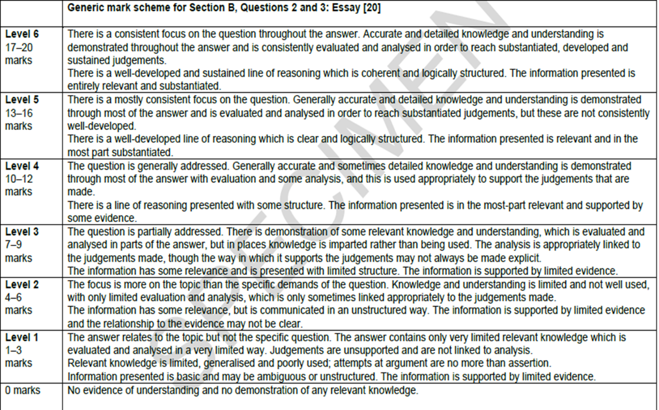
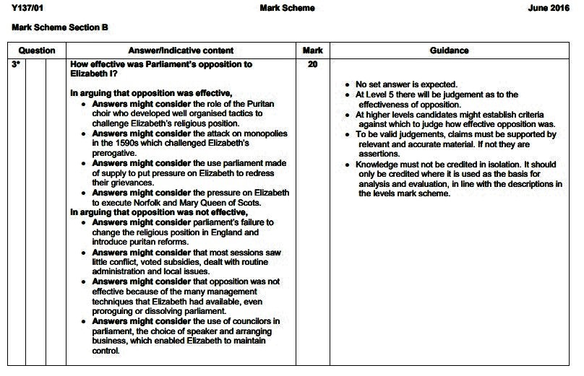
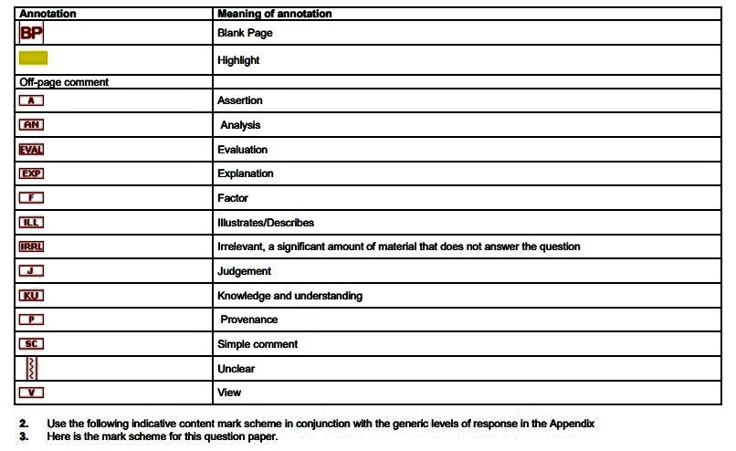
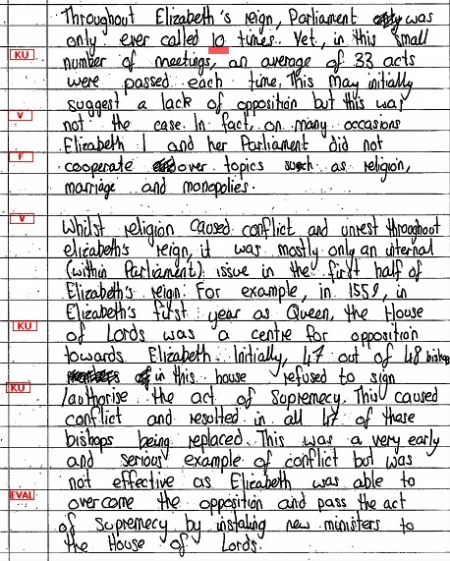

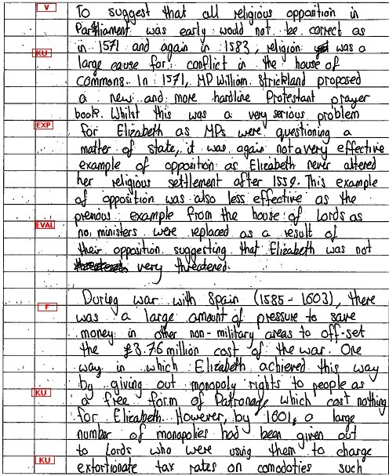

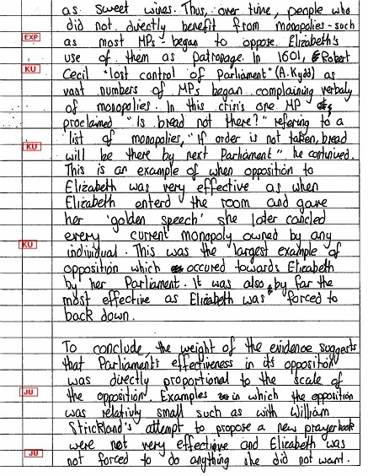
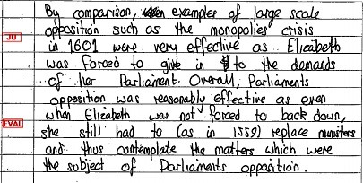
A significant number of candidates failed to establish what “effective opposition” might mean. Too often any disagreement or minor friction between Elizabeth and her Parliaments was regarded as effective. Most candidates had decent knowledge of the topic but many found it difficult to home in on many specific instances or events. This meant generalised understanding only.
Again, only a minority produced nuanced answers which examined factors in some detail before coming to a supported judgement. In terms of effective opposition most dealt sensibly with Elizabeth’s later Parliaments especially on the problem of monopolies. Surprisingly few candidates were able to consider the role of the Puritan choir, or Parliament’s use of supply to pressurise Elizabeth into redressing their grievances. There was a tendency to include names such as Wentworth, Strickland and Cope but without any real understanding of the relevant context. A common error was to regard Elizabeth’s Council as part of Parliament.

Examiner Report

- Level and mark:-

- Reason –

- What the candidate did well –

- From here-

Specimen Question

How far do you agree that Parliament mostly co-operated with
Elizabeth I? Explain your answer.
Specimen Paper – Examiner Guidance

How Far ?...means that candidates should consider the stated factor of
co-operation but also examine alternative explanations. They may, or
may not, agree with the prior importance of the claim in the question.
This will affect the balance of the question but Band 3 will normally
require an adequate paragraph on the stated factor. It will probably not
be advisable to take a chronological approach but answers that do so
should not be underestimated and consigned automatically to a lower
band. A potentially better and perhaps more manageable approach
might be to look at examples of co-operation and disputes and weigh
which were more important. Many candidates might find it easier to challenge the claim in the question. It is easy to support their viewpoint by
referring to the making of the religious settlement, pressures on Elizabeth
I to marry and to execute Mary, Queen of Scots, disputes over Puritan
demands and Parliamentary freedoms, and the unpopularity of
monopolies. On the other hand, most members of both Houses were
loyal to the Queen and deferred to her monarchy. Disputes were often
with a minority. (Some would claim that heated debates were sometimes
the result of councillors wanting to pressurise the Queen rather than
spontaneous examples of opposition.) Peter Wentworth was arrested by
order of the Commons and he always protested his personal loyalty to the
Queen. The crown had the means of encouraging obedience, for
example in the appointment of the Speaker and by the leading presence
of ministers. Elizabeth was usually able to defuse trouble by concessions,
as well as by more forceful vetoes.

January 2009 - “Co-operation rather than conflict.”
Assess this view of Elizabeth’s relationship with her parliaments.

January 2009 Paper – Examiner Guidance

No set answer is looked for but candidates will need to address the question.

Historiography is not a requirement of AS and references to the views of historians are not necessary for any mark, although credit will be given for relevant references. There are a number of areas that candidates might consider when discussing the view that conflict was more pronounced, these are likely to include the issues of parliamentary privilege, religion, especially the religious settlement and the activities of the Puritans, the problem of Mary Queen of Scots, marriage and succession, foreign policy at certain times and financial aspects, such as monopolies. Parliament was a sounding board and allowed the monarch to discover the views of the political elite and for them to take back the laws that they had to impose. However, this might be balanced by the argument that as MPs became better educated they were increasingly able and willing to challenge the control exercised on parliament through Privy Councillors and the Speaker. This may be supported by the argument that parliament was growing in assertiveness and that were anti-government views in the Commons, particularly from the puritan members. There might be discussion of the so-called Puritan choir and their impact and importance. Some may argue that they did not exist, there was no party and few were puritans pushing their religious views, but others may argue they were an active and well-organised lobby that created problems for Elizabeth. Some answers might consider the role of the House of Lords, which helped the queen in the 1590s over subsidies. The presence of Cecil in the Lords from 1572 may also have helped to ensure that there was co-operation. At the highest levels some answers might show that parliament spent longer discussing local issues and those bills were often assed with few problems. Some answers may place parliament in the wider context of the government of England that it was a only a secondary instrument in the governance of the nation, which could be ignored by the court or council or that it was still an irregular part of government.

January 2009 Paper – Examiner’s Report

No report – insufficient candidates

June 2009 Question - How successful were Elizabeth I and her ministers in managing parliament?
June 2009 Paper – Examiner Guidance

No set answer is looked for but candidates will need to address the question.

Candidates may argue that relations with parliament were usually good; however, there were disputes over marriage and the succession, but this was when parliamentary opinion was closer to that of the Privy Council than the Privy Council was to the Queen. These harmonious relations were reinforced by good parliamentary managers such as Mildmay and Norton. Most MPs knew that there were certain boundaries which they could not cross by expressing their opinions. It could be argued that such limitations on the manner of debate caused far less trouble than the Queen’s use of prerogative to prevent debate on issues she considered too sensitive. This point of view might lead some to conclude that parliament was a subordinate body, but this might be balanced by the view that parliament had evolved and grown in political importance and was able to seize the political initiative at the expense of a tired and increasingly incompetent government – to sustain this view answers might focus on the 1590s.

Some candidates might draw attention to the times there were conflicts, such as the succession and the execution of Mary Queen of Scots, however this could be balanced by noting that most legislation was local and passed with little debate. It is possible that some answers will consider the methods used to manage parliament, such as starting debate in the Lords, where after Cecil’s appointment, there was a minister to lead debate.

Answers might argue that MPs were becoming more educated and therefore were increasingly able and willing to challenge the control exercised on parliament through Privy Councillors and the Speaker. In addition, they might argue that there were a growing number of Puritans in parliament who used it to try and bring about changes to the religious settlement. It should be remembered that Elizabeth still had the power to summon, prorogue and dissolve parliament when she wanted and that her ability as a speaker, as with the Golden Speech of 1601 was sufficient to win support. Most parliamentary business was completed without fuss, but at other times there were crises, but they were usually worked through without too much trouble.

June 2009 Paper – Examiner Report

This was not a particularly popular question but a wide range of levels was seen. At the lower end candidates tended to either describe the methods used by Elizabeth to manage parliament or become embroiled in a description of the historiography surrounding Elizabeth and her parliaments, which frequently resulted in detailed descriptions of Neale and the Puritan choir. There were also some candidates who were confused between the terms Parliament, Government and Council.

However, at the top level, candidates were able to discuss the issues and many argued that Elizabeth was able to obtain supply, was successful in calming parliament over issues such as Monopolies and discussed her use of the royal prerogative and whether this suggested she was successful in managing Parliament. There were some answers which also considered the scale of the legislation that was passed and used this to argue that her management must have been successful.

Old Paper questions on Parliament

January 2012
How far was Parliament able to increase its role and influence during the reign of Elizabeth I?
January 2012 Paper – Examiner Guidance

At the higher levels candidates will need to address the issue of ‘how far’ and not simply list examples of where parliament did or did not increase its role and influence. Examiners should also note that historiography is not a requirement at AS, however where it is used to support an argument it should be credited, but candidates who do not mention the Neale/Elton debate should not be penalised. Examiners should also be careful not to over-reward candidates who simply describe the debate.

At the higher levels candidates might make a distinction between the Lords and Commons. Candidates might note that despite the more regular calling of parliament and their apparently increasing role, Elizabeth decided when to summon, prorogue and dissolve parliament and this in itself was a limiting factor. Candidates may make reference to a variety of issues, particularly religion, succession, freedom of speech and monopolies in considering whether parliament increased its role and influence. Some might argue that in nearly all instances it was the queen’s will that triumphed and suggest that this shows no increase in their role and influence. This might be taken further by candidates who argue that in sending Wentworth to the Tower parliament was disciplining itself, aware of Elizabeth’s reaction. Attempts to gain freedom of speech or attack Elizabeth’s prerogative ended in failure. Discussion of the succession and marriage was always curtailed and Elizabeth remained in control.

Some might argue that the latter period saw parliament increase its role in the Monopolies debate, but this can be balanced by the Golden Speech, showing how Elizabeth was able to regain the initiative, even in her later years. Parliament was unable to link supply to the redress of grievances, again suggesting a lack of influence. However, it might be argued that they did increase their influence as a sounding board for government policies and their involvement in a wide range of new social measures in the later part of the period suggests a new role. Some might also suggest that most of their time was spent dealing with local issues suggesting a lack of influence or that many of the debates were stage managed by Privy Councillors to try to get their way, again suggesting a lack of influence.

January 2012 Paper – Examiner Report

Questions on Elizabethan government have often produced weak answers, but this session saw many solid responses and some excellent answers. Most candidates avoided simply describing the historical debate and those who referred to historians were often able to use them to support their argument. It was encouraging to see that many candidates were aware that Parliament included the House of Lords as well as the House of Commons. The better answers focused on role and influence and considered a range of issues, however there were still a significant number who ignored Elizabeth’s right to prorogue or dissolve the house and therefore limit its role and influence. Many candidates displayed a very thorough knowledge of issues such as Monopolies, the execution of Mary Queen of Scots and the question of marriage and the succession. These events were often used to help construct an analytical answer, with many suggesting that its role and influence did not increase as it was summoned only when Elizabeth needed supplies and that she was usually able to get her way through a number of management techniques.

Question from a previous examination

Exam Season | Question
Jan 02 | Should co-operation or conflict be seen as the dominant theme of Elizabeth’s relationship with parliaments ?
Jan 03 | How convincing is the claim that Parliament became more powerful in Elizabeth’s reign ?
Jan 04 | Assess the claim that parliamentary privilege was the most important cause of problems between Elizabeth I and Parliament.
Jan 05 | Which was more important in Elizabeth’s reign, the House of Commons or the House of Lords ? Explain your answer.
June 06 | How far do you agree that Parliament mostly co-operated with Elizabeth I ?
June 07 | How far do you agree that parliamentary privilege was the most important cause of disputes between Elizabeth and parliament during her reign ?
June 08 | How far did Elizabeth control the House of Commons throughout her reign ?

Types of Questions

These are all really factor based essays.
- 02 and 03 are straight questions on the debate, asking you to look at whether the factors (Religion / Marriage and Succession / Parliamentary Privilege / Finance) support the idea of conflict or co-operation.
- 04 is a version of this, asking you to look at the same factors, but naming one as most important (parliamentary privilege).
- 05 looks horrible, but really it is asking you about the same stuff. If the Commons became more important, then conflict is the dominant theme. Hence it is a trip through the factors.

Now attempt to complete the questions planning exercises.
You might like to reflect how different your answers are

TITLE:

“Co-operation rather than conflict.”
Assess this view of Elizabeth’s relationship with her parliaments.

Key Words and Phrase:

Key issues to be discussed:

Linking and Relative Importance:

Line of Argument
 | Argument | Evidence deployed

Introduction

Tie the question to the factors

1

2

3

4

Conclusion

Direct answer to the question

Student

Concerns

TITLE:
Assess the claim that parliamentary privilege was the most important cause of problems between Elizabeth I and Parliament.

Key Words and Phrase:

Key issues to be discussed:

Linking and Relative Importance:

Line of Argument
 | Argument | Evidence deployed

Introduction

Tie the question to the factors

1

2

3

4

Conclusion

Direct answer to the question

Student

Concerns

TITLE:
How successful were Elizabeth I and her ministers in managing parliament ?

Key Words and Phrase:

Key issues to be discussed:

Linking and Relative Importance:

Line of Argument
 | Argument | Evidence deployed

Introduction

Tie the question to the factors

1

2

3

4

Conclusion

Direct answer to the question

Student

Concerns

