Section D
Elizabeth and religion

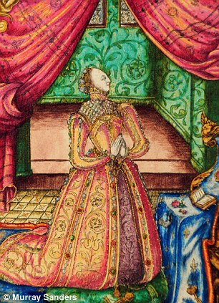

What were Elizabeth’s religious beliefs?

There is disagreement amongst historians about the nature and strength of Elizabeth I’s religious beliefs.

The traditional view is that Elizabeth was not really very religious. Typically, in 1874, JR Green argued that Elizabeth had “the same intellectual contempt for the superstition of Rome as for the bigotry of the Protestant”, whilst soon afterwards AF Pollard refined this to suggest that the Queen was in fact “indifferent in religion”. Evidence for the view that Elizabeth, in a God-fearing age, was in fact agnostic or even atheistic seems slim, and is in part based on Elizabeth’s famous declaration that she “did not want to make windows into the souls of men.”

Today there is a consensus behind S Doran’s argument that Elizabeth was in fact “a committed and conventionally pious Protestant” who got the religious settlement, based on Edwardian doctrines that she wanted. We should remember;

In her youth ~

- Elizabeth was the daughter of Anne Boleyn – the Boleyns were early and committed Protestants. Indeed, Elizabeth herself was the embodiment of the Break with Rome.
- Elizabeth had grown up in the evangelical households of Sir Anthony Denny and Katherine Parr.
- As a teenager she translated Protestant texts such as Erasmus’s “Dialogus Fidei”
- In Edward VI’s reign she was noted for her “Godly (Protestant) zeal”

As Queen ~
- Her first Privy Council was dominated by Protestants.
- “Even before her first Parliament the proclamations of 27th and 28th December ordered the use of the Epistles, gospels, Lord’s Prayer, Creed and Litany in English” (S.Doran)
- By the end of 1558 exiled Protestants, such as Dr William Ball, were invited to return from exile.
- On Christmas Day 1558 Elizabeth walked out of Church rather than witness Bishop Oglethorpe elevate the host (this was part of the Catholic belief in transubstantiation). There was no elevation of the host at Elizabeth’s coronation.

Thus, today historians reject Green and Pollard’s view that Elizabeth was no interested in religion. Historians do however continue to debate the extent of her Protestantism.

- In the 1950s JE Neale argued that she wanted only to restore Henry’s Church Settlement (Catholicism without the Pope).
- William P Havgaard suggests that she wanted to reinstate to Edward VI’s more moderate 1549 1st Prayer Book.
- Whilst more recently, N Jones suggests that Elizabeth wanted to go as far as the radical 1552 Prayer Book.

There are however further complications which make it hard for us to be certain what Elizabeth’s religious beliefs were.

- Elizabeth’s personal tastes were often at odds with the Protestant Church that she seemed to want. For example;

- She disliked married clergy.
- She loved elaborate church music
- She refused to believe that religious images were idolatrous.

- Moreover, given the political realities of the map on page 21, Elizabeth would also need to have considered the political ramifications of the religious settlement that she produced. Hence, today historians such as M Saxon still suggest that whilst “she demanded obedience and outward observance…private devotion was the core of her approach.”. If correct, then this is not so very far away from Pollard’s argument for indifference at the start of the Twentieth Century.

Securing tasks

- Colour code pages 98 and 99.
- Green – evidence that Elizabeth held no strong religious views.
- Yellow – evidence that Elizabeth held “distinctly Protestant views.” (SJ Lee)

- Write a paragraph to explain why most historians today believe that Elizabeth was a committed Protestant. Try to reference historians and use empirical evidence to develop your argument. How far do you agree with this view?

Did Elizabeth get the religious settlement that she wanted in 1559, or was it a
“via media” (a “middle way” or compromise)?

The debate about Elizabeth’s religious beliefs informs the question of how content Elizabeth was with the settlement of 1559. Thus, when in the 1950s JE Neale developed his “Puritan Choir” thesis, he depicted Elizabeth as a religious moderate who wanted only to restore Henrician Catholicism, but was forced into a more extreme Protestant settlement by the actions of her House of Commons. More recently, historians have challenged this. N Jones (in “Faith by Statute”) describes a religious battle in 1559 between a Catholic House of Lords on one side and a Protestant alliance of Elizabeth, her Council, and a “pliant” House of Commons on the other.

Perhaps we will never be certain, as S Doran correctly argues “there is no clear answer to the dispute since so many records relating to the formulation of the 1559 Church Settlement have not survived, and Elizabeth own statements about religious preferences were so ambiguous”. However, there does seem to be much in the idea that “the Settlement was a delicate balance of a variety of forces” (WL Sheils) which took “into account the diplomatic and political situation” (D MacCulloch) – refer again to the map and diagrams on page 21).

The 1559 Religious Settlement drawn up by the administration in 1559 and consisted of three bills which still form the foundation of the Church of England today. The Act of Supremacy (drafted by William Cecil) was designed to cut the connection with Rome that Mary had restored. There were then two acts of uniformity, aimed at restoring the worship to the 1552 pure Protestant standard. However, these bills did not initially pass through the Catholic dominated House of Lords. As D MacCulloch suggests, “they (the Marian bishops) combined to wreck the government’s first attempt to pass the Settlement in February 1559, and refused even to repeal the Marian laws against heresy”. In the end, only after the Marian bishops were forced to resign, removed or arrested did the Religious Settlement pass (in Easter 1559). This legislative settlement was then followed by an administrative one (the Injunctions).
Investigation task

- The following pages explore the terms of the 1559 Religious Settlement. Colour code the pages 107 - 111 below (from N Fellows, B Mervyn, F McCall and my top up comments). For each colour pick out the three best pieces of evidence. Write two paragraphs to explain your choices.

- Green – evidence that the religious settlement was a moderate and political compromise which offered reassurance to Catholics at home and abroad.
- Yellow – evidence that Elizabeth got the Protestant settlement that she wanted.

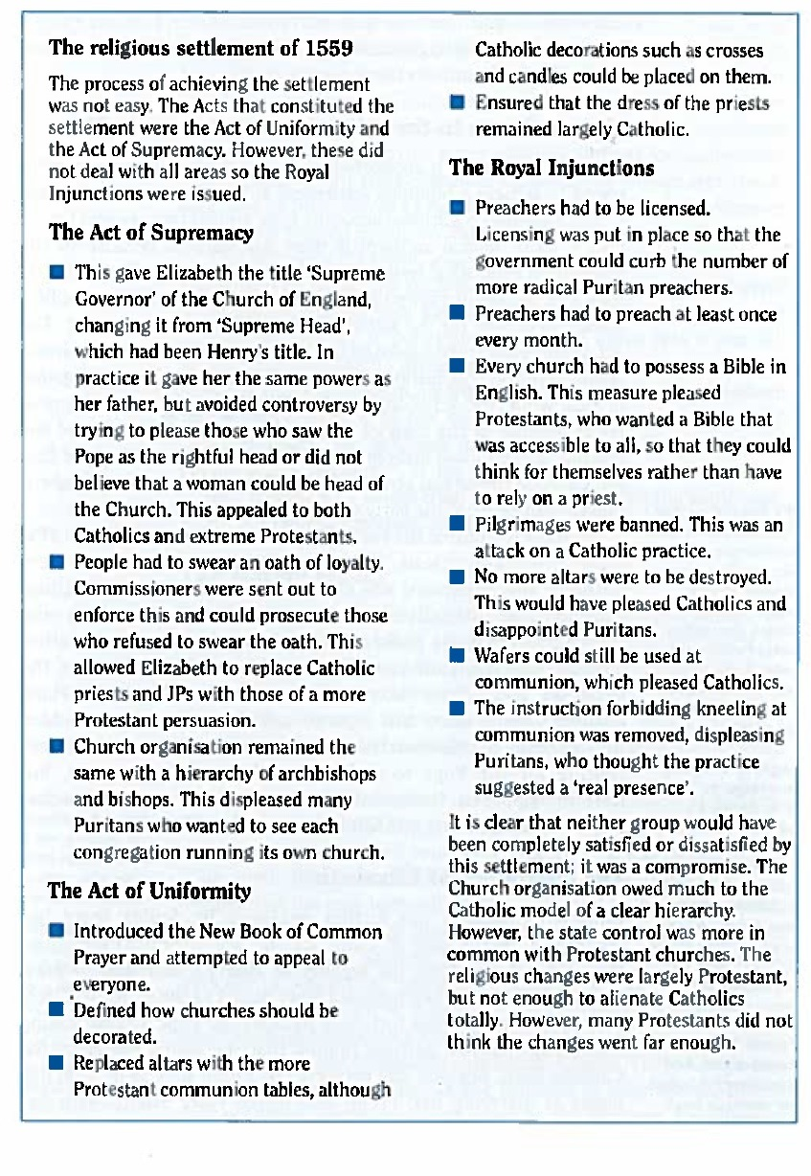
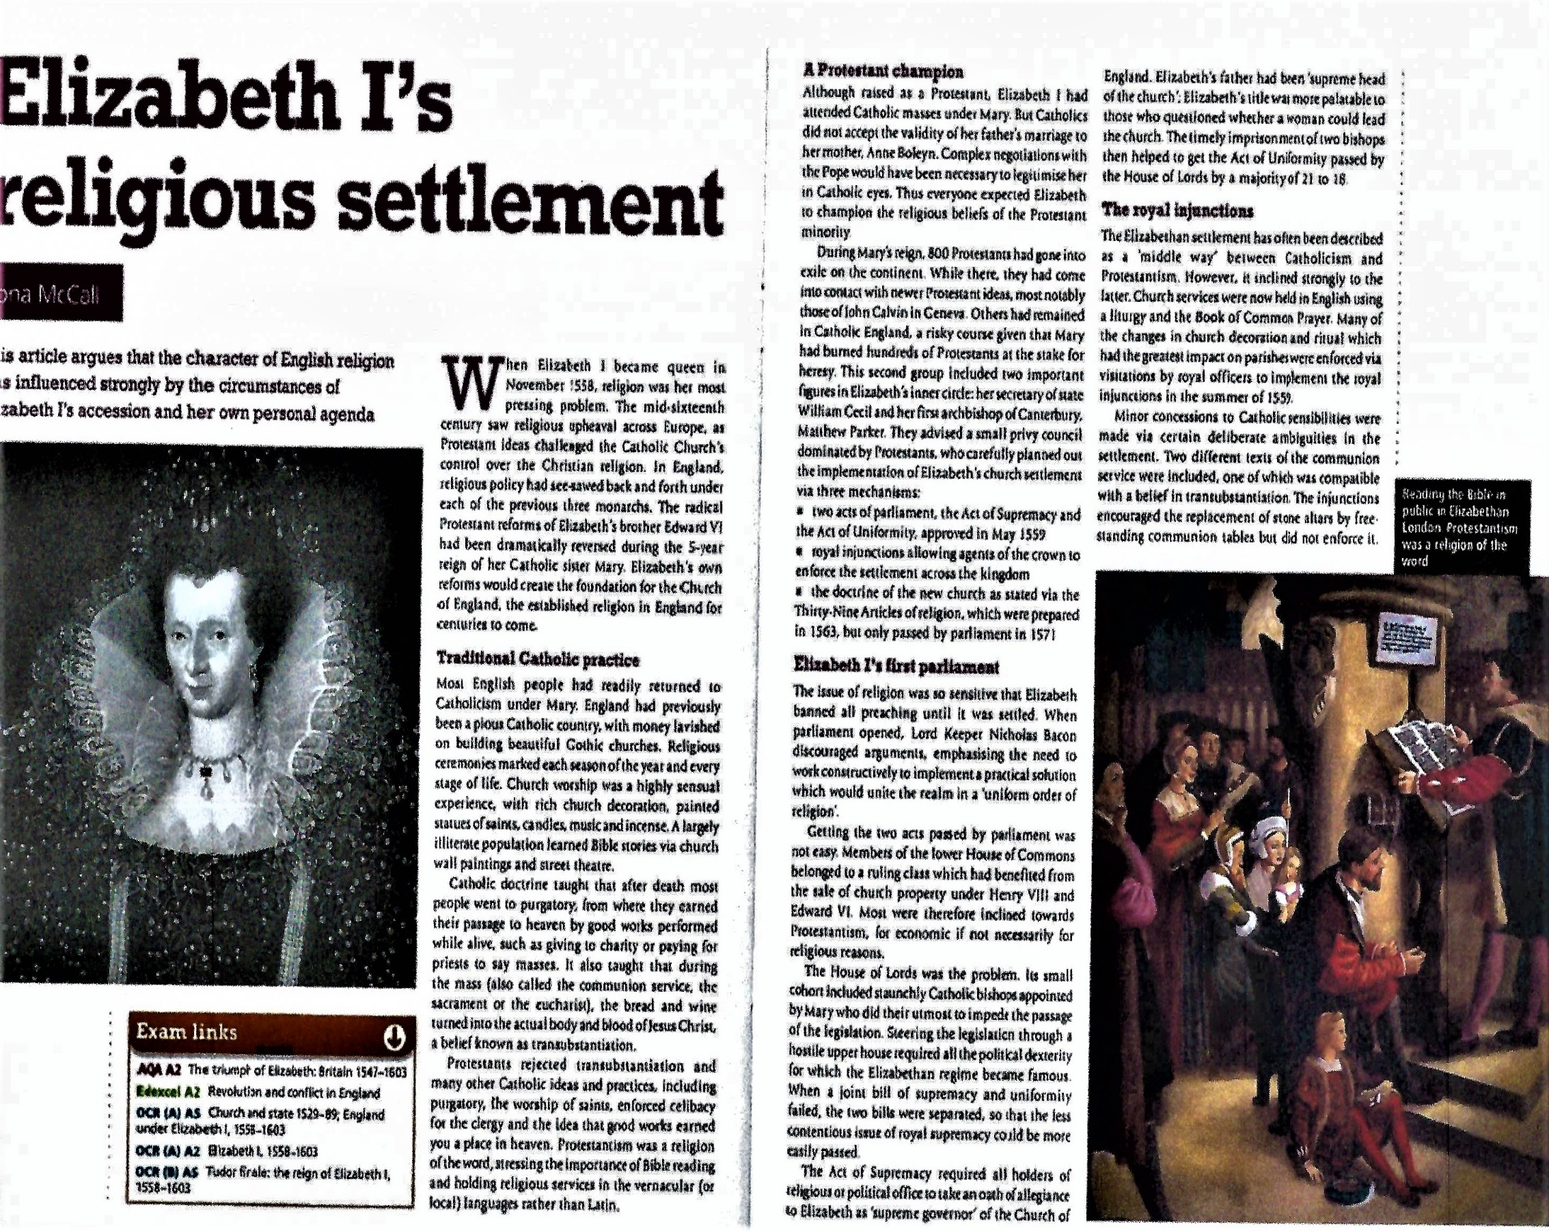
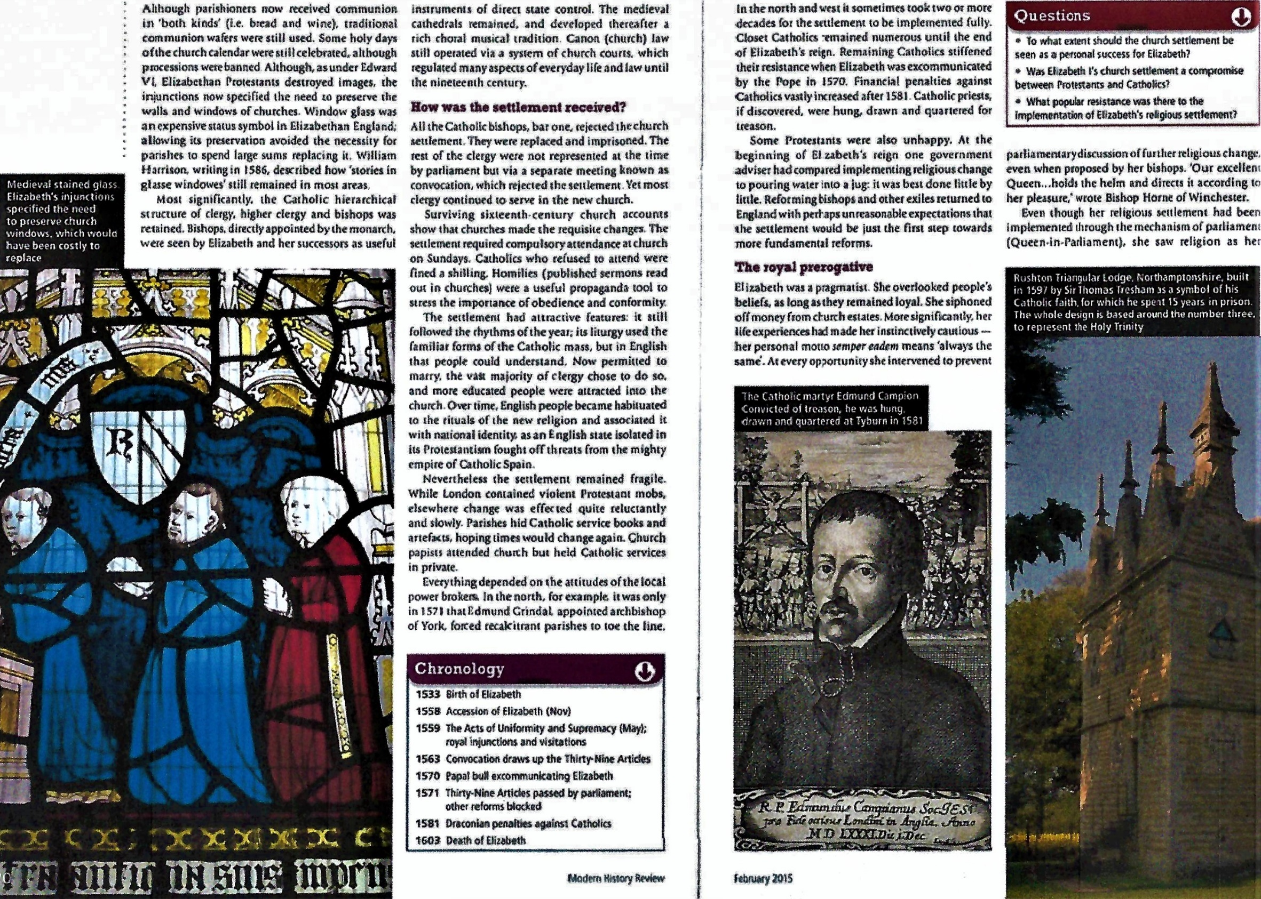
Supporting analysis
R Rex argues that Elizabeth’s personal beliefs can be seen throughout the Settlement. For him, it was “a strange and curious settlement - a Protestant doctrine in a Catholic Church…a stop-gap that left fundamental questions unanswered”. The Settlement was thus very personal to Elizabeth. This can be seen in its approach to the following issues.
• Music
• Candles
• Vestments
• Processions
To conclude the key point in the Act of Supremacy was the Queen taking the title of Supreme Governor rather than Supreme Head of the Church of England. This was WL Sheils’ “balance of forces” in action. Whilst this “made no difference in practice to the extent of Royal authority” (S Doran) it was a very effective “tactical play to ease the consciences of the Catholics for whom the Pope was the Head of the Church on Earth, and of those Protestants who found it difficult to accept a human as Head of God’s Church” (M Saxon).

In addition, it is important to note that;

- The bill incorporated an oath of loyalty of all clergy. This meant outwards allegiance was a minimum requirement.
- The bill repealed the Marian Heresy laws to the displeasure of the Catholics.
- The Church hierarchy system of bishops and archbishops remained in place to the displeasure of the Puritans.

The Act of Uniformity was “distinctly Edwardian in its Protestantism” (N Jones), and as a result had a very difficult passage through the House of Lords. The final bill should be viewed as a fusion of the (moderate) 1549 and 1552 (more extreme) uniformity bills.
- The 1552 Book of Common Prayer was re-imposed on pain of imprisonment to the delight of Puritans.
- However, the guidance on transubstantiation was deliberately vague and the guidance on vestments pleased Catholics and infuriated Puritans.

Even then the Bill only passed 21 to 18 in the House of Lords, with two bishops absent and the Abbott of Westminster imprisoned. Despite effective use of propaganda, censorship, physical intimidation, compromise and sharp political practice the Act of Uniformity only just scrapped through. Immediately all the Marian bishops but Kitchen of Llandaff refused the Oath, but it is estimated that only 4% of lower clergy refused the Oath.

The Settlement was then clarified and enforced through a series of Royal Injunctions in the years from 1559 to 1563. These saw a series of measures that would generally please the Puritans.

- In 1559 the clergy was ordered to wear Edwardian garments.
- Each parish was required to have a Bible in English.
- Matthew Parker (Elizabeth’s new Archbishop of Canterbury) adapted the 42 articles of Edward VI’s reign as the basis of his 39 Articles.
- Ecclesiastical taxes like the taxes of the First Fruits and Tenths was returned to the Crown.
- Mary’s re-founded monasteries were again dissolved.

However, there were also some concessions to the Catholics.

- Clerical marriage was discouraged, with the permission of the bishop and two JPs required.
- Preachers had to be licensed (to stop the spread of Presbyterianism).
- The destruction of altars was stopped.
Thus, this compromise was a “moderate blend of authority and form of worship which harkened back to the early days of Edward VI”. (M Saxon) If it was a “via media” then it was one that was above all a political success for the Crown. The Queen would have been most pleased with the outward conformity of an Act of Supremacy that 96% of village priests were prepared to accept. Catholics would have viewed the Injunctions with growing concern, whilst Puritans hated the retention of a Church hierarchy system that used bishops and archbishops to allow the Crown to control religion.

A diagram to show the position of the 1559 Religious Settlement in relation to the different religious ideas in Elizabethan England

Protestantism Catholicism
Strongest in the South, East and London Strongest in the North, Ireland and Wales

Thus – this was a Protestant settlement that allowed moderate Catholics and some Puritans to stay within the Church of England

The Puritans
Extreme Protestants

Roman Catholics supported Mary’s restoration of links with the Pope and Rome

Securing task
- Write two paragraphs, using the examples from pages 107 – 111 to prove the diagram above.

Essay Marking task
On the following pages is an answer to the 2018 question
To what extent did the 1559 Religious Settlement achieve Elizabeth’s aims?
Before it is the examiner’s marking guide and code sheet. Afterwards is the examiner report. The generic mark scheme can be found below.

- What mark would you give this answer?
- Why / what went well?
- How could it be improved?

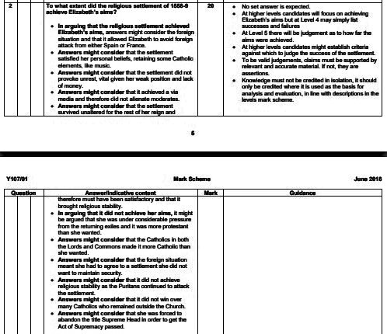

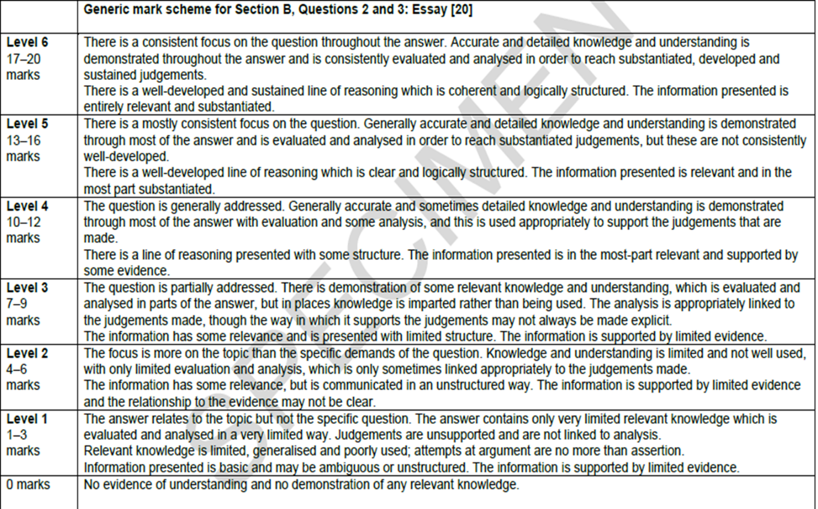
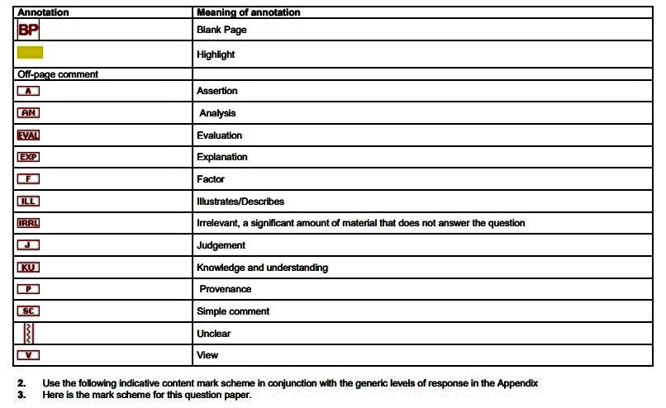
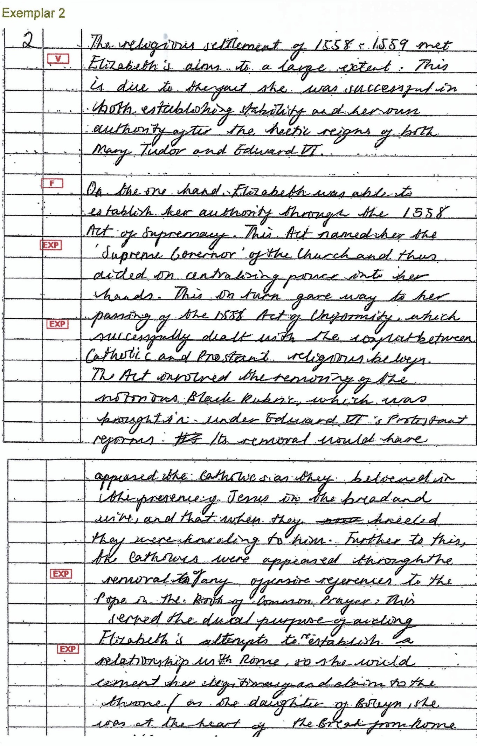
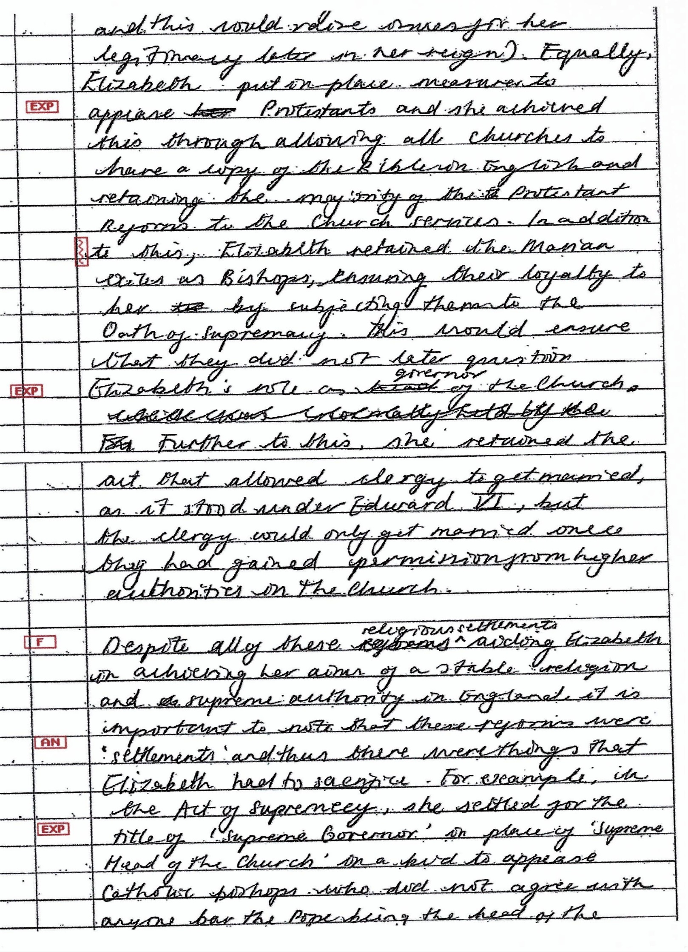
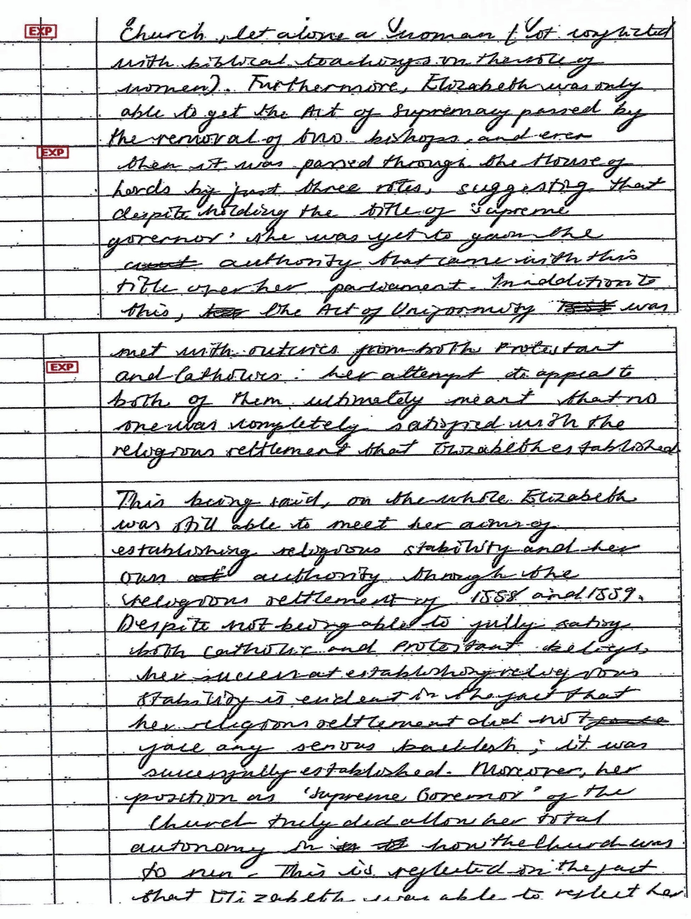
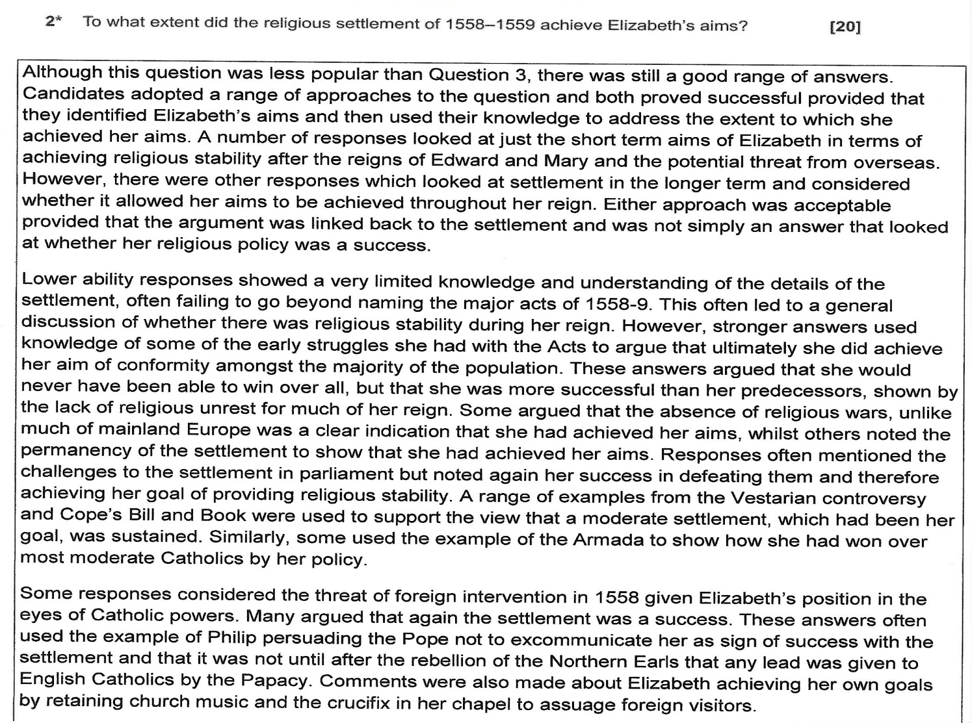
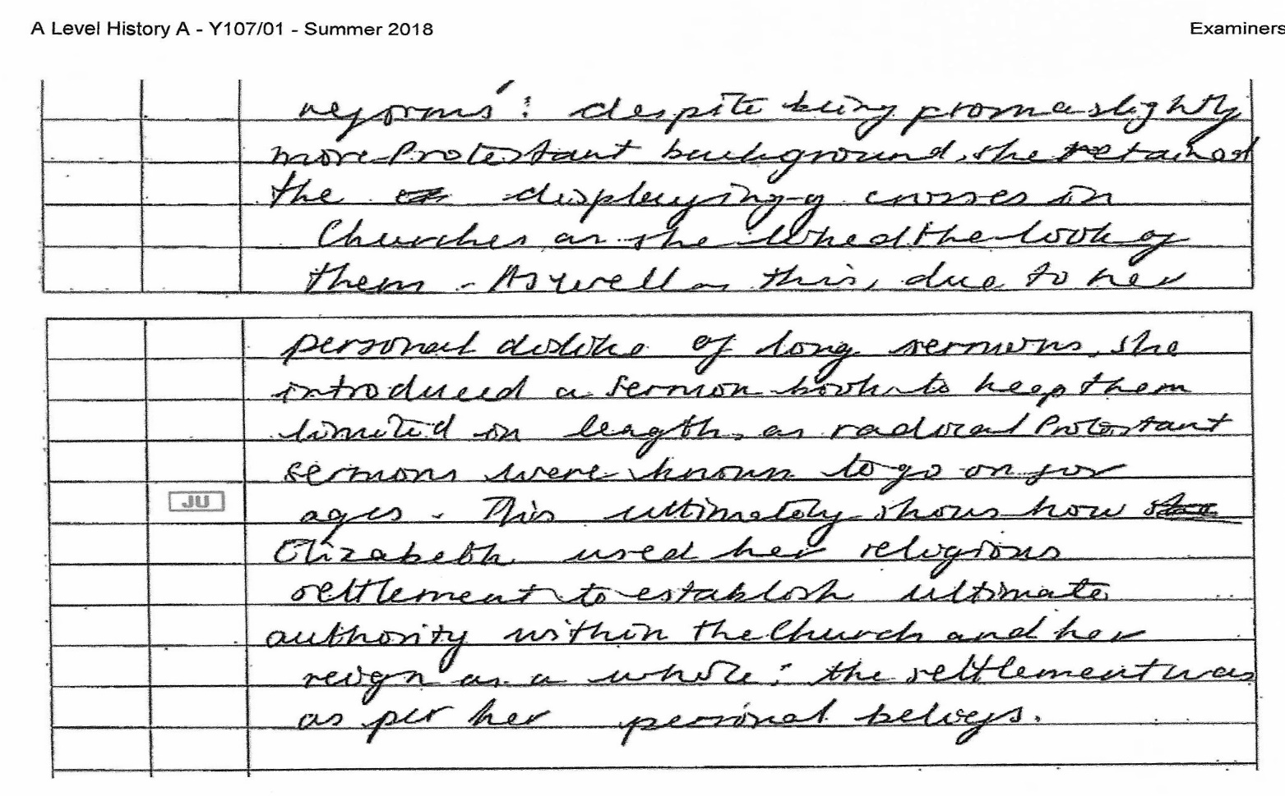
- Level and mark:-

- Reason –

- What the candidate did well –

- From here-

Comparing the seriousness of the Puritan and Catholic challenges to the Elizabethan Religious Settlement (from Tillbrook)

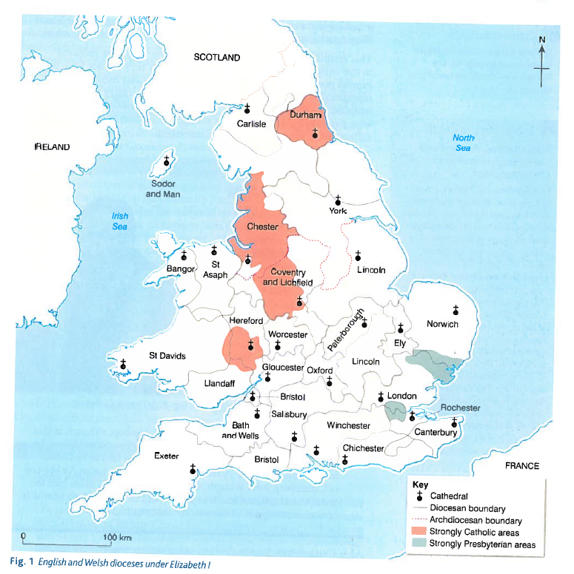
A map to show the main strongholds of Catholicism and Puritanism in 1559.
North and east of the line perhaps a Catholic majority

South and west of the line perhaps a protestant majority.

How serious was the Puritan Challenge to Elizabeth?
Perhaps one of the hardest issues in analysing the seriousness of the Puritan challenge to Elizabeth is the lack of a universally accepted definition of what Puritanism was. It was first used, as a term of abuse for extreme Protestants, by Catholic exiles in 1565. These Protestants would not however have acknowledged the term, instead referring to themselves as “True Gospellers” or simply “the Godly”.
S Doran writes of Puritans as “the radical alternative to the Anglican Church”, and this catch all continues that they were typified by the desire to “align the Church of England with the Reformed Church on the Continent” and sort to “purge the Anglican Church of its Catholic features”. Indeed, one Elizabethan Puritan described the Pope as “the rose-coloured whore seated upon the Beast”.
Two issues in particular separated Puritans from Anglican Protestants;
- Puritans believed that the Church should be reformed as quickly as possible – regardless of the practical problems that this would cause with Catholicism at home or abroad. Many had been part of the struggle to establish Edwardian Protestantism, and Marian exile had hardened them. They had been based in Geneva, where they absorbed Calvinist ideas, and now sought to impose this model into England.

- Puritans also believed that religion and the state should be separated. For Elizabeth, all matters beyond adiaphora (personal salvation) should be decided by the monarch, whilst Puritans thought that a Christian should be “dictated to only by the word of God”. P Collinson brands this “the geological fault-line between Anglicanism and non-conformity”.

It would however be wrong to think of them as a homogenous group akin JE Neale’s “Puritan Choir”. Rather, J Warren is helpful when he identifies three main strands of Puritan thought.

- The Moderates: This group reluctantly accepted the 1559 Religious Settlement, and tried to work from within the Church to reform its structure and doctrines.

- The Presbyterians: This group wanted a Calvinist model of local and elected elders running the Church. This meant the removal of all bishops and archbishops, which in turn made the movement very unpopular with Elizabeth I as it was a direct threat to her royal prerogative. N Fellows argues that “it was probably this that caused Elizabeth to view all Puritans with suspicion.”

- The Separatists: This group wanted to disband the national Church and allow each parish to decide its own direction. They were few in number, but forced Elizabeth to take a very hard line as she feared the development of an Anabaptist movement akin to the one in Munster in 1533-4. Here the Anabaptists had driven out Lutheran Protestants, defied a Catholic Prince, and announced a radical programme including the common ownership of property, polygamy, and the death sentence for blasphemy, adultery, complaining, disobeying a master or spreading gossip.

Securing task
- Write a paragraph to explain what you understand by the term Puritans?
Each of these groups presented Elizabeth with a different challenge, and they will be considered in turn.
The Moderates
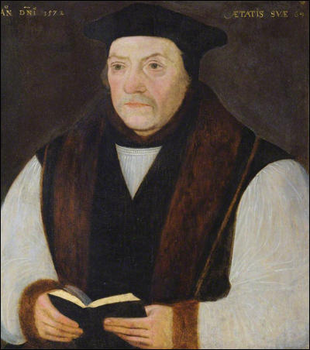
The first Puritan challenge came from within the Church of England. Moderates believed that the 1559 Religious Settlement was not the end of the Protestant reform process. They therefore accepted bishoprics, and then use them to forward the Puritan agenda.
The moderates influence was first felt most at the start of Elizabeth’s reign. They disliked the compromise of the 1559 settlement, and were angered by the appointment of Matthew Parker (shown on the right) as Archbishop of Canterbury because he had never been in exile, and was seen as hostile to their ideas.
At the 1563 Convocation of Canterbury the Puritans sought to “further purify” the Church of England beyond the 1559 Settlement. Their plans were based on the 42 Articles from Edward VI’s reign, which stated that “the Holy Scripture contained all things necessary to salvation”. In the end more extreme Puritan measures were only defeated by one vote (by 59 votes to 58), but this result should be seen as evidence of the extent of Puritan sympathy within the Church.
Above all however the moderates clashed with the Crown in the Vestments Controversy of 1566. The Act of Uniformity had left the clerical dress along Catholic lines, or as one Puritan described it at the time, “the dress of the anti-Christ”. In fact, this was only the most prominent aspect of Puritan hatred of the retained Catholic aspects of the form of worship. Other complaints included the continuation of holy days, the use of the Crucifix, Church music and kneeling in communion. In 1566 when advertisements were laid down on the vestment requirements for clergy 37 priests refused to follow the instructions and were removed from office. This despite Matthew Parker claiming that the dress was based on ancient tradition and Edmund Grindal (the Puritan leader and future Archbishop of Canterbury) stating that the clergy should not “desert out churches for the sake of a few ceremonies”. Even so the challenge yielded no ground from the Crown, and as such should be seen only as evidence of the bad feeling between the Puritans and the Crown. The challenge itself failed utterly.
The next challenge came in Parliament from the so called “Puritan Choir” (JE Neale). Reference to pages 71 - 79 (you must know this information) shows that there was no effective of even organised puritan opposition in the House of Commons. Indeed, when the 39 Articles (the definitive Calvinist statement of doctrine) were proposed in Parliament, they remained untouched because Elizabeth refused to be seen to support an attack on Catholic practice. Hence, as N Fellows concludes, “any review of the achievements of Puritanism within Parliament would have to conclude that it failed”.
Securing task

- Write a paragraph to describe how serious you consider the moderate Puritan challenge to Elizabeth’s religious settlement to be. Use the course language and hard evidence.

Presbyterianism and Prophesying

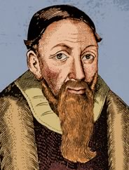
The total defeat of Puritanism in parliament forced the movement to evolve into a campaign based at local level. The episcopacy (the Church’s chain of command controlled by the bishops) was now seen as “a popish hierarchy”, responsible for delays in reforming the Church. As such, in 1569 Thomas Cartwright (Professor of Divinity at Cambridge pictured top right) argued for the abolition of the episcopacy because bishops had no biblical basis for their existence. Instead he argued for a Presbyterian model which would separate the Church and Crown. In 1572, after the failed Catholic Northern Uprising, first John Field and Thomas Wilcox and then Cartwright again issued admonitions about the Church of England to Parliament. Elizabeth would not tolerate such a direct challenge to her Royal Prerogative, and when Field and Wilcox were sent to Newgate Prison Cartwright fled into exile.
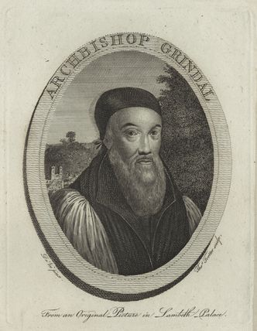
It is important to note that Presbyterianism had some powerful allies in Council. Walsingham in particular was supportive. Moreover, in December 1575 the movement received a significant boost when Edmund Grindal (left) became Archbishop of Canterbury. He was a Marian exile, had ordained Field and supported the Puritan stance on vestments.

At the same time, prophesying gatherings became increasingly popular. These were informal religious meetings with prayers, preaching, discussion and Bible readings. Grindal turned a blind eye to such matters, even when Elizabeth ordered their suppression, and as a result she was forced to suspend her own Archbishop of Canterbury in 1576.

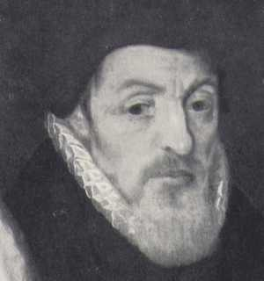
The Presbyterians responded by promoting Walter Travers’s Full and Plain Declaration of Ecclesiastical Discipline. This presented a Puritan book of worship and created a system of locally elected representatives to a National Synod (they first met in Cambridge in 1582). In time it was hoped that this would replace the traditional system from within.

This was “a direct challenge to the Queen’s view that Church government was solely the responsibility of the state” (N Fellows) and brutal suppression followed from Archbishop John Whitgift (right – bottom. Grindal died in 1583). He suspended three hundred clergy, and forcefully established controls to ensure that the 1559 Act of Uniformity was obeyed. Thus, as M Saxon states, “by the time of Field’s death in March 1588 the attempt to establish a clandestine national Presbyterian organisation had failed due to an aggressive campaign by the Church.”
Securing task
- Write a paragraph to describe how serious you consider the Presbyterian challenge to Elizabeth’s religious settlement to be. Use the course language and hard evidence.

The Separatists

By the 1580s Whitgift and Elizabeth had forced Presbyterianism underground. As such, it is difficult to be certain about Puritan activities because they were illegal, and thus secret. It is thought however that despite an acceptance that they could not bring about reform from within the Church and sharply falling numbers they received “a disproportionate amount of attention” (N Fellows) from the Crown.
This led to the rise of Separatism in the 1580s. The key figure here was Robert Browne. In his “Treatise for reformation without tarrying for any” he denied royal supremacy and argued for a truly reformed Church where power rested in the local congregations within a loose confederation (for this reason Separatists are sometimes known as Congregationalists). To the authorities this denial of loyalty was treason akin to the actions of the missionary priests. Hence;
- In 1583 Two Brownists – Tasker and Copping – were hanged for treason under the recusancy laws.
- In 1593 John Greenwood and Henry Bacon were hanged for sedition.

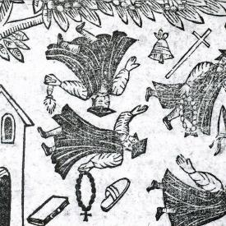
Without doubt however, the most significant separatist action was the Martin Marprelate Tracts. These were a series of six pamphlets and a broadsheet printed on a secret press between October 1588 and September 1589 and distributed with the help of well-organised puritan networks. They were very popular, and this greatly worried the Council. They attacked the Elizabethan church, particularly church government by bishops (hence the pseudonym, Mar-prelate and the image on the right), and argued on behalf of an alternative, Presbyterian system. Their author was almost certainly the Warwickshire gentleman Job Throkmorton, probably assisted by the Welsh cleric John Penry. More than two dozen others are known to have been involved in the tracts’ production and distribution; all risked charges of treason.
The tracts sparked immediate outrage, with the bishop of Winchester stating ‘I think the like was never committed to presse or paper, no not against the vilest sort of men, that have lived upon the earth’, exclaimed Thomas Cooper. Indeed, despite their popularity, they achieved little except to alienate support for the radicals and provoke a further onslaught from Whitgift and Cecil. Central to this was the “Act against seditious sectaries” which punished those who refused to attend an Anglican service, or persuaded others not to attend or denied the Queen’s authority in religious matters. As N Fellows states “not only was the Separatist challenge successfully dealt with, but the government was able to use it to portray all Puritans as subversive at a time when national unity was required in the fight against Spain.”
Thus, the 1590s saw a withering away of the Puritan movement. Key supporters like Leicester, Walsingham and Warwick all died, whilst the war with Spain made Puritanism seems out of step with the national mood. Moreover, the “Act against seditious sectaries” provided a very effective legislative framework to attack any fresh challenges.
Securing task
- Write a paragraph to describe how serious you consider the separatist Puritan challenge to Elizabeth’s religious settlement to be. Use the course language and hard evidence.

How serious was the Puritan threat to Elizabeth?

To conclude, it should be noted that “the lack of organisation and the presence of divisions within the Puritan movement weakened it from the very start” (N Fellows). Moreover, unlike some Catholic groups, Puritanism wanted to challenge Elizabeth’s prerogative rather than overthrow her.
- There was no change to either the Act of Supremacy or the Act of Uniformity
- Neale’s Puritan Choir was not “an opposition group in a significantly new sense: one with a positive programme...the fulfilment of its Protestant destiny”. Indeed, there is no meaningful evidence that it existed at all.
- The Separatists were only ever a very small group, who were easily contained by the “Act against seditious sectaries” and who greatly damaged the image of Puritanism in England.

Evaluation task

11. Re-read this section. Rank the Moderates, Presbyterians and Separatists 1 to 3 (1= biggest threat to Elizabeth) The write a paragraph to explain your judgement. Try to develop your ideas with the course language and hard evidence.

...........................................................................................................................................................................................................................................................................................................................................................................................................................................................................................................................................................................................................................................................................................................................................................................................................................................................................................................................................................................................................................................................................................................................................................................................................................................................................................

Essay Planning Task
- Complete the essay plan below. Think carefully about how you will build your argument. What hard evidence will you deploy? How will you show judgement (relative importance) in the body of your answer.

“Only the serious Puritan challenge to the Elizabethan Religious Settlement was Separatism”
How far do you agree with this statement?
Key Words and Phrase:

Key issues to be discussed:

Linking and Relative Importance:

Line of Argument
 | Argument | Evidence deployed
Introduction

Tie the question to the factors
1

2

3

4

Conclusion
Direct answer to the question

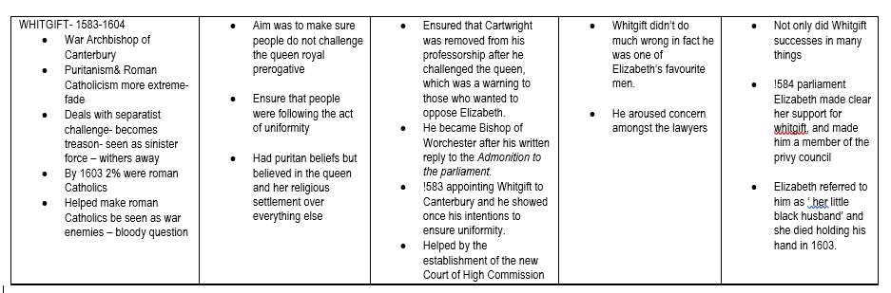
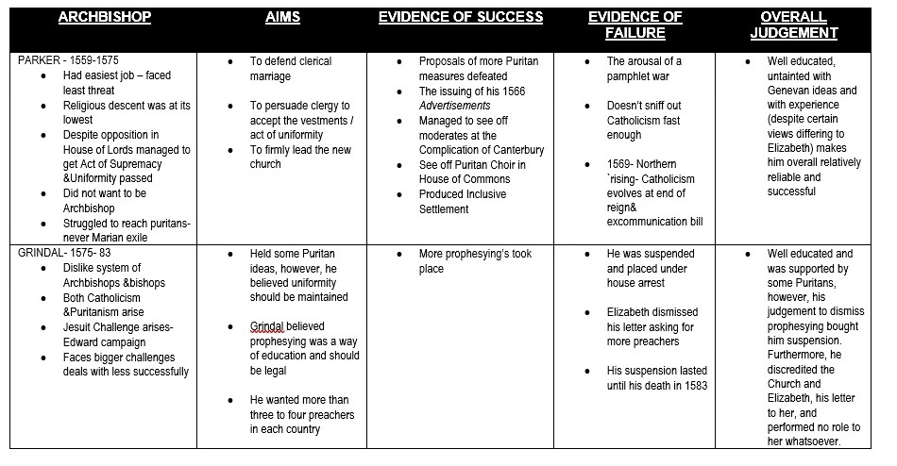
Summary table – Elizabeth’s Archbishops

How serious was the Catholic threat to Elizabeth and her religious settlement?
Early challenges to the Religious Settlement
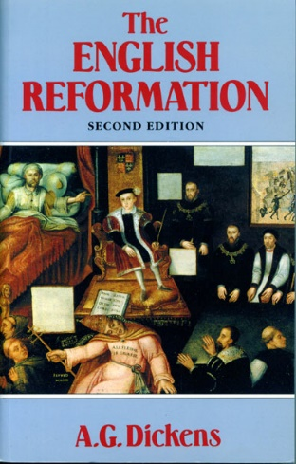
When considering how serious the Catholic threat was to Elizabeth and her Church it is important to first understand the extent and popularity of English Catholicism in 1558.
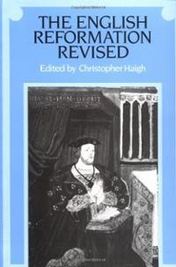
Unfortunately, historians disagree on this question. In “The English Reformation” AG Dickens argued that the move towards Protestantism was fast and popular in the 1550s. He suggested that the brutality of the counter-reformation had made the old religion as unpopular as Mary Tudor herself, stating that “the majority of people cannot possibly have been ardent or even convinced Catholics”. If this was the case, then initially Catholicism was little threat until the arrival of the Douai priests and the Jesuits.
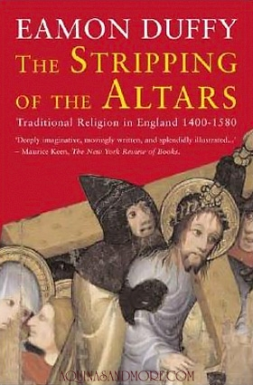
More recently revisionists historians have questioned this view. They propose that the eventual triumph of Protestantism was far from guaranteed, whilst Mary Tudor’s counter reformation had considerable success in restoring the old religion. Hence, in “The English Reformation Revised”, C Haigh argued that “the reign of Mary saw a vigorous and quite imaginative programme of restoration...(and as a result)… widespread attachment to Catholic beliefs and rituals survived both State repression and Protestant evangelism well into the reign of Elizabeth.” This has been supported by E Duffy in “The Stripping of the Altars” with excellent use of local examples. Thus, even in Protestant Kent (see page 109) in 1559, “the Corpus Christi procession attracted a crowd of 3,000 in a last public gesture of allegiance to the traditional faith.” Duffy convincingly argues that at the start of Elizabeth’s reign there was a committed Catholic majority that had not “abandoned hope of the continuance of something of the old faith.”
Indeed, there is plentiful evidence that the initial Catholic threat to the 1559 Religious Settlement was real and substantive.
- As reference back to pages 11 to 16 show, despite their committed Protestant views, Elizabeth and Cecil were forced to include much to please, or at least appease, Catholics in the Settlement. Above all, “the Church organisation owed much to the Catholic model of a clear hierarchy.” (N Fellows).
- It is noteworthy that Elizabeth and Cecil felt that they could only dare impose the very mildest of penalties for passive resistance by Catholics to the 1559 Settlement. Hence, there was only a 12d fine for failing to attend church.
- Despite these moderate terms, the Act of Uniformity only passed through the House of Lords because of the imprisonment of two bishops in the Tower of London and the absence of the Abbot of Westminster.
- Reports for the Privy Council showed that Catholicism remained very strong outside the South East. In 1564 it suggested that a majority of JPs were Catholic, whilst in 1578 in Weaverham, Cheshire the Catholic form of worship still continued without challenge. This showed that to enforce the religious settlement in the localities Elizabeth needed the support of the local gentry. Moreover, when this was not forthcoming, she had to turn a blind eye.

This suggests that Catholicism in the 1560s was potentially a serious threat to the Elizabethan Church. Indeed, we should remember that all the Marian bishops except Kitchen of Landaff resigned rather than swear the Oath of Supremacy. N Fellows argues that “it was only the Pope’s lack of early action that allowed Elizabeth to establish both herself and her Church”.

However, we must not over-sate the early Catholic threat. It was only an organised opposition in the House of Lords at this stage. In reality, most Catholics saw little reason to risk open rebellion. Therefore, is can be argued that the threat from the large numbers of Catholics in England at the start of Elizabeth’s reign was nullified by the stressing of similarities between the new and old services. Hence, F Yates argued that Elizabeth was deliberately presented as “the Virgin Queen to reassure those Catholics pining for the Virgin Mary”, and J Bossy is correct when he argued that for most Catholics in the 1560s it was “survivalism.” There was no plan to overthrow Elizabeth or her Church, but rather just continue with “ingrained observances which defined and gave meaning to the week, the seasons, birth, marriage and death.”
Securing task
- Write a paragraph to describe how serious you consider the Catholic challenge to Elizabeth’s religious settlement to be in the 1560s. Use the course language and hard evidence.

The evolution of the Catholic threat in the late 1560s and early 1570s
Excommunication, Jesuits, and rebellions

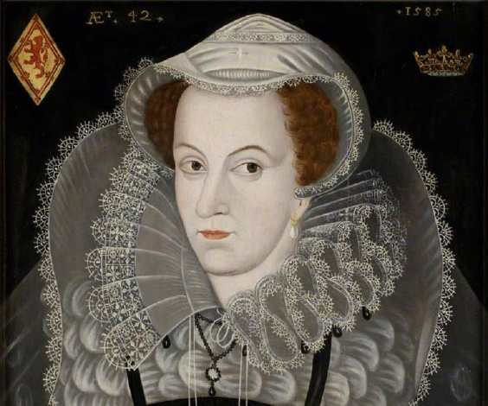
The nature of the Catholic threat to Elizabeth increased markedly because of three external events.

1. In May 1568, Elizabeth’s cousin and the Catholic heir to the throne, Mary Stuart (left – also known as Mary, Queen of Scots) fled to England, seeking aide to crush a Protestant rebellion at home. Elizabeth found herself in an impossible situation. The Catholic Mary was popular in England and as William Cecil stated, the ‘greater number’ regarded her as Elizabeth’s lawful successor.

Elizabeth therefore dared not help Mary, lest she become more powerful and popular. Equally, wedded as she was to the idea that the monarch was “the figure of God's majesty” (Richard II) the Queen also feared to kill the legitimate queen of Scotland. Instead, and typically, Elizabeth placed Mary under house arrest for eighteen years. If this was the least bad option, it still angered the Pope whilst leaving a Catholic heir “that became the focal point for plots and conspiracies” (N Fellows).

To some extent this provoked the second and third external events that increased the Catholic threat to Elizabeth and her Church Settlement. Hence;
1568
Elizabeth’s imprisonment of Mary, Queen of Scots
1570
Elizabeth excommunicated
1569
The Foundation of Douai Seminary

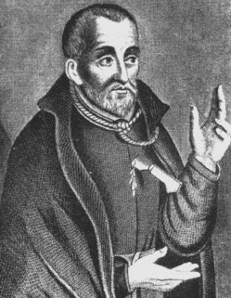
- In an attempt to keep English Catholicism alive, in 1568 an English priest, William Allen, founded an English Catholic seminary at Douai (in France). This created an “inward traffic of priests” (J Bossy) to replace the aging Marian priests who were dying off. The first Douai priest returned to his home land in 1574. By 1575 11 had arrived in England from Douai, and by 1580 this figure had risen to 100. They travelled around the country keeping the old faith alive, but also hoping to convert protestants. They argued for a return to the Council of Trent’s reforms, but pledged political loyalty to Elizabeth.

In addition to these Douai seminary priests, from 1580 The Society of Jesus (the Jesuits) began their mission in England. Unlike the Douai priests, they rejected any compromise with the Queen. In particular, they called for a foreign invasion to impose the counter-reformation and overthrow Elizabeth. The most famous of these priests were Robert Parsons and Edward Campion (left). The latter described his work as “to preach the gospel, to minister the sacraments, to instruct the simple, to reform sinners, to confute errors and to cry alarm against foul vice and proved ignorance.”

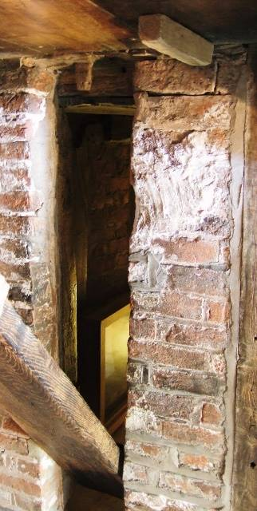
Such actions were of course treason, and 98 of the 438 priests and Jesuits that travelled to England were executed. Campion himself was put to death in 1581. It should be noted here that the priests were tried for treason (a political crime) rather than heresy (a religious one). This went a long way towards reducing sympathy for them as martyrs with the general public. The others survived with the support of the gentry, often hiding in priest holes like the one shown to the right in Harvington Hall.

Traditionally it has been argued that the missionaries helped keep Catholicism alive in England. GR Elton for example suggests that they “arrested the decline of Catholicism and ended the government hope of destroying popery.” However, more recently historians have challenged this view. Today few think that the Douai priests and Jesuits saved Catholicism. J Guy, for example, suggests that the gentry received “a disproportionate use of resources” at the expense of the lower classes. Equally, C Haigh proposes that they had little impact because they concentrated their efforts in the Protestant South and East, and “this misdirection of the priests’ missionary activities allowed Catholicism to continue to wither in its north western homeland.” Finally, differences between the Douai priests and the Jesuits also weakened their message and thus impact.

In addition, Elizabeth and Cecil were very skilled in dealing with the challenge. For example, in 1581 treason was redefined as any subject who withdrew allegiance from the Queen or her Church, and recusancy fines were increased to £20. In 1585 Parliament made it treason to become a priest, and tested this with the so-called “Bloody question”, where the accused was asked to choose between loyalty to the Pope and the Queen.

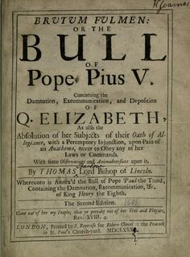
- In 1570 Pope Pius V excommunicated Elizabeth. He issued the “Regnans in Excelsis” Papal Bull (right) which called for the deposition or murder Elizabeth as God’s work. English Catholics were absolved from any oath to the Queen. This was “an unmistakable declaration of war” (GR Elton) and meant that religion was now a political and security question for the Queen. Every Catholic was now a potential traitor. This increased Protestant paranoia and persecution. The “via media” idea was dead. It also energised plots like those shown below (note however that the Northern Rising happened before the issuing of the Bull).

1569
The Northern Rising
Catholic Plots against Elizabeth
(and involving Mary, Queen of Scots)

1586
The Babington Plot

1571
The Ridolfi
Plot

1583
The Throckmorton Plot

The Northern Rising
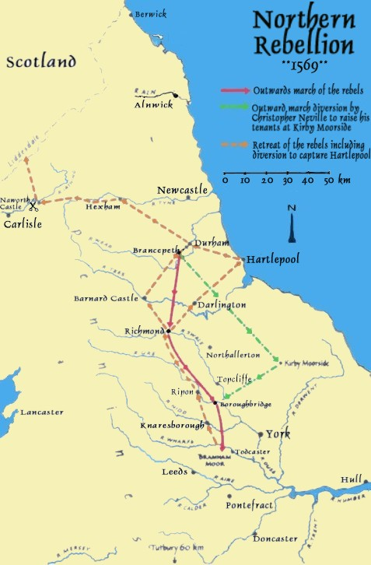
The first serious Catholic challenge to Elizabeth came in the 1569 Northern Rebellion. However, it should be noted that this was not solely about the defence of the Catholic faith. There were also personal and political motives as well.

- Religious motives – The leaders were certainly Catholic. The Earl of Westmoreland had been born a Catholic while the Earl of Northumberland converted in 1567. Moreover, the North of England had hung on to the old religion, and local insecurities had been raised by the new bishop of Durham, the strongly protestant James Pilkington. In addition, the rebels’ actions suggest there was an element of religious motivation as they restored the mass at Durham cathedral.

However, GR Elton was correct when he argued that ‘religion played little part in the disaffection, though it supplied a useful cloak’. Faction and local issues were more important.
- Factional motives - The Northern Earls schemed to overthrow William Cecil who they considered as too influential at court. They held him responsible for the uncertain succession and poor policy decisions. The plan involved Norfolk marrying Mary Queen of Scots who was at the time under house arrest in England.

- Local – The catholic earls of Northumberland and Westmoreland were pushed into rebellion by their tenants and by Sussex [President of the council of the North] calling them to answer for their actions.

What happened?
In 1569 Norfolk left Court and when he was summoned to London, the two earls to called out their follows. On 14 November the rebels entered Durham cathedral, said mass, tore up the English bible and prayer book, and marched south to free Mary Queen of Scots and Norfolk and to restore Catholicism. After minor skirmishes, the earls fled to Scotland. It had been almost bloodless.
How much of a threat was this to the Elizabethan Settlement and the Queen herself?
There was no real danger to the regime. Norfolk and both earls showed no courage or determination, and seemed reluctant to act. Many of the northern gentry had ‘answered coldly’ to rebel calls. Clifford, Earl of Cumberland, failed to act and Dacre was too late. The rebellion was in midwinter, and many rebels were freezing and starving. Further, the support for the rebels was very limited geographically. A Fletcher describes its ‘incoherence and aimlessness’ and afterwards, Elizabeth ordered severe punishments. GR Elton says 800 were executed and the Puritan Earl of Huntingdon became the new president of the Council of the North, but today a figure of 400 is more widely accepted.
Securing task
- Re-read pages on the Catholic threat. Write two paragraphs to describe how the Catholic challenge to Elizabeth’s religious settlement changed in the period 1567-1570. Use the course language and hard evidence. Ensure you consider which problems you think were more (and thus less) serious.

Research task
15. Research the following Catholic plots;
- 1571 - The Ridolfi Plot
- 1583 - The Throckmorton Plot
- 1586 - The Babington Plot

For each plot write a paragraph explaining what happened and how serious a threat it was to Elizabeth. Say where you got your information from. Then rank the seriousness of these plots for Elizabeth using the diagram and space below. Make sure that you justify your ideas and use the course language and hard evidence.

...........................................................................................................................................................................................................................................................................................................................................................................................................................................................................................................................................................................................................................................................................................................................................................................................................................................................................................................................................................................................................................................................................................................................................................................................................................................................................................

Overseas support for Catholicism
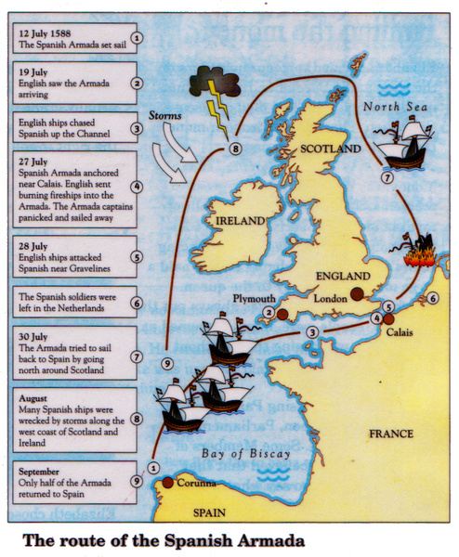
One key aspect of the Catholic threat in the later years was support from abroad. Until the late 1560s, the Catholic threat from overseas was minimal. Until Pius V, the Papacy showed little leadership on the matter, whilst the major Catholic powers of France and Spain were involved in their own domestic religious wars (against the Huguenots and Dutch Rebels).

After the excommunication, the execution of Mary, Queen of Scots, and Elizabeth’s funding of Protestant rebels’ in the Spanish Netherlands however, Phillip II Spain decided to lead a Catholic crusade against the most powerful Protestant country in the world. England was at war with Spain from1585 until 1604, and although the Armada was defeated in 1588, Philip launched other attacks in 1596, 1597 and, in 1601 he landed troops in Ireland.

There is a paradox here. Despite the actions of the seminary priests and Jesuits, Elizabeth’s plan to let Catholicism slowly wither and die had broadly succeeded by the 1590s. Where in the 1560s there was “a small Catholic majority” (C Haigh), by the late 1590s it is thought that the figure may have been as low as 2% of the population. Moreover, the failed plots had allowed Catholicism to appear akin to treason, whilst Spanish involvement made it appear foreign. Yet, despite the effective collapse of domestic Catholicism, this was the moment when the threat was greatest. Luck, in terms of the weather, played a crucial role in defeat of the Amada. If this had gone the other way, then Catholicism would not just have been a threat to the 1559 Religious Settlement, but to Elizabeth’s monarchy and indeed life.
Securing task
- Re-read this section. Write two paragraphs to explain why foreign intervention made the Catholic challenge to Elizabeth much more serious.

Examiner Support – Know the standard
Below is part of the exam report, and part of an answer to the 2019 question –
How serious was the Catholic threat 1558 – 1589?

Many answers, particularly at the lower mark range focused on Mary and then the Armada, with discussion usually lacking balance. Some responses did drift into long accounts of the Armada, but in the strongest answers it was used to show how Elizabeth was able to nullify the Catholic threat by 1589 and even use it to create a sense of national unity. Responses also considered the threat of the Jesuits and seminary priests, as is shown in Exemplar 2 below, where there is good analysis of an issue and interim judgement is reached. If the response reached similar interim judgements about the issues discussed and then an overall judgement, it would reach Level 6.
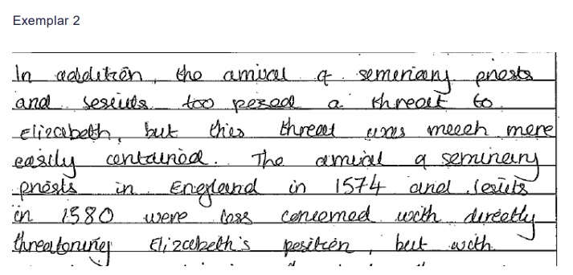

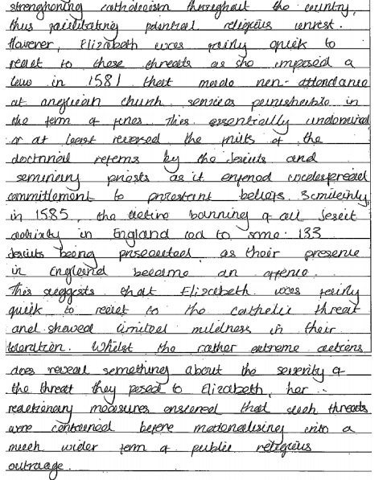
Task
Highlight the interim judgement
Why is this skill so valued by the examiner?

Essay Marking task
- Complete the essay plan below. Think carefully about how you will build your argument. What hard evidence will you deploy? How will you show judgement (relative importance) in the body of your answer.

TITLE:
“Catholicism was only a threat to Elizabeth when it had foreign support”
How far do you agree with this statement?

Key Words and Phrase:

Key issues to be discussed:

Linking and Relative Importance:

Line of Argument
 | Argument | Evidence deployed
Introduction

Tie the question to the factors
1

2

3

4

Conclusion

Direct answer to the question
Was Catholicism or Puritanism the more serious threat to Elizabeth and her religious settlement?
In part, the answer to this question is revealed in the question. Whereas Puritanism did, usually ineffectively, only try to challenge the Royal Prerogative on religion, Catholicism after 1570 challenged the monarch herself. This meant rebellions, assassination attempts, and invasion plots. Some of these were only defeated by good luck. Hence, Catholicism was clearly more serious threat to Elizabeth. However, to conclude we should stress the point that the 1559 was unchanged. In other words, both Catholicism and Puritanism failed to achieve their aims.
A
18. Securing task

For each of these issues;
- Code them as either a Catholic or Puritan threat. Then write the date(s) when they were pressing the Elizabethan Church.
- Then place them on the importance graph.
- Then compare and discuss your conclusions with your peers.
- Now write a couple of paragraphs to explain what your graph shows.

Presbyterianism and Prophesying
B
Catholic Rebellions
C
Opposition to the 1559 Religious Settlement in the House of Lords
D
Opposition from Moderates within the Church of England
ED
Elizabeth’s excommunication
FED
Jesuits and seminary priests from Douai
GED
Overseas support for Catholics and Mary, Queen of Scots
HGED
Separatists
IGED
The Armada

Evidence of the Catholic threat to the Elizabeth and her Church
Evidence of the Puritan threat to the Elizabethan Church
The higher the evidence is placed, the more important you consider it to be
An importance graph to compare the seriousness of aspects of the Puritan and Catholic threat to Elizabeth and her religious Settlement

The last word on this question should really go to John Guy….
“When comparing the Catholic and Protestant threat to Elizabeth, the real answer is neither until 1570”

REVISION
Study the questions below and highlight the key terms in them.
In the space below explain these questions are different

“Puritanism was never a serious threat to the Elizabethan religious settlement”
How far do you agree?
“The Jesuit Challenge was the most serious Catholic challenge to Elizabeth”

How far do you agree with this statement?
“Catholicism was always a more serious threat to the Elizabethan Church than Puritanism”
How far do you agree with this statement?

………………………………………………………………………………………………………………………………………………………………………………………………………………………………………………………………………………………………………………………………………………………………………………………………………………………………………………………………………………………………………………………………………………………………………………………………………………………………………………………………………………………………

Further Reading

There are copies of these book (and lots of others on Elizabeth) in the school library

The Tudor Years – Ed R Sloan
Chapter IX – Elizabeth and Religion – M Saxon

The Emergence of A Nation State –AGR Smith
Chapters XVII and XVIII – The Elizabethan Church and opposition

The Reign of Elizabeth I – SJ Lee
Chapters III, IV, and V – Elizabeth and religion

Elizabeth I – Profiles In Power – C Haigh
Chapter II – The Queen and the Church

Or online you could click onto the following sites

Some excellent articles from History Today

http://elizabethanenglandlife.com/elizabethan-settlement-of-religion-1559.html

https://www.historytoday.com/archive/creating-elizabeth%E2%80%99s-media

https://www.historytoday.com/archive/english-catholics-reign-elizabeth

https://www.historytoday.com/archive/elizabethan-archbishops

