Section E
Elizabeth’s management of financial, economic and social affairs.

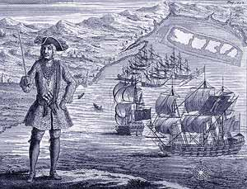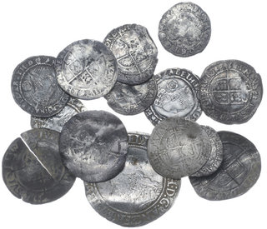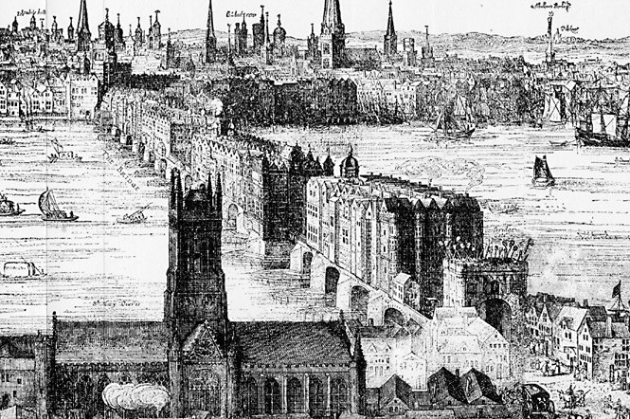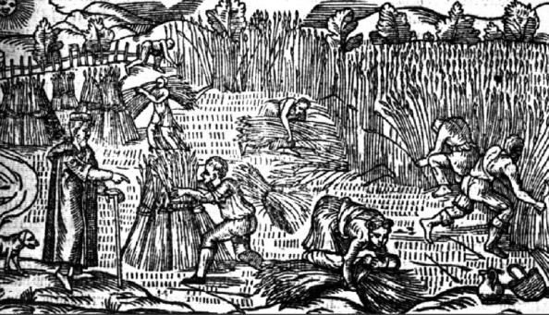
Reference to the PLC and sample questions on page 5 show that to write effectively on this unit of study you need to be able to understand the different financial and economic problems that faced Elizabeth’s regime, and then consider how successfully these were addressed. An important starting point is to remember that the following terms are not interchangeable.

Finance
Economics
Social matters

Finance
When historians consider Elizabeth’s reign as a whole, her financial and Irish policies are usually the areas which attract most criticism. R Sloan for example is typical when he writes of her financial legacy as “a poisoned chalice”...”in which Elizabeth’s cautious and short sighted approach to government proved most damaging.”

The problem with this approach is that is rather generalised. Reference to Figure 1 below reflects this. In reality, Elizabeth faced a series of interlinked financial problems, and the quality of her response to them varied. Our task is to consider their relative seriousness, and analyse how successfully the regime met these challenges.

A diagram to show the interlinked financial problems that the Elizabethan regime faced. The problems shaded yellow (1 and 4) are sometimes presented as successfully handled, whilst the turquoise problems (2 and 3) are often protrayed as failures. You will need to decide if you agree with this.

Problem 1 – The Marian financial inheritance
In recent years there has been a lot of revisionist work done on Mid Tudor government. As part of this, the financial reputations of Mary I and Edward VI (especially the protectorate of Northumberland) have been more positively appraised. DM Palliser reflects this when he states “fortunately for Elizabeth both Northumberland and Mary kept the realm generally at peace and managed, with the aid of Lord Treasurer Winchester, to reduce expenditure and to increase income”. The latter point is particularly noteworthy as Winchester took the important but unpopular decision to update the national tax records. These were to be the Marian Book of Rates, subsequently used by Elizabeth throughout her reign. They increased the Crown’s annual income from £29,000 per annum in 1556 to £83,000 in 1557.
These are valid points, but when Mary died in 1558 England was at war, allied with Spain, against France and Scotland. This added a serious debt and an expenditure problem to the spike in inflation she had inherited from the debasement of Henry VIII and Edward VI. The basic problem was that then, as now, war is expensive. Hence, despite updating the tax records, Mary left a debt of £227,000. Worse still £106,000 of this was owed to the Antwerp exchange at 14% interest per annum. This was close to usury. As Sir Walter Mildmay would later tell the House of Commons, England in 1558 was “grievously afflicted with debts; the burden of which...cannot be remembered without grief”.
Elizabeth had two possible ways to deal with this problem. She could have either increased the revenue coming into the Exchequer, or she could have reduced the expenditure going out. As the Figure 2 below shows, Elizabeth chose the latter option.
A diagrammatic representation comparing the Marian and early Elizabethan exchequer.

Expenditure going out
The
Marian
Exchequer
Revenue coming in

Because Expenditure is >er than Revenue = Growing debt - (in the red)
Less expenditure going out
Similar revenue coming in
The
Early Elizabethan
Exchequer

Because Revenue is >er than Expenditure = Annual surplus and debt paid off
By 1585 the Crown had a cash reserve of £300,000 (in the black)
A diagram to show how Elizabeth and the Marquis of Winchester (her Lord Treasurer until 1572) made these savings.

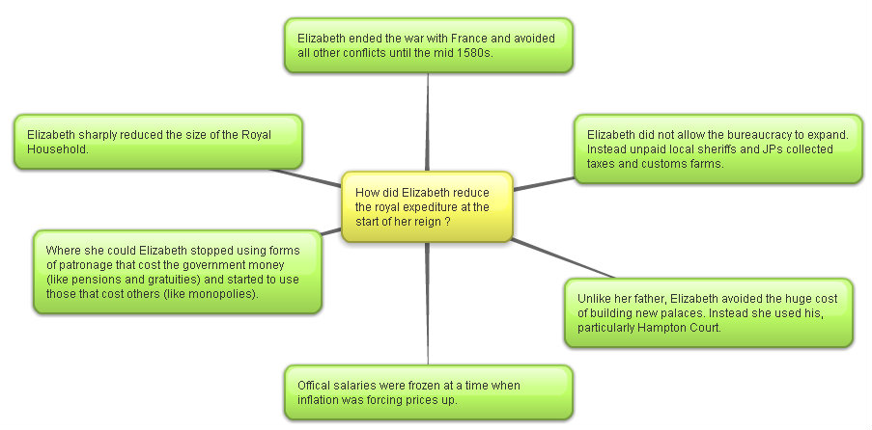

By reducing expenditure Elizabeth ensured that, unlike France and Spain, England did not go bankrupt in the 1570s. As Mildmay continued in his speech to the House of Commons on the matter, “her majesty hath most carefully delivered this country from a great and weighty debt”. Indeed, England was debt free by 1574, and by the outbreak of war with Spain in 1585 the Treasury actually held a cash reserve of £300,000. Her contemporary biographer William Camden, writing shortly after her death described this as her “greatest glory”.

Moreover, historians have united to praise the achievement. C Russell reflects on her “heroic decision to live within the royal income” whilst AGR Smith is uncharacteristically emotive when he writes “it was largely due to the personal and unremitting vigilance of the Queen that England escaped financial disaster.”

Question

- Write a paragraph to explain how Elizabeth addressed the problems of debt and expenditure when she came to the throne.

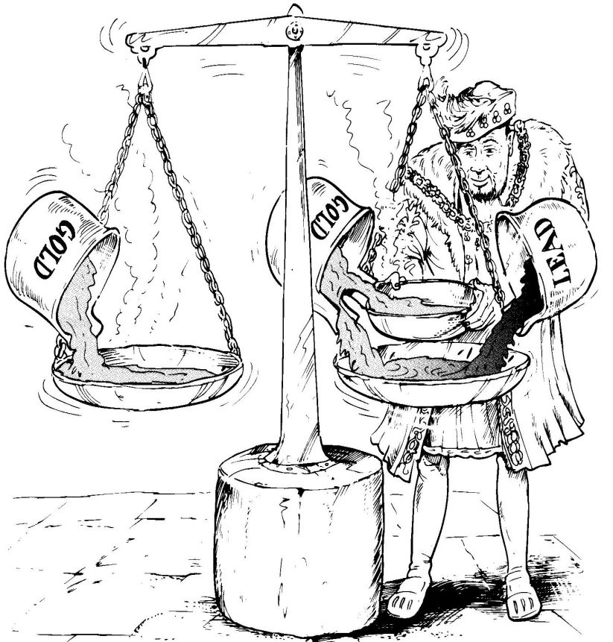
Perhaps even more impressive was Elizabeth’s attempt to deal with the problem of inflation in 1560. As we will see, the causes of Tudor inflation were varied, and in the 1590s the regime really struggled to contain it. However, the spike in prices in the 1550s was thought to be overwhelmingly caused by debasement of the coinage in 1544, and again in 1551. As John Hales wrote in 1581, “immediately after the baseness of our coin in the time of King Henry the prices of all things went up”. Here Elizabeth was very fortunate to be advised by the far-sighted Sir John Gresham who argued that “your Highness hath no other way, but when time and opportunity serveth, to bring your money into fine”.
Cartoon representation of debasement
(B Mervyn)
Elizabeth did this within the first year of her reign. The reform involved bringing in all the debased coins and re-issuing new ones with the proper amount of precious metal. This reduced the Crown’s expenditure in the short term, but it also had the desired effect of slowing inflation in the 1560s and 1570s. As DM Palliser comments “her revaluation did much for England’s international standing...it...was also a domestic success, if judged by its effectiveness and permanence”. The truth of this can be seen on Elizabeth’s tomb, which cites this relaunch of English coinage equal to the 1559 religious settlement and the defeat of the armada, as her greatest achievements.

Question

- Write a paragraph to explain how Elizabeth addressed the problems of inflation at the start of her reign. How successful was she?

However, a bit of context is needed here. This looks like a remarkable achievement for the young monarch, but, it was not a complete success. As R Sloan suggests, this “superficial account disguises some less palatable realities”. In particular, the start of Elizabeth’s reign saw some missed opportunities.

- Some historians argue that Elizabeth’s early failure to introduce reforms to the system of revenue collection at this time would create long term problems for her. C Haigh for example argues that reducing expenditure rather than increasing income in the 1550s created “a hand to mouth existence” which ”had worked well only because it had not been tested. From 1585 it was”. This refers to her need to spend a lot of money to fight the Spanish after this date. She did not have the capacity to increase her ordinary income, and was thus forced to use the damaging extraordinary methods.

- Sir John Gresham also wanted to remove the practice of usury (the act of lending money at an unreasonably high rate of interest) in 1561. This was eventually introduced via the 1571 Act against Usury, which stated that “any lending upon a loan above the rate of ten pounds for the hundred for one year” shall render that loan “utterly void”. In other words, no loan could charge interest above 10% per annum. Had this been introduced in 1561, the Elizabeth could have broken free form the Antwerp money lenders much quicker than she actually did. It is was William Cecil that stopped the Queen, “resisting as usual any fundamental financial reform” (C Read).

Question

- How valid do you consider the criticisms to be of Elizabeth’s early financial policy? Explain your answer.

Question

- Now study the diagram below. Label it with the Achievements of Elizabeth’s early financial policy and Failures of Elizabeth’s early financial policy as you think most appropriate (remember the best argument will be the weightiest). Explain your decision.

An analysis of the achievements and failures of Elizabeth’s early financial policy
Now label the see saw and explain your choice in the box below
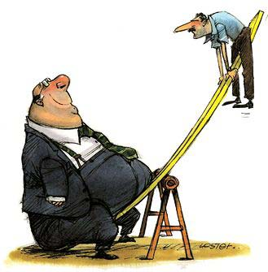

......................................................................................................................................................................................................................................................................................................................................................................................................................................................................................................................................................................................................................................................................................................................................................................................................................................................................................................................................................................................................................................................................................................................................................................................................................................................................................................................................................................................................................................................................................................................................................................................................................................................................................................................................................................................................................................................................................................................................................................................................................................................................................................................................................................................................................................................................................................................................................................................................................................................................................................................................................................................................................................................................................................................................................................................................................................................................................................................................................................................................................................................................................................................................................................................

Problems 2 and 3 – Inflation and the failed Elizabethan response
A diagrammatic representation of the causes of inflation in Elizabeth’s reign.

From the Black Death in the 1340s, to the Wars of the Roses in the1460s prices did not increase in England. For the next two hundred years they rose continually, albeit at different rates. In Elizabeth’s reign prices rose 75% from 1558 to 1603, with two peaks – the 1550s and the 1590s – the latter of which Andrew Pickering describes “close to hyper-inflation”. Context is important here. It is not just that inflation occurred throughout the Early Modern period of English history, it was, as G Reagan suggests “a pan European phenomenon”. In fact, other countries suffered much swifter rises in prices.

Monetary causes of Inflation

- Debasement was unquestionably an important early cause of inflation. However, after Elizabeth revalued the coinage in December 1560, she then did not allow any fresh debasement to occur. It was therefore not a key cause of the inflation spike in the 1590s.

- Elizabeth’s reign saw the continued Habsburg importation of silver from places like the Spanish mines in Potosi in Peru. G Woodward convincingly argues however that “the impact on England appears to have been negligible” as the “Anglo-Spanish wars kept the volume of trade between England and the continent to a minimum”.

Non -monetary causes of Inflation

- Population increase was the most enduring, and perhaps the most important cause of Elizabethan inflation. As Figure 6 below shows, after the terrible influenza outbreak of the early 1560s, England’s population quickly rose from 3 million in 1561 to 4.1 million in 1601. This meant more mouths to feed, and thus higher grain prices. Figure 7 can be partly understood in these terms. For RB Outhwaite this reason “looks to be by far the most important influence on prices”. However, it is noteworthy that he continues that “we must avoid making population pressure do all the work”. In other words, no one reason can, on its own, explain Elizabethan inflation.

Population change in Elizabethan England.

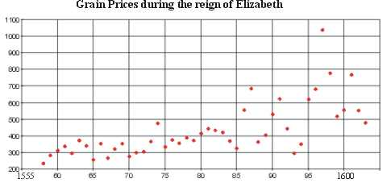
The rising price of grain in Elizabethan England.

- Problems in agriculture were also important. At the time many blamed the process of enclosure for the problems that they faced. One preacher famously described those who enclosed as “cormorants, greedy gulls...and men without conscience...who...leave nothing for others”. In the context of rising food prices, enclosure often meant the converting of arable open fields into closed fields for pasture (sheep farming). This in turn meant that at the very time that there were more mouths to feed, there was less land under tillage. Elizabeth’s government certainly saw this as a matter of concern, and tried to legislate. In 1563 they passed the Act for the Maintaining of Tillage. This was followed up by the 1598 Statues against Conversions to Pasture and the Engrossing of Farms. Both tried to ensure that no further land would be converted to pasture.

Today, we consider enclosure to be less important. As B Mervyn states “by the end of Elizabeth’s reign the total area enclosed, even in the worst affected regions, was less than nine per cent”. In other words, the overwhelming majority of farmland was not taken out of arable production. This argument becomes even stronger when one considers that some enclosed fields continued to be used for growing crops. Further, Elizabeth’s reign also saw the extension of the amount of land under cultivation. Clearly enclosure’s importance has been overstated. We now think that is because historians have been drawn to the topic because of the strong political reaction to the rare forced enclosures. For example, in Mary’s reign, Kett’s Rebellion (1549) in Norfolk complained about “the overgrazing of the commons by greedy landlords...and...rising rents”.

- Consideration of the graph on the previous page, does however suggest a more important short-term cause of rising grain prices. Throughout Elizabeth’s reign there were strings of excellent harvest. However, where there were bad harvests, such as in 1594 – 1597 grain prices quickly inflated through the process of supply and demand. There was actually famine in the North West in this period; however, even then, it was enclosure that was commonly blamed. In 1596 for example there were enclosure riots.

- Finally, another important short-term cause of inflation was the increased expenditure of the government in the Spanish war (1585 – 1604). Reference to figure 8 shows that Elizabeth raised and spent over £4million financing the war. This level of expenditure was obviously inflationary, even allowing for the Crown’s use of purveyance. A further point to make here is that Elizabeth was increasingly forced to use extraordinary forms of finance such as multiple subsidy rounds and monopolies.

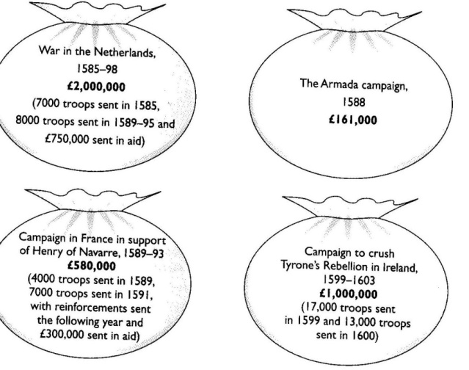

The cost of the Spanish War – B Mervyn

Question
- Which three causes of inflation in Elizabethan England do you consider to be most important?
- Explain your decisions
- Do any of these reasons link together? Explain your decisions.

......................................................................................................................................................................................................................................................................................................................................................................................................................................................................................................................................................................................................................................................................................................................................................................................................................................................................................................................................................................................................................................................................................................................................................................................................................................................................................................................................................................................................................................................................................................................................................................................................................................................................................................................................................................................................................................................................................................................................................................................................................................................................................................................................................................................................................................................................................................................................................................................................................................................................................................................................................................................................................................................................................................................................................................................................................................................................................................................................................................................................................................................................................................................................................................................

......................................................................................................................................................................................................................................................................................................................................................................................................................................................................................................................................................................................................................................................................................................................................................................................................................................................................................................................................................................................................................................................................................................................................................................................................................................................................................................................................................................................................................................................................................................................................................................................................................................................................................................................................................................................................................................................................................................................................................................................................................................................................................................................................................................................................................................................................................................................................................................................................................................................................................................................................................................................................................................................................................................................................................................................................................................................................................................................................................................................................................................................................................................................................................................................

What were the effects of inflation?
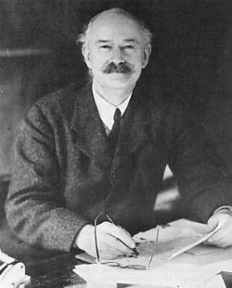
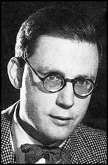
In 1941 RH Tawney (top) argued that inflation changed the balance of power in Elizabethan society. In his famous work “The rise of the Gentry” he suggested the inflation led to “a substantial net swing of capital and income from the aristocracy to the gentry”. In 1953 Hugh Trevor Roper (bottom) challenged this in his work “The Gentry 1540 – 1640”. He suggested that the landed gentry were actually unskilled in managing their estates, and thus suffered from falling rent rolls.
A diagrammatic representation of the classes in the countryside of Elizabethan England. Below the great landed families of the aristocracy were the gentry. The gentry can be considered those who had more land than they could farm themselves. Yeomen tended to be independent farmers with freeholds to the value of 40 shillings, whilst the husbandmen held small amounts of land by tenure. Labourers were usually landless and paid in wages. They made up two thirds of the population.
More recently few historians would argue that no one class in entirety rose or fell because of inflation. However, G Batho has shown that most landowners, be they aristocracy or gentry, managed to increase their incomes. This was because of the higher food prices, and competition for land caused by the rising population. Even so, certain trends can still be identified.
- As the nation’s principle land owner, the Crown suffered a weakening of its overall position because of price inflation. Many of the tenant farmers on crown land had leases which ranged from twenty to a hundred years. Rents were quickly devalued by inflation and this forced the cash strapped Crown to sell the land they owned. Thus, a downward spiral developed. S Atkins, when discussing the impact of inflation in this period, argues that of all the changes it caused the “most momentous was the weakening of the position of the crown”.

- As we have seen, the impact of inflation on the aristocracy depended on the extent to which they were tied to similar long-term leases as the Crown. Where they were, then they “lost ground in the face of rising prices.” (R Tawney). They would then be forced to sell their land, usually to the gentry, to seek fresh sources of income. However, we now think that that this was not widespread, and some members of the aristocracy actually gained via the practice of rack renting (this was where the rent was increased in difficult times but not reduced when the economic climate improved). Certainly, Elizabeth’s reign did not see a large decline in the aristocracy’s numbers. DM Palliser estimates that there were 57 great families in 1558, and 55 in 1603.

- The gentry and to a lesser extent the yeomen and husbandmen generally did do best from inflation. They tended to be those who gained from the existing long-term leases, and they were then in a good position to pick up cheap land that the Crown and aristocracy needed to sell in a hurry. We still need to be careful here however as there were important local differences. G Batho argues the group that suffered the most were the Catholic gentry who, from the 1570s, repeatedly got themselves fined as recusants.

- Perhaps the group that was hardest hit by inflation were wage-earning labourers. They were often paid daily rates, but the rising population kept wages down. Those without any land of their own were most at risk, and in the 1596 for example there were food riots in the affluent county of Oxfordshire.

Question

- Write a paragraph to explain if you agree with M Saxon that Elizabethan inflation led to “a polarisation in late Tudor society between the haves and the have nots”.

The Failure to reform the Elizabethan system of finance

Inflation in itself was not necessarily a bad thing for the Elizabethan government. However, the problem came because it exposed the complete failure of the regime to update its system of revenue collection to match the rising prices. Figure 10 below reflects this. For example, Lockyer and O’Sullivan estimate that if customs revenue had kept pace with inflation, then Elizabeth would, by 1603, have been receiving £168,000 per annum rather than the actual figure of well below £100,000.

The problem infected all the main areas of ordinary revenue, as shown below.
A table to show the failure of ordinary revenue to keep pace with inflation.
Financial Issue | Percentage increase  1558 – 1603
Inflation | 75%
Ordianry income | 50%
Crown rents | 25%

A diagrammatic representation of the Ordinary revenue streams for Elizabethan government.
Rental from Crown lands

Sources of Ordinary Revenue
Customs Duties

Wardships

Fruits of Justice fines

What did the government do wrong?
After her early successes, TA Morris reflects that “Elizabethan finances settled into a characteristically conservative rut”. He continues that they were marked by “unimaginative personnel and machinery...and most importantly...static income”.
- Perhaps the biggest area of criticism was that in Elizabeth’s forty-five year reign the tax records were never updated. Elizabeth continued to use the Marian Book of Rates from 1556. Obviously, each year that this was used, ownership records were less accurate, and revenue fell. Elizabeth and Cecil seemed to have been reluctant to update the records because this would have been politically unpopular. As DM Palliser states, “administrative inertia was the price that the government paid for political stability”.

- One of the ways that Elizabeth had reduced expenditure was via the false economy of cutting back on state tax collectors. Instead, Elizabeth used local landowners and self-declaration to collect her taxes. This was to prove problematical for effective revenue collection.

  - The tone was set by the Queen herself. She often allowed her favourites to simply keep huge sums. For example, the Earl of Leicester owed £35,000 and the Marquis of Winchester (her first Lord Treasurer) was allowed to keep the £34,000 in taxation that he had collected for her on his lands.

  - Worse still the system of self-declaration was widely abused. The rich and powerful simply did not honestly declare their incomes. In 1534, there were fifteen nobles who were assessed by Henry VIII as having an annual income over £1,000. By 1571 self-regulation under Elizabeth meant that this figure had fallen to nine. By 1601 only one noble admitted to such an income. In 1589, at the height of the Spanish War, William Cecil (her second Lord Treasurer) declared his income as £133, 6s and 8d. It is believed that the actual figure was actually closer to £4,000. As the Council complained, there was a “diminution of men’s values heretofore in their assessments”.

Instead the government tried to control inflation by legislation. This can be seen in Figure 12 below. The Statute Regarding the Export of Corn helped to stop grain prices rises, but elsewhere, they failed to stop inflation. Some measures, like the Act for Maintaining Tillage and the Statute against the Conversions to Pasture attacked enclosure. We now know that this was not a main cause of rising prices so it had little impact. Worse, The Statute of Artificers set a maximum, but not a minimum wage rate. Again, rising wages were not a main cause of inflation. The result was that the former slowed much needed modernisation in the countryside, whilst the latter cushioned the landowner’s classes from inflation by passing the cost onto the labourers.
A table to show economic legislation passed in Elizabeth’s reign (adapted from B Mervyn).
Year | Act | Key Points | Analysis
1563 | Act for Maintaining Tillage  Statute  Of  Artificers | - All land which had been under tillage for four years since 1528 could not be converted to pasture.  - This fixed a maximum (but not a minimum wage). It obliged all unemployed people to seek work. Young men had to accept work as labourers, and young women were expected to go into service. | - Showed the Council’s dislike of rising food prices and enclosure.  - This increased poverty for those with work.
1592-3 | Statute  Regarding the export of Corn | - This banned the export of corn unless the home prices was below twenty shillings a quarter.  - The Act for Maintaining Tillage was repealed. | - This stopped grain exports as a cause of rising food prices.  - This showed the Council’s confusion of the true causes of inflation.
1598 | Statute against the Conversions to Pasture  Statute Against the Engrossing of Farms. | - These acts were designed to stop further enclosure after the repeal of the 1563 legislation led to a quickening of the process (particularly in the Midlands – for example Staffordshire enclosure caused real distress 1592 – 1594. | - This further U turn again showed how confused the government was on the issue of enclosure.

Question

- Reread the table on the previous page, and colour code it.

Blue = unhelpful in the fight against inflation and yellow = helpful.
- Elizabeth’s government utterly failed to stop inflation.

Write two paragraphs to explain how far you agree with this statement.

How successful was Elizabeth at financing the Spanish War?
Reference to page 143 shows that in the second half of Elizabeth’s reign war meant that the regime had to spend £3.76 million fighting the Spanish. That Elizabeth managed to raise this huge sum should be seen as a remarkable achievement. However, as the diagram below shows, it required increased use of extraordinary revenue sources.

Expenditure going out
A diagrammatic representation comparing the Marian, early and late Elizabethan exchequer.
Revenue coming in
The
Marian
Exchequer

Because Expenditure is >er than Revenue = Growing debt - (in the red)
Similar revenue coming in
The
Early Elizabethan
Exchequer
Less expenditure going out

Because Revenue is >er than Expenditure = Annual surplus and debt paid off
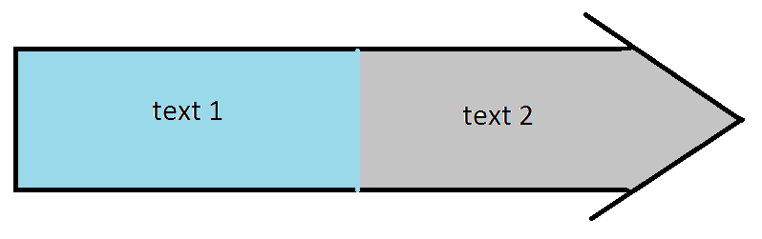
By 1585 the Crown had a cash reserve of £300,000 (in the black)
Lack of reform means ordinary revenue remains about the same, and cannot meet the cost of war
Increased use of extraordinary revenue to make up the shortfall

Increased expenditure going out
The late
(wartime) Elizabethan
Exchequer

Even with increased use of extraordinary revenue the cost of war means Expenditure is >er than Revenue = Growing debt - (in the red again)

Questions
- Study the diagram on the previous page with care. Write a paragraph to explain what it shows.
- How far does it support C Haigh’s argument that the failure to reform finance in the years of peace created “a hand to mouth existence” which ”had worked well only because it had not been tested. From 1585 it was”.

A diagrammatic representation of how the government raised extraordinary revenue to finance the Spanish War.

- Monopolies
Because financing the war was so expensive, Elizabeth increasingly used monopolies as a free form of patronage. S. Atkins defines a monopoly as a “royal patent for the sole right of exporting, importing, manufacturing, or distributing some particular article”. This meant that the monopolist could set prices without fear of competition. Unsurprisingly whilst monopolies were popular in Court, (where, for example, Raleigh had a monopoly on tavern licences, and the Earl of Essex had a monopoly on the import of sweet wines) they were hated in the country because they were often abused and damaged the economy.

This resentment was most clearly seen in 1601, when Elizabeth and Robert Cecil lost control of Parliament. When a list of the monopolies created since 1597 was read out, one MP, William Hakewill, interrupted, "Is not bread there?" and to then add, "If order be not taken for these, bread will be there before the next Parliament." Another MP dubbed the monopolists the "bloodsuckers of the commonwealth." Robert Cecil dammed the behaviour as “more fit for a grammar school as a parliament house”. Elizabeth finally gave in, and had to address Parliament personally, giving her famous Golden Speech. She then cancelled twelve monopolies overnight, halted others in the works, and made monopolists answerable to the common law courts.

Thus, monopolies caused serious economic and political problems for the government.
- Purveyance

Purveyance was the right of the Court to buy commodities at a price that they themselves set. It was meant to be used only in extraordinary times, such as war. However even before 1585 Elizabeth used purveyance widely (for example when on royal progress). Lockyer and O’Sullivan estimate that it saved the queen £40,000 p/a. It was possible to appeal against the prices set by royal purveyors in the Board of Green Cloth. However, as this was run by the royal household, few claims were successful.

After 1585, the war meant that the government started using purveyance legitimately, but on an even greater scale to purchase the materials needed to fight the Spanish. At times this had a disastrous impact on the economy. A good example here was iron production in the Weald area of Kent. Garrett Mattingley argues that the strength and purity of the metal produced there was central to the English defeating the Spanish (as it allowed the cannon on their ships to work in rollers and thus, they could be fired three times faster than the Spanish cannon). Indeed, the Crown did actually own a couple of foundries in the area. However, the war meant that Weald iron was in great demand, and the Crown’s purveyors were sent to fix the purchase price. The problem was that they set it so low that a number of foundries went out of business.

At the same time local areas were increasingly expected to raise their own taxes to pay for fortifications and militia, whilst ship money was extended to inland counties. Thus, just like monopolies, purveyance and increased local taxation did political damage to the government because it was seen as greedy and exploitative. Perhaps more importantly, purveyance distorted the economy, and in extreme cases, forced businesses to close down.

- Forced Loans

As costs of war rose Elizabeth was increasingly forced to resort to borrowing. The corporation of London lent her £200,000, but she also levied forced loans on her richer subjects. Lockyer and O’Sullivan estimate that this raised a further £330,000. Below is a typical Privy Seal for a forced loan from 1589.

...the intended invasion of this realm, upon the great preparations made by the King of Spain...means we need...loving subjects to furnish us by way of a loan. Wherefore we require you to pay the sum of £25.

Forced loans did little damage to the economy; however they made the Privy Council in particular unpopular with those receiving the orders to pay up.

- Selling of Crown lands

In an attempt to raise quick money, and to avoid increased taxation or forced loans, Elizabeth allowed the selling of over £600,000 of Crown lands to raise revenue. This had the advantage of being popular, but it was very short-sighted. It greatly undermined the future financial independence of the monarchy, as future monarchs would not get the rent from this land. As such, they would have to increasingly depend on Parliament. As R Sloan suggests, it was “a poisoned chalice” for the early Stuart monarchs.

- Multiple Subsidies

By far the bulk of this increased revenue (estimated at £2.5 million) came from extra supply from Parliament. Elizabeth became the first monarch in English history to be awarded multiple subsidies by the House of Commons. This was necessary because she had failed to update the Marian Book of Rates, but even so, in 1589 and 1593 Elizabeth was offered double subsidy rounds. In 1597 she was awarded a triple subsidy round, and in 1601, after the Monopolies Crisis and the Golden Speech, Elizabeth was awarded a quadruple subsidy.

The problem with this was that this was again unpopular and, as suggested, it increased the monarch’s dependence on Parliament. This was not really an issue in Elizabeth’s reign, but as Sloan continued, “Elizabeth’s success in papering over the cracks without major innovation created the mistaken impression that the Stuarts sought new taxes for selfish or dangerous purposes”.

Question

- After 18 years of war against Spain Elizabeth only left a debt of £350,000. Write a paragraph to explain your answers for each of the following questions.

    - What is the best argument that this was a success?
    - What is the best argument that it was a failure?
    - Now complete the ranking task on the following page. Do any of these methods of raising finance link together?

An analysis to contrast the achievements and failures of Elizabeth’s attempt to finance to Spanish War 1585 – 1603

Now label the see saw and explain your choice in the box below
(remember the heavier argument is the better argument)

......................................................................................................................................................................................................................................................................................................................................................................................................................................................................................................................................................................................................................................................................................................................................................................................................................................................................................................................................................................................................................................................................................................................................................................................................................................................................................................................................................................................................................................................................................................................................................................................................................................................................................................................................................................................................................................................................................................................................................................................................................................................................................................................................................................................................................................................................................................................................................................................................................................................................................................................................................................................................................................................................................................................................................................................................................................................................................................................................................................................................................................................................................................................................................................................

......................................................................................................................................................................................................................................................................................................................................................................................................................................................................................................................................................................................................................................................................................................................................................................................................................................................................................................................................................................................................................................................................................................................................................................................................................................................................................................................................................................................................................................................................................................................................................................................................................................................................................................................................................................................................................................................................................................................................................................................................................................................................................................................................................................................................................................................................................................................................................................................................................................................................................................................................................................................................................................................................................................................................................................................................................................................................................................................................................................................................................................................................................................................................................................................

Question

- What are the three most serious financial problems that Elizabeth faces in her reign? Explain your decision below, and then explain any links between them. Then complete the table on the following page.

......................................................................................................................................................................................................................................................................................................................................................................................................................................................................................................................................................................................................................................................................................................................................................................................................................................................................................................................................................................................................................................................................................................................................................................................................................................................................................................................................................................................................................................................................................................................................................................................................................................................................................................................................................................................................................................................................................................................................................................................................................................................................................................................................................................................................................................................................................................................................................................................................................................................................................................................................................................................................................................................................................................................................................................................................................................................................................................................................................................................................................................................................................................................................................................................

......................................................................................................................................................................................................................................................................................................................................................................................................................................................................................................................................................................................................................................................................................................................................................................................................................................................................................................................................................................................................................................................................................................................................................................................................................................................................................................................................................................................................................................................................................................................................................................................................................................................................................................................................................................................................................................................................................................................................................................................................................................................................................................................................................................................................................................................................................................................................................................................................................................................................................................................................................................................................................................................................................................................................................................................................................................................................................................................................................................................................................................................................................................................................................................................

Examiner Support – Know the standard
“The cost of war was the most important causes of Elizabeth’s financial problems” -Discuss
Below is the exam report and an example of an essay that probably did not get the mark that the candidate thought it would. It only achieved 9/20 – a grade D.
Read the exam report, the candidate’s answer and the examiner’s comment.
What did they do wrong?
How could you improve this script?
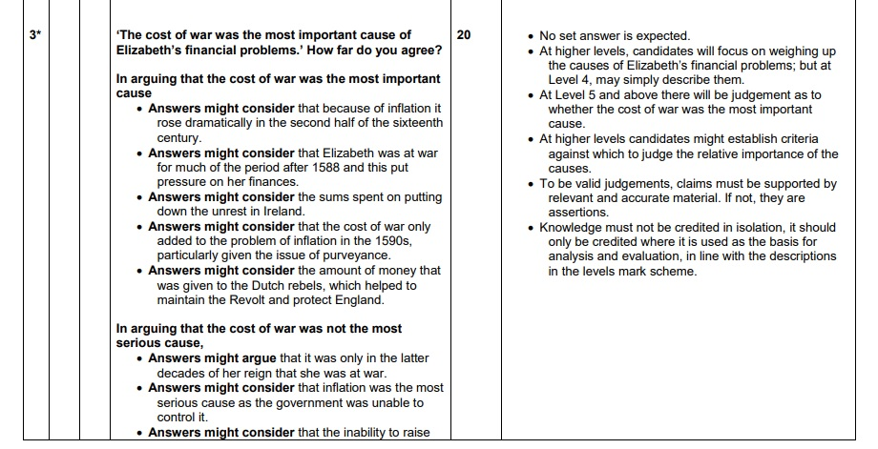
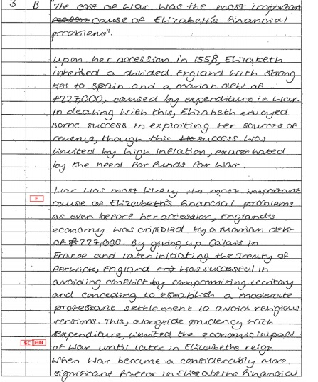

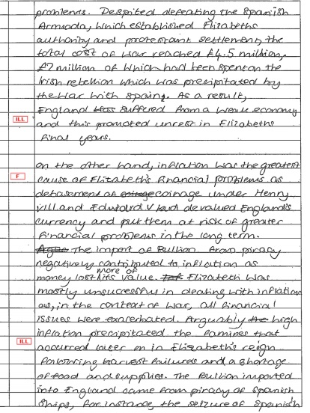

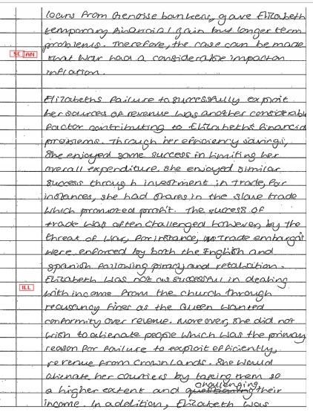

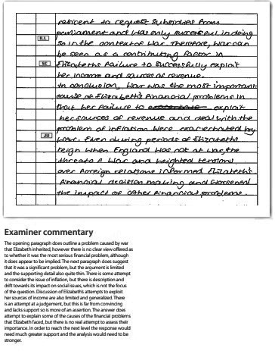
Now explain below what the student did wrong / how they could improve this script.
......................................................................................................................................................................................................................................................................................................................................................................................................................................................................................................................................................................................................................................................................................................................................................................................................................................................................................................................................................................................................................................................................................................................................................................................................................................................................................................................................................................................................................................................................................................................................................................................................................................................................................................................................................................................................................................................................................................................................................................................................................................................................................................................................................................................................................................................................................................................................................................................................................................................................................................................................................................................................................................................................................................................................................................................................................................................................................................................................................................................................................................................................................................................................................................................

Now attempt to complete the questions planning exercises.

January 2010
“Inflation was the most serious financial problem facing Elizabeth I and her government” - How far do you agree?
Examiner Guidance

No set answer is looked for but candidates will need to address the question.

There is a range of financial problems that candidates can consider, but they must give due attention to the named factor, even if they argue that it was not the most important. Inflation had a major impact on crown revenue and impacted on the cost of warfare, which would be a major item of expenditure at the end of the period. Inflation also had an impact on taxation returns, although some may suggest that it was Elizabeth’s failure to update assessments that was the bigger problem. Some may consider the problem of crown expenditure and selling of crown lands, others may look at customs or monopolies as issues.

Examiner Report

Most candidates were able to discuss a range of financial problems, although the degree of detail and precise support varied considerably.

There was usually a reasonable understanding of inflation, re-coinage was mentioned, but knowledge of earlier policies was thin and frequently inaccurate. Many answers argued that the cost of war was the most serious financial problem and were usually able to support this view with reference to the cost of the Spanish conflict and how it contributed to the debt Elizabeth left. The question of the taxation system was often well explained and the problems this created was often supported by reference to Cecil’s self-assessment for the subsidy. This was the ideal opportunity to link inflation and the problems of the tax system, but few seized the chance.

Key Words and Phrase:

Key issues to be discussed:

Linking and Relative Importance:

Line of Argument
 | Argument | Evidence deployed

Introduction
Tie the question to the factors

1

2

3

4

Conclusion
Direct answer to the question

The economy

The forty-five year period of Elizabethan England inevitably saw economic and thus social change. The government was not, like today, expected to have a joined up economic policy, however, they were expected to take responsibility for the following.

- As the earlier notes suggest, they were meant to control public expenditure and raise revenue when required.
- They were meant to control wages and prices.
- They were meant to relieve poverty and maintain public order.
- They were meant to protect and promote overseas trade.

Above all, the Tudors craved stability in economic and social matters, with the former informing the latter. Indeed, as Shakespeare states in Troilus and Cressida “take but degree (the social hierarchy) away, untune that string, and hark what discord follows”. Thus, we need to address the nature and extent of this change, and consider how the differing aspects of the economy link together. We need to understand the economic and social problems of the period, and ask how successfully the government dealt with them?

The diagram on the next page shows these problems as a series of separate economic and social challenges. In reality they were often linked. For example, increased continental demand for English wool products such as the new draperies and the broadcloths led to enclosure in the countryside. Some argue that this in turn led to rising food prices and more poverty and thus the need for new poor laws in the 1590s.

What is clear, is that we need to investigate the links between the different social and economic problems as well as the problems themselves.

Questions

- Write a paragraph to explain what the role of the government was in the Elizabethan economy.
- Study the diagram on the following page – can you suggest any other ways that these differing aspects of the economy may link together.

A diagrammatic representation of the differing social and economic problems faced in Elizabethan England.
Trade
How to respond to the closure of Antwerp?
The different social and economic problems

Industry
- How to encourage new industries
- The impact of the rise of London
Agricultural change
- Enclosure
- Rising food prices
- The development of new practices

“Sturdy beggars”
What to do about the rise of poverty?

How significant were changes in agriculture during the period 1553-1603 ?

“Our multitudes do infect our country with poverty. Our land hath not milk sufficient in the breast to nourish all”.

As the quotation above from Elizabeth’s contemporary Robert Gray suggests, the need to feed the growing population (see figure 6) and the rising food prices that this caused (see figure 7) were the major challenges for agriculture in the period. We need to understand how this “overwhelmingly agricultural country” (D Murphy) responded. In particular, we must consider the two major agricultural developments – the continued move to enclose fields and the local embrace of new agricultural methods.
Enclosure

“The poor at enclosing do grutch because of abuses that fall,
Lest some men should have but too much and some again nothing at all”

As consideration of figure 16 suggests, enclosure is a general term for the act of hedging, ditching and fencing the medieval open fields, common land and wasteland into consolidated and self-contained private farms. This was a controversial process which pre-dated Elizabeth’s reign, and continued into and beyond the Stuart age. At the time, as Thomas Tusser (above) suggests, it was certainly unpopular with many, and was often blamed for rising grain prices. The actions of the “grasping men” (Clapham) had led to Kett’s Rebellion in 1549, there were local anti-enclosure riots in 1597.
A village before (left) and after (right) enclosure
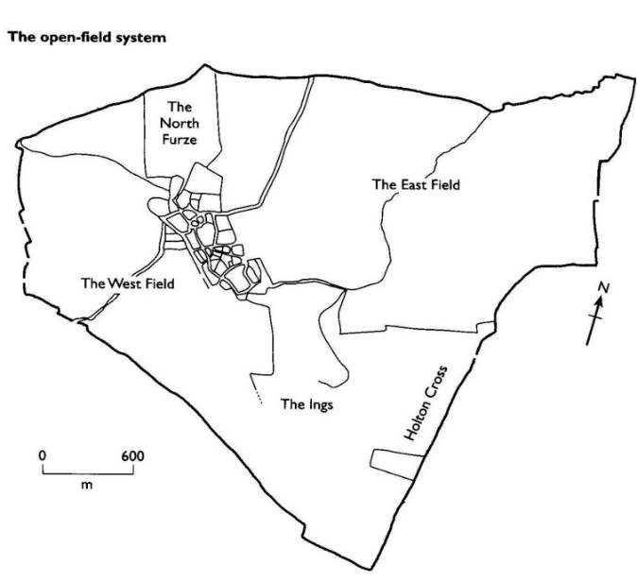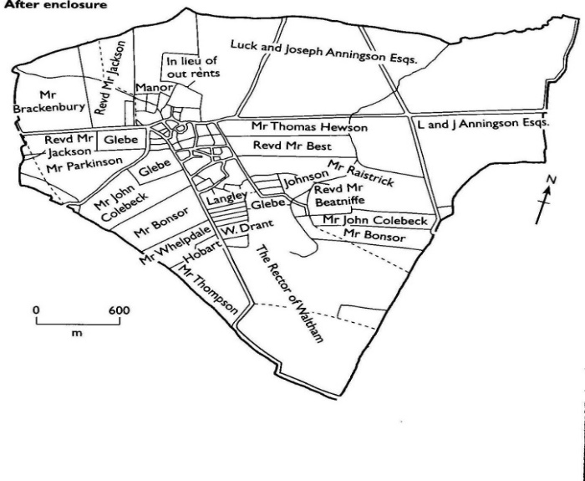

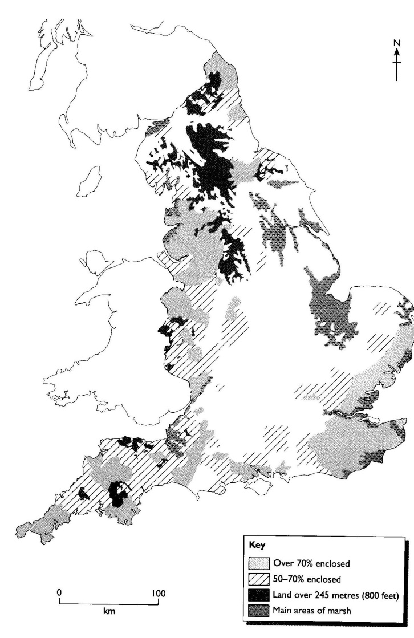
Why was enclosure so unpopular?
A map to show the extent of enclosure by 1600

- The fencing and hedging of common land meant that the very poorest lost their rights to graze their livestock. In times of shortage owning a goat or a cow could be the difference between life and death, and for this reason labourers fought hard to defend their common land rights.

- Another flash point was that tenants (the people who rented their land) had no legal claim to the land that they rented. This meant that they could face summary eviction and the destruction of their way of life by enclosure.

- If enclosure led to a move away from arable (crop) farming to pastoral (sheep) farming then many of the evicted would be left without jobs. This often increased the ranks of the urban poor – much to the concern of both the government and contemporaries.

- Finally enclosure was blamed – wrongly – for rising prices.

Why did landlords want to enclose their fields ?

The simple answer to this was that it usually was very profitable.

- The increased demand for English wool meant that the move to pastoral farming was rarely a risk. Moreover, sheep farming required far fewer labourers and thus had lower overheads.
- In addition, more recently historians have stressed that enclosure was followed by landlords to increase the amount of land under cultivation.
So, was enclosure really a problem?
The most common charge against enclosure was that it turned crops into sheep pastures because wool was a more profitable commodity. This led to the landowners profiting at the expense of the tenant farmers and labourers. In other words agricultural labourers were driven from their land by greedy sheep farmers.

Today few historians accept this argument. AGR Smith is typical when he describes this as “exaggerated and misleading”. As figure 17 shows, there were very real regional differences in the amount of enclosure undertaken. In addition, it is important to note that in Elizabeth’s reign “enclosures were usually carried out to increase the efficiency of arable farming”... because... ”the increase in population meant that corn was more profitable than wool” (B Mervyn). Thus, the policy that was blamed for rising prices in the food riots of 1595 – 1597, probably helped grain production to keep pace with the rising population.

However, in the as the case study on the following page shows, locally enclosure could be very unpopular.

Case study– 1602 – Robert Cecil and the enclosing of the Royal Park Brigstock

In 1602 the royal deer parks at Brigstock were granted by the Crown to Sir Robert Cecil with permission to enclose them. This effectively removed the rights of the villagers of Brigstock and Stanion within the parks. The pasturing of cattle and gathering of fuel were a crucial part of the village economy and the deer a valuable, if illegal, supplement to the diet. The community strongly resented the loss of these rights and were further incensed when Cecil promptly set about cutting down and selling the timber and underwood from Great Park. He also intended removing all the deer from Great to Little Park and leasing it to Sir Thomas Tresham.

There were protests, some of which escalated into riots. Cecil’s officers were attacked, deer were killed and carried home and at one point a ‘troop of lewd women of Brigstock’ were brought in to pressure the workmen in the parks! By the middle of 1603 the ‘bad people of Brigstock’ had by a combination of threat and persuasion been appeased, enabling Cecil’s enclosure and agricultural improvement to proceed.

So what should we think about enclosure ?

Today enclosure is not seen as a major economic problem for the Elizabethans. We think that by 1603, only 9% of England’s farmland had been enclosed. Moreover, there were no wholesale depopulation of villages in the reign. It was, at worst a local problem which hit the very poorest hardest because access to the common land was disproportionally important to them. Ironically, enclosure probably helped to create larger and more efficient arable farms. In addition, enclosure allowed new crops such as woad (used in dying) coleseed (used as fodder) and even tobacco to be experimented with. Moreover, where land was converted to pasture, it was often unsuitable for crops. The wool produced was usually exported, thus bringing European wealth into the country.

The picture is further muddled because the government was so confused about enclosure. As reference to Figure 12 shows, in 1563 they tried to legislate against it in the Act for Maintaining Tillage. The 1592 – 3 Statute regarding the Export of Corn repealed this law, and then in 1598 – after the food riots - the Statute against the Conversions to Pasture and the Statute Against the Engrossing of Farms again tried to outlaw enclosure.

An analysis to contrast the advantages and disadvantages of Enclosure

Now label the see saw and explain your choice in the box below
(remember the heavier argument is the better argument)

......................................................................................................................................................................................................................................................................................................................................................................................................................................................................................................................................................................................................................................................................................................................................................................................................................................................................................................................................................................................................................................................................................................................................................................................................................................................................................................................................................................................................................................................................................................................................................................................................................................................................................................................................................................................................................................................................................................................................................................................................................................................................................................................................................................................................................................................................................................................................................................................................................................................................................................................................................................................................................................................................................................................................................................................................................................................................................................................................................................................................................................................................................................................................................................................

What other changes were there in agriculture in Elizabethan England ?
Perhaps more significant than the emotive topic of enclosure where the other agricultural innovations that were happening across England at this time.
A spider-diagram to show other agricultural innovations in Elizabeth’s reign.
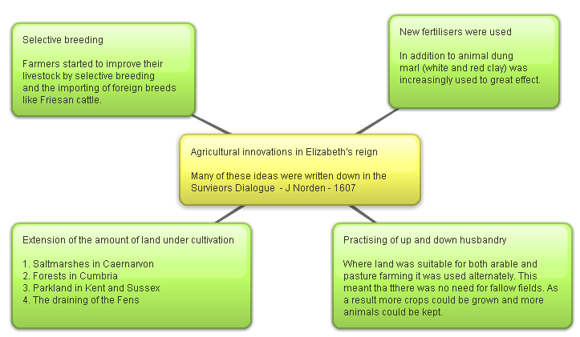
In addition, as London grew, the countryside of the Home Counties increasingly saw the development of specialised market gardens to keep the capital supplied with fresh fruit and vegetables. As William Lambarde described in his 1576 text A perambulation of Kent, there were “orchards of apples and gardens of cherries”.

Task
- Study the diagram above with care. Rank these improvements in order of importance (where 1= most important). Then write a paragraph below to explain your decisions. Which innovation did you disregard? Why?

......................................................................................................................................................................................................................................................................................................................................................................................................................................................................................................................................................................................................................................................................................................................................................................................................................................................................................................................................................................................................................................................................................................................................................................................................................................................................................................................................................................................................................................................................................................................................................................................................................................................................................................................................................................................................................................................................................................................................................................................................................................................................................................................................................................................................................................................................................................................................................................................................................................................................................................................................................................................................................................................................................................................................................................................................................................................................................................................................................................................................................................................................................................................................................................................

How far reaching were these changes?
For Eric Kerridge these changes were substantial and of great importance. He went so far as to argue that “the agricultural revolution took place in England in the sixteenth and seventeenth centuries” (from his 1968 work The Agricultural Revolution).

Today few would share this view, with G.E.Mingay and J Thirsk suggesting that he goes too far. Mingay argues that the rise of modern farming “can be seen as stretching back to the Sixteenth Century” but the important changes “gather pace later”. Thirsk sees the developments of the Elizabeth countryside as part of a broader Tudor “continuum” (i.e. it was not revolutionary). A.G.R Smith finds a comprise between these views by arguing that “we do not need to accept the concept of an agricultural revolution in early modern England to agree that during the sixteenth century English agriculture responded in notable ways to the challenges imposed by a rising population”.

Task
- Study again AGR Smith’s comments at the bottom of page 166. How far do you agree with him ? Write a paragraph blow to explain our answer.

......................................................................................................................................................................................................................................................................................................................................................................................................................................................................................................................................................................................................................................................................................................................................................................................................................................................................................................................................................................................................................................................................................................................................................................................................................................................................................................................................................................................................................................................................................................................................................................................................................................................................................................................................................................................................................................................................................................................................................................................................................................................................................................................................................................................................................................................................................................................................................................................................................................................................................................................................................................................................................................................................................................................................................................................................................................................................................................................................................................................................................................................................................................................................................................................

How significant were changes in industry during the period 1553-1603?

In the mid-Twentieth Century, J.U.Nef argued that Elizabethan England saw “a first industrial revolution”. He suggested that the development of coal and capitalism led to a change in the structure and organisation of industry as English manufacturing specialised and moved towards the factory system and the modern world.

Today few historians would accept such bold claims. Most coal was used for domestic heating (much of it was imported from Sweden) and the main sources of industrial power were water and wind. Elizabethan England was really still a pre-industrial society, where much of what was manufactured “consisted of the direct processing of agricultural products” (D.C.Coleman). As such, many brewers, millers, builders and above all textile workers also worked in agriculture as well as in industry. There was not really a clearly defined industrial sector. Rather, most industries were family businesses run by craftsmen (artificers). It was often seasonal, casual and labour-intensive work in a number of craft industries. Moreover, as the diagram on the next page suggests, most manufacturing processes were carried out in the home. This was known as the domestic or cottage system.
A 1990s school history book’s representation of the domestic system in the production of broadcloths.

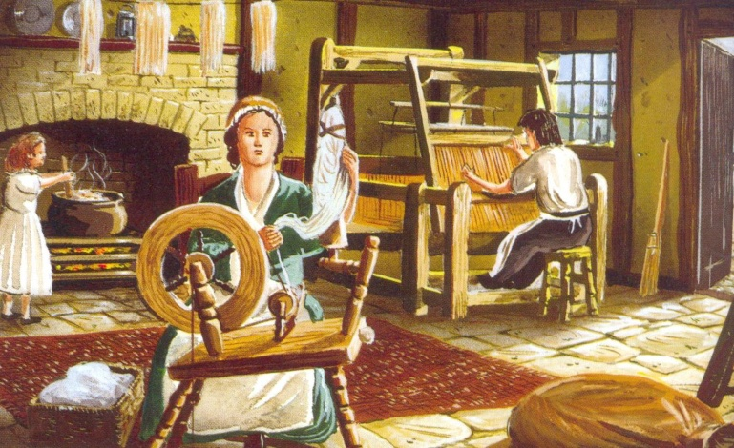

How did industry change in Elizabethan England?

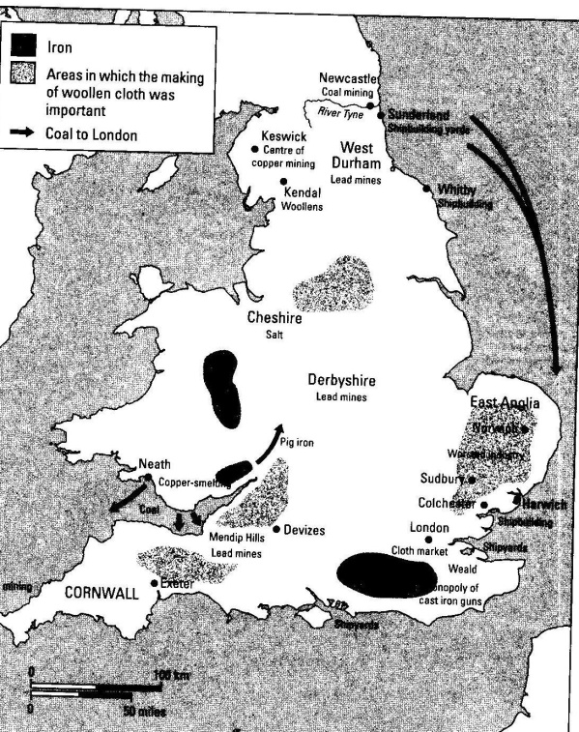
- The Textile industry. By far the most significant industry in Elizabethan England was the textile industry. This included spinning, weaving, and dyeing (all shown above) as well as tailoring and hatting. It was the biggest source of employment after agriculture, and, as Figure 20 shows, it was particularly important in East Anglia, the West Country and Yorkshire.

At the start of Elizabeth’s reign, England was noted throughout Europe for the production of broadcloths. These were thick woollen cloths which were usually exported unfinished.

However, whilst there was no major technical innovation in the industry in the reign, the migration of fleeing European Protestants from northern France and the Spanish Netherlands bought new skills and trading links. In particular, it led to the development of lighter fabrics known as the new draperies. From the 1560s, this industry sprang up in East Anglia and the South East. The thinner product was very popular in the warmer (and rich) southern European markets. At the same time, enclosure ensured that the English textile industry had the cheapest raw wool in Europe. As such, this was a time of growth and progress for the English textile industry.
a map to show woollen cloth, coal and iron production in Elizabethan England.

- Coal and metal production. The production of coal and iron was already well established in 1558. The main coal producing areas of England were Tyneside and Durham, and as Figure 20 suggests, 163,000 tonnes was shipped from Newcastle to London in 1597 – 1598 alone. Today it is thought that the sharp increase coal production shown in Figure 21 was not evidence of Nef’s “first industrial revolution”, but rather the consequence of the rising population shown in Figure 6.

At the same time, war with Spain from 1585 onwards contributed sharply to the increased demand for iron from the Weald in Kent. In 1560 there were only three iron smelting furnaces in the county. By 1590 this had risen to twenty six. By the 1590s London, Sheffield and Birmingham were all developing metal working industries. Equally, lead was required for shot, and from the 1580s production in the Mendip hills sharply increased.

Finally, the Privy Council itself deserves credit for encouraging foreigners with special skills to settle in England. They did this by giving them monopolies and patents. Perhaps the best example of this was that the copper industry in Cumbria was first developed by Daniel Hochsetter from the Tyrol region of Austria.

English and Welsh coal and iron output 1550 – 1650 (adapted from S.J.Lee’s The reign of Elizabeth I). In tonnes per annum.

Year | Coal extraction | Iron production
1550 | 170,000 | 5,000
1650 | 2.500,000 | 24 ,000

English and Welsh mining output 1500 – 1600 (adapted from DM Palliser’s Age of Elizabeth). In tonnes per annum.
Year | Lead | Tin | Copper
1500 | 625 | 600 | 3,300
1580 | 3,300 | 660 | 9,620
1600 | 12,400 | 550 | 11,860

Question

17. Re-read this section, and then write a paragraph to explain how industry changed in Elizabethan England.

Did the growth of London stunt growth elsewhere in Elizabethan England?
Yes | No
The only English industry of any note was the textile industry. The London-based Merchant Adventurers had a monopoly on cloth export, and shipped it in protected convoys from London. By the 1590s 93% of cloth exports went from London. This reflected much provincial decline. Smaller ports such as Rye and King’s Lynn complained that London took their trade.  Finally, as London was four times bigger than the next English city it had economies of scale. Migration meant that it had a never-ending supply of cheap labour, whilst banking, shipbuilding, brewing, catering and leisure industries grew up around the docks. No other city could compete. | However, it is important to note that some towns gained from the growth of London. Newcastle provided the capital with coal, whilst Manchester sent all its cloth there.  Moreover, whilst some provincial ports declined, others, such as Exeter and Bristol flourished with the new trade routes. Moreover, some inland towns also began to specialise. Nantwich grew up as the centre of the salt industry, whilst Reading developed a large leather and tanning business.  As such, the picture was mixed, and to claim London snuffed out other towns and cities is an unhelpful generalisation.

......................................................................................................................................................................................................................................................................................................................................................................................................................................................................................................................................................................................................................................................................................................................................................................................................................................................................................................................................................................................................................................................................................................................................................................................................................................................................................................................................................................................................................................................................................................................................................................................................................................................................................................................................................................................................................................................................................................................................................................................................................................................................................................................................................................................................................................................................................................................................................................................................................................................................................................................................................................................................................................................................................................................................................................................................................................................................................................................................................................................................................................................................................................................................................................................

How did English trade change in the Elizabethan period?

Task
Study the two maps below. List as many differences as you can.

Two maps to show the change in English trade (from B Mervyn). The first shows English trade in 1558, the second in 1603.

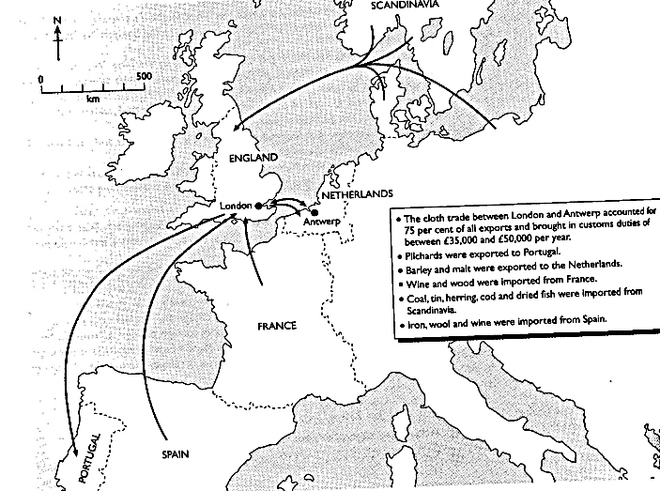

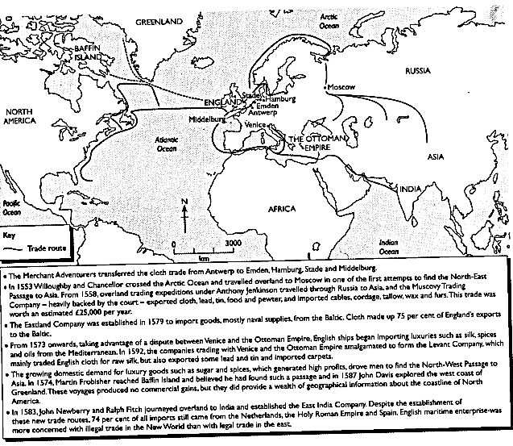

The development of overseas trade is an area of economic activity that is traditionally regarded as a success for the Elizabethan regime. It is important to stress that it was an objective of the goverment to promote exports and reduce imports to create a favouriable balance of trade. The idea was that these customs duties would give financial independence, whist the development of a merchant navy would improve the realm’s security. Whilst this is a generalisation, and there were failures, the dominant theme of trade in the peroid 1558 to 1603 was clearly one of progress and diversification that strengthened both the Crown and the state. As T Boddington comments “Elizabethan seamen contributed greatly to the wealth of the nation. In Elizabeth’s reign ships ventured into every part of the world on voyages of discovery, trade, piracy and slavery.”
The diversification of trade and trade routes
Foreign trade at the start of the Elizabethan age was homogenous and underdeveloped. The vast potential of the Americas was controlled by Spain, whilst the near and far eastern trade routes were dominated by the the Portuguese and Venetians. In short, England was a second rate power, taking the scraps of trade that other more powerful trading nations overlooked.
B Mervyn suggests that in 1558 75% of English exports went to Antwerp. This was unworked wool which was then converted into cloth and re-exported. Beyond the wool trade, England did export small amounts of barley (to the Spanish Netherlands) and pilchards (to Portugal). In addition, the Moscovy Company (founded in 1555) was starting to explore trade with Ivan the Terrible in Russia, and there was very limited trade along the Guinea Coast.
As the table below the nature of English trade developed quickly in Elizabeth’s 45 year reign. It should be seen as one of her great achievements, and laid the foundation for future prosperity.
Year | Trading Company / expedition | Success / Failure + analysis
1555  (Mary) | The foundation of the Muscovy Company started under Mary, but developed quickly at the start of Elizabeth’s reign. | A limited success – a new export market for English wool, but the attempt to establish an overland trade route to Persia failed.
From 1564 | Cloth trade moved from dependence on Antwerp. to Emden, Hamburg, Stade and Middleburg. | An accidental success. The on / off Spanish trade embargo from 1564 on English exports to Antwerp forced diversification.
1579 | Eastland Company established to trade with the Hanse in northern Germany and the Baltic. Import | A success – another export market for English wool, and as the map below shows, developed Eastern coast ports such as Hull.
1592 | The Levant Company formed from the companies trading with Venice and Turkey. Trades silks, spices and currants with the Ottoman Empire and new draperies directly to the Mediterranean. | A notable success. New rich markets opened up to finished English wool products. Weakened Spanish power, and developed a new English fleet.
1583 | Newberry and Fitch establish the East India Company. | Little impact on trade in the short term (75% of Indian trade still going through the Spanish Netherlands).

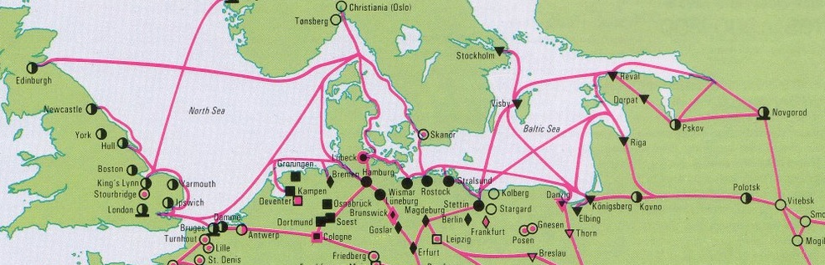
English trade with the Hanseatic League – note how it aided the development of Eastern ports. Eventually the Hanse were expelled from London.

Task
Construct a detailed spider-diagram to show how overseas trade diversified in the Elizabethan Age. Use each of the new merchant adventuring companies as an arm of your diagram.

18. “Developments in overseas trade was an unqualified success”
Write a paragraph to explain how far you agree with this statement.

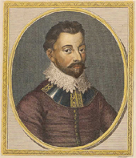
Explorer Case Study – Sir Francis Drake
Taken from - http://www.bbc.co.uk/history/historic_figures/drake_francis.shtml
Francis Drake was born in Tavistock, Devon in around 1540 and went to sea at an early age. In 1567, Drake made one of the first English slaving voyages as part of a fleet led by his cousin John Hawkins, bringing African slaves to work in the 'New World'. All but two ships of the expedition were lost when attacked by a Spanish squadron. The Spanish became a lifelong enemy for Drake and they in turn considered him a pirate.
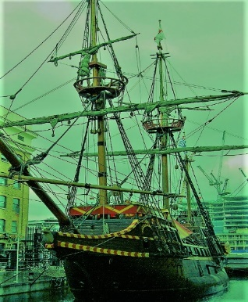
In 1570 and 1571, Drake made two profitable trading voyages to the West Indies. In 1572, he commanded two vessels in a marauding expedition against Spanish ports in the Caribbean. He saw the Pacific Ocean and captured the port of Nombre de Dios on the Isthmus of Panama. He returned to England with a cargo of Spanish treasure and a reputation as a brilliant privateer. In 1577, Drake was secretly commissioned by Elizabeth I to set off on an expedition against the Spanish colonies on the American Pacific coast. He sailed with five ships, but by the time he reached the Pacific Ocean in October 1578 only one was left, Drake's flagship the Pelican, renamed the Golden Hind. To reach the Pacific, Drake became the first Englishman to navigate the Straits of Magellan.
He travelled up the west coast of South America, plundering Spanish ports. He continued north, hoping to find a route across to the Atlantic, and sailed further up the west coast of America than any European. Unable to find a passage, he turned south and then in July 1579, west across the Pacific. His travels took him to the Moluccas, Celebes, Java and then round the Cape of Good Hope. He arrived back in England in September 1580 with a rich cargo of spices and Spanish treasure and the distinction of being the first Englishman to circumnavigate the globe. Seven months later, Elizabeth knighted him aboard the Golden Hind, to the annoyance of the king of Spain.

Discuss

How far is it correct to suggest that Francis Drake that Francs Drake is an over-rated Elizabethan?

Slavery
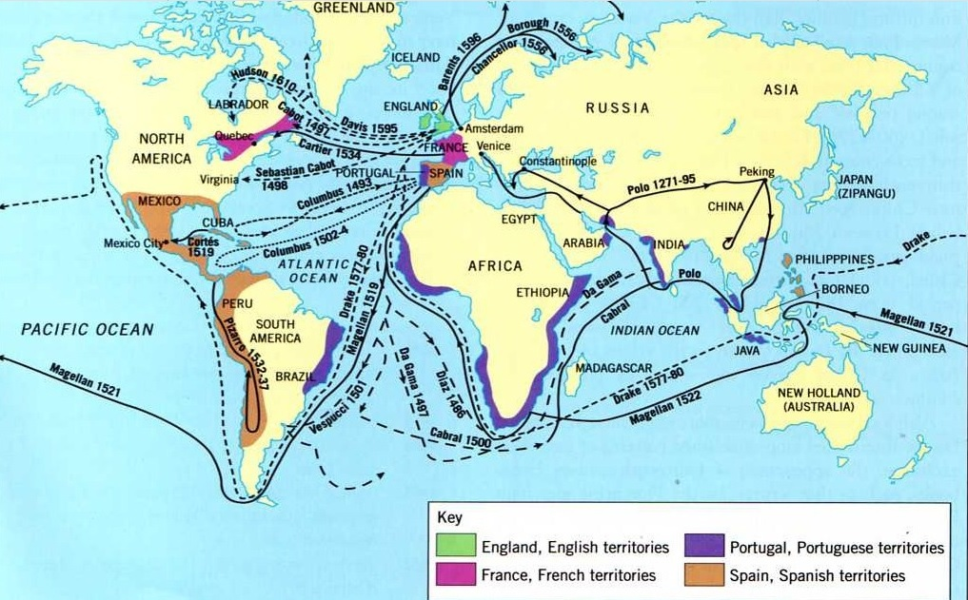

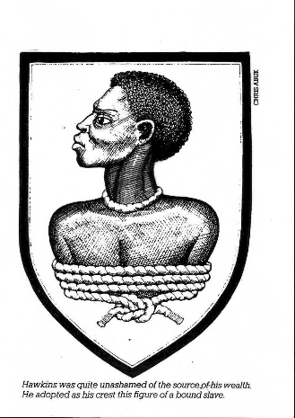 Britain’s involvement in the transatlantic trade in enslaved people from West Africa to the Americas began during the reign of Elizabeth I. This reality
John Hawkins – a merchant adventurer and later a naval administrator – was the first English trader. In 1562, while on a voyage to Hispaniola (Haiti), Hawkins added the transportation of captured Africans to his family’s trading interests in West Africa.

Royal support for Hawkins
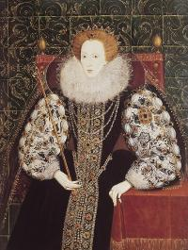
Elizabeth I, 1533-1603, supported Hawkins and profited from slavery. © NMM
A number of important people supported the venture, including:
- Benjamin Gonson, the Treasurer of the Navy
- Sir Thomas Lodge, who was Lord Mayor of London and the Governor of the Russia Company.
Elizabeth I also backed the voyage, expressing a hope that the Africans would not be enslaved without first giving their free consent. She believed that capturing Africans against their will 'would be detestable and call down the vengeance of Heaven upon the undertakers'.

The first slaving expedition
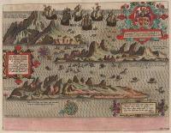
A map of the West Indies, c.1590. © NMM
Hawkins took three ships from London to Sierra Leone in West Africa. Despite whatever assurances he gave to Elizabeth I, Hawkins seized some 300 Africans 'by the sword, and partly by other means'. Many were taken from Portuguese boats.
Hawkins then crossed the Atlantic, selling the Africans into slavery in the Spanish West Indies. He returned to England with tropical produce such as ginger, sugar, pearls and hides, which he then sold to City merchants. Hawkins made a fortune in the process.

Hawkins’ second slaving voyage
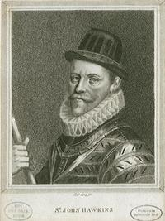
John Hawkins. © NMM
Such was the success of his first slaving voyage that Hawkins undertook a second in 1564-65. This time, Elizabeth I lent Hawkins a royal ship, the 700-ton Jesus of Lubeck. A group of wealthy London merchants and noblemen backed the expedition, expecting a healthy return on their investment.
Hawkins went back to Sierra Leone. He took about 400 captives through a combination of force, negotiation with African rulers and seizure from Portuguese vessels. Again it was highly profitable, producing a return of 60% on the original investment.
Hawkins made huge sums selling the enslaved Africans to the Spanish and then selling tropical goods in England. As a result he was knighted.

Hawkins’ third and unsuccessful voyage
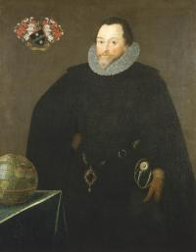
Sir Francis Drake, went on a slaving voyage in 1567-8. © NMM
A third slaving voyage in 1567-68 was a disaster. Hawkins sailed with six ships, including two royal vessels. Between 400 and 500 Africans were captured. Hawkins also seized a Portuguese slave ship.
On the return voyage, bad weather forced the ships into a port in Mexico. A Spanish fleet trapped the English adventurers there and the Spanish captured both the queen’s ships.
Only Hawkins’ ship and that of the young Francis Drake returned safely. All the English cargo was taken and the profit from the expedition was lost.

The trade in enslaved people and war with Spain
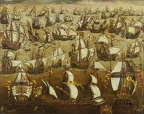
English ships and the Spanish Armada, August 1588. © NMM
Hawkins’ activities irritated the Spanish. They objected to the English breaking their monopoly of West Indies trade.
This growing dispute was one of the reasons for the long war between England and Spain from 1584 until the Peace of London in 1604.
During the conflict, English ships continued to target Spanish colonies in the Americas. This disrupted Spain’s commerce, including its trade in enslaved people. However, Hawkins’ failure brought an end to organized English involvement in the trade for some years.

REVISION
Study the questions below and highlight the key terms in them.
In the space below explain these questions are different

“The development of enclosure was the most significant economic policy of the Elizabethan Age”
Discuss.
“Enclosure policy was the most significant agricultural policy in the Elizabethan Age”
Discuss.

“The development of slavery was the most successful aspect of overseas trade in the Elizabethan age”.
Discuss.

………………………………………………………………………………………………………………………………………………………………………………………………………………………………………………………………………………………………………………………………………………………………………………………………………………………………………………………………………………………………………………………………………………………………………………………………………………………………………………………………………………………………

“Enclosure was the most significant economic development in the Elizabethan age” – discuss.

Key Words and Phrase:

Key issues to be discussed:

Linking and Relative Importance:

Line of Argument
 | Argument | Evidence deployed

Introduction
Tie the question to the factors

1

2

3

4

Conclusion
Direct answer to the question

“The development of the slave trade was the most significant development in overseas trade in the Elizabethan Age” – How far do you agree.

Key Words and Phrase:

Key issues to be discussed:

Linking and Relative Importance:

Line of Argument
 | Argument | Evidence deployed

Introduction
Tie the question to the factors

1

2

3

4

Conclusion
Direct answer to the question

“The development of the slave trade was the most significant development in overseas trade in the Elizabethan Age” – How far do you agree.

Key Words and Phrase:

Key issues to be discussed:

Linking and Relative Importance:

Line of Argument
 | Argument | Evidence deployed

Introduction
Tie the question to the factors

1

2

3

4

Conclusion
Direct answer to the question

For Elizabethen England

In the sixteenth century many people lived in a state of poverty that we find almost impossible to imagine.

There was no Welfare State or Social Security. People who could not earn enough to support themselves were forced to beg.
In 1598, the government passed a Poor Law. Local churches were told to appoint 'overseers' to look after the poor. The area looked after by each church was called a parish.
• The Impotent Poor (helpless people such as the old and blind) were to be paid a small amount of money by the parish, or given a licence to beg.
• The Poor by Casualty (such as wounded soldiers and sick people) were to be put in the parish workhouse.
• The Idle Poor (or 'sturdy beggars') were to be whipped or hanged.

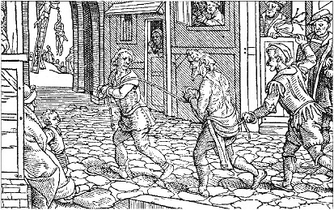
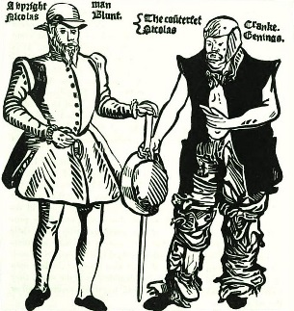
In 1592, Thomas Harman published A Warning for Vagabonds, about fake beggars who would trick you out of your money.
The picture shows:
• Bright Nicholas, who pretended to be an 'upright gentleman' down on his luck.
• A soap eater, who ate soap to make himself froth at the mouth as if he had epilepsy.
Other kinds of sturdy beggars included:
• Tom O'Bedlam (pretended to be mad).
• Whipjacks (pretended to be old sailors).
• Drummerers (pretended to be deaf).

From a letter written in 1596 by Edward Hext, a Justice of the Peace. 1596 was a time of famine in England.
This year there assembled 80 rogues who stole a whole load of cheese . . . .
I say that the large numbers of idle, wandering people and robbers are the chief cause of the food shortage, for they do not work but lie idly in ale-houses day and night, eating and drinking too much . . . .
And when they are put in jail, the poor country people they robbed are forced to feed them.

Act of Parliament, 1597
Every vagabond or beggar... shall be stripped naked from the middle upwards and publicly whipped until his or her body be bloody, and forth with sent to the parish where he was born... If any vagabond or beggar return again, he shall suffer death by hanging.
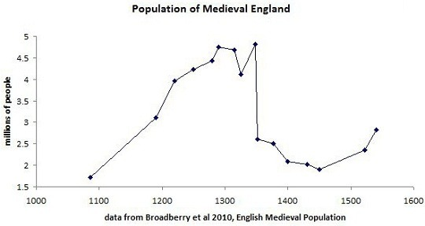
“Satan finds some mischief for idle hands to do.”
~ from Isaac Watts’s “Against Idleness and Mischief”, cited in Bertrand Russell’s “In Praise of Idleness”
During Elizabeth’s reign, the 1572 Vagabonds Act (Act for the Punishment of Vagabonds and for Relief of the Poor and Impotent) redefined vagabonds, somewhat distinguishing between “professional beggars” and the simply unemployed. And in the class of vagabonds, it now introduced rogues: all able bodied men “without land or master” who would neither accept employment nor explain the source of their livelihood. These “masterless men” included fortune tellers, peddlers, tinkers, workmen on strike, and “all fencers, bearwards, common players of interludes, and minstrels (…) wandering abroad without license”.
If a person were apprehended as a rogue, he would be stripped to the waist, whipped until bleeding, and a hole, about one inch diameter, would be burned through the cartilage of his right ear with a hot iron. A rogue who was charged with a second offense could be hanged, unless taken in by someone who would give him work for one year. A rogue charged with a third-offense would only escape death if someone hired him for two years. Note that, unlike the previous brutal punishments established by the Act of 1547, these extreme measures were enforced with great frequency.
With the Act of 1576, Justices of the Peace were authorized to erect a “house of correction” in every county for the punishment of those who refused work where “recalcitrant or careless workers” could be forced to work and punished accordingly. These were the precursors to the workhouses.
The Act of 1578 stated that “…vagrants were to be summarily whipped and returned to their place of settlement by parish constables” (aka beadles). And the Poor Relief Act of 1598 required churchwardens to set the poor to work — binding out pauper children as apprentices from the age of seven.
Also in 1598, the Act For the Punishment of Rogues, Vagabonds and Sturdy Beggars introduced penal transportation: it banished and transplanted “incorrigible and dangerous rogues” overseas — though the system of indentured service would take a few more years to be fully developped. And there were some procedural changes: persons were not to be publicly whipped naked, as previously, but from the middle upwards, and whipped until the body should be bloody. It was at this time that the whipping-post started substituting the cart. Whipping-posts soon became plentiful.
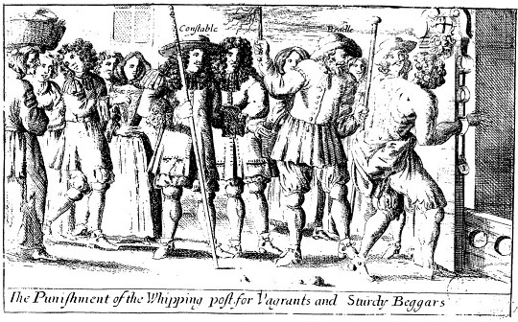
The Elizabethan Poor Law of 1601 is often cited as the beginning of the Old Poor Law system — this legislation lasted for almost two centuries. It clearly distinguished between the “deserving” and “undeserving” poor: the former deserved aid, the latter were rogues, vagabonds, and beggars who were to be whipped or otherwise punished for their unwillingness to work. Able-bodied beggars who had refused work were often placed in Houses of Correction. Of course, refusing “work” meant any work offered, which was typically on appalling terms. In the end, deciding who deserved what was up to the Overseers of the Poor, usually churchwardens or landowners, who had zero incentive to be generous or fair. They tended to recognize as few “deserving” poor as possible (since they’d be responsible for them as Overseers, plus taxed for them as landowners), and were prone to tyrannical behaviour.
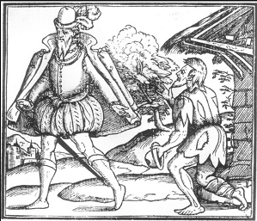 Social and economic legislation occupied a great deal of time in Elizabethan Parliaments and was considered, after the granting of taxation, to be the primary function of the House of Commons. Hundreds of bills were initiated concerning industries such as the manufacture and trade of cloth, leather, and iron; poverty, unemployment and vagrancy; agrarian regulation of land use especially for grain and timber; and the enforcement of morally acceptable behaviour. While some such measures were official in origin, many others arose from particular local issues or were promoted by interested parties, especially companies and corporations, who lobbied for advantageous changes to the law. Arguments over such bills could be particularly contentious, and previously enacted statutes were frequently challenged and revised. Building upon a body of early Tudor ‘commonwealth’ debate and legislation the Elizabethan period produced several landmark Acts such as the Statute of Artificers (1563); the legalization of usury (1571); and a definitive Poor Law (1601).
A policy document among the papers of Elizabeth’s closest advisor, Sir William Cecil, entitled ‘Considerations delivered to the [1559] Parliament’ set out a programme of reforms to be undertaken, including measures to ensure social stability, to bring trade and commerce under greater control, and to improve the education of the nobility and gentry. Not all of its recommendations were ever implemented; nevertheless its influence can be traced through eight statutes passed in 1559 (concerning shoemakers, tanned leather, leather exports, sweet wines, linen cloth, iron mills, English shipping, and the preservation of fish spawn) and a platform of measures enacted in the 1563-6 Parliament that have since been dubbed the ‘Elizabethan economic settlement’. (Tudor Economic Documents, ed. R.H. Tawney and E. Power, i. 325-30.) Perhaps the most significant of these, the Statute of Artificers, was devised by the Privy Council and combined two bills that had failed in 1559 with various additions during its passage through the Commons to produce a cohesive set of regulations concerning labour, apprenticeship and wages. The Navigation Act of 1563 was also promoted by Cecil, particularly a controversial clause introducing the compulsory eating of fish on Wednesdays, or ‘political Lent’ which became known as ‘Cecil’s fast’.
Legislation to relieve poverty was enacted in 1563, 1572, 1576, 1598 and 1601. The Poor Law of 1563 consolidated an array of preceding measures. Upon its expiry in 1571 an alternative was debated but defeated only to re-appear as an official initiative in 1572. The latter introduced compulsory levies for the poor, to be enforced by secular authorities. A further statute enacted in 1576 ‘for setting the poor on work and for the avoiding of idleness’, was probably based upon an idea first proposed in 1571 by Sir Francis Knollys as an attempt to finance a general welfare system. Around a dozen bills concerned with poor relief were considered by the Commons in the 1597-8 Parliament, resulting in the enactment of four new statutes plus the continuation of expiring Acts for the relief of maimed soldiers and mariners. The 1601 Poor Law codified previous measures and remained on the statute book until 1834. (S. Hindle, ‘Poverty and the Poor Laws’, in The Elizabethan World, ed. S. Doran and N. Jones, 301-15.)
The regulation of land use before and after the Tillage Act of 1563 was intended to prevent the conversion of arable to pasture, and any resulting ‘depopulation’ or displacement of rural labour. For much of the sixteenth century enclosures were the target of occasional uprisings and hostility, particularly at times of dearth, and agrarian legislation reflected an attempt to resist the rise of new types of ‘convertible’ husbandry favoured by enclosing landlords who could make greater profits from grazing sheep and growing an ever increasing variety of cash crops. However, such measures became increasingly difficult to enforce, and by 1593 they were quietly repealed without much notice. It was only after a run of dire harvests and an outbreak of anti-enclosure rioting that two traditional measures for the maintenance of husbandry and tillage reappeared on the parliamentary agenda in the 1597-8 Parliament, and eventually passed after heated debate and extensive redrafting. They remained in force following further debate in 1601, despite cogent arguments for their repeal and long haggling over various exemptions and provisos.
A significant percentage of social and economic legislation was the product of increasingly sophisticated lobbying by interest groups, especially London companies such as the Clothworkers, who were prepared to devote considerable resources towards securing the enactment of favourable measures, sponsoring bills in successive Parliaments over a period of decades. (I.W. Archer, ‘London Lobbies in the Later Sixteenth Century’, Historical Journal, 31 (1988), 17-44.) The corporation of London itself was behind an attempt in 1593 to prevent strangers from retailing their wares in the capital. After lengthy debates this was passed by the Commons only to be rejected by the Lords. (Proceedings in the Parliaments of Elizabeth I, ed. T.E. Hartley, iii. 134-9, 142-4, 145-8.)
Other examples of bills that were thwarted by disagreements between the two Houses include sumptuary legislation proposed in 1576, 1589 and 1597-8 intended to restrict what apparel may be worn according to social status. In general many more bills of this kind failed than were enacted, and those that did pass tended to be short-lived. In particular the 1560s and 1590s were periods of intense economic hardship which produced bouts of palliative legislation; once these crises had passed the continued enforcement of penal measures by informers and promoters occasionally became a grievance. There was also increasing concern about the passage of too many laws; standing committees for the continuance and repeal of old statutes became a regular fixture by the end of the reign.

Author: Rosemary Sgroi

Further Reading

There are copies of these book (and lots of others on Elizabeth) in the school library

The Later Tudors – P Williams
Chapter VI – Tudor Society

The Emergence of a Nation State –AGR Smith
Chapter XX - Population, prices and agriculture
Chapter XXI – Industry and trade

England and Wales under the Tudors – S Atkins
Chapter XVII – Economic and social history in Tudor England

Or online you could click onto the following site

An excellent article from History Today

https://www.historytoday.com/archive/poverty-elizabethan-england
Exam Season | Question
June 03 | How successfully did Elizabeth deal with her financial problems?
Jan 06 | How well did Elizabeth I’s government handle its financial problems?
 | The questions below come from a more detailed unit of study only on the Tudor economy.
Jun 04 | How significance were the changes in agriculture during the period 1547 to 1603?
Jan 05 | Assess the claim that Elizabeth’s government was completely unsuccessful in dealing with the problem of poverty during her reign.
Jan 05 | Assess the reasons why rising prices caused problems for many social groups during the period 1547 to 1603.
Jun 08 | How far had the English economy recovered by 1603 from the collapse of the Antwerp cloth market?  Explain your answer.

January 2010
“Inflation was the most serious financial problem facing Elizabeth I and her government”
How far do you agree?
January 2011
How successfully did Elizabeth I handle the financial problems she faced?

January 2012
Assess the causes of Elizabeth I’s financial problems

June 2012
How serious were the financial and economic problems during the reign of Elizabeth?

TITLE:
June 2012
How serious were the financial and economic problems during the reign of Elizabeth I ?
Examiner Guidance

At the higher levels candidates should address the question of ‘how’ and not simply list the financial and economic problems. Candidates might argue that, until 1588, the financial problems were not serious and even afterwards they were handled well so they were not serious.

However, some may argue that they were serious as Elizabeth failed to tackle them and allowed them to worsen. This could be supported by the large debt of £350,000 she left her successor. Some might balance this against her inheritance and argue that because it was not much larger than the one she inherited and was considerably less than continental rulers the problem was not serious. The problem of the taxation system was serious as it had not been updated. It could be argued that by asking fewer to pay subsidies she made the problem worse. At the same time, Crown lands were sold, reducing royal income; it may have reduced the seriousness in the short term, but added to long term difficulties.

Candidates may point to the high rates of inflation, particularly at the end of the period, which were the worst of the century. Agricultural prices were rising at an alarming rate and, added to harvest failures made the 1590s the worst decade of the century. This problem cannot be overestimated as there is evidence of people dying from starvation. The problems were made worse by the continued expense of war with Spain and the problem of dealing with unrest in Ireland.

Examiner’s Report
This question produced many general answers and some strong responses. Informed answers discussed social and economic issues – decline of cloth trade; moving the staple from Antwerp due to Netherlands Revolt; the rising population; Inflation; the effects of the long war against Spain 1585-1604; social instability and the Poor Laws of 1598 and 1601; the drift to the towns.

Some answers failed to distinguish between financial and economic problems. Those that did so seemed better equipped to deal with the latter. Although candidates were aware of the importance of inflation, they seemed uncertain about its effects. In particular, few candidates were aware of the dramatic fall in the value of the subsidy or of the weakness of the system of assessment which was too deeply ingrained in the structure of local government to be eradicated. Some candidates looked at Elizabeth’s financial problems and others discussed England’s as a whole. However, the greatest discriminator was whether candidates were able to assess the severity of the problems, rather than simply explain what the problems were or what had brought them about. Many tried to compare these problems with others like religion and hence had long irrelevant sections. It was a common tactic to look at causes of problems, such as foreign policy, rather than consider how serious the problems were. Above all there was little understanding or discussion of inflation in the period. Many candidates don’t know the difference between economic and economical.

Key Words and Phrase:

Key issues to be discussed:

Linking and Relative Importance:

 | Argument | Evidence deployed

Introduction

Tie the question to the factors

1

2

3

4

Conclusion

Direct answer to the question

Student

Concerns

TITLE:
“Enclosure was the most serious economic problem that Elizabethan England faced”
How far do you agree ?

Key Words and Phrase:

Key issues to be discussed:

Linking and Relative Importance:

 | Argument | Evidence deployed

Introduction

Tie the question to the factors

1

2

3

4

Conclusion

Direct answer to the question

Student

Concerns

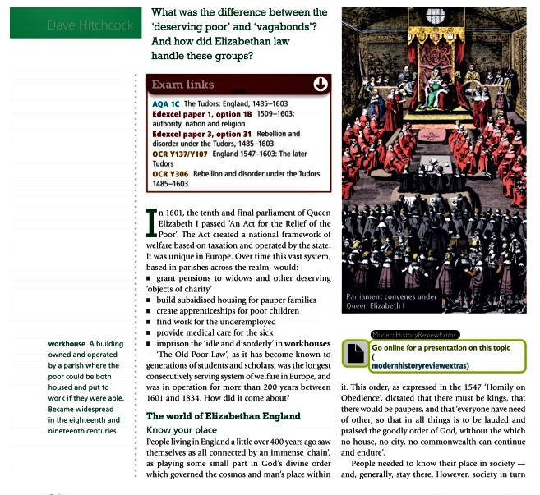
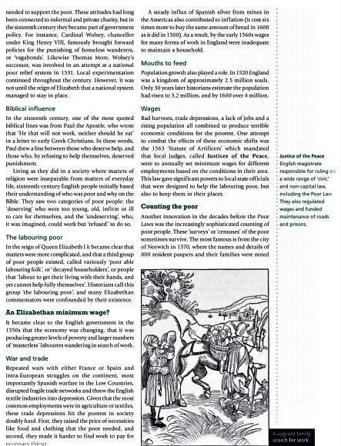
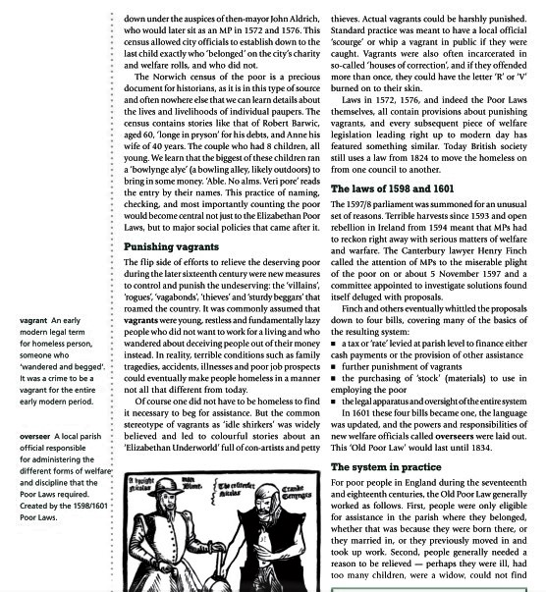
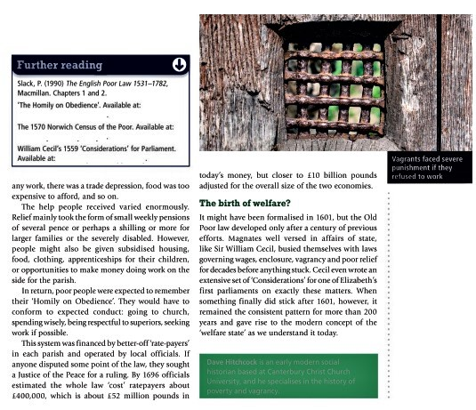
Below is a sample essay that I wrote when the curriculum change was introduced in 2016
I was trying to understand the new mark scheme and here a new topic. As such it very much a work in practice (for example it is too long – 47mins rather than 40mins)
Task
Can you please read it and then give it a level / mark.
- What do you like?
- What would you improve /change? Why?

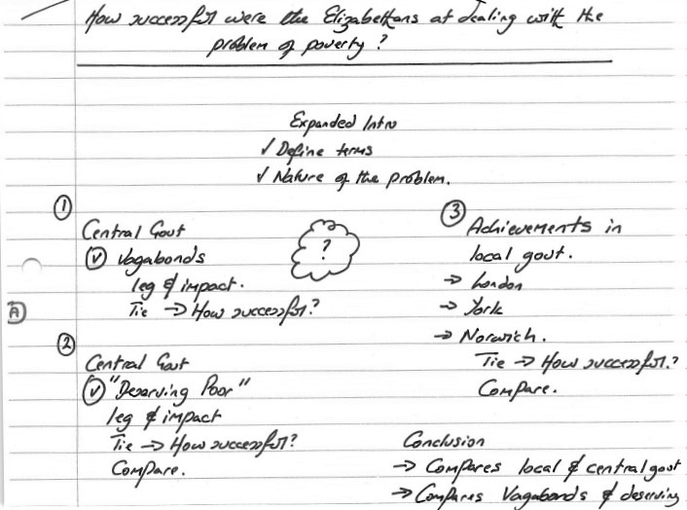
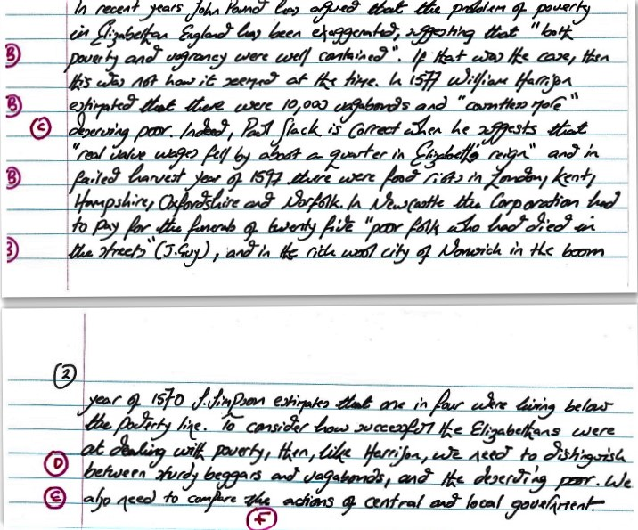
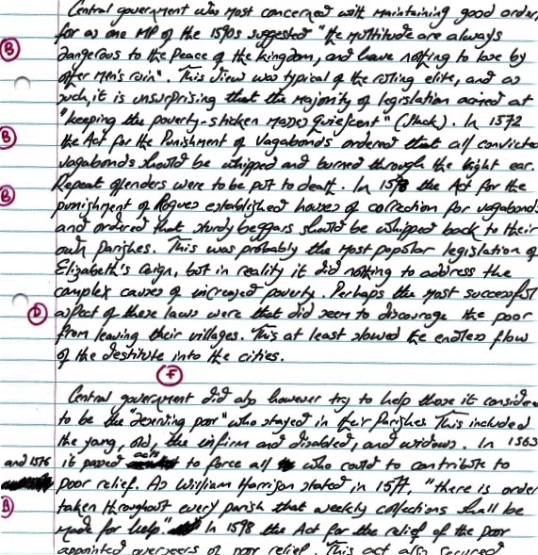
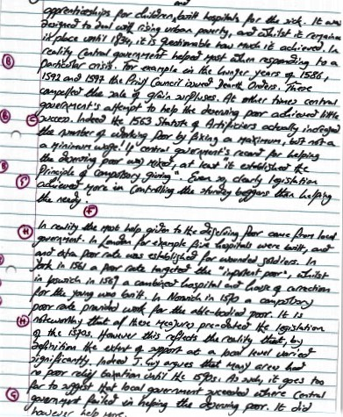

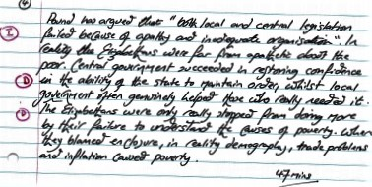
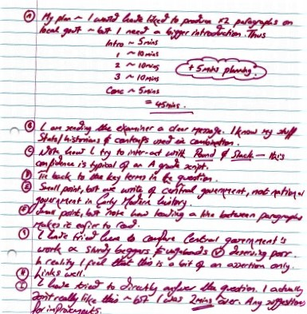
Glossary of words used in this booklet
You should understand these, and be able to use them correctly when you write
Administrative | How the decisions of government were effected / made to happen.
Arable farming | The growing of food crops such as wheat and barley. The price of food was determined by the interaction of its supply (the amount produced) and the demand (the population).
Autocrat | A ruler who has absolute power.
Context | The background to an event which are required to fully understand it.
Customs duties | These were taxes on imports. The most important was the Tonnage and Poundage duties. At the start of each reign, Parliament voted the profits from these to the monarch. They were an essential part of Elizabeth’s ordinary revenues.
Debasement | The act of adding non-precious metals (such as lead) to the coinage of the land. This increased the spending power of the monarch, but led to inflation.
Effective | Achieves the desired results as successfully as possible
Enclosure | The act of hedging, ditching and fencing the Medieval open fields and Common land into self-contained private farms.
Executive power | The power to decisions on matters of state
Inflation | An increase in prices. In Elizabeth’s reign prices rose 75%
Monopolies | This was “royal patent for the sole right of exporting, importing, manufacturing, or distributing some particular article”; (S Atkins). Monopolists could thus set their own prices, and were often very unpopular as a result – in 1601 one MP famously called them “the bloodsuckers of the commonweal”. Elizabeth often used monopolies as a free form of patronage. For example, the Earl of Essex held the monopoly right for the import of sweet wines (sherry) until it was withdrawn from him as a punishment for disloyalty in 1601.
Pastoral farming | The keeping of animals. In Elizabethan England this usually meant sheep for the wool trade. Often the sheep were kept in enclosed fields.
Patriarchy | A society or government controlled by men.
Patronage | The power to control appointments to offices or privileges. The different types are explained on page 42.
Politic skills | The skills of an effective politician – pragmatism and the power to persuade.
Precedent | A first example that sets the standard for future actions.
Prorogue | To discontinue a session of parliament without dissolving it.
Purveyance | This was the right of the Court to buy commodities at a price they themselves set. It was meant to be used only in extraordinary times, such as war. However, Elizabeth used purveyance more widely (for example when on royal progress).
Rack renting | A form of tenure where the rent was not fixed. In theory this allowed for flexibility depending on economic climate. In practice however, many landlords kept rent at a maximum.
Royal prerogative | The executive powers of government, possessed by and vested in a monarch.
Subsidy | A parliamentary taxation round. Sometimes known as supply or Tenth and Fifteenths (tax was meant to be a tenth of the value of moveable goods in urban areas and a fifteenth in rural areas).
Tillage | Land under plough in arable farming.
Usury | The act of lending money at an unreasonably high rate of interest.
Wardships | Principle landowners were technically tenants in chief of Crown, who held their land in return for military service. Underage heirs could not do this military service, so the land was held under royal ward. This wardship could be sold, or exploited for profit. As such, they were a useful additional to the Crown’s ordinary revenue.
Faction | Fluid alliances around “great men” – they were usually motivated by access to patronage. Occasionally they were motivated by policy – for example, the Earl of Leicester’s desire for a more aggressive / Protestant foreign policy in the 1580s.
Chantries | Small chapels in the Catholic faith where prayers are said for the dead to ease their passage through purgatory.
Convocation | A meeting of important clergy – it is really seen as the Church’s parliament.
Ordinal | Details of what the religious service should be followed.
Jesuits | Society of Jesus – from the 1570s it sent priests into Elizabethan England to keep Catholicism alive / undertake missionary work.
Presbyterianism | A branch of Puritan thought that rejects the Crown’s / bishops authority in religious matters. Rather, they believe that Church should be administered locally by the minister with a group of elected elders of equal rank.
Prophesying (preaching service) | Prophecyings were religious training exercises favoured by Presbyterians. For a given Biblical text, a number of sermons would be given, which were then analysed by those present, under the guidance of a moderator
Transubstantiation | According to the teaching of the Catholic Church, "the change of the whole substance of bread into the substance of the Body of Christ and of the whole substance of wine into the substance of his Blood”. This idea of transubstantiation was rejected by Protestants.

