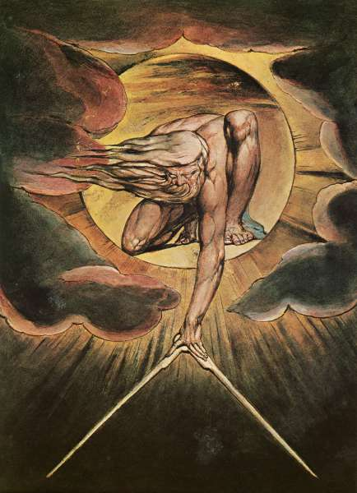
AS Philosophy – Philosophy of Religion
Personal Learning Checklist

Student Name:

Subject Name:  AQA Philosophy | Unit Name:  Philosophy of Religion
Minimum Target Grade: | Aspirational Target Grade:

Knowledge/Specification | Not Yet | Not Sure | Yes | To address this before the exam I will:-
THEME 1 – THE CONCEPT OF GOD
Key Concepts:
Omniscient
Omnipotent
Supremely good
Timeless (eternal)
Within time (everlasting
1.1 God as omniscient, omnipotent, supremely good, and either timeless (eternal) or within time (everlasting) and the meaning(s) of these divine attributes.
Issues with claiming that God has these attributes, either singly or in combination, including:

- The paradox of the stone

- The Euthyphro dilemma

- The compatibility, or otherwise, of the existence of an omniscient God and free human beings.
Knowledge/Specification | Not Yet | Not Sure | Yes | To address this before the exam I will:-
THEME 2 – ARGUMENTS RELATING TO THE EXISTENCE OF GOD
Key Concepts:
Ontological arguments
Cosmological arguments
Design arguments
Problem of Evil

2.1 Ontological arguments, including those formulated by:

- Anselm
- Argument in Proslogion 2

- Argument in Proslogion 3

- Descartes
- Argument in Meditations V

- Leibniz
- Extension of Descartes’ argument

- Malcolm
- Update of Anselm’s ontological argument from Proslogion 3

- Plantinga.
- Using possible worlds in an ontological argument – in God, Freedom and Evil

Knowledge/Specification | Not Yet | Not Sure | Yes | To address this before the exam I will:-
- Issues with the Ontological Argument, including those raised by:

- Gaunilo
‘On Behalf of the Fool’ – the Perfect Island objection.

- Hume
Dialogues Concerning Natural Religion – Reason alone cannot demonstrate the existence of things

- Kant
Critique of Pure Reason – God’s existence can be denied without contradiction. And existence is not a predicate.

Knowledge/Specification | Not Yet | Not Sure | Yes | To address this before the exam I will:-
2.2 The arguments from design: arguments from purpose and regularity, including those formulated by:
- Paley
- Natural Theology’s Argument from analogy

- Swinburne.
- The Existence of God’s Argument from regularities of succession

- Issues with the Argument from Design, including those raised by:
- Paley (himself)
Paley’s anticipations of problems with the analogy

- Hume
Dialogues Concerning Natural Religion:
  - Weakness of the analogy

  - Argument from Effect to Cause

  - Alternative explanations for apparent design

  - A perfect God cannot be inferred from an imperfect creation

Knowledge/Specification | Not Yet | Not Sure | Yes | To address this before the exam I will:-
2.3 The cosmological arguments: causal and contingency arguments, including those formulated by:

- Aquinas’ Five Ways (first three)
- Summa Theologicae’s
  - Argument from motion

  - Argument from efficient causes

  - Argument from contingency and necessity

- Descartes
- Meditations 3 – Descartes’ Causal Principle.

- The Kalam argument.
- Al-Ghazali’s argument that everything has a cause so the universe has a cause

- Issues, including those raised by:

- Hume
Dialogues Concerning Natural Religion and an Enquiry Concerning Human understanding
- The link between cause and effect can be questioned.

- The universe does not need an explanation.

- The argument contradicts itself.
Knowledge/Specification | Not Yet | Not Sure | Yes | To address this before the exam I will:-
- Russell.
1948 Radio Debate with Copleston
- Only propositions can be necessary

- Fallacy of composition

- There might be some events that do not need a cause

- The universe is a brute fact

The problem of evil: how to reconcile God’s omnipotence, omniscience and supreme goodness with the existence of physical/moral evil.

- The logical problem of evil from J.R Mackie’s Miracle of Theism

- The evidential problem of evil from William Rowe

Responses to the Problem of Evil and responses arising from those responses, including:

- The Free Will Defence (Plantinga’s God, Freedom and Evil)

- Soul-making (Hick’s Evil and the God of Love)

Knowledge/Specification | Not Yet | Not Sure | Yes | To address this before the exam I will:-
THEME 3 – RELIGIOUS LANGUAGE
Key Concepts:
Logical positivism
Verification
Falsification
Bliks
Eschatological verification
3.1 Logical positivism: verification principle and verification/falsification (Ayer) – cognitivist accounts of religious language

- Logical Positivism and Verificationism from the Vienna Circle and A.J.Ayer’s Language, Truth and Logic
- Issues with Logical Positivism and Verificationism
- Religious statements are verifiable eschatologically (Hick)
- Flew’s Falsification Principle and the University Debate:
  - Flew on Wisdom’s Gods – religious statements are not falsifiable
  - Hare’ s Bliks – Non-cognitivism: religious statements express viewpoints about the world
  - Mitchell’s Parable of the Partisan

Knowledge/Specification | Not Yet | Not Sure | Yes | To address this before the exam I will:-
3.2 Non-cognitivist accounts of religious language

- Wittgenstein (Philosophical Investigations) – Religious language as a form of life in a language game.
- Braithwaite’s view that religious statements express commitments
- Crombie’s view that religious language is not meaningless (against the critics)

REVISION
Use the information on this checklist to make revision cards and notes
Grade tracking:

Grade | Date | Grade | Date | Grade | Date

Grade | Date | Grade | Date | Grade | Date

Note: You should discuss this checklist regularly with your subject teacher/mentor

