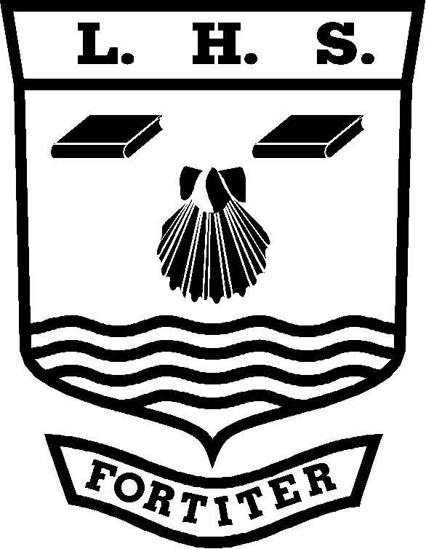
Little Heath Sixth Form
(Geography) Personal Learning Checklist

Student Name: ……………………….…………………………………..………

Unit Name:  Unit 1 Physical and Human Geography  Topic: Coastal Environments. | Unit Code: GEOG1
Minimum Target Grade: | Aspirational Target Grade:

KEY: Red = with difficulty Amber = not sure Green = yes

GCSE Re-Cap (Skills and Knowledge) | Red | Amber | Green
- Coastal processes.
- Features of erosion.
- Features of deposition.
- Coastal recession.
- Coastal management.

Skills | Red | Amber | Green | To address this before the exam I will:-
- Literacy skills- extracting information from a text.

- Ability to annotate photographs and sketches.

- Ability to interpret, describe and comment on information from graphs e.g. line graphs, bar graphs, scatter graphs, pie charts, triangular graphs, radial diagrams, logarithmic scales, dispersion diagrams.

- Ability to interpret, describe and comment on information from maps e.g. atlas maps, base maps, sketch maps, OS maps, maps with proportional symbols, maps showing movement, choropleth, isoline and dot maps.

Knowledge/Specification

- The coastal system – constructive and destructive waves, tides, sediment sources and cells.

- Coastal processes – marine erosion, transportation and deposition; land-based sub-aerial weathering, mass movement and runoff.

- Landforms of erosion: headlands and bays, blow holes, arches and stacks, cliffs and wave cut platforms. Landforms of deposition – beaches and associated features: berms, runnels and cusps,
spits, bars, dunes and salt marshes.
- Case study of coastal erosion – specific physical and human cause(s) and its physical and socio-economic consequences.
- Sea level change – eustatic and isostatic change. Coastlines of submergence and emergence and associated landforms. Impact of present and predicted sea level increase.
- Case study of coastal flooding – specific physical and human cause(s) and its physical and socio-economic consequences. Storm surges.
Case studies: Bangladesh and North Sea 1953) Towyn North Wales.
- Coastal protection objectives and management strategies – hard engineering: sea walls, revetments, rip rap, gabions, groynes and barrages. Soft
engineering: beach nourishment, dune
regeneration, marsh creation, land
use/activity management.
- Case studies of two contrasting areas – one where hard engineering has been dominant and one where soft engineering has been dominant. To investigate issues relating to costs and benefits of schemes,
including the potential for sustainable
management.
Case studies: Sefton Coast and Lyme
Regis.

REVISION
Use the information on this checklist to make revision cards and notes

Grade tracking:
Grade | Date | Grade | Date | Grade | Date
Grade | Date | Grade | Date | Grade | Date
Note: You should discuss this checklist regularly with your subject teacher/mentor

