AS Media Studies Induction Work

The Magazine Industry

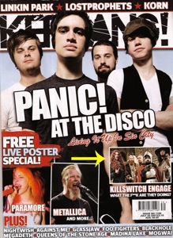

The first thing you will do when you start your Media Studies course in September is research the forms and conventions of a music magazine. You will learn about how they are designed with a specific audience in mind.
Task 01:

Analyse how the two magazine front covers appeal to their particular target audience.

Think about:
Genre
Images
Colours
Font Language

Task 02:

Before you start the course, you need to research and create a presentation (Powerpoint, Slideshare, Prezi) on two magazine companies.

Use the following prompts to help you:

Music magazine Institutions research- Two magazine companies, 1 large (Bauer or IPC) and 1 small (Future, BBC Worldwide)

- Who are the company?
- What is their company history?
- What publications do they manage?
- A detailed look at 2 of these publications and their target audience. At least 1 of these publications should be a music magazine.

Both these induction tasks can form part of your AS coursework, so will prove very useful!

