6 ways to recover from a bad interview
Shannon Norman 29 October 2014
Job interviews can be tough regardless of how qualified you are. If you find yourself let down after a bad job interview, these six tips from Shannon Norman of 1st Contact Umbrella can help restore your confidence and get you back in the game.
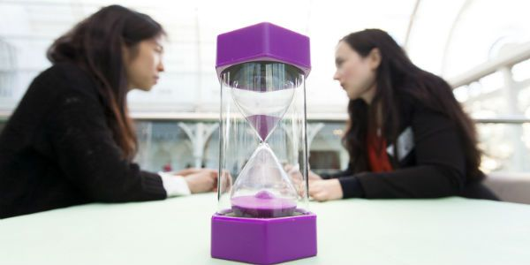"Don't lose hope if you don't get the job. Consider phoning the interviewer and ask why you were unsuccessful.”

1. Reflect on the whole interview
Before jumping to the conclusion that you’ve failed, reflect on the interview as a whole as opposed to only concentrating on the negatives. This can help you see the negatives in a more positive light.
Draw up a list of what you think went well and try not be too hard on yourself. If a particular moment in the interview went well, write it down.
After reflecting on the positives, jot down situations that didn't go so well. Doing this is an easy way to judge your experience and see it from an outsider’s perspective.

2. Turn mistakes into learning points
Mistakes are meant to be made so don't stress about what went wrong in your interview. Instead, focus on how you can prepare for your next interview. For each bad situation you wrote down, think of ways to better handle it if it had to happen again.
Say, for example, you didn't answer a certain question well. Write the question down, analyse your response and then come up with a more thoughtful answer. This will empower you for your next interview.

3. Learn to move on
Consider phoning the interviewer and ask why you were unsuccessful.
One of the worst things that you could do is sit and wonder about whether you’ll get the job or not.
If you don’t hear back from the company regarding your interview as quickly as you would like, don’t cause unnecessary stress for yourself by waiting patiently for that phone call or that email. The best thing to do is to forget about it and move on.

4. Get feedback from the interviewer
Don’t lose hope if you don’t get the job. Consider phoning the interviewer and ask why you were unsuccessful. Perhaps it was because you weren’t a good fit and not necessarily because you interviewed badly.
While you’re at it, ask the interviewer what you should work on. This can give you great insight for future interviews.
When you’re doing all of this, be polite and don't come across as angry. You might apply for another role at the company one day. Even better, they might remember you for future vacancies, so it's best you stay on good terms with them.

5. Make the mirror your best friend
Answering questions in front of a mirror can give you an idea of what the interviewer sees.
Practise answering some of the questions that may come up in an interview in front of the mirror. Answering questions in this way can give you an idea of what the interviewer sees during a job interview and can help you improve the professional image you project.
If you notice that you don’t seem friendly enough or you don’t look enthusiastic, use this time to work on your body language. If you have an expressionless face when answering questions, it can come across negatively. Remember, actions speak louder than words.

6. Keep looking for a job
By this point your level of confidence should be higher than what it was on the day of your bad job interview. The trick is to strike while the iron is hot.
Continue your job search and keep applying for jobs in your field. The more interviews you go for, the more confident you'll become. If you keep your head in the game, you'll be an interview genius in no time.
Shannon Norman is a writer for 1st Contact Umbrella, a company that pays freelancers on behalf of their agencies, providing the benefits of freelancing without the risks of running a limited company.

Also of interest

How to dress for an interview

How to make the most of a mentor

