AS Media Studies

When you start the AS media course in September you will immediately start work on the coursework unit- The Magazine Industry. This coursework is worth 50% of your final mark. For your coursework you are asked to research, plan, construct and evaluate the front cover, contents and double page spread for a new music magazine. You will learn how to take photographs in a studio and learn the tools of both Photoshop and Indesign to construct your product. You also keep your own blog on our site heathenmedia.co.uk to record all your progress and development. The two tasks below form part of the research element of this coursework and will go towards your final mark.

For task 1 you need to consider the genre, images, colours, font and language choices to analyse how the two magazine front covers appeal to their particular target audience.

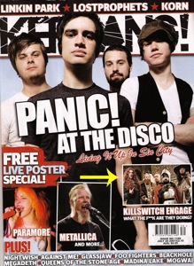
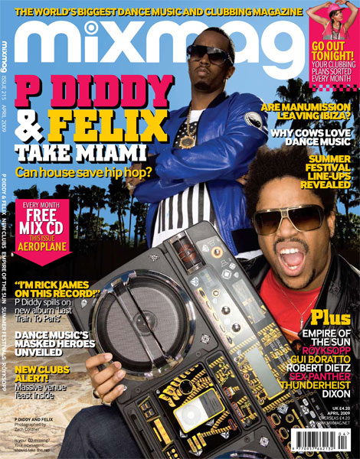
As with all magazines, Mixmag has a particular house style. Fitting a House/Dance genre the 3 colours used are pink, yellow and blue. These stereotypically reflect their genre as they are colours associated with the genre and link to a summer, beach, festival vibe.

In comparison an audience for Kerrang magazine are Indie/ Rock fans. The cover image of the main artists show them staring directly into the camera with a direct mode of address. The camera is at a low angle looking up which makes them seems powerful and a bit intimidating. They facial expressions are quite moody which also adds to this idea.

Task 02:

For the second task you need to research and create a power point presentation on two magazine companies. Again this will form part of the research element of your final mark.

Use the following prompts to help you:

Music magazine Institutions research- Two magazine companies, 1 large (Bauer or IPC) and 1 small (Future, BBC Worldwide)

- Who are the company?
- What is their company history?
- What publications do they manage?
- A detailed look at 2 of these publications and their target audience. At least 1 of these publications should be a music magazine.

Both induction tasks should be completed and uploaded to your media blog (we will set this up for you in September!) by Friday 23rd September 2016.

