**Why study Geography?**

**"Geography is the subject which holds the key to our future."**

Michael Palin, President of The Royal Geographical Society

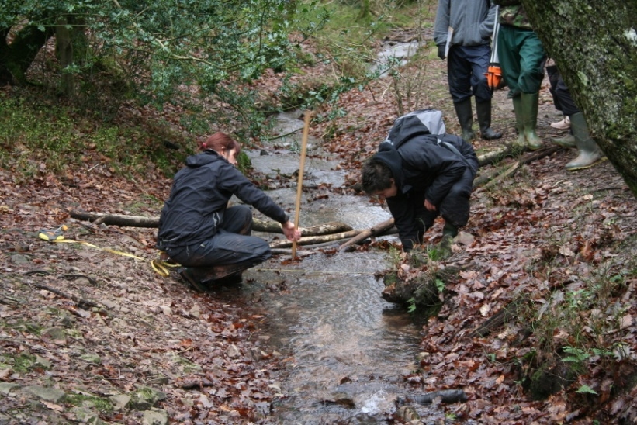

To study Geography at A Level you will require at least a C grade at GCSE.

### ****What are the benefits of studying Geography at A Level?****

### Geography is highly valued by the universities and employers as an A Level choice.

**Key skills**  
At A Level, you will study core Physical and Human Geography. In each area of study you will consider the values and attitudes of decision makers, consider your own values and attitudes to the issues being studied and support your learning of ideas through specific case studies. You will also develop a variety of Geographical skills, which will broaden and deepen existing knowledge and be employed with a greater degree of independence.

The dynamic and skills-based nature of this subject gives Geography one of the highest graduate employment rates of any non specialist degree. A Level Geography is an accepted entry qualification for many specialist and non specialist Higher Education courses.

Students with A Level Geography have access to a wide range of possible career and Higher Education opportunities. Skills that you will develop include collecting, analysing and interpreting data, communicating your findings and developing links between different parts of the subject. These skills are in great demand and Geographers are currently amongst the most employable graduates.

[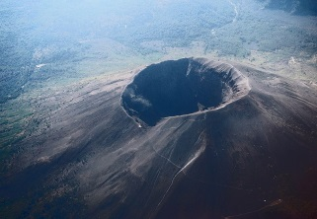](//upload.wikimedia.org/wikipedia/commons/a/af/Vesuvius_from_plane.jpg)Geography combines well with both arts and science subjects. You may already be thinking ahead to potential university and career choices so it is worth bearing in mind that geography is a broad based subject that really fits well for your future progressions. For example, careers in sustainability and green issues, urban regeneration, energy supply, retail location, managing the effects of hazards and climate change, geography is an obvious choice. For careers in the world of business, an understanding of global economics forms an important part of Geography. If you are thinking of a career in law, human rights, international relations or welfare then geography gives you the opportunity to consider relevant issues such as; How do we measure development? What are the consequences of migration on societies? If you are aiming at a future course in Medicine or Vet Med then Geography is a good choice to give your A Level options the breadth that universities like as you will gain a clear understanding of how the environment affects health and survival of people, animals and ecosystems as well enhancing you skills of writing essays and extended reports.

**Geography prepares for the world of work - geographers, with their skills of analysis are highly employable!**

|  |  |  |
| --- | --- | --- |
| |  |  | | --- | --- | |  |  | |
| **What is Geography like at Little Heath School?** Course Content: There is a balance of Physical and Human Geography (Edexcel Geography) Paper 1: A 2 hour exam worth 30% of the final qualification. This paper examines physical geography concepts. Students at Little heath School will study the following topics:   * Tectonic processes and hazards; * The water cycle and water insecurity; * The Carbon cycle and energy security; * Climate change futures   Paper 2: A 2 hour exam worth 30% of the final qualification. This paper examines human geography concepts. Students at Little heath School will study the following topics:   * Globalisation * Shaping places * Super powers * Global development and connections   Paper 3: A 1 hour 45 minute exam worth 20% of the final qualification.  This paper is a synoptic investigation which will be based on a geographical issue within a place based concept. The concept links to the three synoptic themes and is rooted in two or more of the compulsory content areas:   * Players; * Attitudes and Actions; * Futures and Uncertainties.   Paper 4: Independent investigation worth 20% if the final qualification.  Students will define a question or issue for investigation based upon the course content and Edexcel speciation. The investigation will incorporate field work data and research and will be presented as a written report of 3000 to 4000 words.  **Teaching and Learning Styles** A variety of teaching and learning activities will be used throughout the course. These include group activities as well as independent study. A range of visual materials will be used such as PowerPoint presentations, photographs and video clips.  **Field work at Little Heath School**  A level students must complete a minimum of **four days** of fieldwork. Fieldwork must be carried out in relation to physical and human geography. This is a Department for Education (DfE) requirement.  There are two fieldwork opportunities for students at Little Heath School. There is a week long field trip for Year 12 students to Nettlecombe Court in Somerset, where they can collect their data in preparation for their personal investigation. Year 13 students are taken to Sorrento in Italy to study Mt Vesuvius and volcanology in the Bay of Naples. |