AS Media Studies

When you start the AS media course in September you will immediately start work on your first exam unit – Component 1. This exam is worth 35% of your final mark. For this exam you will need to analyse a variety of different media forms (Adverts, Film Posters, Music Videos, Newspapers, Video Games and Radio). You will learn how each of these media forms operate in the industry and how they appeal to certain audiences. You will need to analyse several set products in detail as well as unseen media products to prepare for the exam. The two tasks below will help you prepare for the classes in September.

Task 1:
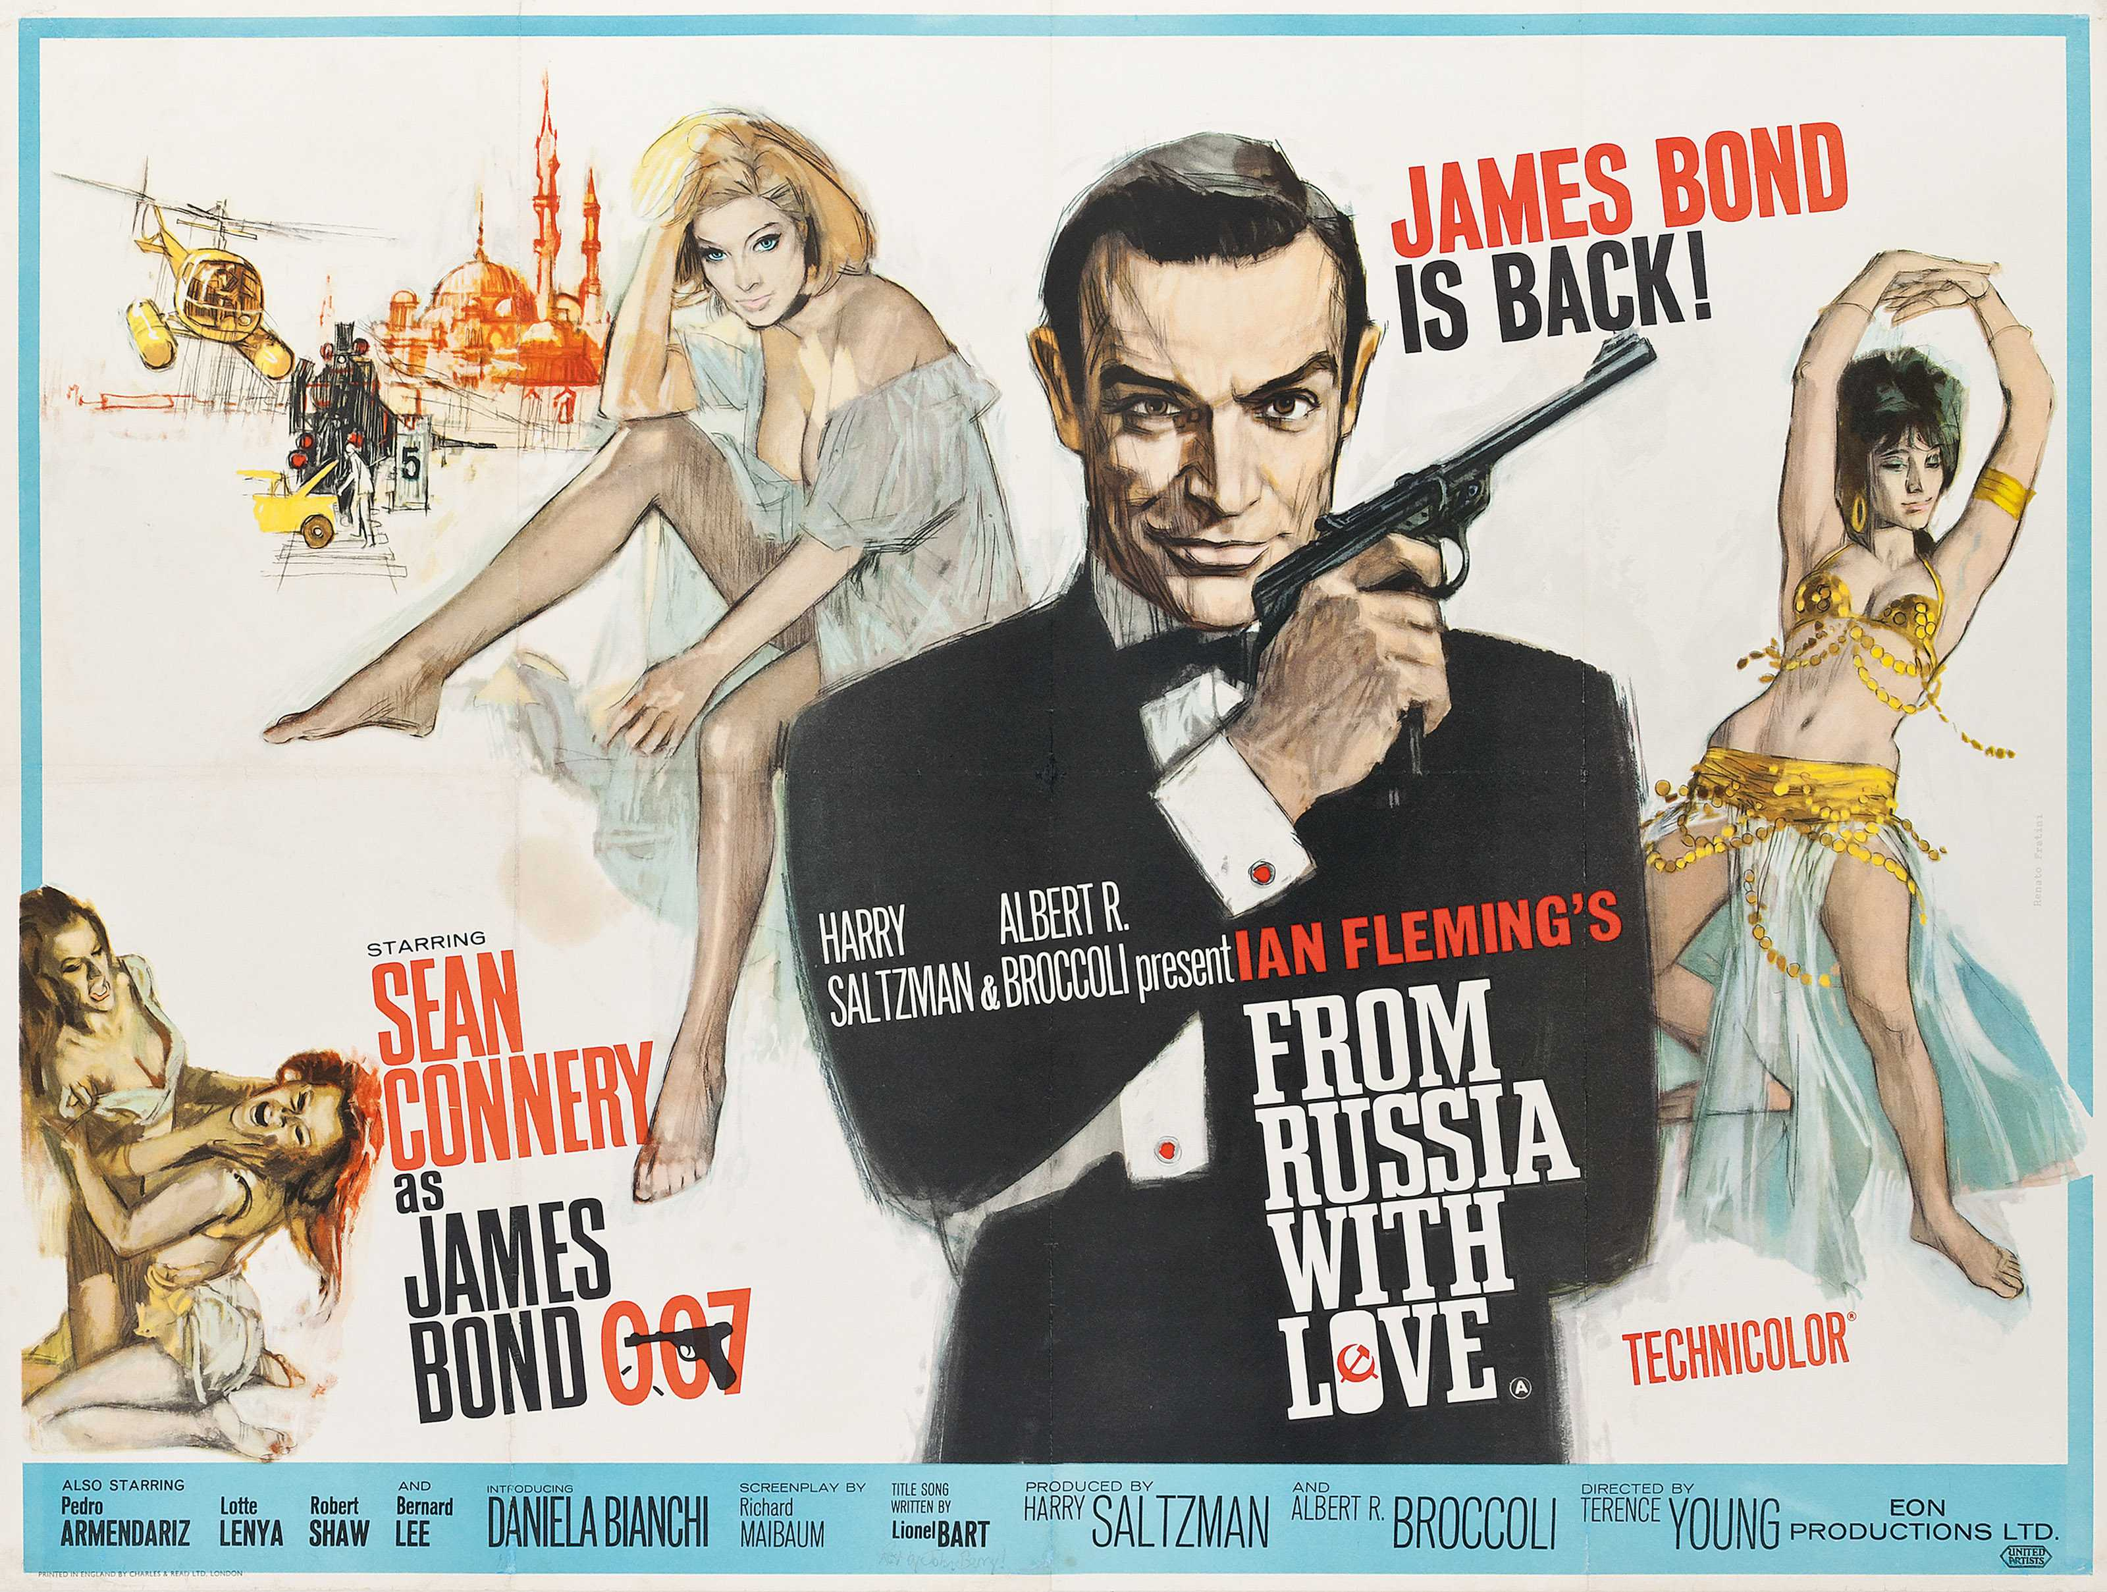

Look at the following adverts. Analyse and identify the following in each:

- Who is being targeted by this advert (gender, age, interests, job etc…)
- How are they being targeted? (Colour scheme, image, language, font etc…)
- What messages does this give about society at the time? (You may need to conduct some additional research into the 1960’s to answer this question fully)

Task 02:

For the second task you need find your own contemporary advert (within the last 5 years) for any product and analyse it in detail. This advert may be print or video based.

Use the following prompts to help you:

- Who is the company?
- What are they advertising?
- Who are they advertising to? How do you know this? (Camera angles, colour scheme, etc…)
- What does your advert tell you about society today?

Both induction tasks should be completed and handed to your teacher on your first lesson in September 2017.

