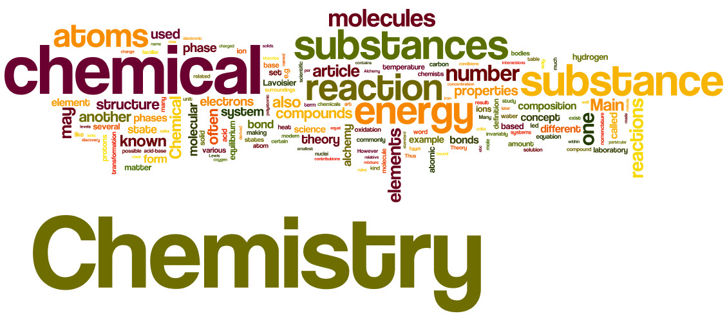

Welcome to A Level

Pre-Course Preparation

In preparation for September we would like you to show that you know the structure of an atom and the supporting evidence for this structure. We would also like you to show you understand how the current model of an atom has developed over time. In order to do this you need to complete the activity overleaf and email your presentation/information booklet to jkissick@littleheath.org.uk by Friday 7th September.

Skills we are looking for are:
- The ability to answer the question – make sure you read the instructions carefully and answer all parts of the question fully.
- The ability to extract relevant information from text and present it clearly using supporting images.
- The ability to use a computer to present information clearly without spending too much time and effort on graphics/presentation.
Expected Time: 2-4 hours
Administrative Tasks:
- Buy an A4 lever arch file with dividers (minimum 5) and some plastic protector wallets. Bring these with you to the first lesson in September.
- Buy a set of coloured pens and a scientific calculator – you will need these every lesson.
- Download a free periodic table app onto your phone (e.g. Merck PTE or RSC).

Pre-Course Reading:
- Read the sample issue and consider subscribing to Chemistry Review Magazine (https://www.hoddereducation.co.uk/parents).
- Consider reading one of the recommended non-fiction books about the periodic table
  - Periodic Tales: The curious lives of the elements by Hugh Aldersey-Williams
  - The Disappearing Spoon by Sam Keane
  - Napoleon’s Buttons: 17 molecules that changed the world by Jay Burreson

If you need any help or have any questions about this work or A level Chemistry you can contact Dr. Kissick by email jkissick@littleheath.org.uk

Introduction
Preparation work for AS Chemistry
No one yet has been able to look inside atoms to see what they are really like. The typical picture of an atom we have in our minds is neither ‘the truth’ nor ‘the right answer’ – it is a good working model which helps to explain many phenomena.
Much evidence has been gathered to support the current model of an atom. The model may change as more evidence comes to light, and it is very likely to become more detailed.
We can sometimes explain things using only a simplified model of the atom. Thinking of atoms as tiny spheres is sufficient to explain the states of matter (the properties of solids, liquids and gases) – but this model is not detailed enough to explain why metals tend to react with non-metals. Models can be simple or elaborate, depending what they are explaining. Keep this in mind as your ideas and understanding of chemistry develop.

What you do
How has the current model of the atom developed? Many scientists contributed to the sequence of gathering knowledge about the atom, but some made particularly important discoveries – they were:
- Joseph J. Thomson (key discovery 1897–1899)
- Hans Geiger, Ernest Marsden and Ernest Rutherford (key discovery 1909)
- Henry Moseley (key discovery 1913)
- James Chadwick (key discovery 1932).
You could start by using your knowledge from GCSE. Then use suitable textbooks and magazine articles (from the library) or the Internet to help you to find extra other information. You will need to carefully think about what information and images to include and what to leave out.

Prepare a series of PowerPoint® slides or an information leaflet (using Word® or Publisher®) on these scientists. Your presentation should cover the following points:
- The name and training each scientist had,
- when each scientist made the discovery they did,
- what was already known about the atom (make sure you link the discoveries – maybe put them in chronological order),
- what each scientist did to contribute to the development of the model of the atom
- what specifically each scientist found out (make sure you describe the experimental results that they collected and where relevant a diagram),
- what conclusions each scientist drew from the results including a diagram of each model.
You should sumarise your findings about the structure of an atom and describe how each scientist contributed to the modern model of atomic structure.

Remember that you need to be selective about the information you present. This is not about how much information you find out it is about what you do with the information. You need to show that you understand how the current model of the atom has developed over time.

