**The Bridge to A level**

**Pixl Y11 Maths**

**Bridging Unit**

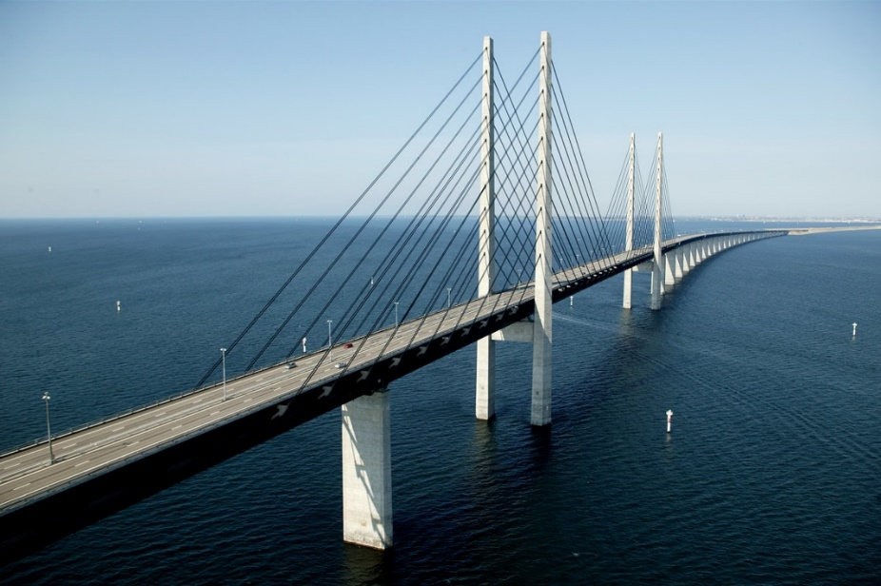

**This pack contains a programme of activities and resources to prepare you to start A level in Maths in September.**

**It is aimed to be used after you complete your GCSE throughout the remainder of the summer term and over the summer holidays to ensure you are ready to start your course in September.**

**The resources include:**

1. **Links with activities on six websites where you can research the topics you will be exploring in your sixth form courses and get a flavour of mathematics beyond GCSE.**
2. **10 key pre-knowledge topics that will help you to be successful in your course. The topics covered are a mixture of GCSE topics, and topics which extend GCSE but which will be very useful on your A level course.**
3. **A diagnostic assessment that will test your key knowledge of these 10 topics.**
4. **Suggested therapies to help you with those topics with which you are having difficulty.**
5. **A second assessment which will test the effectiveness of your use of the therapies.**

**Websites**

**NRich**

<http://nrich.maths.org/secondary-upper>

Mathwire

<http://mathwire.com/archives/enrichment.html>

The History of Maths – Wikipedia

<https://en.wikipedia.org/wiki/History_of_mathematics>

The History of Maths – Youtube video

<https://www.youtube.com/watch?v=cy-8lPVKLIo>

Decision Maths Videos

<https://www.youtube.com/playlist?list=PLD7FCC5C72E63825D>

Statistics v Mechanics – student discussion

<http://www.thestudentroom.co.uk/showthread.php?t=567094>

**10 key Topics**

1 Solving quadratic equations

2 Changing the subject

3 Simultaneous equations

4 Surds

5 Indices

6 Properties of Lines

7 Sketching curves

8 Transformation of functions

9 Trigonometric ratios

10 Sine / Cosine Rule