[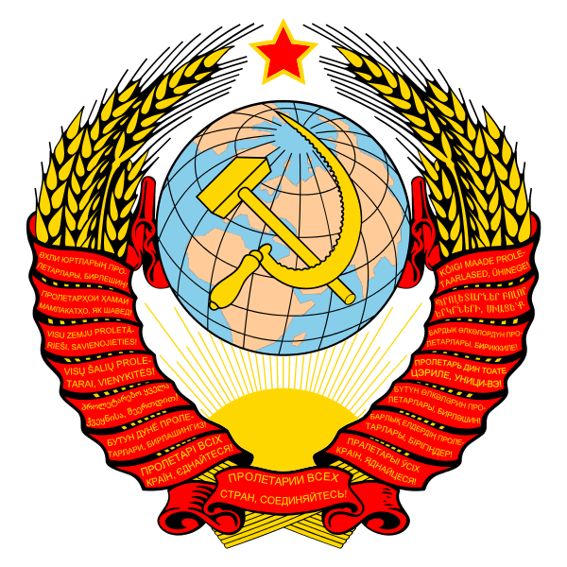](http://upload.wikimedia.org/wikipedia/commons/d/d6/Coat_of_arms_of_the_Soviet_Union.svg)

**Russian Dictatorships Revision - department support - a few words from Mr Podesta**

Hello Comrades:

There is plenty of support from us – please make use of it.

1. **Revision in the Easter Holidays**

**Meet the mark scheme / overview of the course**

**11.00 to 1.00 in T10 on Wednesday 10th April**

1. **After School sessions**

**T10 – 3.30 – 5.30**

|  |
| --- |
| Wed 17th April- Agriculture |
| Wed 24th April - Economics and Industry |
| Wed 1st May - Condition of the workers |
| Wed 8th May – Government and Turning Points |
| Wed 15th May - Reform, Opposition and Repression |
| Wed 22nd May - War and Revolution |
| TBC - Half Term Support |

1. **If you have not yet done so you really should print off the revision work booklet and past questions (on the front page of http://heathenhistory.co.uk/russia/ )**

