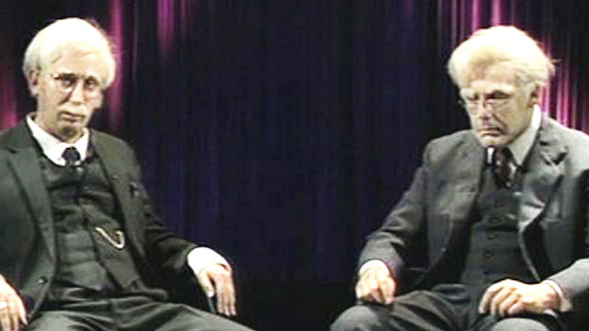
The History Society – Autumn Season (Part One)
T10 – Every Tuesday - 3.30 to 4.30 - Please note that there will be cake
Date | Video | Suitable For
 | - Historiography and the Cold War Season
10/9 | The Betrayal  A history of Stalin and the Warsaw Rising | All – but especially Y13 (coursework).
17/9 | The Cold War – Part One  Comrades  Other episodes will be shown later in the year. | All – but especially Y13 (coursework).
 | - Elizabeth and the historians season
24/9 | “From the Tower to the throne” – David Starkey  Part One of Starkey’s seminal series.  The other episodes will be shown later in the year. | All – but especially Y12
1/10 | "The body of the Queen" – Simon Schama.  A history of Britain Series  A comparison of Elizabeth and Mary Stuart. | All – but especially Y12  Comparative history
8/10 | She-Wolves – Helen Castor  How the Tudor queens Jane, Mary and Elizabeth struggled with a crown made for a male head. | All – but especially Y12  Also a good introduction to feminist reinterpretations.
15/10 | The Time traveller’s guide to Elizabethan England  – Ian Mortimer  The Court and the Rich  The other episodes will be shown later in the year. | All – but especially Y12
22/10 | Elizabeth – The greatest Briton ?  Michael Portillo | All – but especially Y12

The History Society – Autumn Season (Part Two)
T10 – Every Tuesday - 3.30 to 4.30 - Please note that there will be cake
Date | Video | Suitable For
 | - Remembrance Specials
5/11 | The Somme – Frome Defeat to Victory  Part One  This part explains how the British were defeated at the end of the first day of the battle. | All  Especially good for anyone interested in military history or how historiography works.
12/11 | The Somme – Frome Defeat to Victory  Part Two  The conclusion shows how the British learnt from their failures and developed radical new tactics that would help the allies to win the war. | All  Especially good for anyone interested in military history or how historiography works.
 | - Italian Unification Special
19/11 | Warwick histories  Understanding the Unification of Italy | All – but especially Year 12
 | - Russian Dictatorships (Second Season)
26/11 | Twin Tyrants - Stalin and Hitler – Part One  Denys Blakeway  Part One | All – but especially Y13 (Russian).  Comparative history
3/12 | Twin Tyrants - Stalin and Hitler – Part Two  Denys Blakeway  Part One | All – but especially Y13 (Russian).  Comparative history
9/10  MON | Lenin’s Secret Files  A Timewatch Special  Robert Service explores Soviet records in the 1990s | All – but especially Y13 (Russian). See revisionist historians at work.

