GCSE History

Cold War Booklet 1

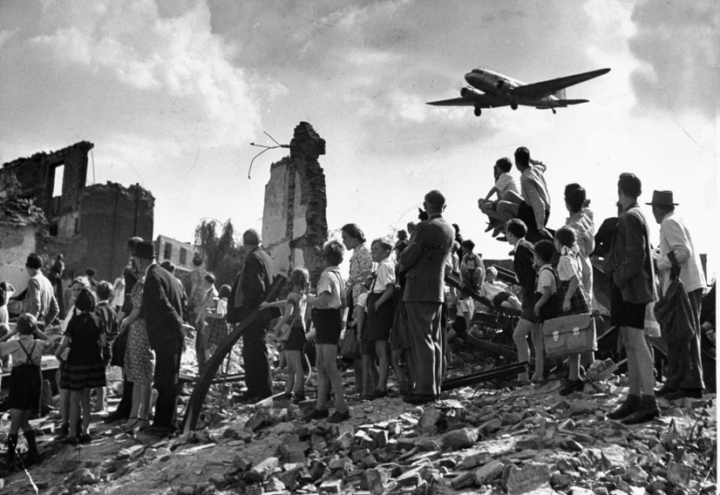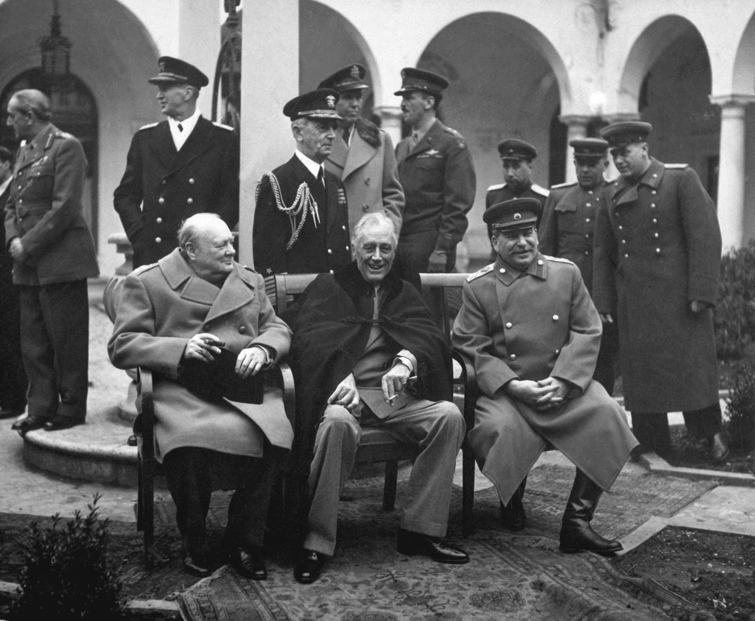**Who was to blame for the Cold War?**

Why did the USA-USSR alliance begin to break down in 1945?

How had the USSR gained control of Eastern Europe by 1948?

How did the USA react to Soviet expansionism?

Who was more to blame for the start of the Cold War, the USA or the USSR?

Remember

Make your revision ACTIVE

The Effective Revision Cycle

This cycle is what you need to do for ALL revision. First, TEST what you know. It’s no good revising the stuff you feel confident on and ignoring the stuff you don’t like and just hoping it doesn’t come up! Once you know the areas you are least confident on REFLECT on why. What needs to change to make you confident on it? Sort that out, and then LEARN it. Be active, use ALL the resources the school has given you to help you.

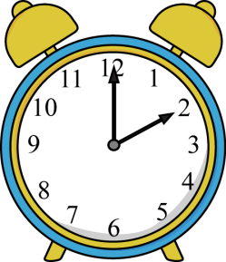TIME YOURSELF! Before you start, take 3 minutes, and 3 minutes ONLY, to write down everything you can remember about our study of the Causes of the Cold War.

**Do regularly to make sure your knowledge is secure.   
Come on, it only takes 3 minutes!**

You will find it useful to highlight the information in this booklet. You will find it **even more useful** if you do this with coded colours:

1 colour to pick out dates

1 colour to pick out the names of key individuals

1 colour to pick out selected key points/facts.

Use the above as a key for your highlighting.

Here’s what’s going to be covered during this booklet...

|  |  |
| --- | --- |
| **Main topic** | **This will include...** |
| 1. The origins of the Cold War | Ideology of Communism and Capitalism  Aims of USA and USSR  Historic actions that led to suspicion |
| 1. The 1945 summit conferences including the parts played by Churchill, Roosevelt, Stalin and Truman at the Summit conferences | Agreements at Yalta and Potsdam  Roles played by individuals  What did Stalin and Roosevelt/Truman get out of the summits |
| 1. Soviet Expansion in Eastern Europe | Motivations for the Soviet takeover of Eastern Europe  Methods of Soviet control  Countries controlled by the USSR |
| 1. The Iron Curtain | Brief background to the speech  Main text of the speech itself |
| 1. The Truman Doctrine | Why the Truman Doctrine was needed  How it was carried out in Europe  Containment |
| 1. The Marshall Plan | Why the Marshall Plan was needed  Who money was given to  Stalin’s reaction to the Plan |
| 1. The Berlin Blockade and consequences | Reasons for the Blockade  Facts about the Blockade  Results of the Blockade |

**You need to have specific facts and details for all of these ready to use in the exam.**

**The origins of the Cold War**

There were a number of things which seemed to make the Cold War inevitable:

Ideologies: The Soviet Union was a Communist country, which was ruled by a dictator and put the needs of the state ahead of personal human rights. The USA was a capitalist democracy which valued freedom and feared Communism. It was not just that the two ideologies were conflicting - they were militant and expansionist. They both believed that the alternative ideology was a threat to their own way of life, and that the only way for the world to be happy was for their particular ideology to take over the world.

“It is useless to try to discover who made the first move to break the alliance. It is impossible to trace the first ‘broken promise’ ... In this ‘marriage of convenience’, the thought that a divorce was inevitable had been in the mind of each partner from the beginning”

Written by the historian Isaac Deutscher, *Stalin* (1969)

Aims: After World War Two Stalin wanted huge reparations from Germany, and a ‘buffer’ of friendly states to protect the USSR from being invaded again. Britain and the USA wanted to protect democracy, and help Germany to recover. They were worried that large areas of eastern Europe were falling under Soviet control.

This meant that the 'Big Three' found it difficult to get agreement at the Conferences (Tehran, Yalta, Potsdam) which outlined the principles of the post-war peace.

Resentment over past events: The Soviet Union could not forget that in 1918 Britain and the USA had tried to destroy the Russian Revolution. Britain and the USA could not forget that Stalin had signed the Nazi-Soviet Pact with Germany in 1939.

**The 1945 summit conferences including the parts played by Churchill, Roosevelt, Stalin and Truman at the Summit conferences**

**Yalta**

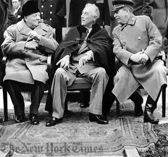Held during the war, on the surface, the Yalta conference seemed successful. The Allies agreed to:

* divide Germany into four ‘zones’, which Britain, France, the USA and the USSR would occupy after the war.
* bring Nazi war-criminals to trial.
* set up a Polish Provisional Government of National Unity 'pledged to the holding of free and unfettered elections as soon as possible'.
* help the freed peoples of Europe set up democratic and self-governing countries
* set up a commission to look into reparations.

At Yalta, the negotiations went very much in Stalin's favour, but this was because Roosevelt wanted Russian help in the Pacific, and was prepared to agree to almost anything as long as Stalin agreed to go to war with Japan. Therefore, Stalin promised that:

* Russia would join the war in the Pacific, in return for occupation zones in North Korea and Manchuria.
* Russia also agreed to join the United Nations.

Although the Conference appeared successful, however, behind the scenes, tension was growing, particularly about reparations, and about Poland.

After the conference, Churchill wrote to Roosevelt that ‘The Soviet Union has become a danger to the free world.’ And on their return home both he and Roosevelt were criticised for giving away too much to the Soviets

**Potsdam**

At Potsdam, the Allies met after the surrender of Germany (in May 1945) to finalise the principles of the post-war peace. Three factors meant that the Potsdam Conference was not successful:

1. **Relations between the superpowers had worsened considerably** since Yalta. In March 1945, Stalin had invited the non-Communist Polish leaders to meet him, and arrested them. Things had got so bad that, in May 1945, the British Joint Planning Group had drawn up plans for 'Operation Unthinkable' - a 'total war ... to impose our will upon Russia'.

**Activity**

Create a mind map with all the outcomes of the Yalta and Potsdam conferences on it.

Draw anything the Allies agreed about in one colour and anything the Allies disagreed about in another colour.

Going for an A? What links can you spot between the agreements and disagreements?

1. Meanwhile, **Roosevelt had died**, and America had a new president, Truman, who was inclined to ‘get tough’ with the Russians.
2. Also, soon after he had arrived at the Conference, **Truman learned (on 21 July) that America had tested the first atomic bomb**. It gave the Americans a huge military advantage over everyone else.

So, at Potsdam, the arguments came out into the open.

The Conference agreed the following:

* to set up the four ‘zones of occupation’ in Germany. The Nazi Party, government and laws were to be destroyed, and 'German education shall be so controlled as completely to eliminate Nazi and militarist doctrines and to make possible the successful development of democratic ideas.
* to bring Nazi war-criminals to trial.
* to recognize the Polish Provisional Government of National Unity and hold 'free and unfettered elections as soon as possible'.
* Russia was allowed to take reparations from the Soviet Zone, and also 10% of the industrial equipment of the western zones as reparations. America and Britain could take reparations from their zones if they wished.

President Truman presented it as a 'compromise', but in fact the Allies had disagreed openly about:

1. the details of how to divide Germany.
2. the size of reparations Germany ought to pay.
3. Russian influence over the countries of eastern Europe.

**Soviet Expansion in Eastern Europe**

Stalin sought to set up a buffer zone of countries in Eastern Europe to protect the USSR against another invasion by Germany – he had seen two invasions in his own lifetime - 1914 and 1941. Above all, Stalin was determined to prevent this happening a third time and he wanted to make sure that Germany was kept weak, whereas the western Allies wanted Germany to be allowed to recover from the effects of the war.

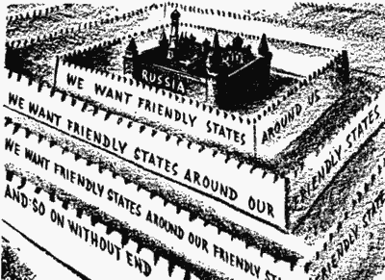During 1946–47, Stalin made sure that Communist governments came to power in all the countries of eastern Europe (the countries which the Soviet Union had conquered in 1945). The Communist description of this process was ‘slicing salami’ – gradually getting rid of all opposition, bit-by-bit and this became known as Salami tactics. In this way, Russia gained control of:

1. **Albania** (1945) – the Communists took power after the war without opposition
2. **Bulgaria** (1945) – a left-wing coalition gained power in 1945; the Communists then executed the leaders of all the other parties.
3. **Poland** (1947) – a coalition government took power in 1945, but the Communists forced the non-Communist leaders into exile.
4. **Hungary** (1947) – see Source A.
5. 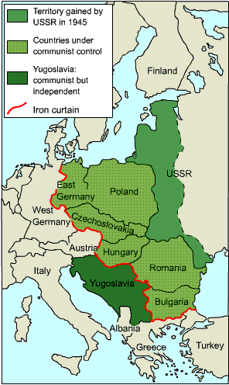**Romania** (1945–1947) – a left-wing coalition was elected in 1945; the Communists gradually took over control.
6. **Czechoslovakia** (1945–48) – a left-wing coalition was elected in 1945. In 1948, the Communists banned all other parties and killed their leaders.
7. **East Germany** (1949) – the Russian turned their zone of Germany into the German Democratic republic in 1949.

**The Iron Curtain**

On 5 March 1946, Winston Churchill gave a speech at Fulton in America. He said ‘a shadow’ had fallen on eastern Europe, which was now cut off from the free world by ‘**an iron curtain’**. Behind that line, he said, the people of eastern Europe were ‘subject to Soviet influence . . . totalitarian control [and] police governments’. This showed the breakdown of the Triple Alliance and how the two sides – East and West – were heading towards the Cold War.

**The Truman Doctrine**

The USA began to be concerned about the growth in popularity of the communist parties in France and Italy during the winter of 1946-47. In February 1947 the British government informed the USA that it could no longer afford to support the Greek government against Communist rebels. The USA had seen the spread of communism in the immediate aftermath of the war and now viewed the prospect of further countries becoming communist with great alarm. The US government stepped in with an offer of $400,000,000 to Greece and Turkey.

Truman’s policy towards the Soviet Union was one of ‘containment’ – he did not try to destroy the USSR, but he wanted to stop it growing any more.

**The Marshall Plan**

From Stettin in the Baltic to Trieste in the Adriatic, an iron curtain has descended across the Continent. Behind that line lie all the capitals of the ancient states of Central and Eastern Europe. Warsaw, Berlin, Prague, Vienna, Budapest, Belgrade, Bucharest and Sofia, all these famous cities and the populations around them lie in what I must call the Soviet sphere, and all are subject in one form or another, not only to Soviet influence but to a very high and, in many cases, increasing measure of control from Moscow.

Winston Churchill, ‘Iron Curtain’ speech, 1946

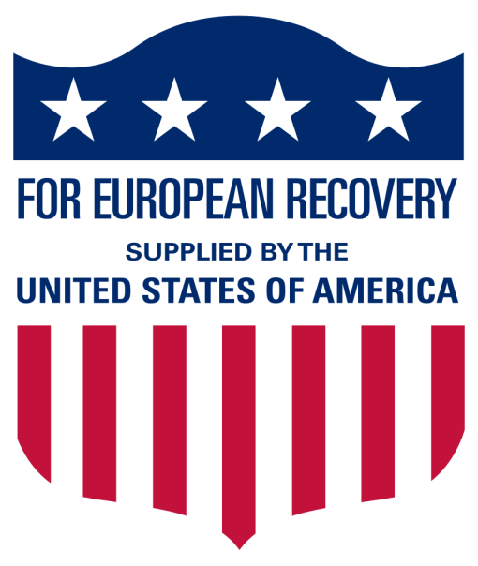In June 1947, General George Marshall made a visit to Europe to see what was needed. He came away thinking Europe was so poor that the whole of Europe was about to turn Communist. Marshall and Truman asked Congress for $17 billion to fund the European Recovery Programme nicknamed **the Marshall Plan** - to get the economy of Europe going again. Congress at first hesitated, but agreed in March 1948 when Czechoslovakia turned Communist. The aid was given in the form of food, grants to buy equipment, improvements to transport systems, and everything "from medicine to mules". Most (70 per cent) of the money was used to buy commodities from US suppliers: $3.5 billion was spent on raw materials; $3.2 billion on food, feed and fertiliser; $1.9 billion on machinery and vehicles; and $1.6 billion on fuel.

**Activity**

Read through the Soviet Expansion in Eastern Europe and the US response.

Create a timeline of events from 1945-1947 with Soviet actions in one colour and American actions in another colour.

Can you pick out one date as being a **turning point** in East-West relations?

The Soviet Union hated Marshall Aid (see Sources D and E). Stalin forbade Communist countries to ask for money. Instead, in **October 1947**, he set up Cominform. Every Communist party in Europe joined. It allowed Stalin control of the Communists in Europe.

**Airlift Facts**

The blockade lasted 318 days (11 months).

In the winter of 1948–49 Berliners lived on dried potatoes, powdered eggs and cans of meat. They had 4 hours of electricity a day.

275,000 flights carried in 1½ million tons of supplies. A plane landed every 3 mins.

On 16 April 1949, 1400 flights brought in 13,000 tons of supplies in one day – Berlin only needed 6,000 tons a day to survive.

**The Berlin Blockade and consequences**

In 1945, the Allies decided to **split Germany** into four zones of occupation. The capital, Berlin, was also split into four zones. The USSR took huge reparations from its zone in eastern Germany, but Britain, France and America tried to improve conditions in their zones.

In June 1948, Britain, France and America united their zones into a new country, West Germany. On 23 June 1948, they introduced a new currency, which they said would help trade.

The next day, Stalin cut off all rail and road links to west Berlin - the **Berlin Blockade**. The west saw this as an attempt to starve Berlin into surrender, so they decided to supply west Berlin by air.

The Berlin Blockade lasted 318 days. During this time, 275,000 planes transported 1.5 million tons of supplies and a plane landed every three minutes at Berlin's Templehof airport.

On 12 May 1949, Stalin **abandoned** the blockade.

**Results of the Berlin Crisis of 1948**

1. Germany was divided into the Federal Republic of Germany (West Germany) and the Democratic Republic of Germany (East Germany) until 1990.
2. The Iron Curtain became permanent.
3. The Cold War broke out into open confrontation, and the two superpowers began an Arms Race.
4. In 1949, the Allies set up the North Atlantic Treaty Organisation (NATO) as a military alliance to resist Soviet Russia.

**Past exam questions**

**You should be able to answer ALL these questions. At least plan answers and practice writing them using the advice on the last page.**

Aiming at A*? Take time to look at the TYPE of questions that are being asked on each topic. If they ask 10 mark questions on it you need to know it REALLY well. If they ask 4 mark questions on it you need specific details to describe. If it’s 6 mark questions then you need to know the different factors you could explain. Most of the topics are a mixture. Are you ready for ALL of them?

**Knowledge Questions**

|  |  |
| --- | --- |
| **Paper 1 Section A: Who was to blame for the Cold War?** | **(c)**  The following were equally to blame for increasing Cold War tensions before 1950: **(i)** Soviet Expansion in Eastern Europe; **(ii)** the Truman Doctrine and Marshall Plan; **(iii)** the Berlin Blockade. How far do you agree with this statement? Explain your answer referring only to **(i), (ii)** and **(iii). [10]**  **(c)** Which country had the more successful policies in Europe between 1945 and 1949; The USA or the USSR? Explain your answer **[10]**  **(c)** How far was the USA responsible for the start of the Cold War? Explain your answer’ **[10]** |
| 1. The origins of the Cold War | **(a)** What is meant by the term ‘Cold War’ **[4]** |
| 1. The 1945 summit conferences including the parts played by Churchill, Roosevelt, Stalin and Truman | **(a)** What did the USSR gain from the Yalta and Potsdam Conferences? **[4]**  **(b)** Explain why it was difficult to reach agreement at the Potsdam Conference **[6]**  **(a)** What decisions about Germany were taken at Yalta and Potsdam? **[4]**  **(a)** Describe what happened at the Potsdam Conference **[4]**  **(a)** What was decided at the Yalta Conferences in February 1945? **[4]** |
| 1. The breakdown of the USA-USSR alliance in 1945-6 | **(b)** Explain why the wartime allies disagreed about Poland in 1945 **[6]**  **(b)** Explain why the USA-USSR alliance had broken down by 1947 **[6]**  **(b)** Explain why the USA was hostile towards the Soviet Union in the years 1945 to 1949 **[8]**  **(b)** Explain why there was a breakdown in relations between the USSR and the West from 1945 to 1946. **[6]** |
| 1. Soviet Expansion in Eastern Europe | **(c)** ‘The USA was successful in containing communism in Europe up to 1949.’ How far do you agree with this statement? Explain your answer **[10]**  **(c)**  The following were equally to blame for increasing Cold War tensions before 1950: **(i)** Soviet Expansion in Eastern Europe; **(ii)** the Truman Doctrine and Marshall Plan; **(iii)** the Berlin Blockade. How far do you agree with this statement? Explain your answer referring only to **(i), (ii)** and **(iii). [10]**  **(b)** Explain why the USA-USSR alliance had broken down by 1947 **[6]**  **(c)** Which country had the more successful policies in Europe between 1945 and 1949; The USA or the USSR? Explain your answer **[10]** |
| 1. US response to Soviet expansion; The Iron Curtain and The Truman Doctrine, The Marshall Plan | **(a)** What was the ‘Iron Curtain’? **[4]**  **(b)** explain why Marshall Aid was offered to countries in Europe **[8]**  **(c)** How successful was the West in Containing Communism in Europe up to 1949? Explain your answer. **[10]**  **(c)**  The following were equally to blame for increasing Cold War tensions before 1950: **(i)** Soviet Expansion in Eastern Europe; **(ii)** the Truman Doctrine and Marshall Plan; **(iii)** the Berlin Blockade. How far do you agree with this statement? Explain your answer referring only to **(i), (ii)** and **(iii). [10]**  **(c)** Which country had the more successful policies in Europe between 1945 and 1949; The USA or the USSR? Explain your answer **[10]**  **(c)** ‘The Berlin Blockade was more to blame than the Marshall Plan for increasing Cold War tension’. How far do you agree with this statement? Explain your answer. **[10]** |
| 1. The Berlin Blockade and consequences | **(b)** Explain why the Soviet Union blockaded West Berlin in 1948. **[8]**  **(b)** Explain why Berlin was a cause of tension between East and West between 1945 and 1949 **[6]**  **(c)**  The following were equally to blame for increasing Cold War tensions before 1950: **(i)** Soviet Expansion in Eastern Europe; **(ii)** the Truman Doctrine and Marshall Plan; **(iii)** the Berlin Blockade. How far do you agree with this statement? Explain your answer referring only to **(i), (ii)** and **(iii). [10]**  **(b)** Explain why the Soviet Union blockaded West Berlin in 1948. **[8]**  **(c)** ‘The Berlin Blockade was more to blame than the Marshall Plan for increasing Cold War tension’. How far do you agree with this statement? Explain your answer. **[10]**  **(b)** Explain the reasons for the Berlin airlift **[6]** |

**Knowledge questions advice**

|  |  |  |
| --- | --- | --- |
| **Command words** | **Question numbers and marks** | **What that means you need to do** |
| Describe ...  What... | 2 (a) 4  3(a) 4  8 (a) 4  9(a) 4 | This is a short question where you need to select key points relevant to the question and write them in clear sentences. You do not need to explain, but if you can only remember 2 or 3 points you can explain to get all four marks. Spend around 4 minutes on this question. |
| Explain...,  Why... | 1 (b) 8  2 (b) 6  3 (b) 6  8 (b) 6  9 (b) 6 | This means you need to explain your answer. For these questions you need to say WHY. Use the words ‘because’, ‘this meant that’, ‘therefore. Write in paragraphs (2 for a 6 mark question and 3 for an 8 mark question)  You need to back up your answer with specific and relevant details from your knowledge. Spend around 8 minutes on a 6 mark and 10 minutes on an 8 mark question |
| How far (10) | 2 (c) 10  3 (c) 10  8 (c) 10  9 (c) 10 | This means you need to weigh up- balance two sides of the answer and give your judgement on how much you agree with the statement.  You should plan what you’re going to write before you write it and follow your plan.  You need to back up your points with specific examples from your knowledge and use to explain each side. Spend at least 20 minutes on a 10 mark question. |

**Source Questions**

ANY source could come up in the exam. It is HIGHLY likely you won’t have seen all the sources before, so you need to practice analysing them.

Label them to pick out the key details and pick out the key pieces of contextual knowledge that will help you to explain.

|  |  |
| --- | --- |
| **Cold War**  **Who was to blame for the Cold War?**  (a) What is the message of the cartoon? Use details from the cartoon and your knowledge to explain your answer [7]  (a) What is the cartoonist’s message? Use details from the cartoon and your knowledge to explain your answer [7] |  |

**Source Questions advice**

|  |  |  |
| --- | --- | --- |
| **Command words** | **Question numbers and marks** | **What that means you need to do** |
| Describe ...  What... | 2 (a) 4  3(a) 4  8 (a) 4  9(a) 4 | This is a short question where you need to select key points relevant to the question and write them in clear sentences. You do not need to explain, but if you can only remember 2 or 3 points you can explain to get all four marks. |
| Explain...,  Why... | 1 (b) 8  2 (b) 6  3 (b) 6  8 (b) 6  9 (b) 6 | This means you need to explain your answer. For these questions you need to say WHY. Use the words ‘because’, ‘this meant that’, ‘therefore. Write in paragraphs (2 for a 6 mark question and 3 for an 8 mark question)  You need to back up your answer with specific and relevant details from your knowledge. |
| How far (10) | 2 (c) 10  3 (c) 10  8 (c) 10  9 (c) 10 | This means you need to weigh up- balance two sides of the answer and give your judgement on how much you agree with the statement.  You should plan what you’re going to write before you write it and follow your plan.  You need to back up your points with specific examples from your knowledge and use to explain each side |

**What else can I do?**

* Have you planned out or answered all the questions?
* Has your revision been effective?
* What areas have you identified as needing the most work? What do you need to do to get confident on them?
* Have you made revision notes on everything in this booklet?
* Have you checked that you remember it?
* Have you come back to this after a few days and a few weeks to check it’s ‘stuck’?
* Have you gone to Memrise to memorise the key information?
* Have you done any extra reading? Go to twitter @LHSGCSEHistory to find links to great websites
* Have you worked with a friend to check each others’ revision?
* Feeling confident? Do a whole Paper 1 in 2 hours. They’re on the History page of the school website, or your teacher can give you one. Give it to your teacher to find out what grade it would be. Even better if you have a go at marking it yourself first.