GCSE History
Cold War Booklet 2
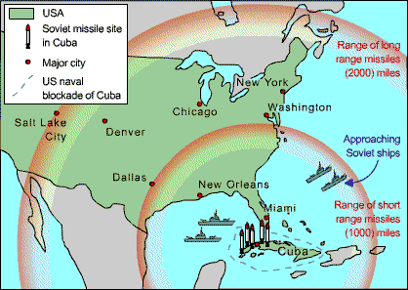
Who won the Cuban Missile Crisis?
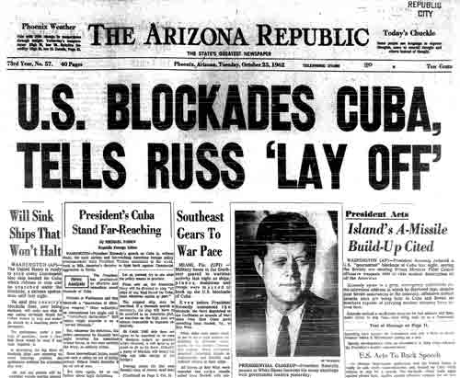
How did the USA react to the Cuban Revolution?
Why did Khrushchev put missiles into Cuba?
Why did Kennedy react as he did?
Who won the Cuban Missile Crisis?

Remember
Make your revision ACTIVE
The Effective Revision Cycle

This cycle is what you need to do for ALL revision. First, TEST what you know. It’s no good revising the stuff you feel confident on and ignoring the stuff you don’t like and just hoping it doesn’t come up! Once you know the areas you are least confident on REFLECT on why. What needs to change to make you confident on it? Sort that out, and then LEARN it. Be active, use ALL the resources the school has given you to help you.

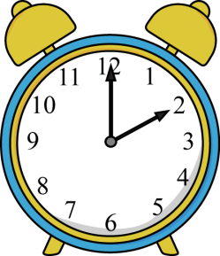
TIME YOURSELF! Before you start, take 3 minutes, and 3 minutes ONLY, to write down everything you can remember about our study of the Cuban Missile Crisis.
Do regularly to make sure your knowledge is secure.
Come on, it only takes 3 minutes!

You will find it useful to highlight the information in this booklet. You will find it even more useful if you do this with coded colours:
1 colour to pick out dates
1 colour to pick out the names of key individuals
1 colour to pick out selected key points/facts.

Use the above as a key for your highlighting.
Here’s what’s going to be covered during this booklet...

Main topic | This will include...
- Nuclear Weapons | Looking at the main weapons that were developed during the Cold War.
- The Cuban Revolution and USA’s reaction | The background to Cuban-American relations. The Communist takeover during the Cuban Revolution and how America responded to it.
- The Bay of Pigs | The causes, events and consequences of the Bay of Pigs invasion.
- The events of the Crisis | How the nuclear missiles ended up on Cuba. Kennedy’s options in responding to the presence of nuclear weapons.
- The role of Khrushchev | Why Khrushchev decided to place missiles on Cuba in the first place.
- How the Crisis panned out | A timeline of the events of October 1962.
- The consequences of the Crisis | Looking at the consequences for Cuba, the USA, the USSR and the rest of the world. A chance to consider whether any one ‘won’ or is to ‘blame’ for the Cuban Missile Crisis.

You need to have specific facts and details for all of these ready to use in the exam.

- Nuclear Weapons
“Nuclear warfare is an utter mistake, even from the narrowest point of self-interest. To spread ruin, misery and death throughout one’s own country as well as that of the enemy is the act of madmen…”
Bertrand Russell, a leading member of Britain’s Campaign for Nuclear Disarmament, CND.
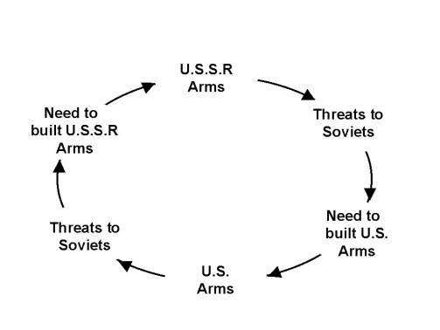
Following America’s demonstration of nuclear power at the end of World War 2, nuclear weapons became a focal point of both the USA and the USSR. One of the main weapons they developed were called Inter-Continental Ballistic Missiles (ICBMs). These were powerful missiles that could be launched from the USA and detonate in the USSR (or vice versa) in the space of 30 minutes. As soon as one country would develop a new type of nuclear weapon, the other country would respond, until we get the following cycle:
Threats to the USA

- The Cuban Revolution and USA’s reaction
Before we get in to the Cuban Missile Crisis, it’s important that we understand the background to this small country, and where the USA and the USSR comes in to it.
1898
America helps Cuba win independence from Spain. After this America plays a big part in Cuban affairs. America builds a huge naval base at Guantanamo in Cuba. America invests a lot of money in to Cuban industry, especially mining and agriculture.
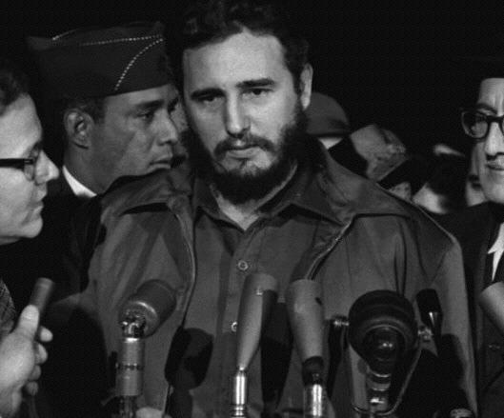
1934
America helps Fulgencio Batista come to power. However, he turns out to be incredibly corrupt and oppressive. He becomes a symbol of American control in Cuba. America was willing to support Batista, even though he was a dictator, because he was equally as opposed to Communism as they were.
1959
After many years of trying, the Communist leader Fidel Castro overthrew Batista during the Cuban Revolution. Castro was charming, clever and ruthless. He quickly killed, arrested or exiled many political opponents. He was very popular amongst the people in Cuba.
Think: Why would America be concerned with about a possible Communist takeover in Cuba? You may find it useful to use the map on the front cover of this booklet to help you.
American reaction to the Cuban Revolution
The USA was taken by surprise at first and decided to recognise Castro as the new leader of Cuba. However, within a short period of time relations between the two countries grew worse. Following the Revolution, thousands of Cuban exiles in the USA who had fled from Castro’s rule formed powerful pressure groups demanding action against Castro. Castro also took over some American-owned businesses in Cuba. He took their land and distributed it to his supporters among Cuba’s peasant farmer population.
In June 1960, the US Central Intelligence Agency (CIA) provided support and funds to Cuban exiles living in America. They also investigated ways to disrupt the Cuban economy, such as damaging sugar plantations. American companies working in Cuba refused to co-operate with any Cuban businesses which oil or other materials which had been provided by the USSR. The American media also broadcast a continued stream of criticism of Castro and his regime. Castro responded to the US with a mixed approach. He reassured Americans living in Cuba that they were safe and he allowed the USA to keep its naval base (Guantanamo Bay). He said he simply wanted to run Cuba without interference. However, by the summer of 1960, Cuba had allied with the USSR. The Soviet leader Khrushchev signed a trade agreement giving Cuba $100 million in economic aid. Castro also began to receive weapons from the Soviet Union and American spies knew this!
Task: Think about what America could do next in response to this close alliance with Cuba? We know what does happen, but think of what possible alternatives there could be.
- The Bay of Pigs
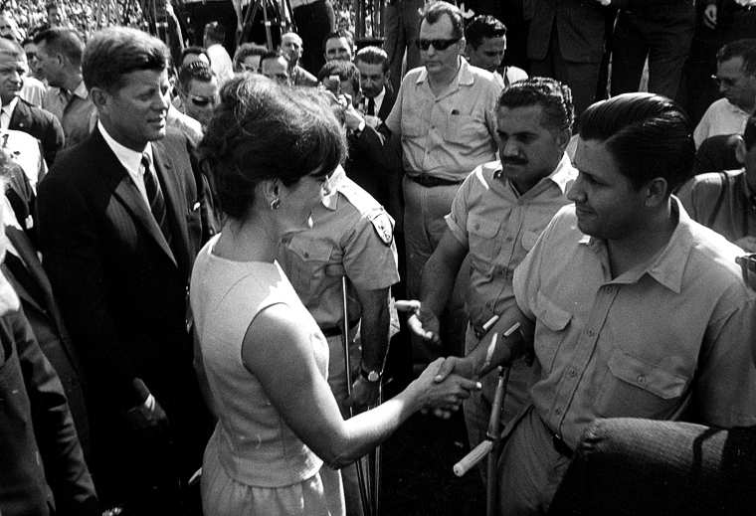
After the Cuban Revolution, America banned all trade to and from Cuba and imposed a boycott on all Cuban produce. They also broke off all diplomatic relations with the county. President Kennedy hoped that his would force the Cubans and Castro back in to the arms of America but instead it pushed them further towards the Soviet Union. He felt an invasion of Cuba was his only option.

Think: What were the risks of America invading Cuba?
In April, 1961, President Kennedy, (who had not been President for very long), decided to support an invasion of Cuba carried out by Cuban exiles: a group of Cubans who had fled to America when Castro took over. The invasion was to be a secret, and kept away from public attention.
Bay of Pigs Events
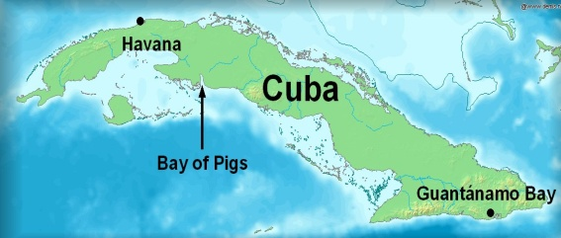
The Cuban exiles were given military training, weapons and transport from the CIA and aimed to launch an attack on the coast of Cuba at the coast of Cuba at the Bay of Pigs. They intended to establish a base for undercover activities against Castro and were confident that the Cuban people would support them. A force of 1400 exiles landed in Cuba, and found themselves facing over 20,000 Cuban troops. There was no support from the Cuban people as America had hoped. Those exiles who were not killed were quickly taken captive. Even though Kennedy was able to claim that there was no direct American involvement in the invasion (remember, it had been a secret), the Cuban leader Castro and the Soviet leader Khrushchev knew that it had been planned by the CIA. President Kennedy was left humiliated.
Bay of Pigs Consequences
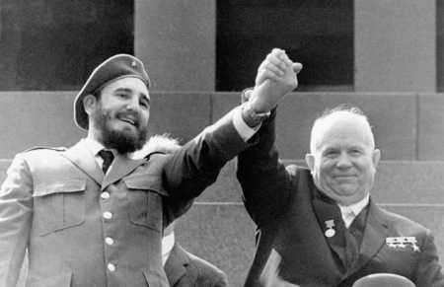
The invasion convinced Castro that he needed more support from the USSR. In September 1961, Khrushchev publicly announced that he would provide weapons to Cuba. Within months, Castro had an army with the latest military equipment: tanks, missiles and a large number of experts to help train his troops. The USA was alarmed at what was happening in Cuba. In July 1961, Castro had nationalised all American industries, meaning that they were now owned by the government and not individuals (in true Communist style). In December, Castro announced that he himself was a Communist (to nobody’s surprise).
What the Americans were most concerned about was nuclear weapons. Khrushchev did not give Castro nuclear weapons, but his friendship with the Cuban leader meant that there was every chance that he might try to station nuclear weapons on the island. In September 1961, President Kennedy warned the Soviet Union that he would not allow Cuba to become a base for Soviet nuclear missiles. Khrushchev assured Kennedy that he had no intention of doing so. But Khrushchev was lying: if nuclear weapons could be stationed on Cuba without being detected then that is what he would do.
Task: Why was the Bay of Pigs a disaster for President Kennedy?
Go to http://www.bbc.co.uk/podcasts/series/witness/all and scroll down to the 18th April 2014 to listen to a 10 minute podcast by one of the Cuban exiles involved in the Bay of Pigs invasion. Feel free to make some notes as you listen.

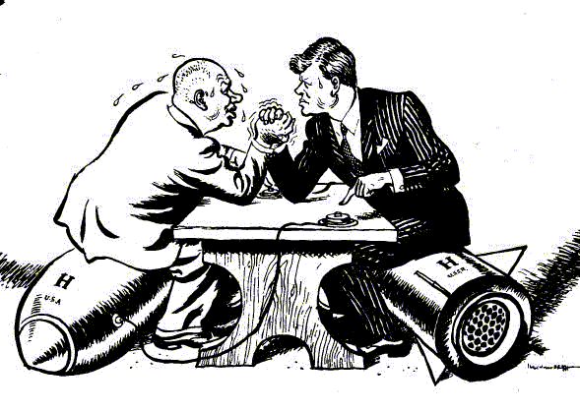
- The events of the Cuban Missile Crisis
This famous cartoon summarises the Cuban Missile Crisis.
Task: Label the key parts of this cartoon. You may wish to add all the detail you know now or wait until you have gone through the rest of the booklet.

Kennedy was extremely fearful that the USSR would use its alliance with Cuba to create nuclear missile bases on the island, and so putting nuclear weapons right on America’s doorstep. On the 11th September, 1962, Kennedy made a speech where he said that he was prepared to prevent Cuba from becoming a Soviet nuclear base by ‘any means necessary’.
Think: What does this phrase ‘by any means necessary’ suggest about the lengths Kennedy was prepared to go to?
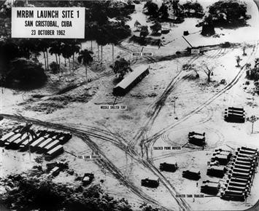
On Sunday, 14th October, 1962, American spy-planes flew over Cuba and took photographs of what military experts identified as nuclear missile sites that were being built by the USSR.
Further photographs showed that the sites were at different stages of development, some that could have been ready to launch missiles in just 7 days. American spy planes also reported that 20 Soviet ships were on the way to Cuba carrying missiles.
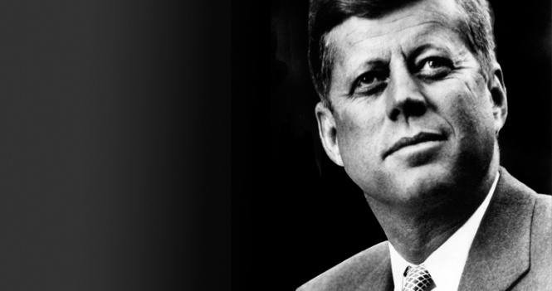
What am I going to do? The Soviets have got possible nuclear missiles on my doorstep…People already think I’m weak thanks to the Bay of Pigs disaster! I could launch a full scale attack, but that could provoke World War III.
What do you think I should do?
Kennedy was faced with five options:
Task: Go through each of Kennedy’s options and decide which two you would go with (and in what order) and which you would not have chosen. It doesn’t matter about what actually happened, rather what you would have done in Kennedy’s position.
Option | Details |  | Your choice
 | For | Against
Do nothing? | America still had greater nuclear power than the USSR. They USA could still destroy the USSR so it is possible that the USSR wouldn’t use their weapons. | The USSR had lied about Cuban missiles. Kennedy had already issued a warning to the USSR. Doing nothing would be a sign of weakness.
Surgical air attack? | It would destroy the missile bases before they were able to use them. | The attack would likely kill USSR soldiers and so the USSR would retaliate. It would seem immoral to attack without any warning.
Invasion? | Would get rid of the missiles and Castro too. The American forces were already trained and available to do this. | It would more than likely lead to the USSR and/or Cuba invading America or other American controlled territories, like Berlin.
Diplomatic pressure? | It would avoid any physical conflict. | If the USA was forced to back down then it would look like a sign of weakness.
Blockade? | A blockade would show that the USA was serious but it would not be a direct act of war. It would mean Khrushchev would need to make the next move. The USA had a strong navy. | It would not solve the main problem of the missiles being on Cuba. The USSR may retaliate by blockading Berlin like they did in 1948.
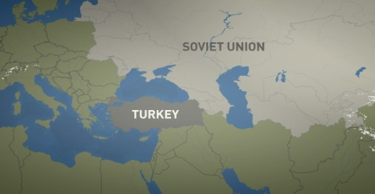
Something for us to be aware of...
Key Term: Blockade
A ban on the USSR bringing in any further military supplies to Cuba, enforced by the US navy who would stop and search Soviet ships. It would also call for the Soviet union to withdraw anything from Cuba that was placed there by them.
Whilst Khrushchev was keeping nuclear weapons on Cuba, America was keeping nuclear weapons in Turkey.
- The role of Khrushchev
Why did Khrushchev place missiles on Cuba?
- To bargain with the USA – Khrushchev wanted the missiles as a bargaining tool. If he had missiles on Cuba, he could agree to remove them in return for some American compromises.
- To test the USA – In the strained atmosphere of Cold War politics the missiles were designed to see how strong the Americans really were – whether they would back off or face up. The Soviet Union wanted to test out Kennedy.
- To trap the USA – The missiles were a trap. Khrushchev wanted the American to find them and be drawn in to a nuclear war. He did not even try to hide them.
- To defend Cuba – The missiles were genuinely meant to defend Cuba.
- To get the upper hand in the arms race – Khrushchev was so concerned about the missile gap between the USA and the USSR that he would seize any opportunity he could to close it. With missiles on Cuba it was less likely that the USA would ever launch a ‘first strike’ against the USSR.
Think: Do you feel any of Khrushchev’s reasons for placing missiles on Cuba are justified or understandable?
- How the Crisis panned out
14 October
A US U2 spy plane flew over Cuba. The pictures it took shocked the American military. The photographs taken by the plane showed that the USSR had put medium-range nuclear missiles in Cuba. For the first time the USSR could launch a surprise missile attack at most US cities.
16 October
The US military flew another spy mission over Cuba. It confirmed there were missiles on the island. They decided to inform the President. President Kennedy and his close advisors formed a committee to take control of the crisis. This committee was known as Ex-com.
22 October
Kennedy decided to blockade Cuba. This meant surrounding the island with US warships to prevent the Soviets bringing in more missiles. Kennedy went on TV and told the American people that the Soviets were threatening world peace.
23 October
Khrushchev denied there are any missiles on Cuba and said the USA was behaving like pirates. He accused Kennedy of trying to threaten Cuba and start a nuclear war.
24 October
In a nerve-wracking stand-off, Soviet ships approached the blockade. US ships were ready to fire on them – this would have led to war. The Soviet ships turned around at the very last moment.
25 October
Another U2 mission showed that the missiles were still being set up on Cuba.
26 October
Khrushchev sent a letter to Kennedy. He said he would remove the missiles if the USA agreed not to invade Cuba and ended the blockade.
27 October
Khrushchev sent another letter. This time he also asked for the US missiles to be removed from Turkey. Kennedy said he cannot agree to this. A U2 spy plane was shot down over Cuba. This angered the US military who demanded that Kennedy should launch an attack on Cuba. Kennedy refused. Kennedy decided to ignore the second letter from Khrushchev and just accept the first one. He also announced that he will attack Cuba if the missiles were not removed. Kennedy also secretly agreed to remove the missiles from Turkey.
28th October
Khrushchev agreed to remove the missiles. The Crisis was over.
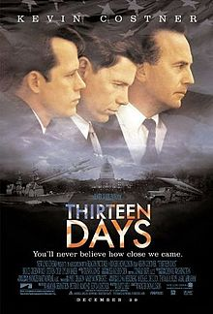
The film Thirteen Days goes through a Hollywood version of what happened during the Cuban Missile Crisis. If you’d like to watch it you can currently find the full version at the link below.
https://www.youtube.com/watch?v=tho5ZYLiuoc

- The consequences of the Crisis
“Even after it was all over President Kennedy made no statement attempting to take credit for himself or for his administration for what had occurred. He instructed all his staff that no interview should be given, no statement made, which would claim any kind of victory. He respected Khrushchev for properly determining what was in his own country’s interests and in the interests of mankind. If it was a triumph, it was a triumph for the next generation and not for any particular government or people”. By Robert Kennedy
- Following the crisis, Cuba stayed Communist and highly armed. However, the nuclear missiles were withdrawn under United Nations supervision.
- Both Kennedy and Khrushchev emerged with something from the crisis. Kennedy gained a greatly improved reputation in his own country and throughout the West for avoiding a nuclear war. With Cuba remaining Communist, Khrushchev had held on to a conveniently placed ally. The fact that he had to back down was soon forgotten back in the USSR, who were equally as relieved to avoid a nuclear war, with Khrushchev being seen as a reasonable peacemaker.
- Both leaders were prepared to take greater steps to prevent a nuclear war following the crisis. A permanent ‘hot line’ phone link direct from the White House in the USA to the Kremlin in Russia was set up to keep lines of communication between the two sides open. Furthermore, in 1963, both sides signed a Nuclear Test Ban Treaty. It did not stop the development of nuclear weapons but it did limit the testing of the weapons; this should not be underestimated, it was an important step forward and a sign that the Cold War was ‘thawing’.
- Within the USA, the crisis had an effect on anti-Communist opinion. Many felt that a Communist Cuba was an inconvenience to the USA, a nuclear war, however, would mean the end of the human race. Many people began to put the issue of Communism being on their doorstep in to perspective and the idea of invading Cuba faded away.

Task: In your opinion, who do you feel ‘won’ the Cuban Missile Crisis? The USA? The USSR? Cuba? Nobody? Everybody? Try to see if you can find at least one reason for each of these options.
Who was to blame for the Cuban Missile Crisis?
America?
They had missiles in Europe.
They had been very nervous about Castro and had not really treated him with respect.
They plotted against Castro and launched the Bay of Pigs invasion.
The USA had cut trade and diplomatic links.
Kennedy had appeared weak after the Bay of Pigs and during his meeting with Khrushchev in 1961.
The USSR?
They had put the missies there.
They give weapons and aid to Cuba.
They had provided trade deals that angered the USA.
They had tried to take advantage of a new and apparently weak President.
Cuba?
Castro had tried to do deals with the USA, but these had failed.
He then became anti-American and seized US businesses.
He also allowed Soviet troops and missiles into Cuba.
Think: Do you feel it is possible to blame any country in particular for the Cuban Missile Crisis?
Past exam questions
You should be able to answer ALL these questions. At least plan answers and practice writing them using the advice on the last page.

Aiming at A*? Take time to look at the TYPE of questions that are being asked on each topic. If they ask 10 mark questions on it you need to know it REALLY well. If they ask 4 mark questions on it you need specific details to describe. If it’s 6 mark questions then you need to know the different factors you could explain. Most of the topics are a mixture. Are you ready for ALL of them?
Knowledge Questions
Paper 1 Section A: Who won the Cuban Missile Crisis? | (c) ‘The Cuban Missile Crisis was never a threat to world peace.’ How far do you agree with this statement? Explain your answer. [10]  (c) ‘The USA was more responsible for causing the Cuban Missile Crisis than the USSR’. How far do you agree with this statement? Explain your answer [10]
- The Cuban Revolution and USA’s reaction | (a) Describe relations between Cuba and the USA between 1859 and the Bay of Pigs invasion of 1961 [4]  (b) Explain why the USA was concerned about events in Cuba between 1959 and 1961 [8]  (a) Describe the USA’s reaction to the Cuban Revolution [4]  (a) Describe how Cuba changed under Castro [4]  (b) Explain Kennedy’s options after missile sites were discovered in Cuba [6]  (a) Describe the USA’s response to Castro’s seizure of power in Cuba [4]
- The Bay of Pigs | (a) What happened in the Bay of Pigs invasion of 1961? [4]  (a) Describe the Bay of Pigs invasion [4]  (a) Describe the USA’s response to Castro’s seizure of power in Cuba [4]  (b) Explain why the failure of the Bay of Pigs invasion caused problems for the USA [6]  (a) Describe American involvement in the Bay of Pigs incident in 1961. [4]
- The events of the Crisis | (b) Why did Khrushchev send missiles to Cuba in 1962? Explain your answer. [6]  (b) Explain why the USA was concerned about Soviet missiles in Cuba [6]  (b) Explain why Khrushchev placed missiles in Cuba [6]  (b) Explain why the Soviet Union became involved in Cuba. [6]  (b) Explain why President Kennedy took action against Soviet missile bases in Cuba in 1962. [6]
- The role of Khrushchev | (b) Why did Khrushchev send missiles to Cuba in 1962? Explain your answer. [6]  (c) ‘Khrushchev handled the Cuban Missile Crisis very well.’ How far do you agree with this statement? Explain your answer [10]  (c) ‘Kennedy handled the Cuban Missile Crisis better than Khrushchev did’. How far do you agree with this statement? Explain your answer. [10]
- The role of Kennedy | (b) Explain why Kennedy was successful in dealing with the Cuban Missile Crisis [8]  (c) ‘Kennedy handled the Cuban Missile Crisis better than Khrushchev did’. How far do you agree with this statement? Explain your answer. [10]  (b) Explain why Kennedy could claim victory in the Cuban Missile Crisis [8]
- The resolution of the Crisis | (b) Explain why Kennedy was successful in dealing with the Cuban Missile Crisis [8]  (c) ‘Kennedy handled the Cuban Missile Crisis better than Khrushchev did’. How far do you agree with this statement? Explain your answer. [10]  (c) ‘The Cuban Missile Crisis was a victory for the Soviet Union.’ How far do you agree with this statement? Explain your answer. [10]  (b) Explain why Kennedy could claim victory in the Cuban Missile Crisis [8]  (c) How far was the Cuban Missile Crisis a failure for the USSR? Explain your answer. [10]
- The consequences of the Crisis | (c) The outcomes of the Cuban Missile Crisis were equally successful for: (i) the USA; (ii) the USSR; (iii) Cuba. How far do you agree with this statement? Explain your answer referring only to (i), (ii) and (iii). [10]
Knowledge questions advice
Command words | Question numbers and marks | What that means you need to do
Describe ...  What... | 2 (a) 4  3(a) 4  8 (a) 4  9(a) 4 | This is a short question where you need to select key points relevant to the question and write them in clear sentences. You do not need to explain, but if you can only remember 2 or 3 points you can explain to get all four marks. Spend around 4 minutes on this question.
Explain...,  Why... | 1 (b) 8  2 (b) 6  3 (b) 6  8 (b) 6  9 (b) 6 | This means you need to explain your answer. For these questions you need to say WHY. Use the words ‘because’, ‘this meant that’, ‘therefore. Write in paragraphs (2 for a 6 mark question and 3 for an 8 mark question)  You need to back up your answer with specific and relevant details from your knowledge. Spend around 8 minutes on a 6 mark and 10 minutes on an 8 mark question
How far (10) | 2 (c) 10  3 (c) 10  8 (c) 10  9 (c) 10 | This means you need to weigh up- balance two sides of the answer and give your judgement on how much you agree with the statement.  You should plan what you’re going to write before you write it and follow your plan.  You need to back up your points with specific examples from your knowledge and use to explain each side. Spend at least 20 minutes on a 10 mark question.

Source Questions
ANY source could come up in the exam. It is HIGHLY likely you won’t have seen all the sources before, so you need to practice analysing them.
Label them to pick out the key details and pick out the key pieces of contextual knowledge that will help you to explain.
The question will be something like:

(a) What is the message of the cartoon? Use details from the cartoon and your knowledge to explain your answer [7]
(a) What is the cartoonist’s message? Use details from the cartoon and your knowledge to explain your answer [7]

Source Questions advice
Knowledge Question command words | Question numbers relevant for and marks | What that means you need to do
Describe ...  What... | 2 (a) 4  3(a) 4  8 (a) 4  9(a) 4 | This is a short question where you need to select key points relevant to the question and write them in clear sentences. You do not need to explain, but if you can only remember 2 or 3 points you can explain to get all four marks.
Explain...,  Why... | 1 (b) 8  2 (b) 6  3 (b) 6  8 (b) 6  9 (b) 6 | This means you need to explain your answer. For these questions you need to say WHY. Use the words ‘because’, ‘this meant that’, ‘therefore. Write in paragraphs (2 for a 6 mark question and 3 for an 8 mark question)  You need to back up your answer with specific and relevant details from your knowledge.
How far (10) | 2 (c) 10  3 (c) 10  8 (c) 10  9 (c) 10 | This means you need to weigh up- balance two sides of the answer and give your judgement on how much you agree with the statement.  You should plan what you’re going to write before you write it and follow your plan.  You need to back up your points with specific examples from your knowledge and use to explain each side

What else can I do?
- Have you planned out or answered all the questions?
- Has your revision been effective?
- What areas have you identified as needing the most work? What do you need to do to get confident on them?
- Have you made revision notes on everything in this booklet?
- Have you checked that you remember it?
- Have you come back to this after a few days and a few weeks to check it’s ‘stuck’?
- Have you gone to Memrise to memorise the key information?
- Have you done any extra reading? Go to twitter @LHSGCSEHistory to find links to great websites
- Have you worked with a friend to check each others’ revision?
- Feeling confident? Do a whole Paper 1 in 2 hours. They’re on the History page of the school website, or your teacher can give you one. Give it to your teacher to find out what grade it would be. Even better if you have a go at marking it yourself first.

