GCSE History
Cold War Booklet 3
Why did the USA fail in Vietnam?
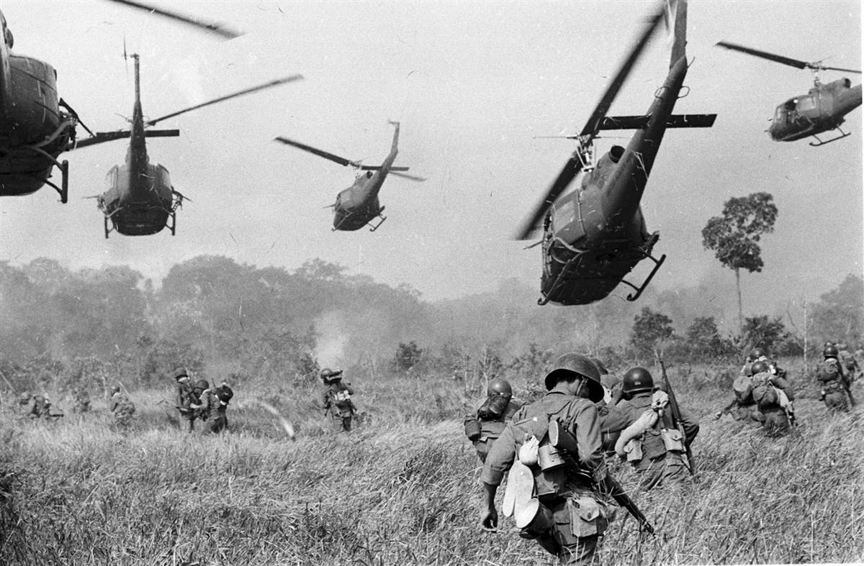
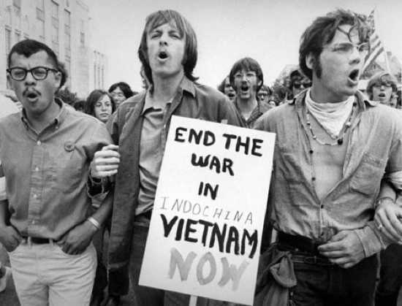
Why did the USA get increasingly involved in Vietnam?
What were the different ways that the USA and the Communists fought the war?
Whose tactics were the most effective – the USA’s or the Communists’?
Why did the USA withdraw from Vietnam?

Remember
Make your revision ACTIVE
The Effective Revision Cycle

This cycle is what you need to do for ALL revision. First, TEST what you know. It’s no good revising the stuff you feel confident on and ignoring the stuff you don’t like and just hoping it doesn’t come up! Once you know the areas you are least confident on REFLECT on why. What needs to change to make you confident on it? Sort that out, and then LEARN it. Be active, use ALL the resources the school has given you to help you.

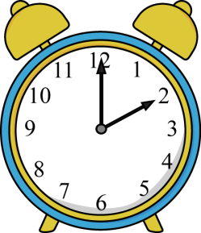
TIME YOURSELF! Before you start, take 3 minutes, and 3 minutes ONLY, to write down everything you can remember about our study of the Vietnam War.
Do regularly to make sure your knowledge is secure.
Come on, it only takes 3 minutes!
You will find it useful to highlight the information in this booklet. You will find it even more useful if you do this with coded colours:
1 colour to pick out dates
1 colour to pick out the names of key individuals
1 colour to pick out selected key points/facts.

Use the above as a key for your highlighting.
Here’s what’s going to be covered during this booklet...
Main topic | This will include...
- Background to the conflict in Vietnam | Geography of Vietnam.  Early stages of the war.
- Why America got involved in Vietnam. | Looking at the longer term reasons why America would get involved in Vietnam.
- Increased involvement in Vietnam. | How Kennedy and Johnson escalated America’s involvement in Vietnam up to 1963.  The Gulf of Tonkin incident.
- Tactics used by both sides. | Comparison of tactics used by the Viet Cong and the US army.
- The Tet Offensive | A key event from the War regularly discussed in a) part questions.
- The Media and Protest | Reasons for America withdrawing from the Vietnam War.
- Getting out of Vietnam | Strategies used by Nixon to end the war.  How the war in Vietnam comes to an end.
You need to have specific facts and details for all of these ready to use in the exam.
Don’t forget the exam questions and other revision advice at the end of the booklet!
Let’s get started...
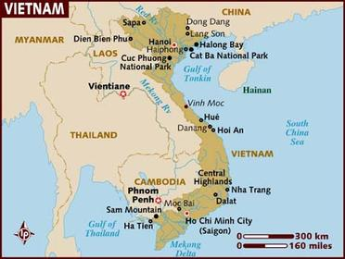
- Background to the conflict in Vietnam
Vietnam is a country in South East Asia. It borders China, Laos and Cambodia. It is a country that relies heavily on agriculture, with the majority of the population being peasants. There have always been large areas of poverty in Vietnam.
At the turn of the 20th Century, Vietnam was a French colony and remained this way until the Japanese took over during the Second World War. However, Vietnam’s drive for independence would be influenced by neighbouring China becoming Communist during the early 1950s.
In 1954, Vietnam was divided in two. North Vietnam (which bordered China) became Communist under their leader Ho Chi Minh. South Vietnam became anti-Communist and was led by a man called Diem. Diem was a Catholic, however the people he ruled over were mainly Buddhist. He was a very strict, repressive and unpopular ruler. Tensions between the two halves of the country grew until in 1956, a Civil War broke out. This war got the attention of America...
Think: Before you move on to the next section, think, why would America care about what was going on in Vietnam? How does this fit in with other topics we have studied this year?
- Why did America get involved in Vietnam?
It can be said that America had two main reasons for getting involved in the conflict that was happening in Vietnam:
- To protect and encourage Vietnamese independence.
- To stop the spread of Communism
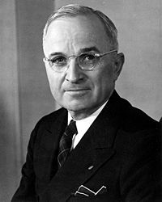
To protect and encourage Vietnamese independence
America has always seen itself as the defenders of freedom. In 1947, President Truman released his Truman Doctrine. In it, he said:
“The free people of the world look to America for support in keeping their freedom. I believe that it must be the responsibility of America to support people who are defending themselves against countries who are trying to take them over. I believe that we must help free people to work out their own destiny in their own way”.
America saw themselves as responsible to help Vietnam protect their independence.
To stop the spread of Communism
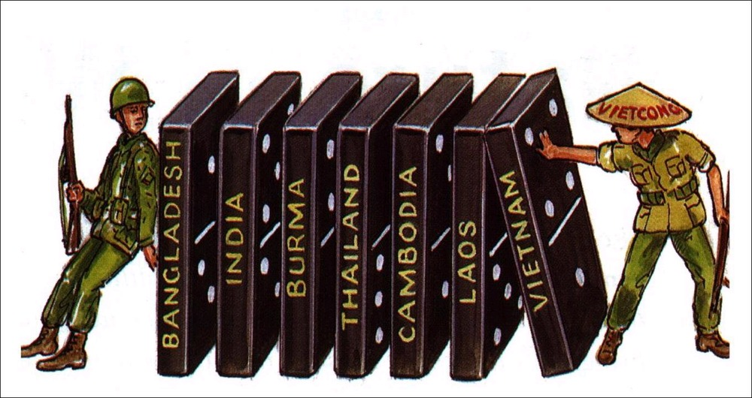
The American Presidents at this time (Truman especially) were strongly anti-Communist. When the Civil War broke out in Vietnam in 1956, they were worried that South Vietnam would not be able to stand up to the Communist North, who would be heavily supplied by neighbouring China and the USSR. So, America decided to provide help to Diem in South Vietnam through money and weapons.
America feared that if Vietnam became Communist then its neighbouring countries (Laos and Cambodia) would do the same, and if that happened to those countries, then the same thing would happen to their neighbours, and so on. This idea was known as the Domino Theory, and was used by President Kennedy in the early 1960s to justify his continued involvement in the conflict in Vietnam. At this time, President Khrushchev of the USSR made a speech which made the Domino Theory sound very much like a reality.
- Increased involvement in Vietnam
By the time President Kennedy took charge in America in 1961, the conflict in Vietnam was still going strong with no sign of an end in sight. America was still providing aid to South Vietnam through money and weapons. Kennedy increased this somewhat by providing them also with military ‘advisers’ from the US army, however these troops were under instruction not to fight in the war, just advise the South Vietnam armed forces.
Following Kennedy’s assassination in 1963, Lyndon Johnson took over as President. Johnson intended to carry on with Kennedy’s plans in Vietnam. However, this was all to change in August 1964.
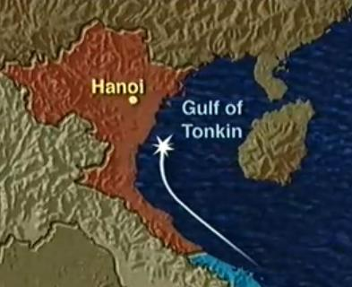
In early August, 1964, an American naval ship called ‘The Maddox’ was attacked off the East coast of North Vietnam (the Communist bit) in the Gulf of Tonkin (see map). When they examined the damage, the Americans noticed that the missiles that attacked the ship were from North Vietnam. The attack was considered an act of aggression against America, so President Lyndon Johnson drew up the Tonkin Gulf Resolution:
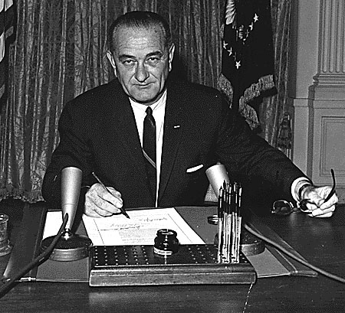
“Now, let it be known that the American government supports the President to take all necessary measures to stop any armed attack against the United States… The United States is prepared to take all necessary steps to help Vietnam against the Communists that are trying to take over. After the attack on the Maddox, we are prepared to go to war in Vietnam about this…”
From here, America was at war with Vietnam and the number of troops involved escalated.
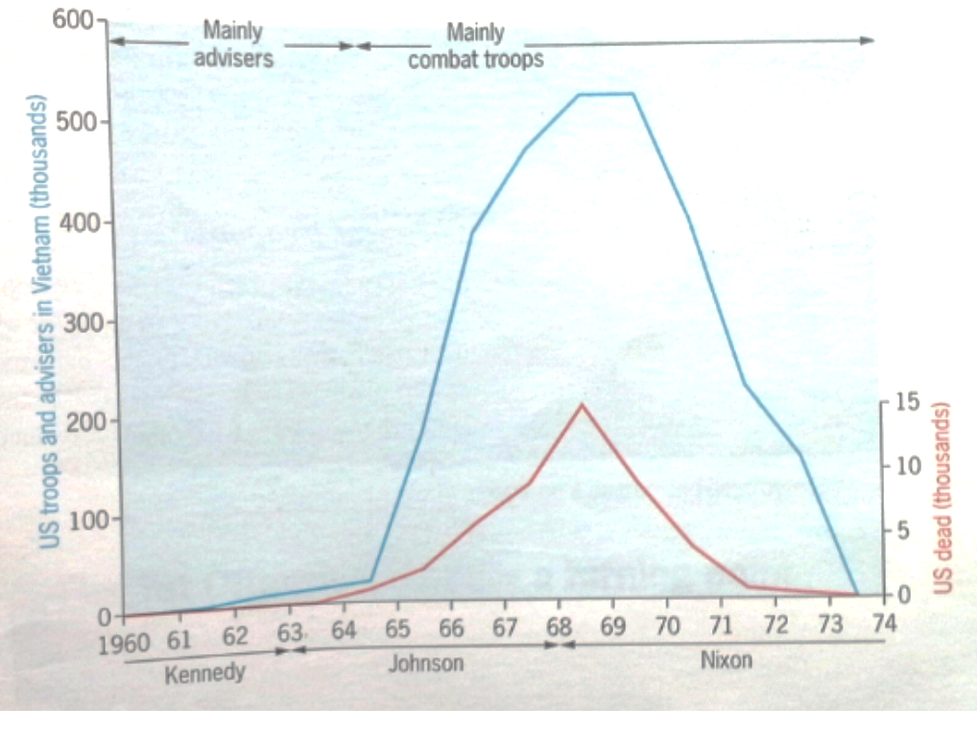
Task: Have a look at the graph. The upper line represents the number of US troops in Vietnam and the lower line shows the number of deaths. What observations can be made from this graph? Can you link the information to any of the key moments from our Vietnam study? How did Johnson get such a high number of troops involved?

- Tactics used by both sides
Key Term: Viet Cong
The Viet Cong were those who fought on the side of the Communists in the Vietnam War. They were mainly peasants. The American soldiers often referred to them as ‘VCs’, ‘Victor Charlies’ or sometimes just ‘Charlie’.
Viet Cong Tactics

The Viet Cong were a very special type of fighting force. They were tough and resilient, and although they were low in numbers, they gave the impression to their enemy that they were everywhere. The mainly did this through the use of guerrilla tactics.
The Viet Cong guerrilla’s were taught to wear down the enemy and wreck their morale. They would retreat when the American’s attacked them, then attack the Americans when they would set up camp or would tire, and when the American’s would retreat, the Viet Cong soldiers would pursue them and keep fighting. They refused to give in.
Key Term: Guerrilla
Guerrilla soldiers are difficult to identify as they do not wear a uniform. They blend in to the civilian population and act in a way so as to avoid suspicion.

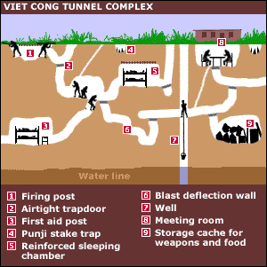
However, it can be said that the Viet Cong’s greatest tactic was the way they used their territory and surroundings to their advantage. They created vast tunnel complexes to house everything they needed rather than having a camp above ground that could be easily attacked. In the event an enemy soldier got in to the tunnels, they were full of traps and secret passage ways that would allow the Viet Cong to escape. The CIA in America estimated that there were approximately 240km of these tunnels.

As well as this, the Viet Cong had the Ho Chi Minh trail that helped to keep the Communist forces supplied. Whenever the trail was attacked by their enemy, the Viet Cong had 40,000 Vietnamese peasants on side who were dedicated to repairing the trail.
Think: How did the tactics used by the Viet Cong enable them to have an advantage over the Americans? Why is it possible to say that this was somewhat of an unfair advantage?
American Tactics
The Americans had 3 main tactics they used in response to the tactics used by the Viet Cong: bombing campaigns, chemical weapons and search and destroy missions.
Bombing Campaigns – On 7th February 1967, President Johnson launched Operation Rolling Thunder, a bombing campaign used to try and destroy key industrial and military targets in North Vietnam as well as the Ho Chi Minh trail. More bombs were dropped on North Vietnam than were dropped in the whole of the Second World War (including the two atomic bombs used on Japan). However, this tactic could not defeat the Communist, it could only slow them down. It was also an incredibly expensive tactic: it was estimated that it would cost $400,000 to kill one Viet Cong soldier.
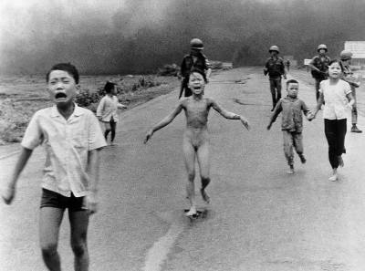
Chemical Weapons - the US developed powerful chemical weapons such as ‘Agent Orange’ and Napalm. These were effectively weed killers and were used to destroy the jungle where the Viet Cong hid. However, the chemicals were hazardous to humans and would burn through skin and bone. Many civilians and soldiers were killed by these chemicals, and in the longer term, they polluted the soils and water supplies in Vietnam.
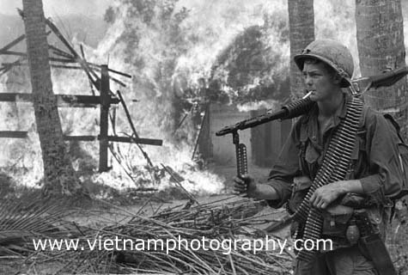
Search and Destroy Missions – On these missions, American soldiers would descend on village and destroy any Viet Cong forces they found (keeping in mind it was almost impossible to spot a Viet Cong soldier thank to their guerrilla tactics). They would often burn entire villages in the hope to scare their enemy out. Although the missions did kill Viet Cong soldiers, they also had many problems. The targets were not always 100% correct and often resulted in huge numbers of civilian deaths. These missions made the American forces unpopular with the peasant population and instead pushed them towards supporting the Viet Cong.
The My Lai Massacre is an example of the problems with the Search and Destroy missions. In March, 1968, a unit of young American soldiers were sent on a Search and Destory mission to My Lai, a suspected Viet Cong Headquarters. They were wrongly told that the civilians would not be there and they were instructed to destroy the village. Within 4 hours, nearly 400 civilians had been killed, men, women, children and the elderly without a single Viet Cong soldier being found. The US claimed it was a successful mission and lied about the number of civilian deaths. However, a year later the truth came out. The American public were horrified.
Think: How far do you feel the tactics used by the American army were the reason for its failure in Vietnam?
- The Tet Offensive
The Tet Offensive is considered by many to be a significant turning point in the war in Vietnam. In 1968 the Viet Cong launched a major offensive during the Tet New Year holiday; Viet Cong fighters attacked over 100 cities and other military targets. One Viet Cong commando unit tried to capture the US embassy in Saigon (the then capital of Vietnam). Around 4,500 Viet Cong fighters held down a much larger US and South Vietnamese force in Saigon for two days. In many ways, the offensive was a complete disaster for the Communists. They hoped that the people of South Vietnam would rise up and join them. They didn’t. The Viet Cong lost around 10,000 experienced fighters in the space of two days. They seemed defeated and President Johnson thought this was the victory they had been waiting for. However, the reality was that Tet was no victory for either side. In America, the offensive raised hard questions about the war: There were nearly 500,000 US troops in Vietnam and the USA were spending $20 billion a year on the war. So why had the Communists been able to launch a major attack that took US forces completely by surprise? US and South Vietnamese forces quickly retook the towns captured in the offensive, but in the process they used enormous amounts of artillery and air strikes (bombs) in which many Vietnamese citizens were killed and the ancient city of Hué was destroyed.
Think: Why can we consider the Tet Offensive to be a turning point in the Vietnam war? (A turning point is when the course of History changes. After this point (or event) things are never the same again. Sometimes turning points are positive, when the change that happens is for the better, sometimes they are negative, when things change for the worse.)
- The Media and Protests
Following the Tet Offensive in 1968, barely 26% of the American population supported the war.
Task: Before you read on, list the reasons why the Vietnam war was unpopular with the American people.
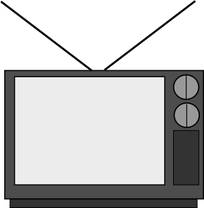
The public opinion was that no progress was being made in Vietnam. Both the media and the protest movements heavily influenced public opinion disagreeing with the war.
The Media
Newspaper and television journalists covered every aspect of the war in detail; it was the first war to be fully broadcast on television. The media brought the reality and the horrors of war into people’s living rooms. They reported on the effects of American bombing and use of chemical weapons like Napalm on the Vietnamese people, showing them dead or homeless. They interviewed prisoners of war who had been tortured and even showed them being executed. The media also showed the impact of the war on the USA itself, broadcasting the body bags containing dead American soldiers being flown back home as well as reporting on the spiralling costs of the war.
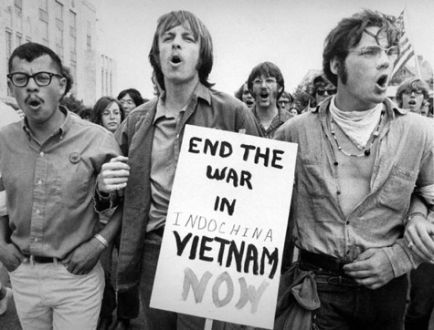
Think: Was it right that the American media broadcast this to their people? Do you believe it should have been censored?
The Protest Movement
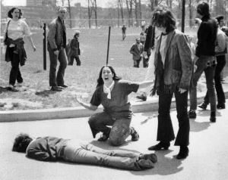
During the 1960s, popular culture in America put across a message of ‘love, peace and harmony’. Somehow escalating numbers of innocent Vietnamese civilians and young American men being killed did not fit with this. Half a million young Americans were fighting in a war that was very unpopular with students. University students sparked a nation-wide protest movement against the war in Vietnam. Many protested by becoming ‘draft-dodgers’, where men refused to be conscripted in to the war in Vietnam. Several large scale protest marches were held in Washington DC in 1969 and 1970, with numbers participating exceeding 1 million. Although the protests were meant to be peaceful in nature, they often ended in violent clashes with the police. The worst incident came in May 1970 at Kent State University, Ohio. Panicked National Guard troops opened fire on a crowd of protestor, resulting in four students being killed and 11 others injured. The media in America and abroad were horrified by the events and only served to show just how futile the war in Vietnam had become.
Think: Were the American government right to respond with force to the student protests against the war in Vietnam?
Task: As you will see from the table at the end of this booklet, (c) part questions regularly focus on the reasons why America withdrew from Vietnam, especially looking at the roles of:
(i) American military tactics,
(ii) The media and
(iii) The protest movement.
Give each reason above (i, ii and iii) a score from 1 to 10 depending on how important you felt they were in America withdrawing from Vietnam. How can you link the three reasons together?
- Getting out of Vietnam
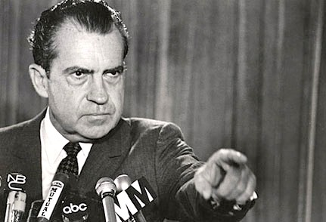
After the Tet Offensive, President Johnson decided not to run again for election and President Nixon took his place. In his election campaign, Nixon had promised the American people that he would get America out of Vietnam. But this was easier said than done...
Nixon couldn’t just say that it had all got too much and so they were getting out of Vietnam straight away.
- 1. America had been convincing people both at home and abroad that the war was both just and vital to American interests.
- 2. Thousands of Americans died fighting for their country in the war. Immediate withdrawal would have been seen as an insult to their memory.
- America would have to admit to losing the war and the Communists winning. Think about the Domino Theory! If Vietnam fall becomes a Communist country, who will next?!
It was now a question of: “How can the USA get out of Vietnam without looking like a defeat?”.
Task: Look back at the map in section (c). What impact does Nixon have on troop numbers in Vietnam?
In the early 1970s, Nixon used four main strategies to get America out of Vietnam:
Pressure on China and the USSR  In 1969 the USSR and China fell out and it even seemed possible that the two countries would go to war. So both countries tried to improve their relations with America. In 1970, Nixon met with the USSR to discuss limiting nuclear weapons. Nixon used this opportunity to see if the USSR could persuade North Vietnam to end the war. He did the same with China in 1972. | Peace Negotiations  Nixon’s Security Adviser Henry Kissinger worked tirelessly to end US involvement in Vietnam. From early 1969, he met regularly with the Vietnamese peace negotiator, Le Duc Tho.
‘Vietnamisation’  ‘Vietnamisation’ was the idea of handing the war over to the South Vietnamese, which would allow American forces to back out and letting the Vietnamese sort it out between themselves. By the end of 1971, 400,000 troops left Vietnam. | Bombing  Nixon increased the bombing campaigns against North Vietnam to show he was not weak. He also invaded Viet Cong bases in Cambodia (see map in section a), causing outrage across the world, even in the USA – the Kent State protest was in response to this.

Think: What were the advantages and disadvantages of each of these strategies?
How the war ended
- 1972 – North Vietnamese launch a major attack but are unable to conquer South Vietnam.
- Jan. 1973 – Le Duc Tho, Nixon and the South Vietnamese President Thieu signed a peace agreement.
- 29th March 1973 – the final US troops leave Vietnam.
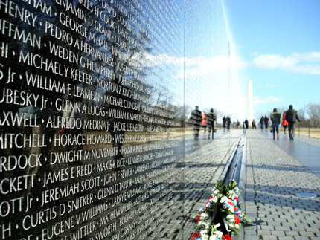
- April 1975 – The capital city, Saigon, falls to the Communist forces. This signals the end of the war in Vietnam with a Communist victory. Thousands of Vietnamese men, women and children desperately try to flee the country, seeking refuge in the US embassay.

Knowledge Questions
Paper 1 Section A: Why did the USA fail in Vietnam?
1. Increasing US involvement in Vietnam | (b) Explain the reasons why the USA became involved in Vietnam. [6]  (b) Explain the reasons why the USA became involved in Vietnam up to and including 1965. [6]  (b) Explain why US involvement in Vietnam increased between 1954 and 1964 [8]  (a) Describe the involvement of the USA in Vietnam before Johnson became President in 1963. [4]  (a) What was the ‘domino theory’ [4]  (a) What involvement did American have in Vietnam between 1954 and 1962? [4]
- Main events | (a) What was the Tet Offensive? [4]  (b) Explain why the war in Vietnam became increasingly unpopular in America [8]  (a) Describe the involvement of the USA in Vietnam before Johnson became President in 1963. [4]  (b) Explain why the Vietnam War became unpopular in the USA [6]  (a) What involvement did American have in Vietnam between 1954 and 1962? [4]  (c) ‘The main reason for American withdrawal from Vietnam was the Tet Offensive of 1968.’ How far do you agree with this statement? Explain your answer. [10]
- Tactics used by both sides | (a) Who were the Vietcong? [4]  (c) Which was more important in bringing about the USA’s failure in Vietnam: the military tactics of the North Vietnamese r public opinion in the USA? Explain your answer. [10]  (a) What military tactics did the Americans use in the Vietnam War? [4]  (b) Explain why the Vietcong was an effective fighting force [6]  (b) Explain why the methods used by the Americans to try to defeat to Vietcong were unsuccessful. [6]  (b) Explain why the tactics used by the Communists were effective [6]  (c) ‘The Tactics of the USA was the main reason for its failure in the Vietnam War’. How far do you agree with this statement? Explain your answer. [10]  (b) Explain why the Communists used guerrilla tactics in the Vietnam War. [6]
- Reasons America withdrew | (c) Which was more important in bringing about the USA’s failure in Vietnam: the military tactics of the North Vietnamese or public opinion in the USA? Explain your answer. [10]  (c) ‘The most important reason for America’s withdrawal from Vietnam was military failure.’ How far do you agree with this statement? Explain your answer [10]  (c) ‘Media coverage was more important than protest movements in causing America to withdraw from Vietnam.’ How far do you agree with this statement? Explain your answer. [10]  (c) The following were equally important reasons for America withdrawing from Vietnam: (i) Public opinion in America; (ii) Guerrilla warfare. How far do you agree with this statement? Explain your answer referring only to (i) and (ii). [10]  (c) ‘American public opinion was more important than military failure in causing the USA to withdraw from Vietnam.’ How far do you agree with this statement? Explain your answer. [10]  (b) Explain why the Vietnam War became unpopular in the USA [6]  (c) ‘The Tactics of the USA was the main reason for its failure in the Vietnam War’. How far do you agree with this statement? Explain your answer. [10]  (c) ‘The main reason for American withdrawal from Vietnam was the Tet Offensive of 1968.’ How far do you agree with this statement? Explain your answer. [10]  (b) Explain why America withdrew from the Vietnam War. [8]

Knowledge questions advice
Command words | Question numbers and marks | What that means you need to do
Describe ...  What... | 2 (a) 4  3(a) 4  8 (a) 4  9(a) 4 | This is a short question where you need to select key points relevant to the question and write them in clear sentences. You do not need to explain, but if you can only remember 2 or 3 points you can explain to get all four marks. Spend around 4 minutes on this question.
Explain...,  Why... | 1 (b) 8  2 (b) 6  3 (b) 6  8 (b) 6  9 (b) 6 | This means you need to explain your answer. For these questions you need to say WHY. Use the words ‘because’, ‘this meant that’, ‘therefore. Write in paragraphs (2 for a 6 mark question and 3 for an 8 mark question)  You need to back up your answer with specific and relevant details from your knowledge. Spend around 8 minutes on a 6 mark and 10 minutes on an 8 mark question
How far (10) | 2 (c) 10  3 (c) 10  8 (c) 10  9 (c) 10 | This means you need to weigh up- balance two sides of the answer and give your judgement on how much you agree with the statement.  You should plan what you’re going to write before you write it and follow your plan.  You need to back up your points with specific examples from your knowledge and use to explain each side. Spend at least 20 minutes on a 10 mark question.

Source Questions
ANY source could come up in the exam. It is HIGHLY likely you won’t have seen the source before, so you need to practice analysing the sources.
Label them to pick out the key details and pick out the key pieces of contextual knowledge that will help you to explain

The question will be something like:

(a) What is the message of the cartoon? Use details from the cartoon and your knowledge to explain your answer [7]
(a) What is the cartoonist’s message? Use details from the cartoon and your knowledge to explain your answer [7]
Source Questions advice
Command words | Question numbers | What that means you need to do
What is the message...? | 1 (a) [7]  7 (a) (b) or (c) [6] or [7] | You need to do three things (ASK)  Answer the question  Details from the Source to support your answer  Details from you Knowledge that explains the message. Spend around 8 minutes on it
Why was this source published in...? | 7 (a) (b) or (c) [7] | You need to use ASK for this question too. This question is asking you two things; the PURPOSE of the cartoon, what it’s trying to do; and why at that TIME? What was happening in that year or in that period to mean that source was published then? You must use your own knowledge and details from the source to answer. (They could ask it without the date for [6] marks). Spend around 8-10 mins on each source question)
How far...? | 7 (a) (b) or (c) [6] or [7] | This means you need to weigh up – balance two sides of the answer and give your judgement on how much you agree. Give evidence from the source to back up each side. Consider where the source has come from (provenance) to help you decide which side it supports. Use your own knowledge to support your argument. Spend around 8-10 mins on each source question)
How useful...? | 7 (a) (b) or (c) [6] or [7] | This means you need to decide how much we get from this source as historians for the issue in the question. E.g. if it’s: How useful is this source for an historian studying the New Deal? Use the source and your knowledge to explain your answer. [6] then it’s asking you what we CAN get from this source, how much evidence it does give us, and what it misses out, what we know that isn’t in the source. This needs to be weighed up and you need to make a clear judgement. Spend around 8-10 mins on each source question)
What else can I do?
- Have you planned out or answered all the questions?
- Has your revision been effective?
- What areas have you identified as needing the most work? What do you need to do to get confident on them?
- Have you made revision notes on everything in this booklet?
- Have you checked that you remember it?
- Have you come back to this after a few days and a few weeks to check it’s ‘stuck’?
- Have you gone to Memrise to memorise the key information?
- Have you done any extra reading? Go to twitter @LHSGCSEHistory to find links to great websites
- Have you worked with a friend to check each others’ revision?
- Feeling confident? Do a whole Paper 1 in 2 hours. They’re on the History page of the school website, or your teacher can give you one. Give it to your teacher to find out what grade it would be. Even better if you have a go at marking it yourself first.

Use this space to write yourself a ‘to do’ list, or to write questions about anything you’re not clear on to ask your teacher.

..................................................................................................................................................................................................................................................
..................................................................................................................................................................................................................................................
..................................................................................................................................................................................................................................................
..................................................................................................................................................................................................................................................
..................................................................................................................................................................................................................................................
..................................................................................................................................................................................................................................................
...........................................................................................................................................................................................................................................................................................................................................................................

