GCSE History
USA Booklet 1
How far did the US economy boom in the 1920s?
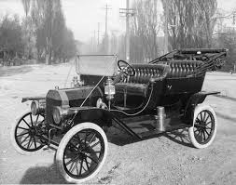

On what was the economic boom based?
Why did some industries prosper while some did not?
Why did agriculture not share in the prosperity?
Did all Americans benefit from the boom?

Remember
Make your revision ACTIVE

The Effective Revision Cycle

This cycle is what you need to do for ALL revision. First, TEST what you know. It’s no good revising the stuff you feel confident on and ignoring the stuff you don’t like and just hoping it doesn’t come up! Once you know the areas you are least confident on REFLECT on why. What needs to change to make you confident on it? Sort that out, and then LEARN it. Be active, use ALL the resources the school has given you to help you.

TIME YOURSELF! Before you start, take 3 minutes, and 3 minutes ONLY, to write down everything you can remember about our study of the Boom.
Do regularly to make sure your knowledge is secure.
Come on, it only takes 3 minutes!
You will find it useful to highlight the information in this booklet. You will find it even more useful if you do this with coded colours:
1 colour to pick out dates
1 colour to pick out the names of key individuals
1 colour to pick out selected key points/facts.

Use the above as a key for your highlighting.
Here’s what’s going to be covered during this booklet...
Main topic | This will include...
The impact of the First World War on the American economy | The trade between the USA and the rest of Europe  The key trades that the USA took over  The reasons the USA did not suffer as much as Europe
The expansion of the US economy during the 1920s | The 5 main factors for the boom: Republican Policies (4), the First World War, a new state of mind, industrial strength, new industries and methods.  Arguments about the importance of these factors  US isolationism  The role of Ford  The assembly line  Other key consumer industries and products.
The fortunes of older industries | Why mining, textiles and older industries did not do well.  The importance of tariffs and a weak export market.
Hire purchase and advertising | What ‘hire purchase’ means, the importance of it in the boom in consumer goods.  The down-side of hire purchase  The importance of advertising
Increase in standard of living and consumerism | The new ‘state of mind’ about consumer goods.  The groups that benefitted from the rise in standard of living.  Examples of consumer goods that were popular.
The decline of agriculture | The reasons why agriculture did not do well: Competition, overproduction, falling prices. Farming figures and facts
Weakness in the economy by the late 1920s | The problems in agriculture and the older industries.  The weakness of the export market.  The poor distribution of wealth.
You need to have specific facts and details for all of these ready to use in the exam.
The impact of the First World War on the American economy
Know your stuff!
What were the main industries that the USA took over?
What did the USA sell to Europe?
When did the USA join the First World War?

America was in a fortunate position as the First World War ended. The war had not directly damaged American society and it had led to increased demand for American goods. This resulted in the rapid growth of industry and farming. The US sold arms and munitions to Britain and France, and massive amounts of foodstuffs as well. They were also able to take over Europe’s trade around the world, exporting to the European colonies.
By the end of the war the USA had also overtaken Germany’s successful chemicals industries. Explosives manufacture during the war also stimulated a range of by-products which became new American industries.
Historians have called this time a USA’s second industrial revolution, helped greatly by the war.
The USA was not affected badly by the war because they were not in the war long enough, they only joined in 1917, the year before the war ended. There was a little dip at the end of the war but by 1922 it was growing fast again.

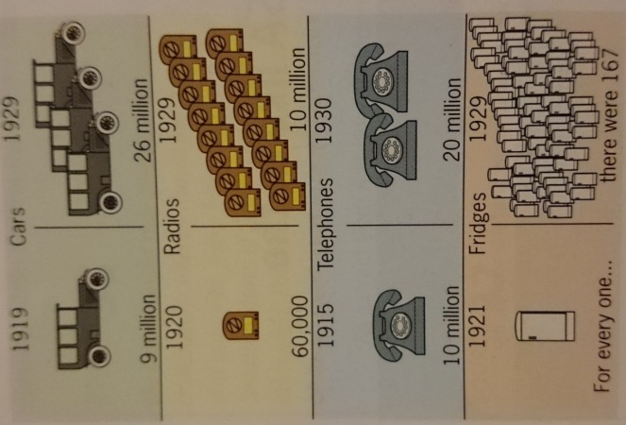
The expansion of the US economy during the 1920s

During the 1920s the USA’s economy was growing quicker than ever before. It was the richest and most powerful country in the world and its industry was booming. Much of the boom was based on people buying more and more consumer goods. The reasons this was possible are below. You need to know these reasons and how they caused the boom.

Republican Policies
Know your stuff!
What was the Fordney McCumber Tariff?
Name the super-corporations from the 1920s
Why did the Republicans keep taxes low?
What does Laissez Faire mean?

From 1920 to 1932 all the US presidents were Republican, and Republicans dominated Congress. Their beliefs included:
- Tariffs – The Republicans believed in import tariffs which made it expensive to import foreign goods. For example, in 1922 Harding introduced the Fordney-McCumber tariffs which made imported food expensive in the USA. These tariffs protected businesses against foreign competition and allowed American companies to grow even more rapidly.
- Laissez Faire - the Republicans believed that government should interfere as little as possible in the everyday lives of the people. This attitude is called ‘laissez-faire’. In their view, the job of President was to leave the businessman alone – to do his job. That was where prosperity came from.
- Low taxation – The Republicans kept taxation as low as possible. This brought some benefits to ordinary working people, but it brought even more to the very wealthy. The Republican thinking was that if people kept their own money, they would spend it on American goods and wealthy people would reinvest their money in industries.
- Trusts – The Republicans also allowed the development of trusts. These were super-corporations, which dominated industry. Men such as Carnegie (steel) and Rockerfeller (oil) had almost complete control of their sector of industry. Republicans believed that the ‘captains of industry’ knew better than politicians what was good for the USA.
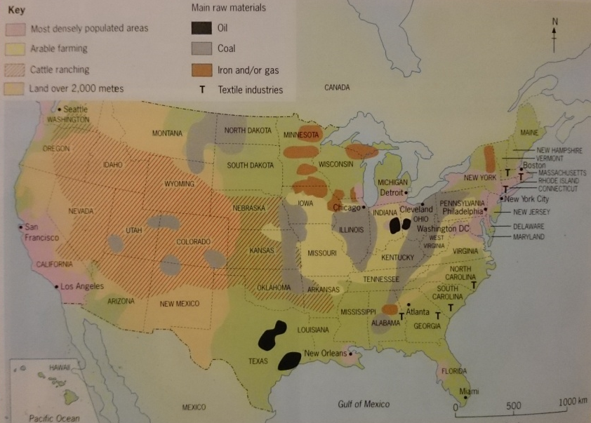
Industrial strength

The USA had vast natural resources. As well as a growing population working in industry, it also had large amounts of oil, coal, iron and vast amounts of land for farming.

By the 1920s the USA was the foremost in developing new technology such as motor cars, telephones and electric lighting. In fact, electricity and electrical goods were a key factor in the USA’s economic boom. The USA’s new film industry led the world. The managers of these industries were increasingly skilled and professional, and there were selling more and more of their products not just in the USA but in Europe, Latin America and the Far East.
Know your stuff!
What were the USA’s main natural resources?
Which industries were strongest?

New industries and methods

Through the 1920s new industries and new methods of production were developed. These industries were able to exploit the vast resources of raw materials to produce steel, chemicals, glass and machinery. Telephones, radios, vacuum cleaners and washing machines were mass-produced on a vast scale, making them cheaper so more people could buy them. These industries used the latest, most efficient techniques proposed by the ‘Industrial Efficiency Movement’.

Production of cars | 1926 | 4.3 million
 | 1929 | 5.3 million
Number of cars registered | 1920 | 8.1 million
 | 1929 | 23.0 million
Values of radios sold (in US dollars) | 1922 | 60.0 million
 | 1929 | 824.5 million
The most important of these new booming industries was the motor-car industry. Cars were first built in the 1890s by blacksmiths and skilled craftsmen. They were expensive and took a long time. Car production was revolutionised by Henry Ford. He used a moving production line (or assembly line) so each worker had one or two small jobs to do as the car moved past them. This made cars much quicker and cheaper. The most famous is the Model T Ford. More than 15 million were produced between 1908 and 1925. In 1927 they came of the production line at a rate of one every 10 seconds.

A new state of mind
Get the vocab right
Consumer goods
Radios, cars, fridges, vacuum cleaners – all things people (or consumers) bought during the 1920s

One thing that links all other factors was an attitude or state of mind. Most Americans believed that they had a right to ‘prosperity’ (wealth). For many it was a main aim in life to have a nice house, a good job and plenty to eat, and for their home to be filled with the latest consumer goods. Consuming more and more was seen as part of being American. In earlier decades, thrift (being careful with money) was seen as a good quality, in the 1920s, Americans wanted to spend their money.

Hire purchase and advertising
KEY FACT
8 out of 10 radios and 6 out of 10 cars were bought on credit

The new industries got Americans to buy their products using mass nationwide marketing techniques. Agencies were set up to sell cars, cigarettes, clothing and other consumer items. Poster advertisements, radio advertisements, and travelling salesmen encouraged Americans to spend. They were encouraged to ‘buy now, pay later’ with the new hire purchase schemes.

Revise the causes of the boom:

Make a detailed mind map of the causes of the boom using what you’ve read so far. Draw on any links between factors and explain them. Which factor do you think was the most important? Why?

Why did the USA’s economy boom in the 1920s

You could also skip to the back page and have a go at some of the exam questions on this topic to check your revision

Increase in standard of living and consumerism

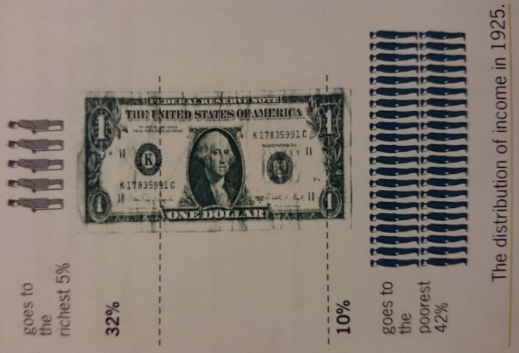
Lifestyles changed significantly during the 1920s, for some Americans. The invention and popularity of the car meant that people could buy homes in the suburbs, which further boosted house building. It stimulated a growth of hundreds of other smaller businesses like hot dog stands and petrol stations. It also led to the growth of leisure industry as people went to an increasing number of holiday resorts. Cities grew as people moved further and further out and people benefitted from the labour saving machines such as washing machines and vacuum cleaners. However, these lifestyle changes only applied to a small number of Americans, who lived in cities and earned good wages. This is what the second topic (Booklet 2) is all about.

The fortunes of older industries

Workers in many older industries, such as coal, leather and textiles, did not benefit much from the economic boom. Leather and textiles were protected from foreign competition, but not from domestic (internal) competition. New man-made products replaced natural textiles. Workers salaries only rose very slowly, so they could not purchase the new consumer goods.

The decline of agriculture
Total US farm income dropped from $22 billion in 1919 to just $13 billion in 1928. The reasons for this are below

Overproduction  In the 1920s the average US farmer was each year growing enough to feed his family and 14 others. More and more land was being farmed, using improved machinery like the combine harvester and improved fertilisers meant much more food was being produced than actually needed. | Competition  Farmers were struggling against competition from highly efficient Canadian wheat producers. At the same time the US population was actually falling so there were fewer mouths to feed.  On top of this the tariffs in Europe reduced their potential market.
Falling prices  Because farmers were producing too much prices fell as competition went up. In 1920 alone farm prices fell by 50% as farmers desperately tried to sell their produce. Hundreds of rural banks collapsed in the 1920s and there were 5 times as many farm bankruptcies as in the decade before. | Tariffs  The problems were made worse by the fact that the farmers did not have a significant export market for their goods. Europe was poor and could not buy a lot of US produce, and Europe did not like the high US tariffs that had stopped it from exporting to the USA.

Because of these problems 6 million rural Americans were forced of the land in the 1920s. Many of these were unskilled workers who migrated to the cities, where there was little demand for their labour. America’s black population was particularly badly hit. Many were sharecroppers, which meant they were not paid any wages, but instead were given a share of the crop that was made. They had always done the least skilled jobs. As they lost their jobs on the farms, three-quarters of a million became unemployed.

The worst hit were the southern states of the USA. Farms here depended on cotton or tobacco. Not only were prices rock bottom but the crops were often destroyed by pests such as the boll-weevil.
Weakness in the economy by the late 1920s
- The USA became richer during the 1920s but the wealth was not shared out equally. In 1929 one third of all income was earned by just 5 percent of the workforce. In the same year about 60 percent of American families were still living in poverty.
- Some major industries did not grow (coal and textiles).
- Farmers were producing too much food
- Many ordinary Americans did not share in the boom. African Americans suffered discrimination and had the worst jobs.

Make a table like the one below and list the key evidence for each side

Signs of ‘boom’ or prosperity | Signs of weakness

Past exam questions
You should be able to answer ALL these questions. At least plan answers and practice writing them using the advice on the last page.

Aiming at A*? Take time to look at the TYPE of questions that are being asked on each topic. If they ask 10 mark questions on it you need to know it REALLY well. If they ask 4 mark questions on it you need specific details to describe. If it’s 6 mark questions then you need to know the different factors you could explain. Most of the topics are a mixture. Are you ready for ALL of them?
Knowledge Questions
- The impact of the First World War on the American economy | (c) ‘The impact of the First World War was the most important cause of the economic boom of the 1920s.’ How far do you agree with this statement? Explain your answer. [10]  (a) What benefits did the First World War bring to the American economy? [4]
- The expansion of the US economy during the 1920s | (c) How far do you agree that American industry boomed in the 1920s because of Republican policies? Explain your answer. [10]  (a) Describe the Republican government’s economic policies in the 1920s [4]  (c) ‘Hire purchase credit was the most important reason for the economic boom in the USA’. How far do you agree with this statement? Explain your answer. [10]  (c) To what extent was the economic boom of the 1920s caused by new methods of production? Explain your answer [10]
- Mass production in the car and consumer durables industries | (a) Describe how an assembly line operated. [4]  (c) To what extent was the economic boom of the 1920s caused by new methods of production? Explain your answer [10]
- The fortunes of older industries | (b) Explain why some US industries did not benefit from the economic prosperity of the 1920s [6]  (b) Explain why the US economy was already showing signs of weakness before the Wall Street Crash [6]
- Hire purchase and advertising | (c) ‘Hire purchase credit was the most important reason for the economic boom in the USA’. How far do you agree with this statement? Explain your answer. [10]
- Increase in standard of living and consumerism | (b) Explain why the lifestyle of some women changed in the 1920s. [6]  (a) Describe the American cinema and movie industry in the 1920s. [4]
- The decline of agriculture | (b) Explain why American farmers faced problems during the 1920s. [6]  (b) Explain why the US economy was already showing signs of weakness before the Wall Street Crash [6]  (b) Explain why many American farmers suffered financial difficulties in the 1920s. [6]  (b) Explain why many farmers did not share in the economic prosperity of the 1920s [6]
- Weakness in the economy by the late 1920s | (b) Explain why some US industries did not benefit from the economic prosperity of the 1920s [6]  (b) Explain why the US economy was already showing signs of weakness before the Wall Street Crash [6]  (b) Explain the consequences of over-production in the 1920s. [6]

Knowledge questions advice
Command words | Question numbers and marks | What that means you need to do
Describe ...  What... | 2 (a) 4  3(a) 4  8 (a) 4  9(a) 4 | This is a short question where you need to select key points relevant to the question and write them in clear sentences. You do not need to explain, but if you can only remember 2 or 3 points you can explain to get all four marks. Spend around 4 minutes on this question.
Explain...,  Why... | 1 (b) 8  2 (b) 6  3 (b) 6  8 (b) 6  9 (b) 6 | This means you need to explain your answer. For these questions you need to say WHY. Use the words ‘because’, ‘this meant that’, ‘therefore. Write in paragraphs (2 for a 6 mark question and 3 for an 8 mark question)  You need to back up your answer with specific and relevant details from your knowledge. Spend around 8 minutes on a 6 mark and 10 minutes on an 8 mark question
How far (10) | 2 (c) 10  3 (c) 10  8 (c) 10  9 (c) 10 | This means you need to weigh up- balance two sides of the answer and give your judgement on how much you agree with the statement.  You should plan what you’re going to write before you write it and follow your plan.  You need to back up your points with specific examples from your knowledge and use to explain each side. Spend at least 20 minutes on a 10 mark question.

Source Questions
ANY source could come up in the exam. It is HIGHLY likely you won’t have seen any of the 3 USA sources before, so you need to practice analysing the sources.
Label them to pick out the key details and pick out the key pieces of contextual knowledge that will help you to explain
(a) How useful is this source as evidence to an historian studying America in the 1920s? Use the source and your knowledge to explain your answer. [7]

(b) What is the message of this cartoon? Use the cartoon and your knowledge to explain your answer. [7]

(c) Why was this photograph taken? Use the source and your knowledge to explain your answer. [6]

(b) Why was this source produced in American in the 1920s? Use the source and your knowledge to explain your answer. [6]

(c) How far does this source expalin why there was an economic boom in the 1920s? Use the source and your knowledge to explain your answer. [7]

Source Questions advice
Command words | Question numbers | What that means you need to do
What is the message...? | 1 (a) [7]  7 (a) (b) or (c) [6] or [7] | You need to do three things (ASK)  Answer the question  Details from the Source to support your answer  Details from you Knowledge that explains the message. Spend around 8 minutes on it
Why was this source published in...? | 7 (a) (b) or (c) [7] | You need to use ASK for this question too. This question is asking you two things; the PURPOSE of the cartoon, what it’s trying to do; and why at that TIME? What was happening in that year or in that period to mean that source was published then? You must use your own knowledge and details from the source to answer. (They could ask it without the date for [6] marks). Spend around 8-10 mins on each source question)
How far...? | 7 (a) (b) or (c) [6] or [7] | This means you need to weigh up – balance two sides of the answer and give your judgement on how much you agree. Give evidence from the source to back up each side. Consider where the source has come from (provenance) to help you decide which side it supports. Use your own knowledge to support your argument. Spend around 8-10 mins on each source question)
How useful...? | 7 (a) (b) or (c) [6] or [7] | This means you need to decide how much we get from this source as historians for the issue in the question. E.g. if it’s: How useful is this source for an historian studying the New Deal? Use the source and your knowledge to explain your answer. [6] then it’s asking you what we CAN get from this source, how much evidence it does give us, and what it misses out, what we know that isn’t in the source. This needs to be weighed up and you need to make a clear judgement. Spend around 8-10 mins on each source question)

What else can I do?
- Have you planned out or answered all the questions?
- Has your revision been effective?
- What areas have you identified as needing the most work? What do you need to do to get confident on them?
- Have you made revision notes on everything in this booklet?
- Have you checked that you remember it?
- Have you come back to this after a few days and a few weeks to check it’s ‘stuck’?
- Have you gone to Memrise to memorise the key information?
- Have you done any extra reading? Go to twitter @LHSGCSEHistory to find links to great websites
- Have you worked with a friend to check each others’ revision?
- Feeling confident? Do a whole Paper 1 in 2 hours. They’re on the History page of the school website, or your teacher can give you one. Give it to your teacher to find out what grade it would be. Even better if you have a go at marking it yourself first.

