GCSE History
USA Booklet 2
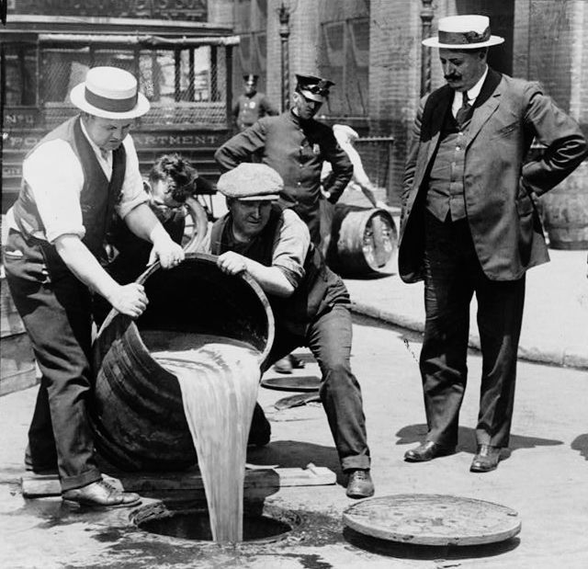
How far did US society change in the 1920s?
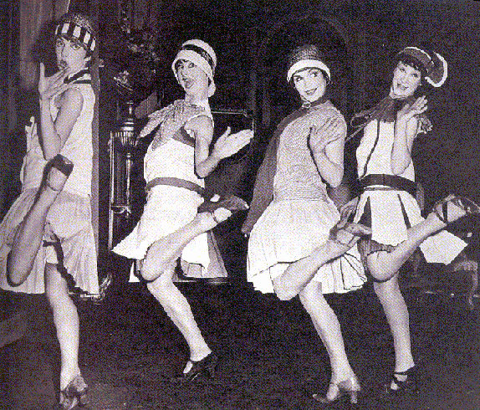

How widespread was racial intolerance in US society?
What were the ‘Roaring Twenties’?
Why was prohibition introduced, and then later repealed?
How far did the roles of women change during the1920s?

Remember
Make your revision ACTIVE
The Effective Revision Cycle

This cycle is what you need to do for ALL revision. First, TEST what you know. It’s no good revising the stuff you feel confident on and ignoring the stuff you don’t like and just hoping it doesn’t come up! Once you know the areas you are least confident on REFLECT on why. What needs to change to make you confident on it? Sort that out, and then LEARN it. Be active, use ALL the resources the school has given you to help you.

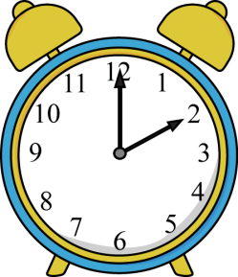
TIME YOURSELF! Before you start, take 3 minutes, and 3 minutes ONLY, to write down everything you can remember about our study of Society in the 1920s.
Do regularly to make sure your knowledge is secure.
Come on, it only takes 3 minutes!
You will find it useful to highlight the information in this booklet. You will find it even more useful if you do this with coded colours:
1 colour to pick out dates
1 colour to pick out the names of key individuals
1 colour to pick out selected key points/facts.

Use the above as a key for your highlighting.
Here’s what’s going to be covered during this booklet...
Main topic | This will include...
- Race relations and discrimination against African Americans | Evidence of discrimination against black people and how the lives of black people did not improve.  Evidence to show how the lives of some black people improved during the 1920s
- The Ku Klux Klan | Aims of the Ku Klux Klan  History of the KKK  Membership of the KKK
- The ‘Roaring Twenties’ | Building cities and how this contributed to the Roaring Twenties. Jazz music and new dance crazes.
- Film and other media | Films, their popularity and how they affected the morals of the USA. Success and growth of the radio.
- The Red Scare | What the Red Scare was  Long Term reasons for the Red Scare  Short Term reasons for the Red Scare
- The case of Sacco and Vanzetti; | Background of the case  How it relates to the Red Scare  The fate of Sacco and Vanzetti
- Gangsterism and corruption | Actions of Al Capone  Tactics of Gangsters  How Corruption took hold among America’s officials  Effects of Prohibition on organised crime
- Prohibition and reasons for its repeal in 1934 | Reasons for Prohibition to be introduced  Reasons for Prohibition to be repealed
- Change and continuity in the roles of women. | Why the lives of women changed  Areas in which women’s lives did change  Areas in which women’s lives were still limited
You need to have specific facts and details for all of these ready to use in the exam.
Race relations and discrimination against African Americans
How far were the 1920s a time of racism and discrimination for Black Americans?
It was a time of racism and discrimination
Many things show that the 1920s was a time of racism and discrimination. The American Government refused to pass laws banning lynching’s or giving Black Americans the vote. Alongside this the Jim Crow Laws prevented Black Americans from mixing with whites ('segregation'), denied them equality of education and civil rights, and prevented them from voting.
Lynching’s still took place in Southern states where mobs of white people often hanged ('lynched')
Blacks Americans whom they suspected of a crime (usually the police turned a blind eye).
Even in the northern states black Americans ended up with the low-paid menial jobs, such as janitors, bootblacks, cooks, houseboys, baggage handlers, waiters, doormen, dishwashers and washroom attendants. In 1919, white Americans in Chicago rampaged through Black neighbourhoods after a drowning black man clinging to a log had drifted into a whites-only swimming area.
Finally life expectancy for blacks increased from 45 to 48 between 1900 and 1930, but they were still a long way behind the whites, whose life expectancy increased from 54 to 59 over the same period. Many black people in the northern cities lived in great poverty. In Harlem in New York they lived in poorer housing than whites, yet paid higher rents. They had poorer education and health services than whites.
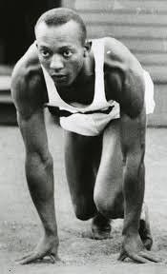
There were some improvements in the position of black people:
There is some evidence that the position of some black people improved during the 1920s. There were many role models for black Americans and some Black Americans became famous - the sprinter Jesse Owens (see picture), the baseball player Jackie Robinson, the dancer Josephine Baker. They were an inspiration to other Black Americans.
There was a cultural flowering in the New York Black neighbourhood of Harlem, based on jazz, but also excellent Black architects, novelists, poets and painters. Many of these believed in 'Artistic Action' - winning equality by proving they were equal.
Finally in both Chicago and New York, there was a small but growing black middle class. There was a successful ‘black capitalist’ movement, encouraging black people to set up businesses. In Chicago they ran a successful boycott of the city’s chain stores, protesting that they would not shop there unless black staff were employed. By 1930 almost all the shops in the South Side belt where blacks lived had black employees.
Task: Identify the 3 main arguments for each side and give them a number out of 10 to represent how far they show black people were discriminated against in the USA.
Pick out your most convincing argument from both sides and write a paragraph to explain it.

The Ku Klux Klan
The KKK was a white supremacy group which was made up of WASPs
W – White A – Anglo S- Saxon P – Protestants
The KKK was a white supremacist group which used brutal violence with Black people being lynched or burned. They believed that white people should be the most powerful group in the United States.
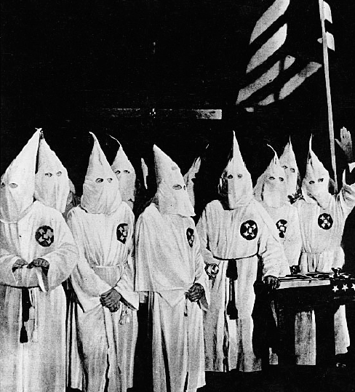
The KKK was banned in 1872 but it still continued to operate with Judges and other high ranking officials being Klan members, so it was difficult to stop them.

It was strongest in the midwest and rural south, where working-class whites competed with black people for unskilled jobs. In it had 1921 it had 100,000 Members but by 1925 it had 5 million Members.
Exam tip!
Pick out 4 key facts from the information on the Ku Klux Klan which could help you answer a 4 mark ‘describe’ question.

The ‘Roaring Twenties’
William E Leuchtenberg, The Perils of Prosperity, 1958.
“There was never a time in American history when youth had such a special sense of importance as in the years after the First World War. There was a gulf between the generations like a geological fault. “

The 1920s in the United States, called “roaring” because of the culture of the decade. The Roaring Twenties was a time when many people defied Prohibition, indulged in new styles of dancing and dressing, and rejected many traditional moral standards.
In 1920, for the first time in American history, more Americans lived in towns and cities than in the country. In New York, the skyscrapers were built because there was no more land available. But even small cities, where land was not in short supply, wanted skyscrapers to announce to the country that they were sharing in the boom.

Jazz music became an obsession among young people. Such was the power of jazz music that the 1920s became known as the Jazz Age. Along with jazz went new dances such as the Charleston, and new styles of behaviour which were summed up in the image of the flapper, a woman who wore short dresses and make-up and who smoked in public (more on this later).

Finally contraceptive advice was openly available for the first time. Sex outside marriage was much more common than in the past. All these things contributed (as well as Film and other media) contributed to the 1920s being called ‘the Roaring Twenties’.

Film and other media
During the 1920s the average amount of hours Americans worked fell and average wages rose. A lot of this spare time and money was channelled into entertainment, especially watching films and listening to the radio.
Almost everyone in the USA listened to the radio. Most households had their own set. People, who could not afford to buy one outright, could purchase one in instalments. The choice of programmes grew quickly. In August 1921 there was only one licensed radio station in America. By the end of 1922 there were 508 of them.
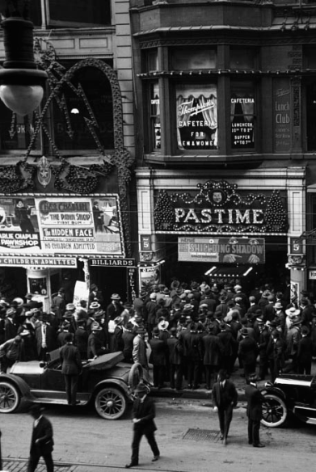
In films new stars like Charlie Chaplin and Buster Keaton made audiences roar with laughter, while Douglas Fairbanks thrilled them in daring adventure films. Until 1927 all movies were silent. In 1927 the first ‘talkie’ was made. During the 1920s movies became a multi-billion dollar business. In 1920 40 million cinema tickets were sold per week, in 1929 100 million cinema tickets were being sold each week. That’s as many as are sold in a year in Britain today.
Task:
Create a mindmap with ‘Roaring 20s’ in the middle of it.
List as many of the changes as you can.
Going for A? Assign each change a number out of 10 depending on how far it changed. Which was the biggest change of the 1920s?
Films influenced people’s morals. Film stars such as Theda Bara and Clara Bow were sold as ‘It’ girls. Everybody knew that ‘It’ meant ‘sex’. Hollywood turned out dozens of films a month about ‘It’, such as Up in Mabel’s Room, Her Purchase Price and A Shocking Night. Male stars too, such as Rudolph Valentino, were presented as sex symbols. Women were said to faint at the very sight of him as a half-naked Arab prince in The Sheik.
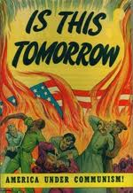
The Red Scare
This was a period during the 1920s when fear of Communism was at an all-time high among ordinary people in America. This was due to a number of reasons:
- There had been mass immigration into the USA before the 1920s, most of it from Europe. Between 1850 and 1914 10% of the population of Europe left for a new life in America. These people had very different customs and a very different way of life to many Americans.
- Many immigrants came from Eastern Europe and countries such as Russia and Ukraine. Communism was very popular in these countries and it was believed that these new political beliefs would ‘infect America’. After the Russian Revolution in 1917, which created the first Communist country in the world, Americans believed the same thing could happen in America.
- Communism was a wildly different set of beliefs to those of ordinary Americans. Communists believed that the government should be overthrown and that there should be no free trade or private profit for individuals. The ‘American dream’ persuaded Americans that they could ‘get rich quick’. Communism meant state control of agriculture and industry, taking it away from its owners, which alarmed Americans.
Aiming for an A?
Can you link any of these causes of the Red Scare together?
Do you think that one cause is more important than the others?
- Finally during the 1920s there were a large number of strikes in America. Some 400,000 American workers went on strike. Even the police in Boston went on strike and looters and thieves roamed the city. There were race riots in 25 towns. many prominent Americans in the 1920s saw the strikes as the dangerous signs of Communist interference.
The case of Sacco and Vanzetti
Two high-profile victims of the Red Scare were Italian Americans Nicola Sacco and Bartolomeo Vanzetti. They were arrested in 1920 on suspicion of armed robbery and murder. They called themselves anarchists. Anarchists hated the American system of government and believed in destroying it. Their trial became less a trial for murder, more a trial of their political beliefs. The case against them was very shaky. The prosecution relied heavily on racist slurs about their Italian origins, and on stirring up fears about their political views. The judge at the trial said that although Vanzetti ‘may not actually have committed the crime attributed to him he is nevertheless morally culpable [to blame] because he is the enemy of our existing institutions’. After the trial, the judge referred to the two as ‘those anarchist bastards’.
A lawyer commenting on the Sacco and Vanzetti case:
‘Judge Thayer is narrow minded . . . unintelligent . . . full of prejudice. He has been carried away by fear of Reds which has captured about 90 per cent of the American people.’
Sacco and Vanzetti were convicted on flimsy evidence. After six years of legal appeals, Sacco and Vanzetti were eventually executed in 1927, to a storm of protest around the world from both radicals and moderates who saw how unjustly the trial had been conducted.
Gangsterism and corruption
Gangsters grew rich from the profits of Prohibition (see next section for why this was introduced and repealed). Suppliers of illegal alcohol made vast fortunes, with Al Capone being one of the most famous. He made around $60 million a year from his speakeasies. His view was that ‘Prohibition is a business. All I do is supply a public demand.’
His tactics began with building up a huge network of corrupt officials among Chicago’s police, local government workers, judges, lawyers and prohibition agents. He even controlled Chicago’s mayor, William Hale Thompson. One famous incident of Capone’s violence was the St Valentine’s Day Massacre in 1929. Capone’s men murdered seven of his rival Bugsy Moran’s gang, using a false police car and two gangsters in police uniform to put Moran’s men off their guard. This was similar to how many Gangsters during the 1920s acted. The gangs fought viciously with each other to control the supply of alcohol as well as the speakeasies. They made use of new technology, especially automobiles and the Thompson sub-machine gun. In Chicago alone, there were 130 gangland murders in 1926 and 1927 and not one arrest.
The lack of arrests was down to corruption among many officials. In some cities, police officers were quite prepared to direct people to speakeasies. Even when arrests were made, it was difficult to get convictions because more senior officers or even judges were in the pay of the criminals. One in 12 prohibition agents was dismissed for corruption.
Other famous gangsters:
- Dan O’Banion (Irish gang leader murdered by Capone)
- Pete and Vince Guizenberg (hired killers who worked for Bugsy Moran and died in the St Valentine’s Day Massacre)
- Lucky Luciano (Italian killer who spent ten years in prison).
This corruption was down to Prohibition. Illegal stills to supply the alcohol sprang up all over the USA as people made their own illegal whisky – moonshine. About two-thirds of the illegal alcohol came from Canada. The vast border between the USA and Canada was virtually impossible to patrol. Other bootleggers brought in alcohol by sea. They would simply wait in the waters outside US control until an opportunity to land their cargo presented itself.
The demand for alcohol was huge. By 1925 there were more speakeasies in American cities than there had been saloons in 1919. A Government report into how easy it was to get alcohol came back with the following conclusions:
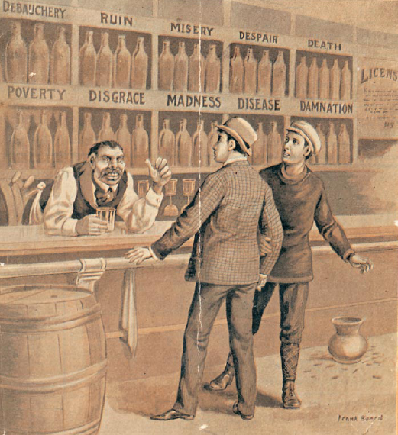
• Chicago: 21 minutes • Atlanta: 17 minutes • Pittsburg: 11 minutes
• New Orleans: 35 seconds (he was offered a bottle of whisky by his taxi driver when he asked where he could get a drink!)
Prohibition and reasons for its repeal in 1934
Why was it introduced?
In the nineteenth century, in rural areas of the USA there was a very strong ‘temperance’ movement. Members of temperance movements agreed not to drink alcohol and also campaigned to get others to give up alcohol. Most members of these movements were devout Christians who believed that alcohol damaged family life.
The temperance movements persuaded their state governments to prohibit the sale of alcohol within the state. Through the early twentieth century the campaign gathered pace. It became a national campaign to prohibit (ban) alcohol throughout the country. By 1916, 21 states had banned saloons.
The temperance movement claimed that ‘3000 infants are smothered yearly in bed, by drunken parents.’ The USA’s entry into the First World War in 1917 also helped to persuade people that alcohol should be banned. Drinkers were accused of being unpatriotic cowards. Most of the big breweries were run by German immigrants who were portrayed as the enemy. In 1917 the movement had enough states on its side to propose the Eighteenth Amendment to the Constitution. This banned the making, distributing and selling of alcohol. It became law in January 1920 and is known as the Volstead Act.
Why was it repealed?
The St Valentine’s Day Massacre was a large cause for repealing Prohibition (see earlier section). Many claimed that Prohibition had made the USA lawless, the police corrupt and the gangsters rich and powerful. When the Wall Street Crash was followed by the Depression in the early 1930s, it was believed that legalising alcohol would create jobs, raise tax revenue and free up resources tied up in the impossible task of enforcing prohibition. The Democrat President Franklin D Roosevelt was elected in 1932 and prohibition was repealed in December 1933.
Change and continuity in the roles of women.
What were the lives of women like before the 1920s?
Activity
Draw up a list with two sides – ‘women’s lives changed’ and ‘women’s lives did not change’. Write as many arguments in as you can.
Going for an A? Give each change a number out of 10 for how far things did/did not change. Explain which side you most agree with.
Middle-class women in the USA, like those in Britain, were expected to lead restricted lives. They had to wear very restrictive clothes and behave politely. They were expected not to wear make-up. They had to have a chaperone with them when they went out with a boyfriend. Most women were expected to be housewives. Very few paid jobs were open to women. Most working women were in lower-paid jobs such as cleaning, dressmaking and secretarial work.
Why did things change?
Jobs: When the USA joined the war in 1917, some women were taken into the war industries, giving them experience of skilled factory work for the first time. In urban areas more women took on jobs – particularly middle-class women. They typically took on jobs created by the new industries. There were 10 million women in jobs in 1929, 24 per cent more than in 1920.
Morals: For younger urban women many of the traditional rules of behaviour were eased as well. Women wore more daring clothes. They smoked in public and drank with men, in public. They went out with men, in cars, without a chaperone. They kissed in public. Women were less likely to stay in unhappy marriages. In 1914 there were 100,000 divorces; in 1929 there were twice as many. Much of this was down to the influence of Cinema and other media (see earlier section).
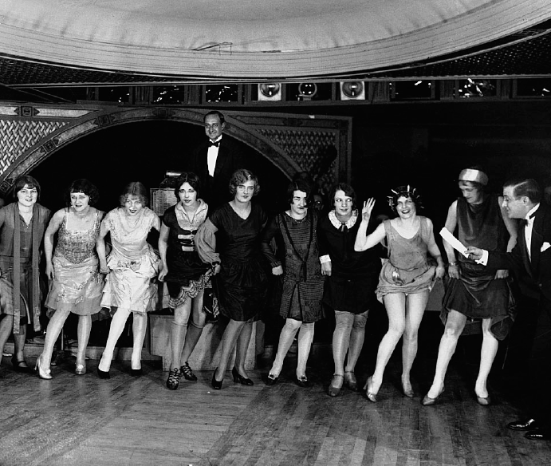
Spare time and disposable income: Through the 1920s they shared the liberating effects of the car, and their domestic work was made easier (in theory) by new electrical goods such as vacuum cleaners and washing machines.
With money of their own, working women became the particular target of advertising. Even women who did not earn their own money were increasingly seen as the ones who took decisions about whether to buy new items for the home. There is evidence that women’s role in choosing cars triggered Ford, in 1925, to make them available in colours other than black.
How far did the lives of women change?
There is lots of evidence to show that their lives did change – see the evidence in the section above about the amount of women in new jobs and the new choices available to women. However there were still problems for women.
Women were still paid less than men, even when they did the same job. Political parties wanted women’s votes, but they didn’t particularly want women as political candidates as they considered them ‘unelectable’. The Anti-Flirt Association tried to persuade young Americans to behaved decently. Most girls, especially in rural America, still behaved 'decently', got married and had babies.

Past exam questions
You should be able to answer ALL these questions. At least plan answers and practice writing them using the advice on the last page.

Aiming at A*? Take time to look at the TYPE of questions that are being asked on each topic. If they ask 10 mark questions on it you need to know it REALLY well. If they ask 4 mark questions on it you need specific details to describe. If it’s 6 mark questions then you need to know the different factors you could explain. Most of the topics are a mixture. Are you ready for ALL of them?
Knowledge Questions
- Race relations and discrimination against African Americans | (a) What problems did black people face in the USA during the 1920s? [4]  (c) ‘Americans were intolerant in the 1920s’. How far do you agree with this statement? Explain your answer. [10]
- The Ku Klux Klan | (a) What problems did black people face in the USA during the 1920s? [4]  (a) What was the Ku Klux Klan? [4]
- The ‘Roaring Twenties’ | (a) Describe the main changes in popular entertainment in America in the 1920s. [4]  (a) Describe the American cinema and movie industry in the 1920s. [4]
- Film and other media | (a) Describe the American cinema and movie industry in the 1920s. [4]  (a) Describe the main changes in popular entertainment in America in the 1920s. [4]
- The Red Scare | (b) Explain why there was a ‘Red Scare’ in America in the 1920s. [6]  (c) ‘Americans were intolerant in the 1920s’. How far do you agree with this statement? Explain your answer. [10]
- The case of Sacco and Vanzetti; | (b) Explain why Sacco and Vanzetti were executed [6]  (a) Describe the Sacco and Vanzetti case [4]
- Prohibition and reasons for its repeal in 1934 | (b) Explain why Prohibition failed [6]  (c) ‘Prohibition ended because it encouraged gangsters’. How far do you agree with this statement? Explain your answer. [10]  (b) Explain why prohibition was introduced. [6]
- Gangsterism and corruption; | (c) ‘Prohibition ended because it encouraged gangsters’. How far do you agree with this statement? Explain your answer. [10]
- Change and continuity in the roles of women. | (c) How far did the lives of American women change in the 1920s? Explain your answer. [10]  (b) Explain why the lifestyle of some women changed in the 1920s. [6]  (c) ‘1920s America was a land of opportunity for women’. How far do you agree with this statement? Explain your answer [10]

Knowledge questions advice
Command words | Question numbers and marks | What that means you need to do
Describe ...  What... | 2 (a) 4  3(a) 4  8 (a) 4  9(a) 4 | This is a short question where you need to select key points relevant to the question and write them in clear sentences. You do not need to explain, but if you can only remember 2 or 3 points you can explain to get all four marks. Spend around 4 minutes on this question.
Explain...,  Why... | 1 (b) 8  2 (b) 6  3 (b) 6  8 (b) 6  9 (b) 6 | This means you need to explain your answer. For these questions you need to say WHY. Use the words ‘because’, ‘this meant that’, ‘therefore. Write in paragraphs (2 for a 6 mark question and 3 for an 8 mark question)  You need to back up your answer with specific and relevant details from your knowledge. Spend around 8 minutes on a 6 mark and 10 minutes on an 8 mark question
How far (10) | 2 (c) 10  3 (c) 10  8 (c) 10  9 (c) 10 | This means you need to weigh up- balance two sides of the answer and give your judgement on how much you agree with the statement.  You should plan what you’re going to write before you write it and follow your plan.  You need to back up your points with specific examples from your knowledge and use to explain each side. Spend at least 20 minutes on a 10 mark question.

Source Questions
ANY source could come up in the exam. It is HIGHLY likely you won’t have seen any of the 3 USA sources before, so you need to practice analysing the sources.
Label them to pick out the key details and pick out the key pieces of contextual knowledge that will help you to explain
(b) Why was this cartoon published at this time? Use the source and your knowledge to explain your answer [7]
(c) How useful is this source as evidence about American society at this time? Use the source and your knowledge to explain your answer. [7]
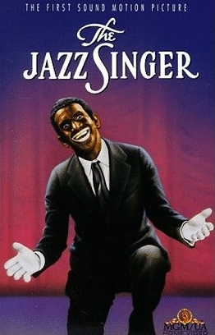

(a) Why was this poster published? Use the source and your knowledge to explain your answer. [6]

(b) How far does this source prove that prohibition was successfully enforced? Use the source and your knowledge to explain your answer. [7]

Command words | Question numbers | What that means you need to do
What is the message...? | 1 (a) [7]  7 (a) (b) or (c) [6] or [7] | You need to do three things (ASK)  Answer the question  Details from the Source to support your answer  Details from you Knowledge that explains the message. Spend around 8 minutes on it
Why was this source published in...? | 7 (a) (b) or (c) [7] | You need to use ASK for this question too. This question is asking you two things; the PURPOSE of the cartoon, what it’s trying to do; and why at that TIME? What was happening in that year or in that period to mean that source was published then? You must use your own knowledge and details from the source to answer. (They could ask it without the date for [6] marks). Spend around 8-10 mins on each source question)
How far...? | 7 (a) (b) or (c) [6] or [7] | This means you need to weigh up – balance two sides of the answer and give your judgement on how much you agree. Give evidence from the source to back up each side. Consider where the source has come from (provenance) to help you decide which side it supports. Use your own knowledge to support your argument. Spend around 8-10 mins on each source question)
How useful...? | 7 (a) (b) or (c) [6] or [7] | This means you need to decide how much we get from this source as historians for the issue in the question. E.g. if it’s: How useful is this source for an historian studying the New Deal? Use the source and your knowledge to explain your answer. [6] then it’s asking you what we CAN get from this source, how much evidence it does give us, and what it misses out, what we know that isn’t in the source. This needs to be weighed up and you need to make a clear judgement. Spend around 8-10 mins on each source question)

What else can I do?
- Have you planned out or answered all the questions?
- Has your revision been effective?
- What areas have you identified as needing the most work? What do you need to do to get confident on them?
- Have you made revision notes on everything in this booklet?
- Have you checked that you remember it?
- Have you come back to this after a few days and a few weeks to check it’s ‘stuck’?
- Have you gone to Memrise to memorise the key information?
- Have you done any extra reading? Go to twitter @LHSGCSEHistory to find links to great websites
- Have you worked with a friend to check each others’ revision?
- Feeling confident? Do a whole Paper 1 in 2 hours. They’re on the History page of the school website, or your teacher can give you one. Give it to your teacher to find out what grade it would be. Even better if you have a go at marking it yourself first.

Use this space to write yourself a ‘to do’ list, or to write questions about anything you’re not clear on to ask your teacher.

........................................................................................................................................................................................................................................................................................
........................................................................................................................................................................................................................................................................................
........................................................................................................................................................................................................................................................................................
............................................................................................................................................................................................................................................................................................................................................................................................................................................................................................................................................................................................................................................................................................................................................................................................................................................................................................................................................................................................................................................................................................................................................................................................................................................................................................................................................................................................................................................................................................................................................................................................................................................................................................................................................................................................................................................................................................................................................................................................................................................................................................................................................................................................................................................................................................................................................................................................................................................................................................................................................................................................................................................................................................................................................................................................................................................................................................................................................................................................................................................................
............................................................................................................................................ ............................................................................................................................................ ............................................................................................................................................ ............................................................................................................................................ ............................................................................................................................................ ............................................................................................................................................ ............................................................................................................................................ ............................................................................................................................................

