GCSE History
USA Booklet 3
What were the causes and consequences of the Wall Street Crash?
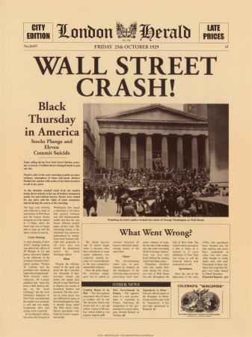
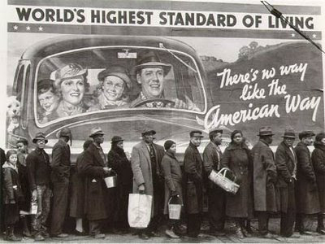

How far was speculation responsible for the Wall Street Crash?
What impact did the Crash have on the economy?
What were the social consequences of the Crash?
Why did Roosevelt win the election of 1932?

Remember
Make your revision ACTIVE
The Effective Revision Cycle

This cycle is what you need to do for ALL revision. First, TEST what you know. It’s no good revising the stuff you feel confident on and ignoring the stuff you don’t like and just hoping it doesn’t come up! Once you know the areas you are least confident on REFLECT on why. What needs to change to make you confident on it? Sort that out, and then LEARN it. Be active, use ALL the resources the school has given you to help you.

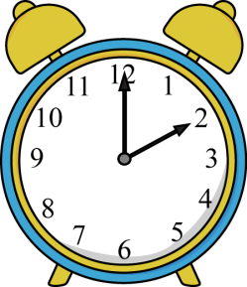
TIME YOURSELF! Before you start, take 3 minutes, and 3 minutes ONLY, to write down everything you can remember about our study of the Wall Street Crash.
Do regularly to make sure your knowledge is secure.
Come on, it only takes 3 minutes!

You will find it useful to highlight the information in this booklet. You will find it even more useful if you do this with coded colours:
1 colour to pick out dates
1 colour to pick out the names of key individuals
1 colour to pick out selected key points/facts.

Use the above as a key for your highlighting.
Here’s what’s going to be covered during this booklet...
Main topic | This will include...
- The Wall Street Crash and its financial effects | What Wall Street was  How Wall Street worked  Key terms (speculation, stocks, shares, dividends)  The reasons why Wall Street crashed.
- The Economic and Social effects for Americans in urban areas | Unemployment  Homelessness  Poverty  Starvation
- The Economic and Social effects for Americans in rural areas | The impact on farmers  Bankruptcy  Dustbowls  Migrant workers
- The reaction of President Hoover to the Crash and the Depression | The Bonus Marchers and ‘Hoovervilles’  Republican beliefs about the crash  The ‘do nothing’ president  The ‘Garner-Wagner Relief Bill  Tax cuts
- The Presidential election of 1932 | Hoover’s and Roosevelt’s programmes  Roosevelt’s campaign  Election results  Roosevelt’s election promises
- Reasons why Roosevelt won | Hoover’s response to the Depression  Strengths of Roosevelt’s campaign  Roosevelt’s background  The context of the Great Depression
- The contrast between Roosevelt’s and Hoover’s views on the role of government | Republican and democrat beliefs on the economy  How the beliefs affected the economy in the 1920s and 1930s
You need to have specific facts and details for all of these ready to use in the exam.
The Wall Street Crash and its financial effects
What was Wall Street?
To set up a company you need money to pay staff, rent premises, buy equipment etc.
Most companies raise this money from investors. In return, these investors own a share in the company. They become ‘shareholders’
These shareholders can get a return on their money in two ways.
- By receiving a dividend – a share of the profits (dividends) made by the company
- selling their shares.
If the company is successful, the value of the shares is usually higher than the price originally paid for them
Investors buy and sell their shares on the stock market. The American stock market was known as Wall Street.
The price of shares varies from day to day. If more people are buying than selling, then the price goes up. If more people are selling than buying, the price goes down.
For much of the 1920s the price of shares on the Wall Street stock market went steadily upwards.
Get the vocab right
Use this page to write definitions on each of the words below
Speculation
Stocks
Shares
Dividends
Profit
Key Term: Speculation
Some people used the stock market to make money. If they didn’t have the money to buy shares already, they would borrow money from the bank to buy them. They would then sell the shares when they have gone up, and pay back the bank, keeping the rest of the profit for themselves. This is risky, if the shares don’t go up then the buyer, or speculator, has to pay back the loan anyway. It can also make the market unstable if people buy and sell shares very quickly without much knowledge of the market. About 600,000 of the 20 million investors were speculators. Some speculators could even ‘guy on the margin’ which meant they only put down 10 percent of the cash needed and borrowed the rest. The Pennsylvania Railroad became known as the ‘petticoat line’ because women speculators owned 50 percent of the company,
Why did Wall Street Crash?
Throughout most the 1920s the rise in stock prices was quite steady. There were even some downturns. But in 1928 speculation really took hold. Demand for shares was at an all-time high and prices were rising at an unheard-of rate. In March, Union Carbide shares stood at $145. By September 1928 they had risen to $413.
Long Term Causes
The longer-term causes of the Wall Street Crash were the weaknesses in the US economy (also in your 1920s booklet)
- Overproduction in agriculture drove prices down.
- Overproduction of consumer goods drove prices down.
- Inequality – the rich were very rich, and got richer because of the boom, while the poor were very poor and their lives were not improved by the boom. Everyone who was every going to buy a car, or a radio, or a fridge, has already bought one. Many rural areas still did not have electricity yet either.
- Foreign competition – foreign countries had lots of choices on where to buy consumer goods from, and the US lost out because their tariffs during the 1920s made foreign goods more expensive and European countries did the same to the US’s goods.
Short Term Causes
CONFIDENCE
Confidence was vital in all this. If people are confident that prices will keep rising, there will be more buyers than sellers. However, if they think prices might stop rising, all of a sudden there will be more sellers and... crash, the whole structure will come down.
Short-term causes related to shares. Many ordinary Americans bought shares in American companies. Normally this is good for business. However, in the USA in the 1920s the rush to buy caused problems.
- Many people bought and sold shares to make quick profits instead of keeping their money invested for some time. They were the speculators, not investors.
- Companies were forced by shareholders to pay out profits to shareholders rather than re-investing them.
- Americans borrowed money on credit to buy their shares.
Once people started worrying about the long-term weaknesses in the US economy, disaster struck. In September 1929, the prices of shares began to come down – slowly to start with – but people soon began to realise that the shares they owned were worth less than the loans they had used to buy them. Suddenly, everyone tried to get rid of their shares. The worst day was ‘Black Tuesday’, 29 October 1929. As a result, share prices collapsed.
Company | Share values in cents
 | 3 Sept 1928 | 3Sept 1929 | 13 Nov 1929
New York Central | 256 | 256 | 160
Union Carbide and Carbon | 413 | 137 | 59
Electric Bond and Share | 203 | 186 | 50

Revise the causes:
What were the most important causes of the Wall Street Crash? Once you’ve picked out the causes and written them into a table, do the same again but put the long term and short term causes in order of how important you think they were.
Short-term causes | Long-term causes

The Effects of the Crash
The effects of the crash were disastrous for people all over America. Even all over the world, as the Great Depression affected the economies of many other countries too. We can break the effects down into the effects on business and the economy, the effects on people in the cities (urban) and those in the countryside (rural)

Fill in the mind map as you go through the effects.
Business and economic consequences
Consequences for people in the countryside (rural)
The effects of the Wall Street Crash

Consequences for people in towns (urban)

The effects for businesses and the economy
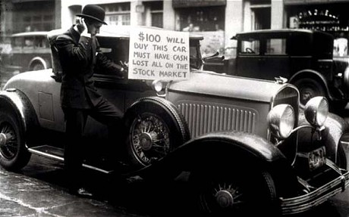
In 1929, 659 banks failed. As banks failed, people stopped trusting them, and many withdrew their savings. In 1930 another 1,352 went bankrupt. The biggest of these was the Bank of the United States in New York, which went bankrupt in 1930; one third of New Yorkers saved with it. 1931 saw escalating problems in European banks, which had a knock-on effect in the USA. Panic set in. Around the country, billions of dollars was withdrawn from banks. People felt that physical money was their only security. Another 2,294 banks went under in 1931.
The downward spiral was firmly established. Businesses cut production further and laid off more workers. They reduced the wages of those who still worked for them. Between 1928 and 1933 both industrial and farm production fell 40% and average wages fell by 60%.
All workers were laid off or were paid less, the bought even less. By 1932 the USA was in the grip of the most serious economic depression the world had ever been seen. By 1933 there were 14 million unemployed and 5,000 banks had gone bankrupt. The USA’s international trade had also been drastically reduced; falling from $10 billion in 1929 to $3 billion in 1932.
There are a lot of dates, figures and statistics in the last 3 paragraphs. Make sure you get some of them onto your mind map and LEARN them. They’ll make you stand out from the rest!

The Economic and Social effects for Americans in urban areas
The effects of the Crash were disastrous
- Many individuals were bankrupt – they could not pay back the loans they used to buy their (now worthless) shares.
- Some homeowners lost their homes because they could not pay their mortgages.
- Even some who had savings lost their money when banks collapsed.
- The collapse of businesses lead to mass unemployment. Un 1932 in Cleveland, 50 % of workers were now unemployed, and in Toledo 80%.
- At night the parks were full of the homeless and unemployed.
- Every town had a ‘hooverville’ (named after President Hoover).
- The rubbish tips were crowded with families hoping to scrape a meal from the leftovers of more fortunate people. Trhough 1931, 238 people were admited to hospital in New York suffering from malnutrition or starvation. 45 of them died.
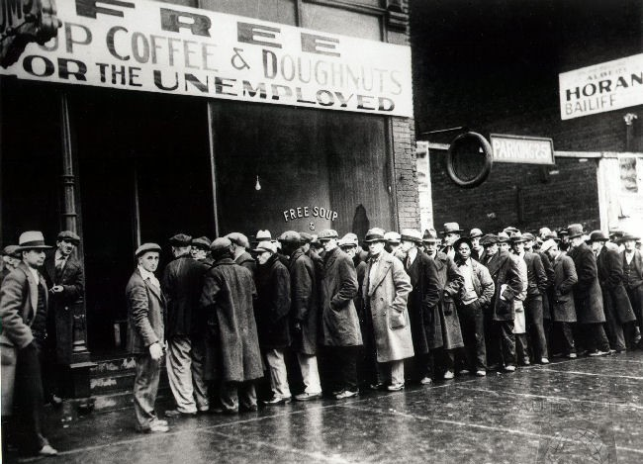
Last summer, in the hot weather, when the smell was sickening and the flies were thick, there were a hundred people a day coming to the dumps... a widow who used to do housework and laundry, but now had no work at all, fed herself and her fourteen year old son on garbage. Before she picked up the meat she would always take of her glasses so that she couldn’t see the maggots.
From New Republic Magazine, February 1933

The Economic and Social effects for Americans in rural areas
People in agricultural areas were hardest hit by the Depression, because the 1920s had not been kind to them anyway.
- Huge numbers of farmers were unable to pay their mortgages.
- Some farmers organised themselves to resist banks seizing their homes. When sheriffs came to seize their property, banks of farmers holding pitch forks and hangman’s nooses persuaded the sheriffs to retreat.
- The price farmers could get for their livestock made it impossible to make money. One man killed 3,000 sheep and threw them down a canyon because it cost £1.10 to take a sheep to the market and then he would get less than a dollar for it.
- Most farmers had no choice but to pack their belongings into their trucks and live on the road. They picked up work where they could.
- Over-farming and drought in the central southern states turned millions of acres into a dust bowl and drove farmers off their land. Many of these ruined farmers headed to California to look for work.

The reaction of President Hoover to the Crash and the Depression
This part of the topic is all about what Hoover got wrong and what Roosevelt got right. Fill in a table or highlight in your booklet to ensure you’re confident on both
Hoover’s mistakes | Roosevelt’s strengths

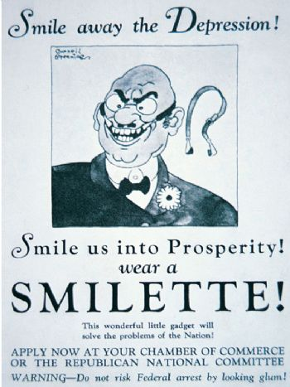
Hoover was unable to solve the problems of the Depression. It was partly his own fault; he insisted that ‘prosperity (wealth) is just around the corner’ and people criticised him bitterly for it. He was called the ‘do nothing President’. Hoover did try to fix the problems of the Depression. He cut taxes in 1930 and 1931. He tried to persuade business leaders not to cut wages. He set up the Reconstruction Finance Company, which propped up banks to stop them going bankrupt. He tried to protect US industries by introducing tariffs. But this just made the situation worse.
A 1932 Democrat election poster
Know your stuff!
What were the Republicans beliefs about the economy? Why does it crash? How does it grow? How involved should government be?

Hoover and the Republicans were reluctant to change their basic policies. They believed the causes of the depression were due to economic problems in Europe. They said prosperity would come back naturally. In 1932 Hoover blocked the Garner-Wagner Relief Bill, which would have allowed Congress to provide $2.1 billion to create more jobs.
The thing that did the most damage to Hoover’s reputation was how little he tried to help people who were suffering. He believed it was not the government’s job to provide relief. Republicans were afraid that people would become lazy and less independent if they were helped.
The Bonus Marchers
In 1932 thousands of servicemen who had fought in the First World War marched on Washington asking for their war bonuses (a kind of pension) to be paid early. They camped peacefully and sang patriotic songs. Hoover refused to meet with them. He appointed General Douglas McArthur to handle it and he ordered police and troops to use tear gas and burn the marchers’ camps. Hoover publicly thanked god that the USA still knew how to deal with a mob.
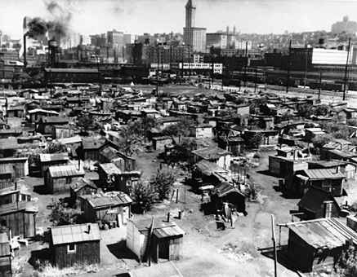
‘Hoovervilles’
Hoovervilles were temporary shanty towns built by migrant workers forced of the land. They are a sign of what Americans thought of Hoover by naming them after him. Homes were built out of wood, cardboard and bits of metal that people could find. Hoovervilles were built on empty areas of land and were sometimes cleared by the authorities for trespassing.
Other nicknames also started, like a ‘Hoover-blanket’ for an old piece of newspaper used by the homeless to sleep under, or ‘Hoover-leather’ for a piece of cardboard used to patch holes in old shoes. A ‘Hoover wagon’ was a car with horses tied to it because the owner could not afford fuel.
What will be the key issues that will decide the presidential election in 1930. Go back through what you’ve done so far and pick out the 4 main things the votes will need from the next president. Then put them in order of importance.
The Presidential election of 1932
Hoover was incredibly unpopular by 1932. His opponent, Democrat politician Roosevelt, in the election was a huge contrast.
Roosevelt’s main characteristics were:
- He was not a radical, but he believed in ‘active government’ to improve the lives of the ordinary people, although only if self-help and charity help had failed.
- He believed in spending money on getting people back to work. As Governor of New York he had already started doing this in his own state.
- He was not afraid to ask for advice on important issues from a wide range of experts, such as factory owners, union leaders and economists.
His plans were rather vague and general. But he realised that people wanted action, whatever that action was.

Hoover’s and Roosevelt’s programmes
“In Hoover we trusted and now we are busted”
Famous banner carried in a demonstration of Iowa farmers
Use the information on the previous two pages to summarize Hoover and Roosevelt’s plans for fixing the economy.
Reasons why Roosevelt won
Roosevelt was confident in victory, but took no chances. He went on a grand train tour of the USA in the weeks before the election and mercilessly attacked the attitude of Hoover and the Republicans. In a 20,8000km campaign trip he made 16 major speeches and another 60 from that back of his train. He promised the American people a ‘New Deal’.
The election was a landslide victory for Roosevelt. He won by 7 million votes and the Democrats won a majority of seats in Congress. It was the worst defeat the Republicans had ever suffered.
EXAM FOCUS
The only questions that have come up on the election are 10 mark questions. This means your revision needs to give you the evidence to be able to weigh up the different reasons that Roosevelt won. You need to have an opinion on which was the most important reason.

The contrast between Roosevelt’s and Hoover’s views on the role of government
Use the table below to check you’re confident on Republican and Democrat ideas about the role of government. You should write them out then cover them up and write them from memory to check you’ve remembered.
Key Republican ideas | Key Democrat ideas
Republicans believe in laissez faire. Economies go up and down naturally, and government involvement in this will just cause problems | It is government’s job to improve the lives of ordinary people.
People should be able to look after themselves; social security is not the job of the government- if the government helps people they will just get lazy. | The government should spend money on getting people back into jobs. It should also help the sick, old and unemployed.
The only way the government should intervene is to change tax rates. It is important to protect American industry and trade with tariffs. | The government should get help from experts and get really involved in improving the economy.
It’s Europe’s fault we’re in a depression and Government intervention isn’t really necessary. The republicans helped make the boom, so it will come again. | The depression was at least partly created by problems in the American economy and it is our responsibility to fix the problems.

Past exam questions
You should be able to answer ALL these questions. At least plan answers and practice writing them using the advice on the last page.

Aiming at A*? Take time to look at the TYPE of questions that are being asked on each topic. If they ask 10 mark questions on it you need to know it REALLY well. If they ask 4 mark questions on it you need specific details to describe. If it’s 6 mark questions then you need to know the different factors you could explain. Most of the topics are a mixture. Are you ready for ALL of them?
Knowledge Questions
Paper 1 Part 2: What were the causes and consequences of the Wall Street Crash? | (a) Describe the main features of stock market speculation in the USA during the 1920s. [4]  (a) Describe the stock market boom in American in the 1920s [4]
- The Wall Street Crash and its financial effects | (b) Explain the causes of the Wall Street Crash. [6]  (c) The following were equally responsible for the Wall Street Crash: (i) speculation on the stock market; (ii) overproduction by American industries. How far do you agree with this statement? Explain your answer referring only to (i) and (ii). [10]  (b) Explain the reasons for the Wall Street Crash in 1929. [6]  (b) Explain the consequences of over-production in the 1920s. [6]
- The Economic and Social effects for Americans in urban areas | (c) The following were consequences of the Wall Street Crash in the USA between 1929 and 1932:  (i) mass unemployment  (ii) the collapse of banks  (iii) homelessness.  Which of these consequences do you think was the most important? Explain your answer referring only to (i), (ii) and (iii). [10]  (a) Describe the social consequences of the Wall Street Crash. [4]
- The Economic and Social effects for Americans in rural areas | (a) Describe the social consequences of the Wall Street Crash. [4]
- The reaction of President Hoover to the Crash and the Depression | (b) Explain why Hoover was unsuccessful in dealing with the effects of the Depression. [6]
- The Bonus Marchers and ‘Hoovervilles’ | (a) Describe what happened to the Bonus Marchers [4]  (a) Describe a Hooverville [4]
- The Presidential election of 1932 | (c) ‘The main reason Roosevelt won the 1932 Presidential election was because he promised change.’ How far do you agree with this statement? Explain your answer [10]  (c) ‘The most important reason Roosevelt won the election of 1932 was because he fought an effective campaign.’ How far do you agree with this statement? Explain your answer. [10]  (c) Hoover’s policies were the main reason why he lost the 1932 Presidential election.’ How far do you agree with this statement? Explain your answer. [10]
Knowledge questions advice
Command words | Question numbers and marks | What that means you need to do
Describe ...  What... | 2 (a) 4  3(a) 4  8 (a) 4  9(a) 4 | This is a short question where you need to select key points relevant to the question and write them in clear sentences. You do not need to explain, but if you can only remember 2 or 3 points you can explain to get all four marks. Spend around 4 minutes on this question.
Explain...,  Why... | 1 (b) 8  2 (b) 6  3 (b) 6  8 (b) 6  9 (b) 6 | This means you need to explain your answer. For these questions you need to say WHY. Use the words ‘because’, ‘this meant that’, ‘therefore. Write in paragraphs (2 for a 6 mark question and 3 for an 8 mark question)  You need to back up your answer with specific and relevant details from your knowledge. Spend around 8 minutes on a 6 mark and 10 minutes on an 8 mark question
How far (10) | 2 (c) 10  3 (c) 10  8 (c) 10  9 (c) 10 | This means you need to weigh up- balance two sides of the answer and give your judgement on how much you agree with the statement.  You should plan what you’re going to write before you write it and follow your plan.  You need to back up your points with specific examples from your knowledge and use to explain each side. Spend at least 20 minutes on a 10 mark question.

Source Questions
ANY source could come up in the exam. It is HIGHLY likely you won’t have seen any of the 3 USA sources before, so you need to practice analysing the sources.
Label them to pick out the key details and pick out the key pieces of contextual knowledge that will help you to explain.
(a) What is the message of this cartoon? Use details of the cartoon and your knowledge to explain your answer. [7]

(c) Why was this poster published in America in 1932? Use the source and your knowledge to explain your answer. [7]

(a) How far does this source explain why the USA had serious economic problems in 1929? Use the source and your knowledge to explain your answer. [6]

(b) How useful is this source as evidence of how the Depression affected people? Use the source and your knowledge to explain your answer. [7]

(c) Why was this source published in 1932? Use the source and your knowledge to explain your answer. [7]

Source Questions advice
Command words | Question numbers | What that means you need to do
What is the message...? | 1 (a) [7]  7 (a) (b) or (c) [6] or [7] | You need to do three things (ASK)  Answer the question  Details from the Source to support your answer  Details from you Knowledge that explains the message. Spend around 8 minutes on it
Why was this source published in...? | 7 (a) (b) or (c) [7] | You need to use ASK for this question too. This question is asking you two things; the PURPOSE of the cartoon, what it’s trying to do; and why at that TIME? What was happening in that year or in that period to mean that source was published then? You must use your own knowledge and details from the source to answer. (They could ask it without the date for [6] marks). Spend around 8-10 mins on each source question)
How far...? | 7 (a) (b) or (c) [6] or [7] | This means you need to weigh up – balance two sides of the answer and give your judgement on how much you agree. Give evidence from the source to back up each side. Consider where the source has come from (provenance) to help you decide which side it supports. Use your own knowledge to support your argument. Spend around 8-10 mins on each source question)
How useful...? | 7 (a) (b) or (c) [6] or [7] | This means you need to decide how much we get from this source as historians for the issue in the question. E.g. if it’s: How useful is this source for an historian studying the New Deal? Use the source and your knowledge to explain your answer. [6] then it’s asking you what we CAN get from this source, how much evidence it does give us, and what it misses out, what we know that isn’t in the source. This needs to be weighed up and you need to make a clear judgement. Spend around 8-10 mins on each source question)

What else can I do?
- Have you planned out or answered all the questions?
- Has your revision been effective?
- What areas have you identified as needing the most work? What do you need to do to get confident on them?
- Have you made revision notes on everything in this booklet?
- Have you checked that you remember it?
- Have you come back to this after a few days and a few weeks to check it’s ‘stuck’?
- Have you gone to Memrise to memorise the key information?
- Have you done any extra reading? Go to twitter @LHSGCSEHistory to find links to great websites
- Have you worked with a friend to check each others’ revision?
- Feeling confident? Do a whole Paper 1 in 2 hours. They’re on the History page of the school website, or your teacher can give you one. Give it to your teacher to find out what grade it would be. Even better if you have a go at marking it yourself first.

Use this space to write yourself a ‘to do’ list, or to write questions about anything you’re not clear on to ask your teacher.

........................................................................................................................................................................................................................................................
........................................................................................................................................................................................................................................................
........................................................................................................................................................................................................................................................
........................................................................................................................................................................................................................................................
........................................................................................................................................................................................................................................................
........................................................................................................................................................................................................................................................
........................................................................................................................................................................................................................................................
........................................................................................................................................................................................................................................................
........................................................................................................................................................................................................................................................
........................................................................................................................................................................................................................................................
........................................................................................................................................................................................................................................................
........................................................................................................................................................................................................................................................
........................................................................................................................................................................................................................................................
........................................................................................................................................................................................................................................................
........................................................................................................................................................................................................................................................

