Development of a Dictatorship in Germany 1918 to 1945.
Time-line & Revision Notes for Edexcel IGCSE History Unit A3
The final stages of World War One. 1918 (21 March) The Ludendorff or Spring Offensive is launched but eventually fails.
http://www.youtube.com/watch?v=O5DZi6PiPRY&NR=1
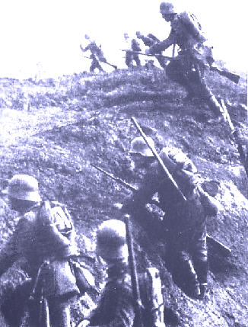

1918 (8 Aug. to 11 Nov.) Allies launch counter attack with the 100 Days Offensive.
http://www.youtube.com/watch?v=FTeFLA6LNtY&playnext=1&list=PLDB08B46741EFC2A6

1918 (August) Difficult conditions being experienced in Germany because of naval blockade by the allies and also from August onward Europe experiences a deadly influenza epidemic.

1918 (29 Oct.) German sailors mutiny in the port of Wilhelmshaven.
(4 Nov.) Mutiny of German navy spreads to other ships in the port of Kiel.
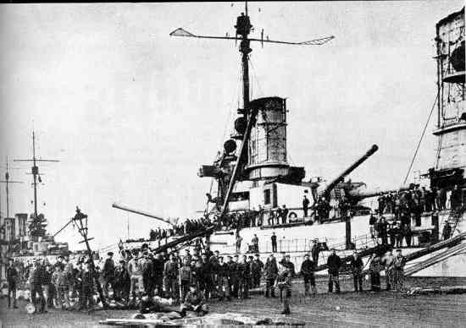

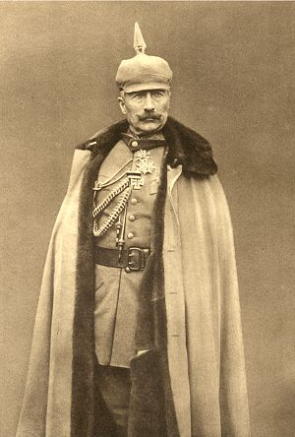
1918 (7 Nov.) Kurt Eisner leads a workers rebellion in the Bavarian state capital of Munich. Local ruler King Ludwig III flees for his life. Bavaria declared a peoples state.

1918 (Nov. 9) Kaiser Wilhelm agrees to abdicate and he escapes to take up residence in Holland.
Friedrich Ebert, leader of the Social Democratic Party (SPD) becomes Chancellor of the new Republic.

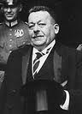
Friedrich Ebert

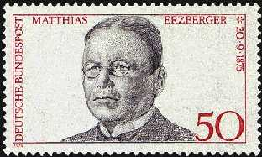
1918 (11 Nov.) Armistice signed by Matthias Erzberger on behalf of the new Weimar Republic.

1919 (6 Jan) Rosa Luxemburg and Karl Liebknecht lead a left wing (communist) uprising in Berlin. Ebert accepts assistance from the Freikorps and German army to neutralise the communist threat. 1919 (9 Jan.) At the same time as this uprising Anton Drexler is forming a German workers party (DAP) in Bavaria. On 15 January Rosa Luxemburg and Karl Liebknecht are shot and killed by members of the Freikorps. Rosa Luxemburg’s body is unceremoniously dumped in the canal.

Far Left – Plaque to Rosa Luxemburg.

Near Left – Karl Liebknecht
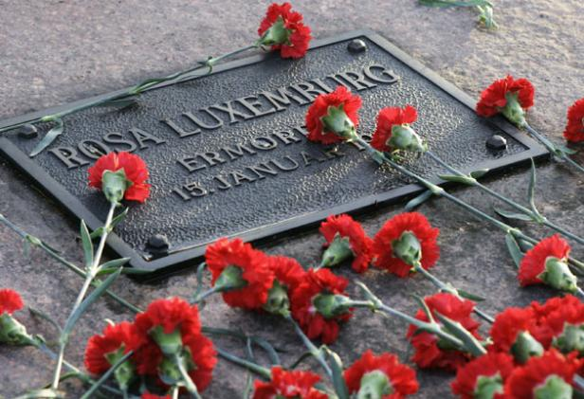
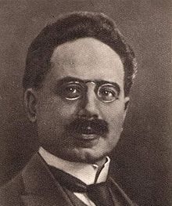

1919 (Feb.) German elections held. All men and women over 20 allowed to vote. Ebert elected as first president. The new assembly met in Weimar. Ebert makes promises to influential individuals: 1) Promises General Groner that there will be no reform of the army. 2) He reassures Hugo Stinnes (industrialist) that there will be no nationalisation of private businesses. 3) Ebert also gains support from Karl Legien by promising a maximum of an 8 hour working day.

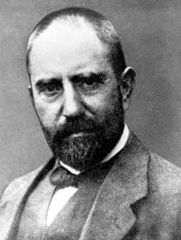
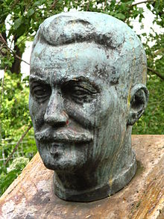
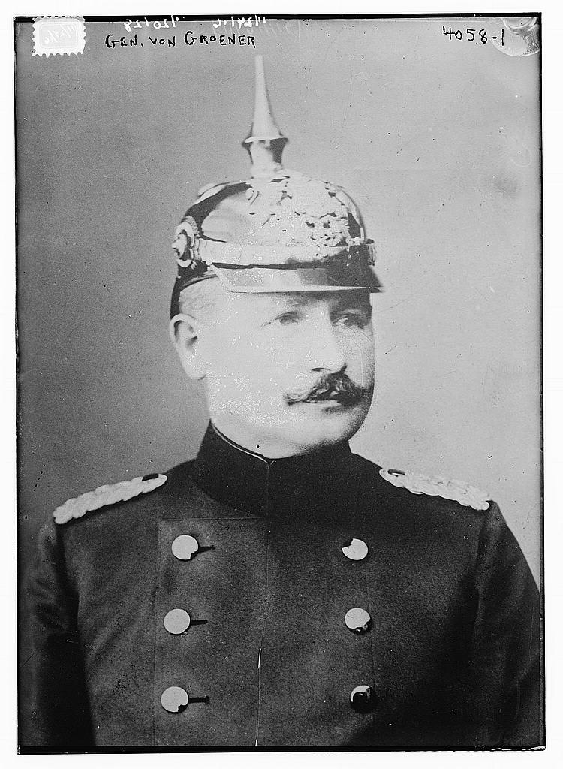

General Groner Hugo Stinnes Karl Legien
1919 (28 June) Signing of the Treaty of Versailles by Dr. Muller and Dr. Bell, two very insignificant representatives of the Weimar Government.
http://www.youtube.com/watch?v=ShRA8HRMR4Q
The Treaty of Versailles.
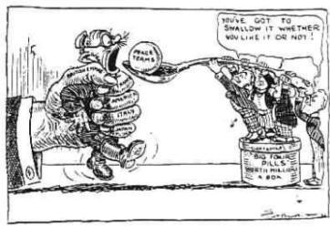
Germany must swallow the pill of the Treaty of Versailles.
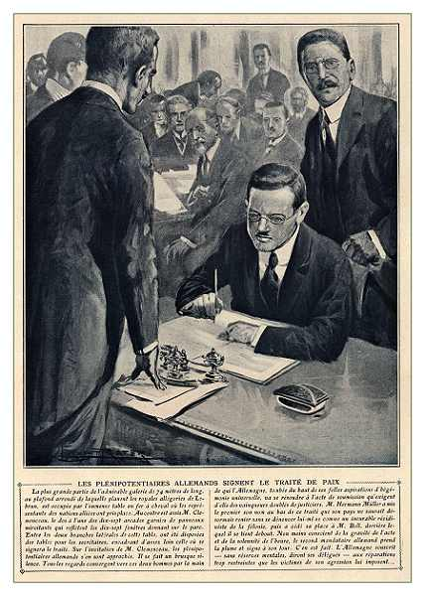

1919 (Sept.) Adolph Hitler attends his first meeting of the German Workers Party as a spy for the army (checking out political groups). He is impressed by their views and joins the party by the end of the month. During this period of political unrest there are incidents of violence and in particular assassinations. 1919 (7 Nov.) Hugo Hasse was shot. He was a pacifist and a member of the Weimar Government.

1920 (Feb.) Adolph Hitler is now working as Anton Drexler’s right hand man and they formulate “The 25 Point Programme”. 1920 (13 March) Wolfgand Kapp (Reichstag politician for the National Peoples’ Party) along with the commander of the Berlin Reichswehr (army), Luttwitz and 5000 supporters march on Berlin. The ordinary people and workers of Berlin do not support this right wing attempt at grasping power and a general strike causes the collapse of the Kapp Putsch…. http://www.youtube.com/watch?v=48lSpWMnSpA …. The Kapp Putsch. Reichwehr (Imperial Defence) – The military organisation of Germany, 1919 to 1935 then renamed Wehrmacht (defence Force).

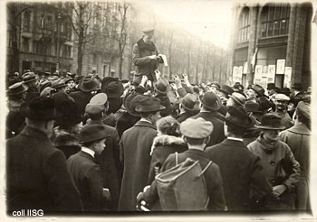
1920 (June) DAP membership reaches 1000 members. 1920 (August) Hitler persuades the political group to re-name itself NSDAP or NAZI party for short. They also adopt the swastika and the one arm raised salute at the same time. 1920 (End of year) The NAZI party has over 3000 members and also owns its own newspaper (Volkischer Beobachter).

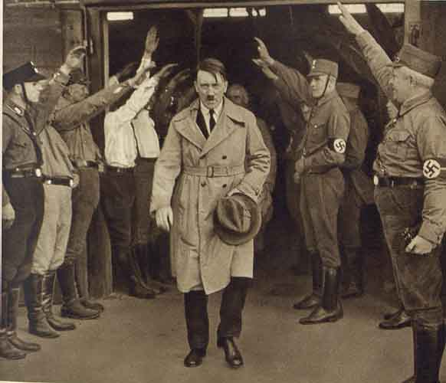
1921 (August) Another political killing. Matthias Erzberger. He is the same politician that signed the Armistice on November 11 – 1918.

1921 – Hitler becomes Nazi party leader and creates the SA (Sturmabteilung – Brown shirts). In addition to the SA Hitler forms his own body guard called the Stosstrupp (Shock Troop). He also created a cohort of close followers under him. This included: Ernst Rohm, Herman Goering, Rudolf Hess and Julius Streicher.

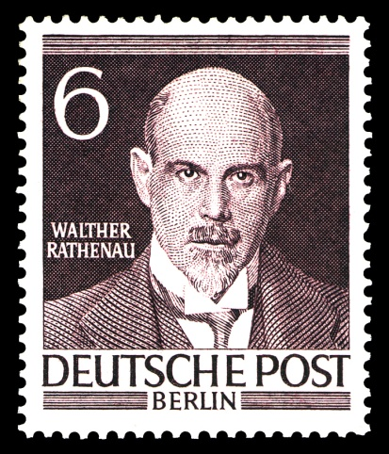
Far Left – 1922 Hyperinflation takes hold and by 1923 it reaches extreme levels.
Near Left – More political killing in 1922 when Walter Rathenau (Weimar foreign minister) is machine gunned to death in the streets of Berlin.
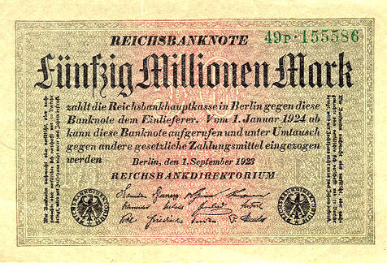

1923 (Sept.) Gustav Stresemann becomes new Chancellor of the Weimar Republic and by November he has cancelled the old German mark for the temporary rentenmark. By the end of the month, Stresemann changes his role and becomes the Foreign Secretary. At the same time, (November 8th) Adolph Hitler attempts his Munich Putsch. The party is not yet strong enough so his take-over fails. http://www.youtube.com/watch?v=18WlSbVja-g&feature=related … 1923
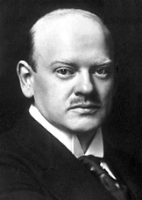
Gustav Stresemann

http://www.youtube.com/watch?v=lbvMnFwe4lc
1924 (Feb.) Seen to the left, the defendants of the Beer Hall Putsch. The trial started in February and was concluded in April. Hitler was sent to Landsberg prison along with Hess for a sentence of 5 years. He served only 264 days and during his stay he wrote his book Mein Kampf with the help of his deputy Rudolf Hess.
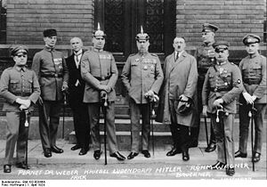

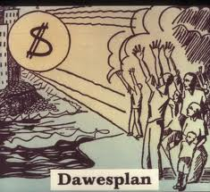
1924 (April) Allies agree the Dawes Plan whereby the reparation payments were reduced and the American banks agree to invest 800 million marks in Germany.
Defendants in the Beer Hall Putsch trial. From left to right: Pernet, Weber, Frick, Kiebel, Ludendorff, Hitler, Bruckner, Röhm, and Wagner. Note that only two of the defendants (Hitler and Frick) were dressed in civilian clothing.

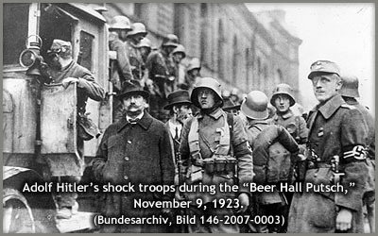
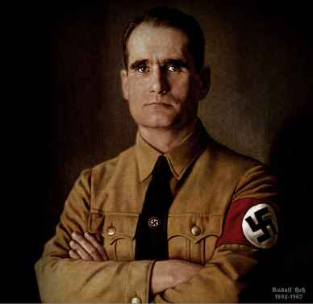
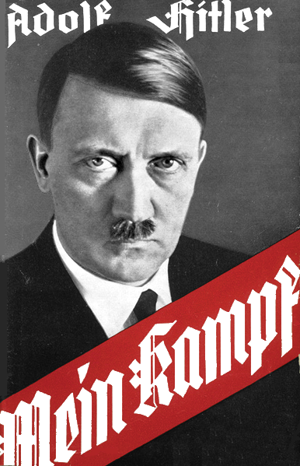
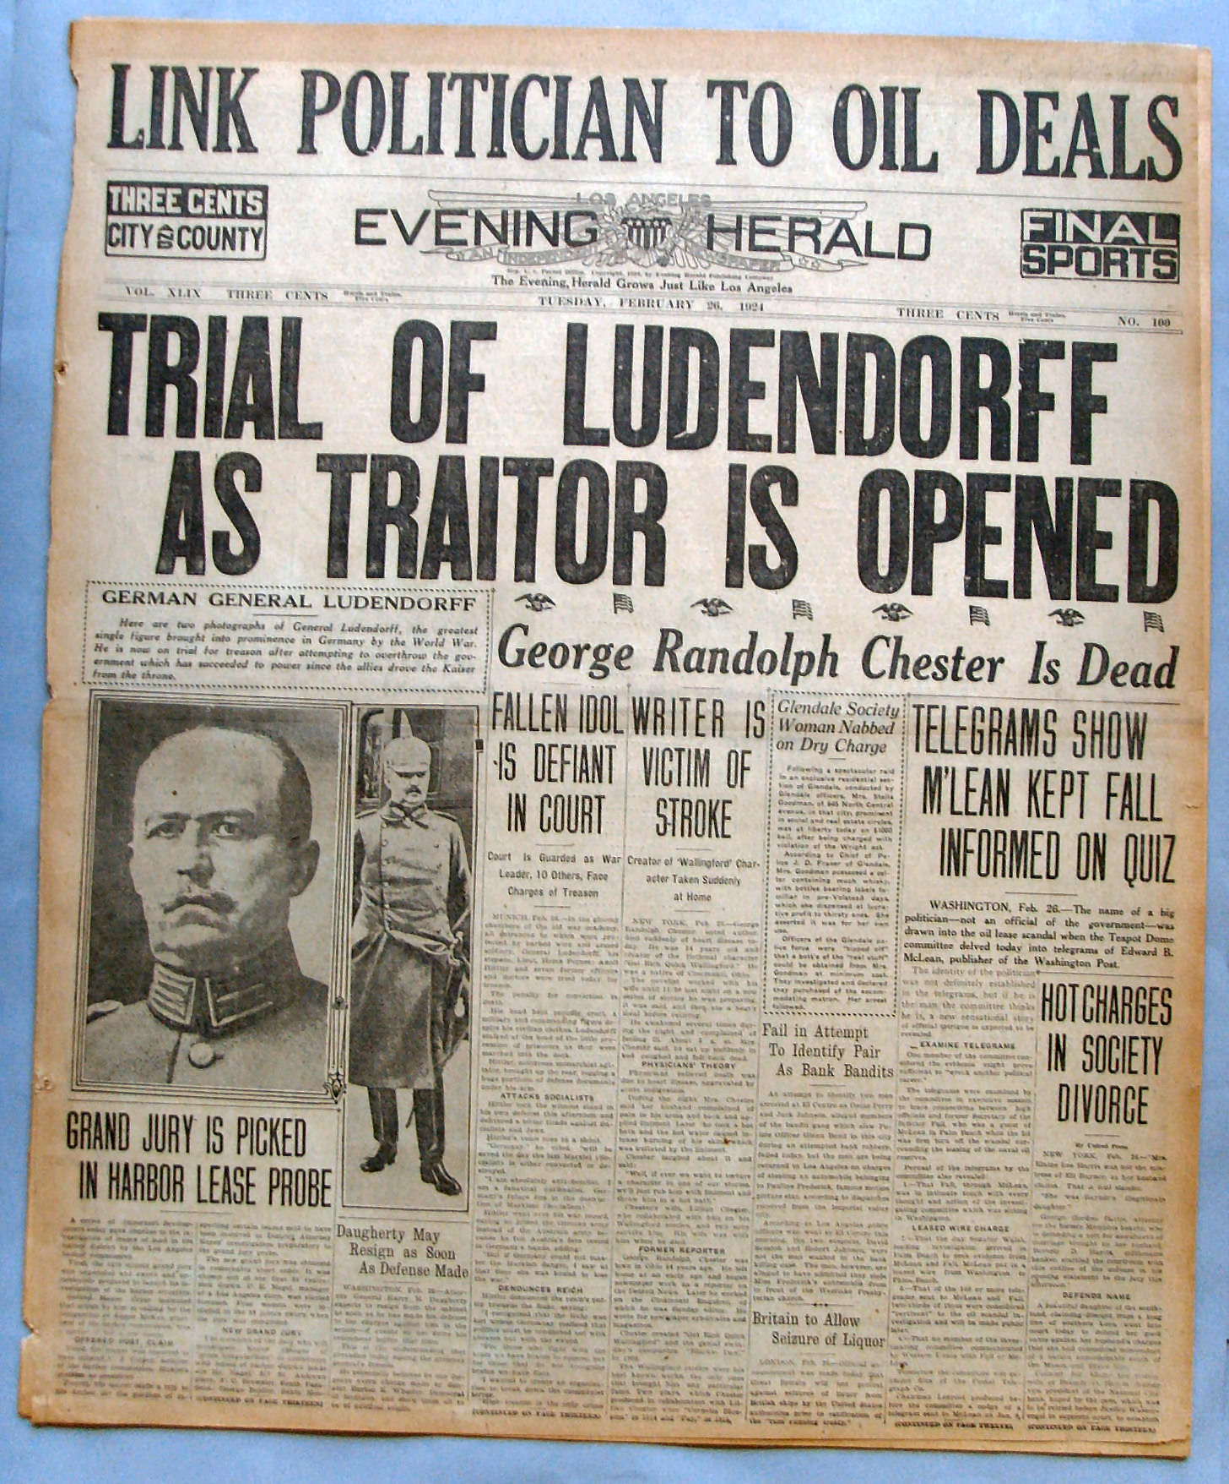
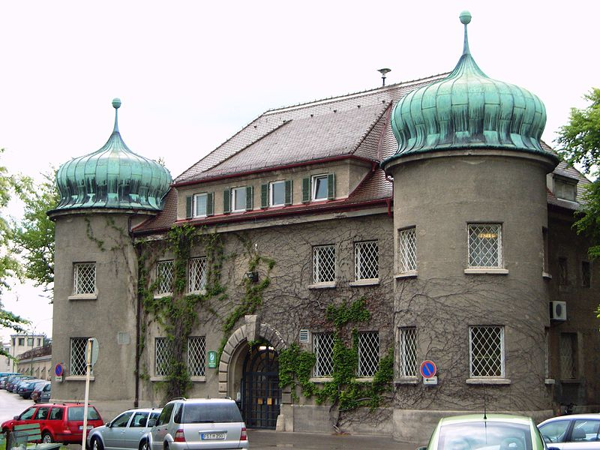

The publicity afforded by the trial helped to establish the NSDAP and in 1924 they secured 32 seats in the Reichstag elections of that year. 1925 (Feb.) Hitler re-launched the Nazi party. Because he did not trust some in the party like Rohm who controlled the SA troops, he also sets up a new security group called the Schutzstaffel (Protection squad) or SS. Originally run by Julius Schreck and then secondly by Heinrich Himmler. Unlike the SA who wore brown shirts, the SA wore black shirts. 1925 Paul von Hindenburg the 78 year old ex-German Army field marshal added stability to the Weimar Government by becoming its Chancellor.

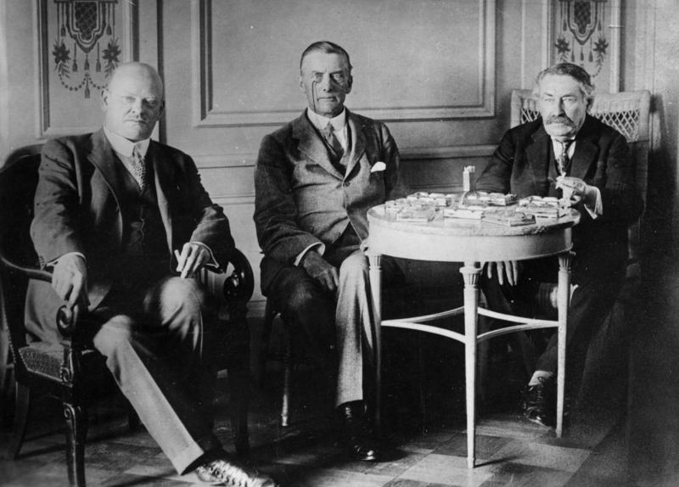
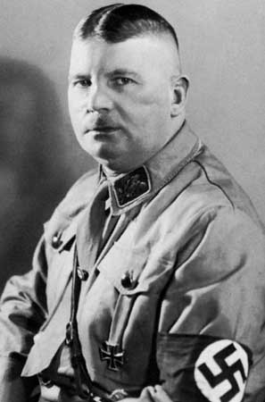
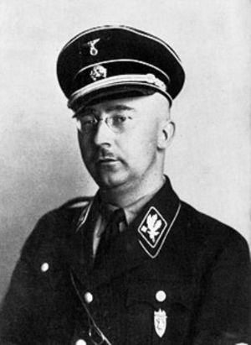
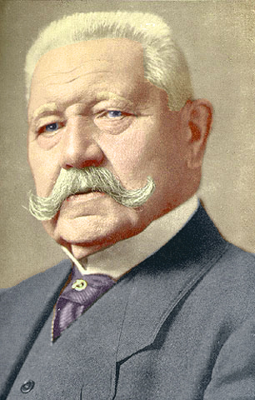

Hindenburg Stresemann, Austen Chamberlain, Briand Ernst Röhm Heinrich Himmler

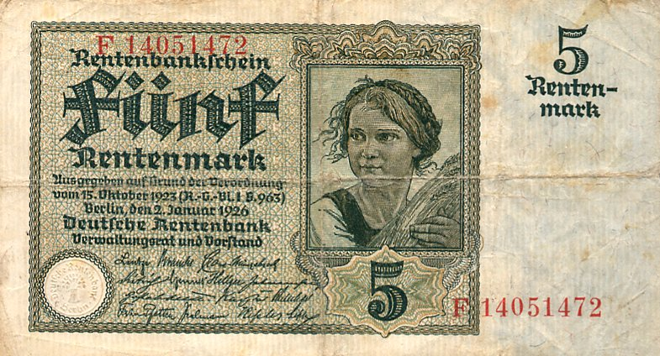
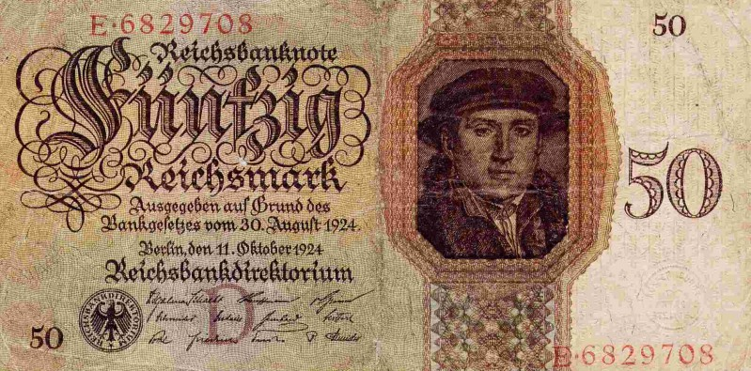

1926 Germany is allowed to join the League of Nations

1928 – Nazi Party has over 100,000 members but a bad year for seats in government (only 12 seats). Because Germany is on the road to recovery the Weimar Government support is fairly stable.
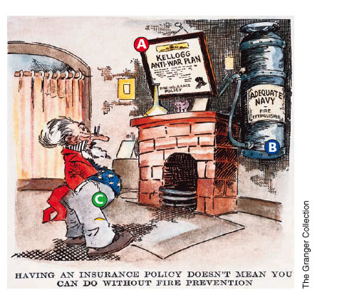
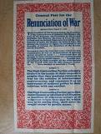
1928 (Aug.) Kellog-Briand pact is signed. Germany is one of 65 countries who agree not to use war to achieve their foreign policy aims. 1929 (Aug.) The Young Plan was agreed whereby the reparations bill would be reduced from £6.6 billion to £2 billion. 1929 (3 Oct.) Gustav Stresemann dies of heart attack. 1929 (Late October) Share prices fall on Wall Street stock exchange (USA). This had a knock on effect for German banks that relied on a strong USA economy! The Weimar Republic was about to lose its popularity. 1929-30 Unemployment 1.3 million & industrial production down by 10%. 1930-31 Unemployment 4.3 million & industrial production down by 30%.

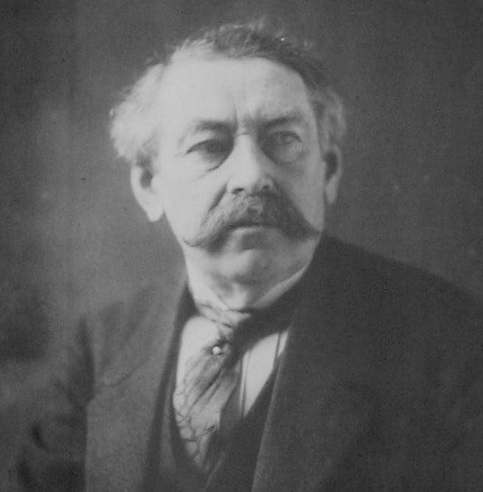
Aristide Briand
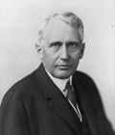
Frank Kellogg

1930-32 Heinrich Brüning is the Chancellor. In the space of two years the Weimar Government had to rely on 115 presidential decrees to maintain the ability to make decisions and keep control. The reputation of the government was sinking fast. 1930-32 The SA organisation now had over 400,000 Storm Troopers. They were very active in disturbing other political party meetings and supporting the Nazi Party. 1932 (April) Brüning tries to ban the SA & SS. Kurt Von Schleicher organises a conspiracy in the Reichstag against Brüning and Hindenburg agrees to sack him. Schleicher puts forward Von Papen as new Chancellor whereby Hindenburg agrees. Von Schleicher offers Nazis a place in the coalition under Von Papen thinking he can control the Nazis. Hitler agrees and thus the Nazis get their first foothold in the government. 1932 (July) Nazis win 230 seats in the General Election and therefore become the largest party in the Reichstag. Hitler tries to get rid of Von Papen but Hindenburg resists. 1932 (November) Von Papen calls another election in the hope that the Nazis lose some of their support. They do lose 34 seats but even with 196 seats gained, it still makes them the largest party. Papen had to resign. 39 business tycoons sign a document calling for Hitler to become the new Chancellor. 1932 (2 December) Hindenburg once again resists the appointment of Hitler and chooses Von Schleicher who becomes Chancellor. Schleicher tries to get Hindenburg to make him head of a military dictatorship because of the threat from the Nazis and in particular Hitler. Schleicher’s plan to take control backfires and he loses all support in the Reichstag. Von Papen persuades Hindenburg that Hitler can be controlled from within so Hindenburg reluctantly appoints Hitler as the new Chancellor 1933 (January).

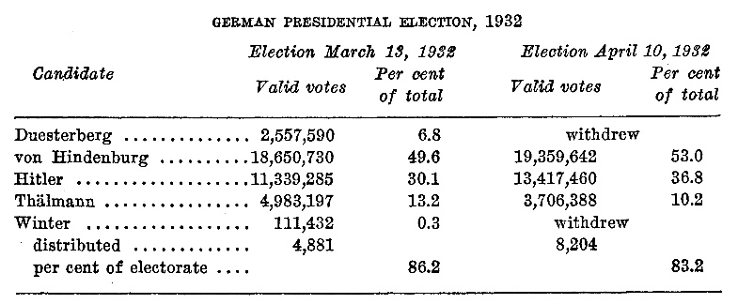 (Thallmann was the Communist candidate)

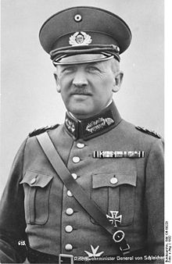
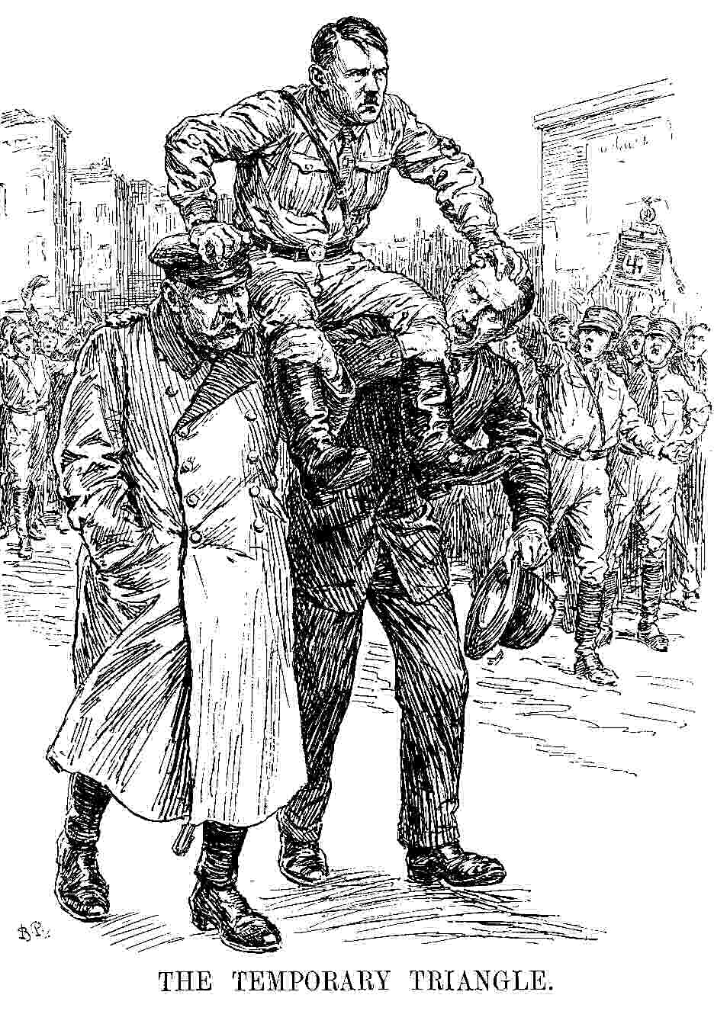
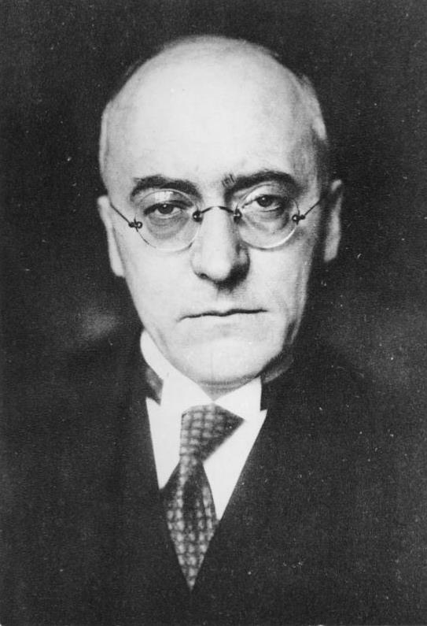

Heidrich Bruüning Kurt Von Schleicher Hindenburg-Hitler-Von Papen

1933 (27 February) The Reichstag building is destroyed by fire. A young Dutch communist is caught on site and is executed. Hitler uses this incident to declare a state of emergency. Having done this he can now use decrees to govern Germany.

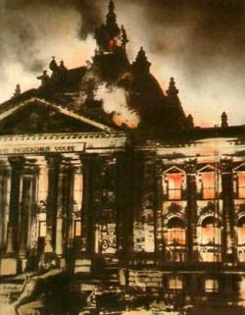
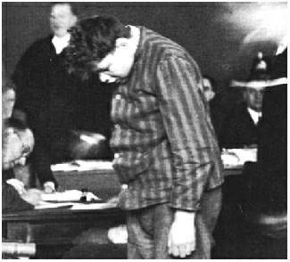

1933 (5 March) Elections held. It was a bloody election campaign with many violent clashes including 70 deaths. Political opponents were imprisoned by decree and many were attacked by the SA troops. Consequently the Nazis increased their Reichstag members to 288. Hitler used his power to ban the Communists from taking up their 81 seats in Parliament. With the support of the other Nationalist parties he now had a 2/3 majority so could legally change the constitution. 1933 (23 March) Hitler passes the Enabling Act. This marked the end of the Weimar Republic and democracy in Germany at this time.

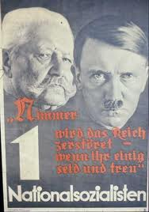
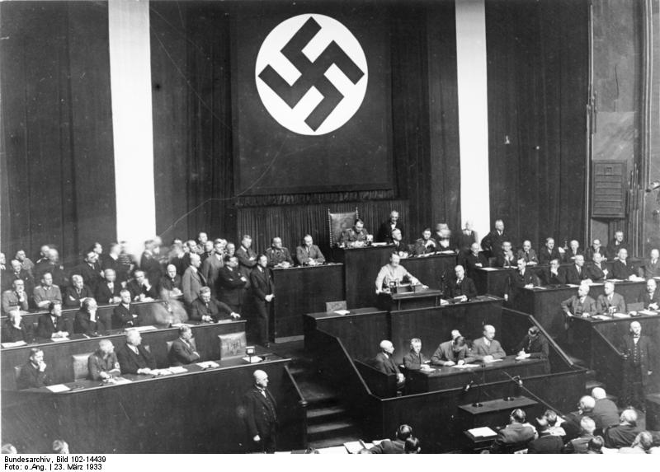
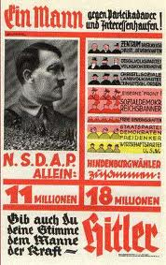

1933 (May) New law created. Trade Unions banned and strikes are now illegal. In its place the DAF was created (The German Labour Front). The working week was on average increased by 6 hours and the DAF had powers to punish workers. http://en.wikipedia.org/wiki/German_Labour_Front The Nazis also set up the RAD (National Labour Service. This provided manual work for the unemployed. 1933 (July) Another new law imposed. It is a law against the establishment of other parties. The NSDAP is now the only official political party in Germany. Hitler reaches a concordat (Reichkonkordat) with the Pope regarding the position of the Roman Catholic Church in Germany. http://en.wikipedia.org/wiki/Reichskonkordat 1933 (Sept.)The leader of the Protestant Church (Ludwig Müller) is made the Reich Bishop of the Christian Movement. The Protestants initially accept Hitler’s protection from the Anti-Christian communists. Some Pastors like Nie Möller, spoke out against Hitler. He set up the Pastors Emergency League in order to campaign against Hitler. He ended up in a concentration camp (1937).

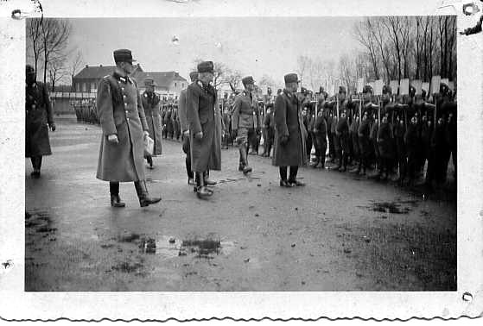
The RAD
National Labour Service
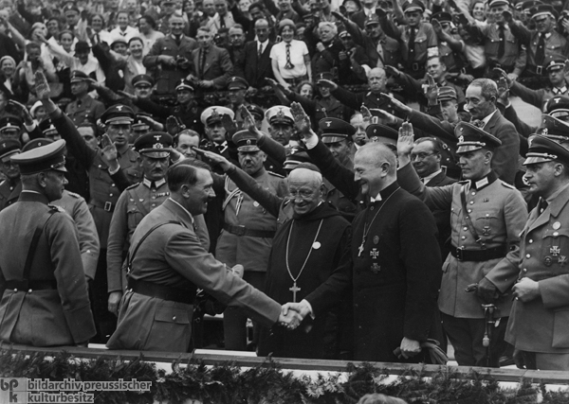
Ludwig Muller is made Reich Bishop of the German Christian Movement.

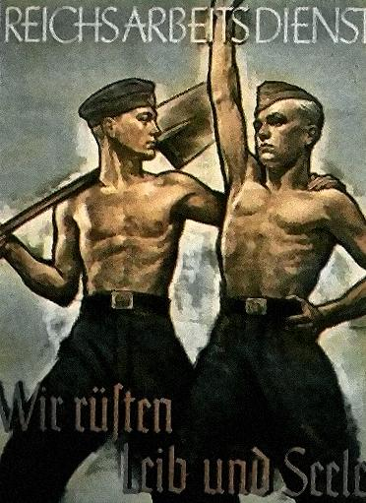
THE GERMAN LABOUR FRONT
(DAF)

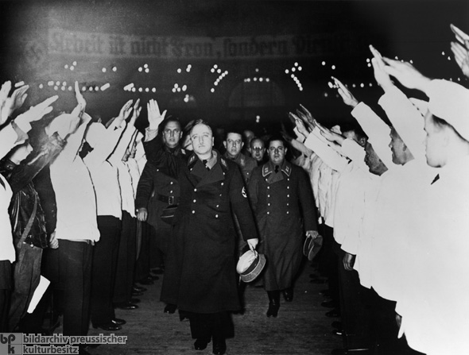
Robert Ley – Head of German Labour Front

1933 The Gestapo (German secret police) set up by Hermann Goering and later to be run by Reinhard Heydrich (1936). 1933 Joseph Goebbels made Minister of People’s Enlightenment & Propaganda. His aim is to control the people through the use of mass rallies, parades, newspapers, radio & the cinema. In Germany there were more radios per person than any other country in Europe.

1933 First Nazi concentration camp set up at Dachau (for men). Also Meringen Camp set up for women. The concentration camps were set up to take political prisoners or undesirables like prostitutes, Jews or gypsies. http://en.wikipedia.org/wiki/Dachau_concentration_camp 1933 The squeeze is put on the Jews in the following ways: Nazis boycott of Jewish businesses. Jews banned from government jobs, inheriting land, joining the Army and entering restaurants. 1933 Rearmament spending … 3.5 billion marks. 1933 Unemployment … 4.8 million. 1933 German Army … 100,000men.

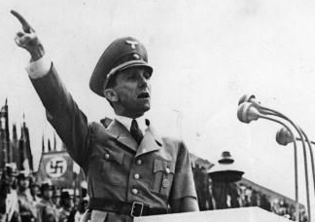
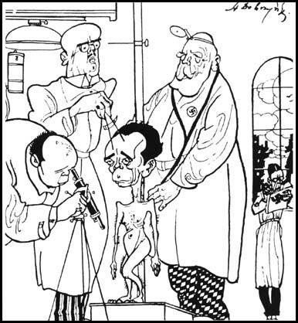

1933 The Law for the Encouragement of Marriage is passed. Financial incentives of 1000 mark loans are offered to mothers who left work and had children. On the birth of the fourth child the debt was wiped out. Special medals were offered to the mothers of large families: 4/5 children = Bronze. 6/7 children = Silver. 8+ children = Gold award.

The Mother’s Cross Award
GOLD
SILVER
BRONZE
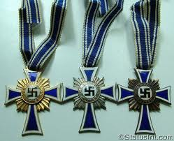

1934 (January) No more local government control in the regions of Germany (Abolishment of Lander Parliaments). 1934 (30 June) The Night of the Long Knives. The SA now had 3 million members under the command of Ernst Rohm. Hitler feared that Rohm may become an enemy and take power from him. Hitler used the Night of the Long Knives to wipe out most of his competitors.

1934 (2 August) Paul von Hindenburg dies aged 87. Hitler declares himself as Germany’s Fuehrer and forces an oath of loyalty from every soldier in the Army. This was the start of Hitler’s Third Reich.

1935 Launch of the Lebensborn Programme by Heinrich Himmler, head of the SS. Firstly it provided nurseries and financial aid but was further developed whereby women had children with members of the SS. Some of these children were offered for adoption to wealthy German families. The idea was to produce genetically pure Aryans into the German populace. http://www.jewishvirtuallibrary.org/jsource/Holocaust/Lebensborn.html
1935 It became compulsory for all young men to serve for 6 months in the RAD (National Labour Service).

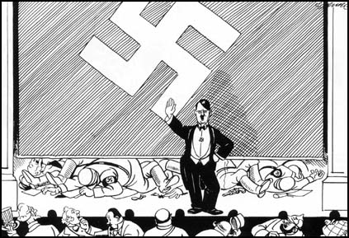
http://www.spartacus.schoolnet.co.uk/GERnight.htm
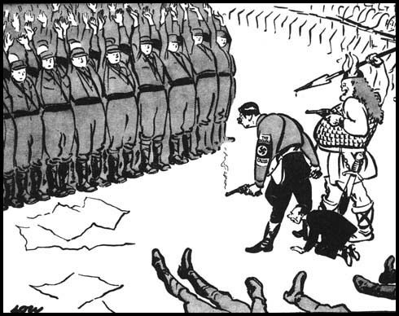
Night of the Long Knives - Cartoon

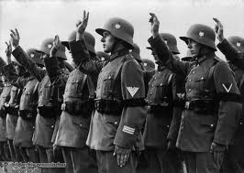
Wehrmacht soldiers swear allegiance to Hitler
http://en.wikipedia.org/wiki/Wehrmacht#Origin_and_use_of_the_term

1935 (15 Sept.) The creation of the Nuremberg Laws against the Jews. Jews could no longer: Be German citizens, have a right to vote, hold government offices, hold a German passport, be allowed to marry a German citizen, have certain seats on trains and buses and they would also be required to wear a yellow patch for instant identification. http://en.wikipedia.org/wiki/Yellow_badge

1935 Liselotte Hermann – member of the KDP (Communists) was discovered sending information about secret weapons out of Germany. She is tried for treason and eventually (June 1938) is beheaded. 1935 Mildrid Harnack (A University teacher) & her husband Arvid, begin sending out information about the Nazi Party to the US & Soviet Governments. The spy circle was later to be called the ‘Red orchestra’ by the Nazis.
http://en.wikipedia.org/wiki/Mildred_Harnack

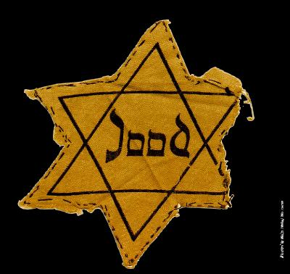
Dutch Badge 1942
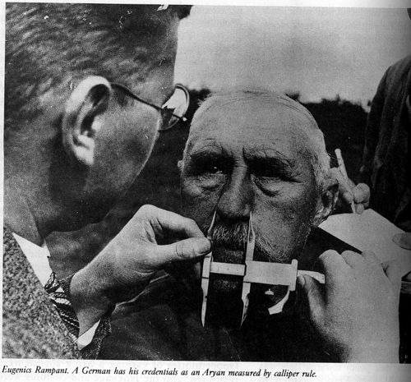

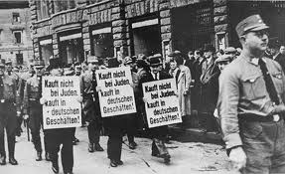

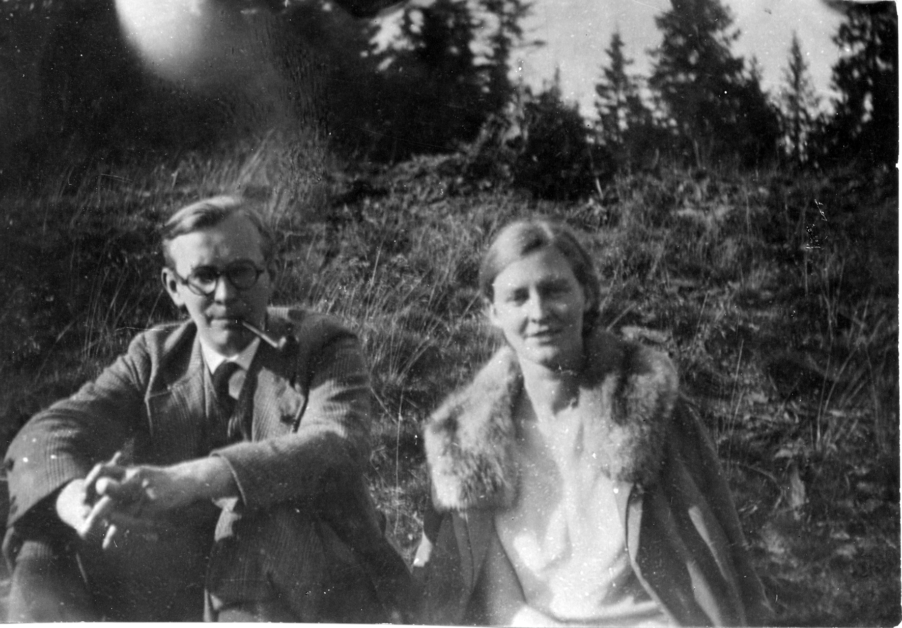
Arvid & Mildred Harnack
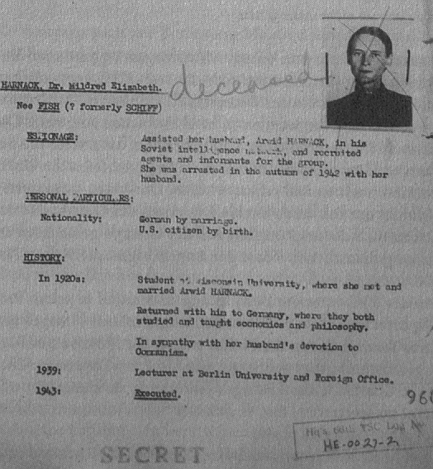

1936 German Army = 500,000 & Unemployment down to 1.6 million. 1936 Hitler’s secret memo “Within 4 years Germany must be able to wage war.” 1936 The Gestapo (Non uniform police set up by Goering in 1933) are placed under the control of the SS and to be led by Reinhard Heydrich. 1936 Berlin Olympics – This event used as a propaganda tool. The Nazis built a stadium to hold 110,000 spectators. Germany managed to win more medals than any other country that participated. The only embarrassment occurred in that the black athlete, Jesse Owens won 4 gold medals. How could a person from an inferior race & creed be so successful!
http://www.historylearningsite.co.uk/1936_berlin_olympics.htm
http://www.youtube.com/watch?v=1dyns367ExE Opening Ceremony Olympics 36
http://www.youtube.com/watch?v=XXIe5GbLSUs&feature=related Olympics 1936
http://www.youtube.com/watch?v=K1XclGwJY8s&NR=1 Berlin Olympics 1936.

1937 Buchenwald Concentration Camp set up for 1,000 prisoners. 1937 Pope Pius XI realising that the Concordat between the Nazis and the Roman Catholic Church had collapsed, he issued a public criticism of Adolph Hitler. This statement has since received the title “With Burning Anxiety” 1937 (6 May) The Hindenburg, Airship Disaster. 35 people die when the Airship catches fire in New Jersey – USA. This spells the end of Airship travel. 1937 Pastor Martin Niemoller sent to Concentration Camp (Sachsenhausen then Dachau). He survived both. Below is a famous quote by Niemoller but there is some dispute as to the order in which he listed the groups who suffered at the hands of the Nazis. http://en.wikipedia.org/wiki/Martin_Niem%C3%B6ller

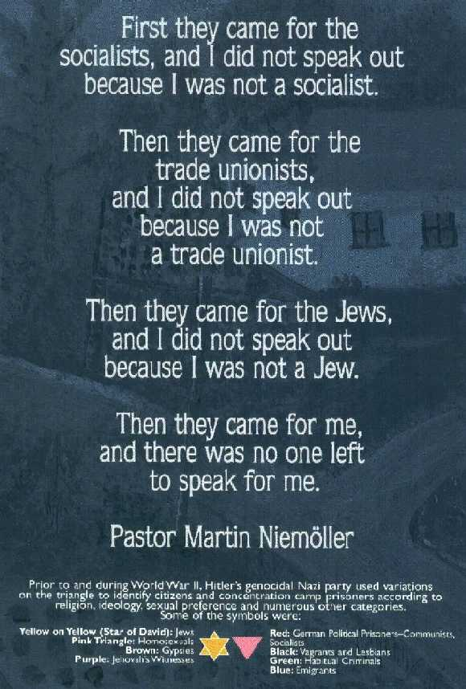
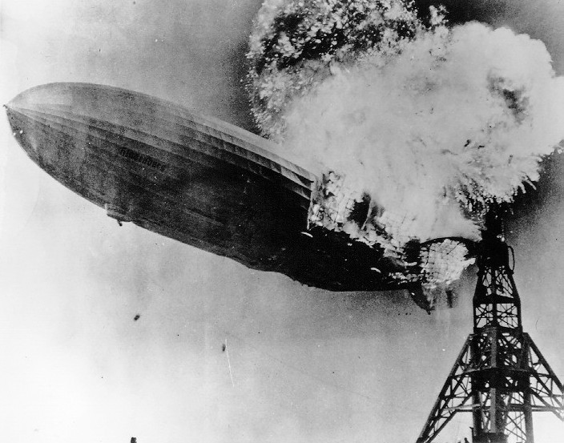
The airship LZ 129 Hindenburg

1938 Unemployment down to 0.5 million. 1938 Concentration Camp inmates used for business enterprises such as production of army uniforms. 1938 Additions to the Nuremburg Law restrictions on the Jews: 1) Jewish doctors, dentists and lawyers forbidden to work with Aryan Germans. 2) Jews forced to carry special identity cards. 3) All Jewish possessions had to be registered allowing easier confiscation of goods by the Nazi authorities. 1938 (7 Nov.) A young Polish Jew called Hershel Grynszpan, shot a German national called Ernst Von Rath in the embassy in Paris. (9 Nov.) Rath dies. During the next few days, Hitler & Goebbels instigate a hate campaign on the Jews in Germany. Hundreds of shops, homes and synagogues were destroyed by the Nazis. So much glass damage was caused that it was thus named Kristallnacht (Crystal night or the night of broken glass).
http://www.historyplace.com/worldwar2/timeline/knacht.htm
http://www.youtube.com/watch?v=HrombDUtOYY… kristallnacht slide show.
http://www.youtube.com/watch?v=SCj9RJU2Y1Y Night of Broken Glass
http://www.youtube.com/watch?v=HFA-AP8xeQ0&feature=related

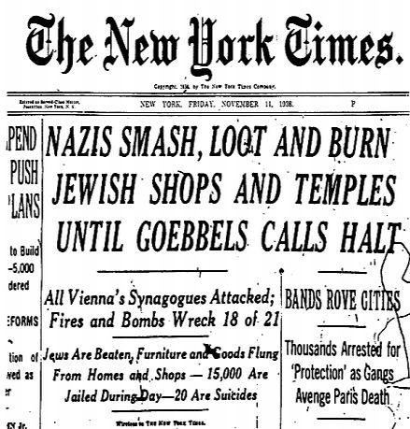
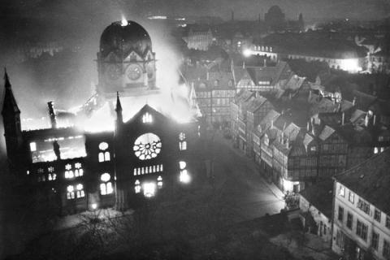

1939 By this time there were 6 concentration camps holding about 20,000 prisoners. Germany also had 7,000 miles of autobahns provided by RAD (National Labour Force). 1939 (Jan.) The Reich Office for Jewish Emigration was set up in order to carry out the forced expulsion of the Jews from Germany. 1939 (April) Orders were issued to evict all Jews from their homes and they were herded into certain areas of the cities. Thus was the birth of the Jewish ghettos. The intention was to keep them there until they could be deported or transported!! http://www.youtube.com/watch?NR=1&v=5gn7YOwkAXQ Ghettos. 1939 (Sept.) Germany invades Poland (1st September) and 2nd World War starts the following day. This invasion sees the successful use of Blitzkrieg tactics. 1939. The Re-armament bill = 26 billion marks and the German Army contains approximately 900,000 men. 1939 (End of) Buchenwald Concentration Camp now contains 10,000 prisoners.

1940 (March) Hitler & Mussolini hold a conference at Brenner Pass. The end result is that Italy joins the War on the side of Germany. 1940 (April) The Germans invade Denmark and Norway in order to control the coastline of the North Sea. At this time the Concentration Camp at Auschwitz is being built. 1940 (May) Pro-Nazi Norwegian Army Major Vidkum Quisling becomes leader of Norway. In England the Prime Minister Neville Chamberlain mismanages the campaign to help defend Norway and is replaced by Winston Churchill. 1940 (15 May) Holland and Luxemburg quickly falls to the might of the German Army and surrenders. The Belgian Army resists for three weeks but is finally defeated on (27 May). German soldiers and tanks advance into Northern France. 1940 (27 May to 4 June) Allied troops are trapped on the beaches of Dunkirk. Operation “Dynamo” is carried out whereby 700 assorted small and large boats sailed across the English Channel to rescue the 350,000 soldiers.

http://www.youtube.com/watch?v=R9EhW_piX6A
http://www.5min.com/Video/The-Defeat-of-France-and-the-Battle-of-Dunkirk-in-1940-516911266
1940 (10 June) Italy declares War on France and Britain. 1940 (22 June) General Huntziger signs an armistice which concludes the Fall of France. The collaborationist government takes over the running of occupied France (The Vichy Government). 1940 (August) The Battle of Britain commences. German bombers and fighter aeroplanes hit targets all over Britain in order to try and gain control of the skies in preparation for invasion in September. 1940 (September) Blitzkrieg of London starts. At same time Italians invade North Africa. (27 September) Tripartite pact between Germany, Italy and Japan. 1940 (October 7) Germany invades Romania in an attempt to secure oil supplies. (12 October) Operation Sea Lion (codename for invasion of England) is indefinitely postponed because of the inability of the Luftwaffe to defeat the Royal Air Force. Battle of Britain ends (31 October). 1940 (December) There are a number of British successes fighting against the Italians in North Africa.

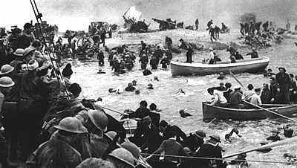
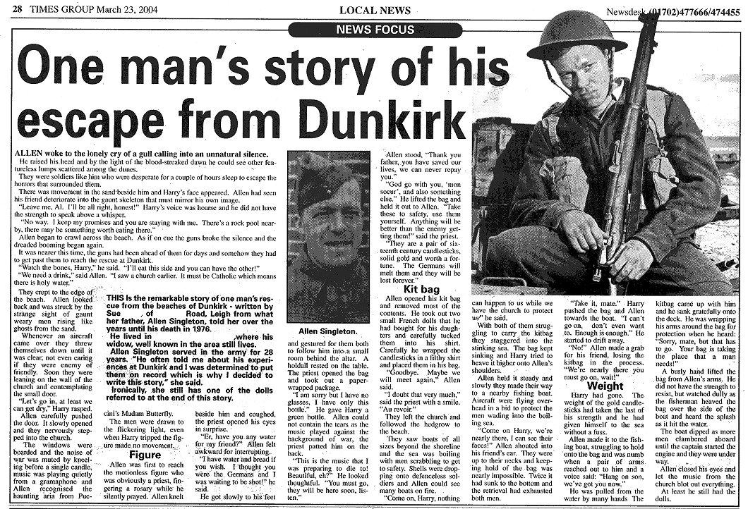

1941 (February) Erwin Rommel arrives in Tripoli to lead the German Afrika Korps against the British and Australian troops controlling North Africa. 1941 (April) Yugoslavia and Greece fall to the Germans. 1941 Several naval battles fought: HMS Hood sunk (May 24), Bismarck sunk (May 27), Ark Royal Aircraft Carrier sunk by U-boat off the coast of Gibraltar (November 13). See below in order: HMS Hood, Bismark & Ark Royal Carrier.

1941 (June 22) Germany attacks Soviet Union as Operation Barbarossa starts. In the same month the Nazi SS-Einsatzgruppen begin mass murder.
http://www.historyplace.com/worldwar2/timeline/einsatz.htm
1942 (September 1) Nazis order Jews to wear yellow stars. 1941 (September 29) Nazis murder 33,771 Jews at Kiev. 1941 (Sept. Oct. & Nov.) Intense fighting between the Soviet Union and the Germans around the cities of: Kiev, Odessa, Kharkov, Sevastopol, Rostov & Moscow.

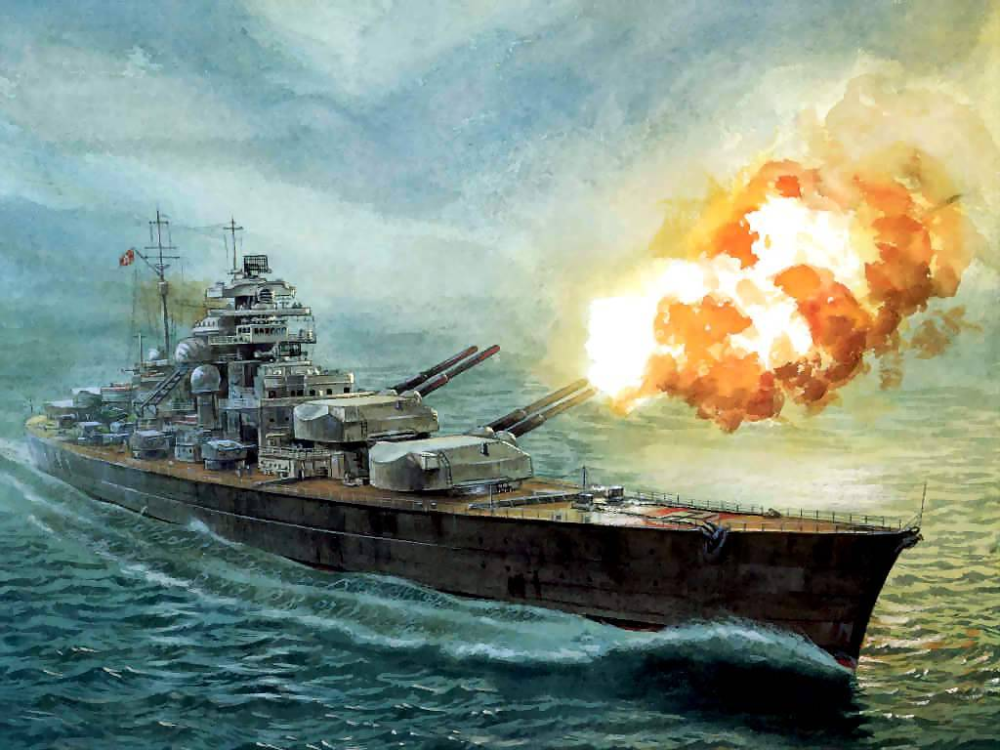
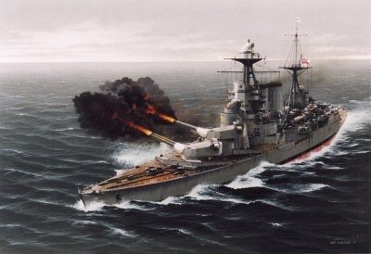

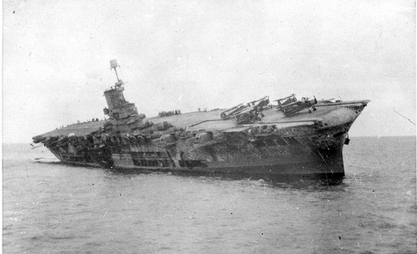

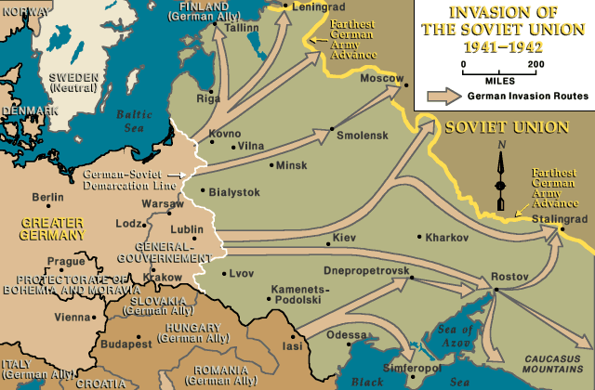

http://www.google.co.uk/search?q=Operation+Barbarossa&tbo=p&tbm=vid&source=vgc&hl=en&aq=f … Operation Barbarossa.
http://www.5min.com/Video/The-Success-of-Operation-Barbarosa-in-1941-516911309 ... Operation Barbarossa.
1941 (December 7) Japanese bomb Pearl Harbour. 1941 (December 8) United States and Britain declare war on Japan. 1941 (December 11) Hitler declares war on the United States.
http://www.youtube.com/watch?v=HAnOtWm5OrM … Attack on Pearl Harbour.
http://www.youtube.com/watch?v=Nt13c3olXkU … Pearl Harbour.
1941 (December 19) Hitler takes control of the German Army.

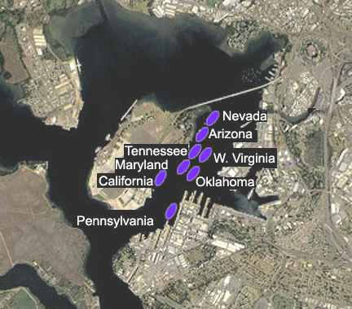
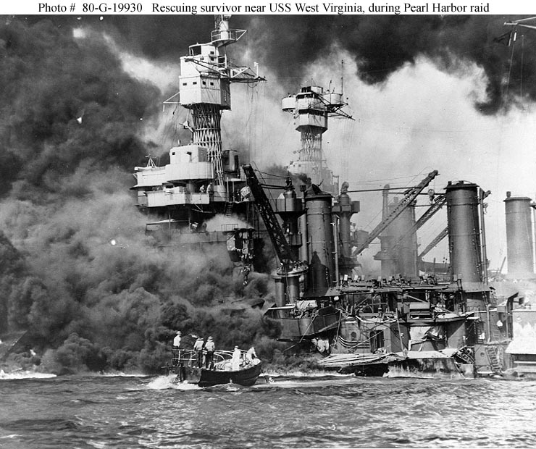

http://en.wikipedia.org/wiki/Attack_on_Pearl_Harbor
1942(Jan.20) SS leader Heydrich holds Wannsee Conference in order to co-ordinate the “Final Solution of the Jewish Problem”. 1942 (May 30) First ever 1000 bomber air raid one Germany (City of Cologne). 1942 (June 4) Heydrich dies after wounds from an attack on him in (Prague - May27). In the same month mass murder of the Jews by gassing commences at Auschwitz. 1942 (June 30) After Rommel’s counter offensive in North Africa he reaches El Alamein near Cairo. (30 June & 1 July) First battle of El Alamein. 1942 (July 22) First deportations from the Warsaw Ghetto and the Treblinka extermination camp opened. 1942 (September) Montgomery pushes Rommel back at the Battle of Alam Halfa. Later in September the battle of Stalingrad begins. 1942 (October 5) SS executions in the Ukraine. http://www.historyplace.com/worldwar2/timeline/engineer.htm

1942 (November 1) In North Africa the allied attack on the Axis forces is successful at El Alamein and Rommel is in retreat. 1943 (January 23) Montgomery and the 8th Army take Tripoli and regain an important port on the Mediterranean. 1943 (February 2) The first major defeat for Hitler’s armies when the Germans surrender at Stalingrad. 1943 (february18) Nazis arrest White Rose resistance group in Munich.

http://en.wikipedia.org/wiki/White_Rose
1943 (March) … 27 allied merchant ships sunk in the Atlantic as the U-boat campaign reaches a climax. 1943 (April) The Waffen SS attack the Jews in Warsaw Ghettos. Resistance is ended by the middle of May. http://www.historyplace.com/worldwar2/timeline/warsaw.htm 1943 (May 13) Italian and German troops surrender in North Africa. 1943 (May 22) Donitz suspends his U-boat operations in the North Atlantic. 1943 (July 9 & 10) Allied troops land in Sicily. 1943 (July 25 & 26) Mussolini arrested and the Fascist government falls. 1943 (September 11) German troops occupy Rome and the following day Mussolini is rescued. He re-establishes a Fascist government. 1943 (October 4) Heinrich Himmler gives a speech to National, Regional leaders and SS officers about the purity of the German race and the part to be played by the extermination of the Jews within his plans. http://www.historyplace.com/worldwar2/timeline/posen.htm ... Himmler speeches. 1943 (October 13) Italy declares war on Germany. 1943 (November 28) The first meeting of the big three in Teheran (Stalin, Churchill & Roosevelt). Preliminary planning for advances from both east & west. http://www.historyplace.com/worldwar2/timeline/teheran.htm

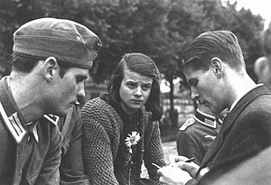
Members of the White Rose, Munich 1942. From left: Hans Scholl, his sister Sophie Scholl, and Christoph Probst.

1943 (December) Soviets advance against the Germans in the Ukraine. 1944 (January) Soviets open up another front by advancing into Poland. 1944 (Jan. to March) Most of the activities of the British and US troops are directed at progressing up the Italian peninsula. 1944 (May) German forces are on the retreat in Sevastopol, Crimea and the Anzio area in Italy. The allied forces enter Rome (June 5). 1944 (June 6) D-Day landings on the beaches of Normandy. Throughout June and July the battle rages for control of Normandy. 1944 (June 13) First German V-1 rocket attack on Britain.

1944 (July 20) Assassination attempt by some of the German Army officers fails and the culprits are rounded up. The aftermath saw about 7000 arrested and almost 5000 people executed. http://en.wikipedia.org/wiki/20_July_plot http://www.youtube.com/watch?v=rzqvSViaAyk&feature=fvsr 1944 (July 24) Soviet troops discover and liberate the first concentration camp at Majdanek. 1944 (August 4) The Gestapo arrest Anne Frank and her family in Amsterdam, Holland. http://en.wikipedia.org/wiki/Anne_Frank

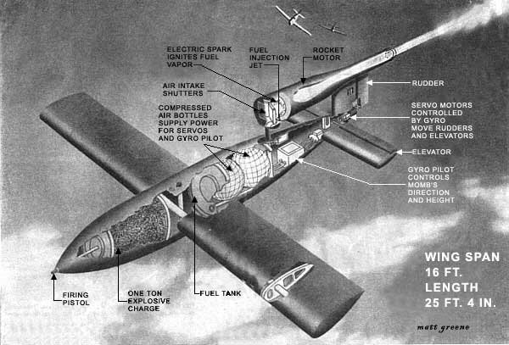

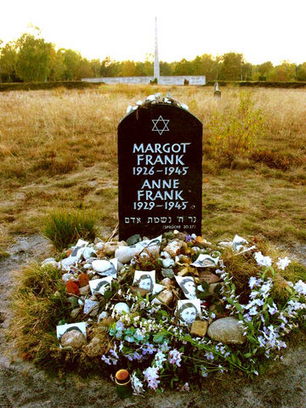

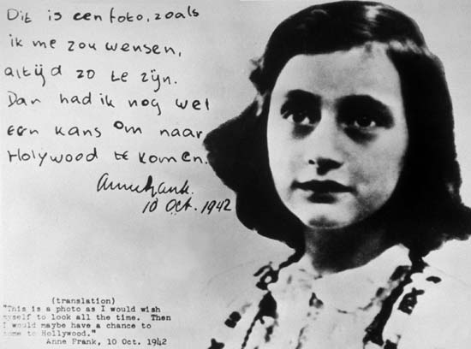

1944 (August 19) Resistance uprising in Paris. (August 25) The city of Paris is liberated. 1944 (September 17) Allies reach the border of Holland and under the leadership of Montgomery they launch the largest ever airborne assault codenamed Market Garden. The attack was not successful but however it further drained the resources of the German Army. http://en.wikipedia.org/wiki/Operation_Market_Garden 1944 (October 14) Allied troops liberate Athens. On the same day Field Marshal Erwin Rommel commits suicide. 1944 (October 30) Gas chambers at Auschwitz are used for the final occasion. 1944 (December) The German Army with concentrated use of the Panzer tank divisions initiate a surprise attack known as the Battle of the Bulge in the area of the Ardennes. On 17 December the Waffen-SS murder 81 POW’s at Malmedy. http://en.wikipedia.org/wiki/Battle_of_the_Bulge http://www.youtube.com/watch?v=bf0WpZPOReo&feature=related 1944 (December 26) Patton relieves Bastogne and the threat of further German advance is cancelled. By January 17 the Germans have withdrawn from the Ardennes area.

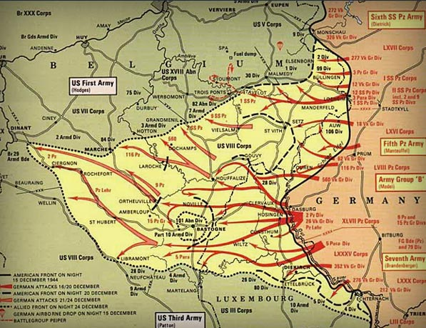

1945 (January) Soviet troops capture Warsaw in Poland and also liberate Auschwitz Concentration Camp. 1945 (February 4 to 11) Churchill, Stalin and Roosevelt meet at Yalta to discuss the post war re-organisation of Europe after Germany was defeated. http://en.wikipedia.org/wiki/Yalta_Conference 1945 (March 7) Allies move into Cologne and establish a crossing point over the River Rhine. 1945 (April): Discovery of stolen art treasures in German salt mines. (12)The allies liberate Buchenwald Concentration Camp. (12) President Roosevelt dies and is succeeded by Harry Truman as the President of the USA. (16) Soviets begin their attack on Berlin and the Americans enter Nuremberg. (18) In the Rhur area the German Army surrenders. By April 21 the Soviets reach Berlin. (28) Mussolini is captured by Italian partisans and then hanged.

1945 (April 29) US 7th Army liberated Dachau Concentration Camp. 1945 (April 30) Adolph Hitler commits suicide. 1945 (May 2) German troops in Italy surrender. 1945 (May 7) Unconditional surrender by all of the German forces to the allies and the following day (May 8) is named V-E (Victory in Europe) Day. 1945 OTHER DEVELOPMENTS DURING THE SECOND PART OF THIS YEAR. May 23 – SS–Reichsfuhrer Himmler commits suicide. June 5 – The governing of Germany is taken over by the allies. June 26 – United Nations Charter is signed in San Francisco by 50 of the foundation member countries. http://en.wikipedia.org/wiki/United_Nations_Charter July 1 – French, British and American troops move into Berlin to join up with the Soviet forces. July 16 – The first atomic bomb test by the Americans and on the same day the Potsdam conference commences between the allied leaders. http://en.wikipedia.org/wiki/Potsdam_Conference

Churchill – Truman – Stalin Atlee – Truman – Stalin
July 26 – Clement Atlee replaces Winston Churchill as the British Prime Minister. August 6 – The first atomic bomb is dropped on the industrial city of Hiroshima in Japan. Three days later (August 9) the second atomic bomb is dropped on the city of Nagasaki. http://en.wikipedia.org/wiki/Atomic_bombings_of_Hiroshima_and_Nagasaki http://www.youtube.com/watch?v=7Dr7M9zU4_0&feature=fvst http://www.youtube.com/watch?v=PuX7mx-PIY4&feature=related August 14 – The Japanese agree to an unconditional surrender and on September 2 they sign the surrender agreement. The same day is named V-J Day (Victory over Japan). 1945 (October 24) The World Organisation known as the United Nations is born. 1945 (November 20) The Nuremberg war crimes trial begins. http://en.wikipedia.org/wiki/Nuremberg_Trials http://www.youtube.com/watch?v=ZAo9LM0xfrU http://www.youtube.com/watch?v=KTsTzOhklDk

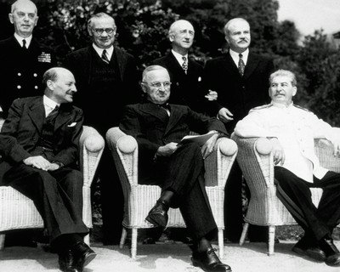
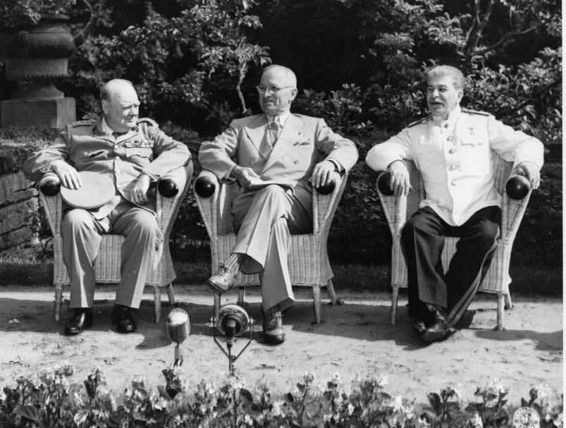

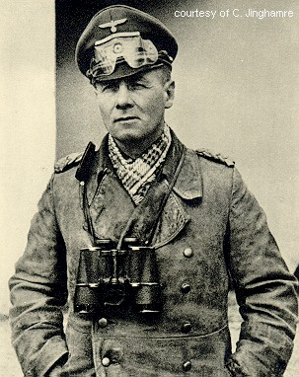
Erwin Rommel – Desert Fox
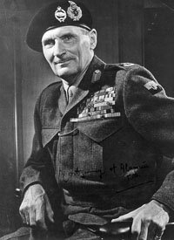
Field Marshal Bernard Law Montgomery

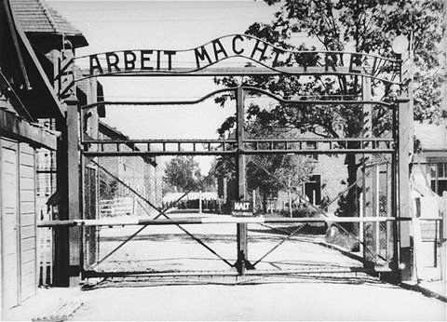
Auschwitz
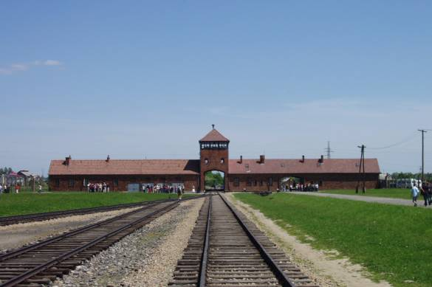
Auschwitz

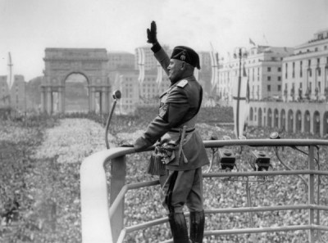
Mussolini
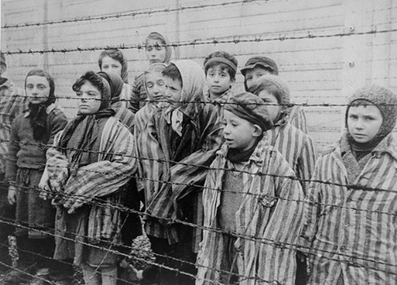

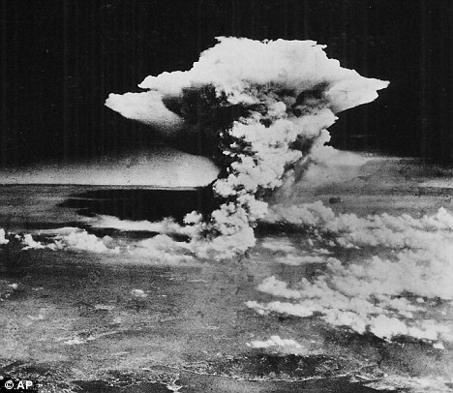
Hiroshima
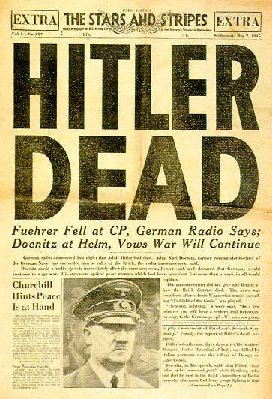

Reference page for internet resources.
http://en.wikipedia.org/wiki/Weimar_Republic ... The Weimar Republic.
http://en.wikipedia.org/wiki/German_Revolution_of_1918%E2%80%9319 … Spartacist Uprising.
http://www.spartacus.schoolnet.co.uk/GERrevolution.htm ... German Revolution 1919
http://en.wikipedia.org/wiki/German_Labour_Front ... German Labour Front.
http://www.spartacus.schoolnet.co.uk/GERgoebbels.htm ... Goebbels.
http://www.spartacus.schoolnet.co.uk/GERnight.htm ... Night of the Long Knives.
http://en.wikipedia.org/wiki/Wehrmacht …. The German armed forces 1935 to 1945
http://en.wikipedia.org/wiki/Mildred_Harnack … Mildred Harnack.
http://www.historylearningsite.co.uk/1936_berlin_olympics.htm ... 1936 Olympics.
http://www.jewishgen.org/ForgottenCamps/Camps/BuchenwaldEng.html ... Buchenwald.
http://www.historyplace.com/worldwar2/timeline/knacht.htm ... Kristallnacht.
http://en.wikipedia.org/wiki/Red_Orchestra_(espionage) ... The Red Orchestra Resistance Organisation.
http://www.euronet.nl/users/wilfried/ww2/1940.htm … Events 1940.
http://www.historyplace.com/worldwar2/timeline/ww2time.htm 1941
http://www.historyplace.com/worldwar2/timeline/einsatz.htm Nazi SS-Einsatzgruppen begins mass murder.
http://en.wikipedia.org/wiki/Yellow_badge … The badge for the Jews … The Star of David.
http://en.wikipedia.org/wiki/Attack_on_Pearl_Harbor ... Pearl Harbour.
http://www.historyplace.com/worldwar2/timeline/engineer.htm Eyewitness account of the Einsatz murders.
http://www.historyplace.com/worldwar2/timeline/warsaw.htm … The Warsaw Ghetto.
http://www.historyplace.com/worldwar2/timeline/posen.htm ... 1943 - Oct.4 – Himmler at Posen.
http://en.wikipedia.org/wiki/Anne_Frank ... Anne Frank in Holland.
http://en.wikipedia.org/wiki/Operation_Market_Garden ... Allied Advance called Market Garden.
http://en.wikipedia.org/wiki/Yalta_Conference ... Meeting between Churchill, Stalin & Roosevelt.
http://en.wikipedia.org/wiki/United_Nations_Charter ... United Nations Charter.
http://www.eyewitnesstohistory.com/berlin.htm ... The Soviets enter Berlin.
http://en.wikipedia.org/wiki/Bernard_Montgomery,_1st_Viscount_Montgomery_of_Alamein … Montgomery (Field Marshal).
http://en.wikipedia.org/wiki/Erwin_Rommel ... Erwin Rommel.
http://en.wikipedia.org/wiki/Nuremberg_Trials ..... The Nuremberg war crimes trials.

Reference Page for Video Clips.
http://www.youtube.com/watch?v=O5DZi6PiPRY&NR=1 The Ludendorff Offensive 1918
http://www.youtube.com/watch?v=idZuVcTTGuU&feature=related … Spartacist revolution 1919.
http://www.youtube.com/watch?v=Ob8B5YNG2VE&NR=1 … Spartacist Revolution 1919.
http://www.youtube.com/watch?v=48lSpWMnSpA … The Kapp Putsch.
http://www.youtube.com/watch?v=18WlSbVja-g&feature=related Hyperinflation & Germany 1923.
http://www.youtube.com/watch?v=lbvMnFwe4lc … Beer Hall Putsch-November 1923.
http://www.youtube.com/watch?v=JrwjbZsdBJo …. Wall Street Crash 1929
http://www.youtube.com/watch?v=1dDfVwzJbW4&feature=related … Depression in Germany 1929.
http://www.youtube.com/watch?v=1dyns367ExE ….. Opening Ceremony Berlin Olympics
http://www.youtube.com/watch?v=K1XclGwJY8s&NR=1 … Jesse Owens … Berlin 1936.
http://www.youtube.com/watch?v=XXIe5GbLSUs&feature=related …. Jesse Owens 1936 Olympics.
http://www.youtube.com/watch?NR=1&v=5gn7YOwkAXQ … Jewish Ghettos 1939
http://www.youtube.com/watch?v=3QtfxRTZdKk … Buchenwald & Dachau (Liberation).
http://www.youtube.com/watch?v=sHcJtU9dr6I&NR=1 Liberation of Conc. Camp. Band of Brothers.
http://www.5min.com/Video/The-Defeat-of-France-and-the-Battle-of-Dunkirk-in-1940-516911266
http://www.google.co.uk/search?q=Operation+Barbarossa&tbo=p&tbm=vid&source=vgc&hl=en&aq=f … Operation Barbarossa.
http://www.5min.com/Video/The-Success-of-Operation-Barbarosa-in-1941-516911309 ... Op. Barb.
http://www.youtube.com/watch?v=HAnOtWm5OrM … Attack on Pearl Harbour.
http://www.youtube.com/watch?v=Nt13c3olXkU … Pearl Harbour.
http://www.youtube.com/watch?v=rzqvSViaAyk&feature=fvsr …The bomb plot to assassinate Hitler.
http://www.youtube.com/watch?v=bf0WpZPOReo&feature=related …The Battle of the Bulge (Ardennes).
http://www.youtube.com/watch?v=ZAo9LM0xfrU … Nuremberg war crimes trials (1)
http://www.youtube.com/watch?v=KTsTzOhklDk … Nuremberg war crimes trials (2)

