Henry VII’s rule of England.
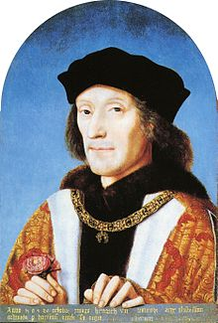

Henry VII was not born as a direct heir to the throne, although he was part of the House of Lancaster. This house was fighting another, the House of York, for control of the throne. Henry VII defeated the House of York at the Battle of Bosworth. In doing so he won the ‘War of the Roses’ and became the last English monarch to win the throne through warfare.

Henry VII's grip on power was far from secure. His claim to the throne was shaky and he was plagued by plots and conspiracies. He arranged marriages for his children to try and strengthen his position. Henry secured a marriage between his eldest son, Arthur, and the Spanish princess, Catherine of Aragon, in 1501. But in 1502 the 15-year-old Arthur died suddenly, leaving Catherine a widow and making his younger brother, Henry, the new heir to the throne. It was suggested that Catherine should marry the young Henry instead, although this was never confirmed during Henry VII’s lifetime.

Henry VII rebuilt the royal finances by avoiding war and promoting trade. He also enforced heavy taxes to the point of ruthlessness. His clever financial plan meant he was able to leave a fortune to his son, the future Henry VIII.

Henry VII began the work of building a more modern rule. He changed the legal system so that the Court of Star Chamber was set up to deal with legal matters. He worked hard to create better law and order in Wales and the north (who often argued with the King) through the creation of special councils and giving more power to the justices of the peace. This gave the monarchy more power over England.

Henry tried to avoid foreign wars and through arranged marriages and treaties, he improved relationships with European countries. However, it meant that England was not really seen as a big or powerful country.

