Many Germans refused to accept that they had been defeated in the First World War. The terms of the Treaty of Versailles – especially the territorial changes (see map 2 copymaster 1), the payment of reparations and demilitariation – were considered to be greatly unfair in Germany.

The terms of the Treaty of Versailles, including the payment of reparations and demilitariation, were considered to be greatly unfair by Germany. Many Germans refused to accept that they had even been defeated in the First World War.

The new German government faced problems from the start. The Kaiser abdicated in 1918 amid mutiny and rebellion. The Spartacists tried to overthrow the new government in the winter of 1918–19 and Berlin was plagued by riots and street violence. The Government, based in the city of Weimar where it was safer, put down this rebellion with the help of right-wing Freikorps (military units).

The government signed the Treaty of Versailles in November 1919. Wolfgang Kapp, a right winger who hated the government for signing the treaty, tried to take power aided by the Freikorps. This putsch was defeated when the left-wing trade unions organised strikes in support of the government.

In 1922, Germany was bankrupt. Germany failed to pay part two of the reparations and the French invaded the Ruhr coalfields as payment. The workers in the Ruhr went on strike following the orders of their government; many left the Ruhr and had to be re-housed. The government could not afford these costs and decided to print more and more paper money. This led to the hyperinflation of 1923. Many Germans suffered. 1929 was the year of the Wall Street Crash in the USA which caused a world-wide recession. Germany was badly affected and, by 1933, over six million workers were unemployed.

Hitler’s rise to power has to be understood in the light of what happened in Germany between 1918 and 1933. The Nazis tried to take power by putsch in 1923, but failed. By the 1930s, after years of recession and unemployment, people were ready to vote for them. In July 1932, the Nazis were the biggest party in the Reichstag. President Hindenburg at first refused to make Hitler Chancellor, but gave in after the Reichstag fire of February 1933, fearing a communist threat. In the March 1933 elections, Hitler’s Brown Shirts terrorised the opposition and the Nazis got 288 seats. Hitler still did have not a majority. However, the Nationalist Party decided to help him and their 53 votes added to the Nazi’s 288 gave Hitler a small majority.
Source 1 From a German newspaper, 28 June 1919
4
Overview of Germany 1918 – 45
VENGEANCE GERMAN NATION!

Today in the Hall of Mirrors a disgraceful treaty is being signed. Never forget it. There will be vengeance for the shame of 1919.

Source 2 From a German magazine, 1937

The caption asks ‘What would Tommy [nickname for a British Soldier] have said if the same was done to him as to the German?’
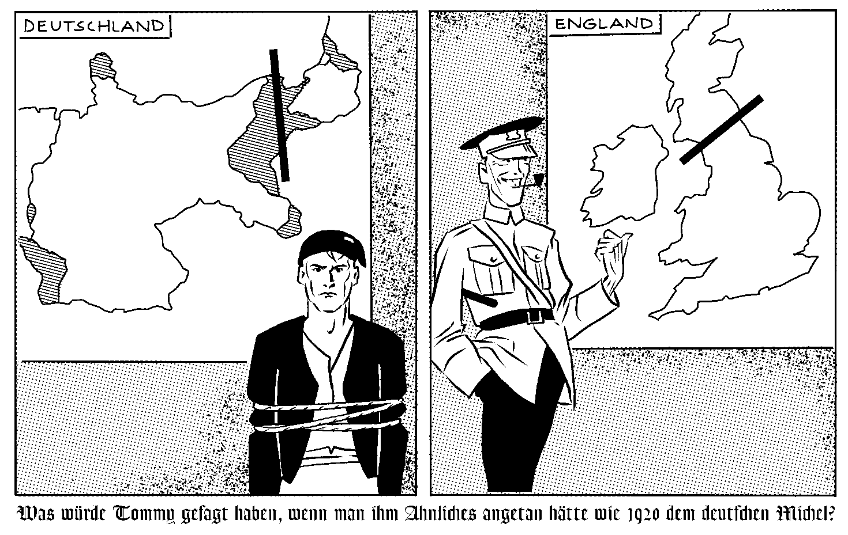

A German banknote, value 1,000,000,000 marks, issued November 1923
5
The Weimar Republic
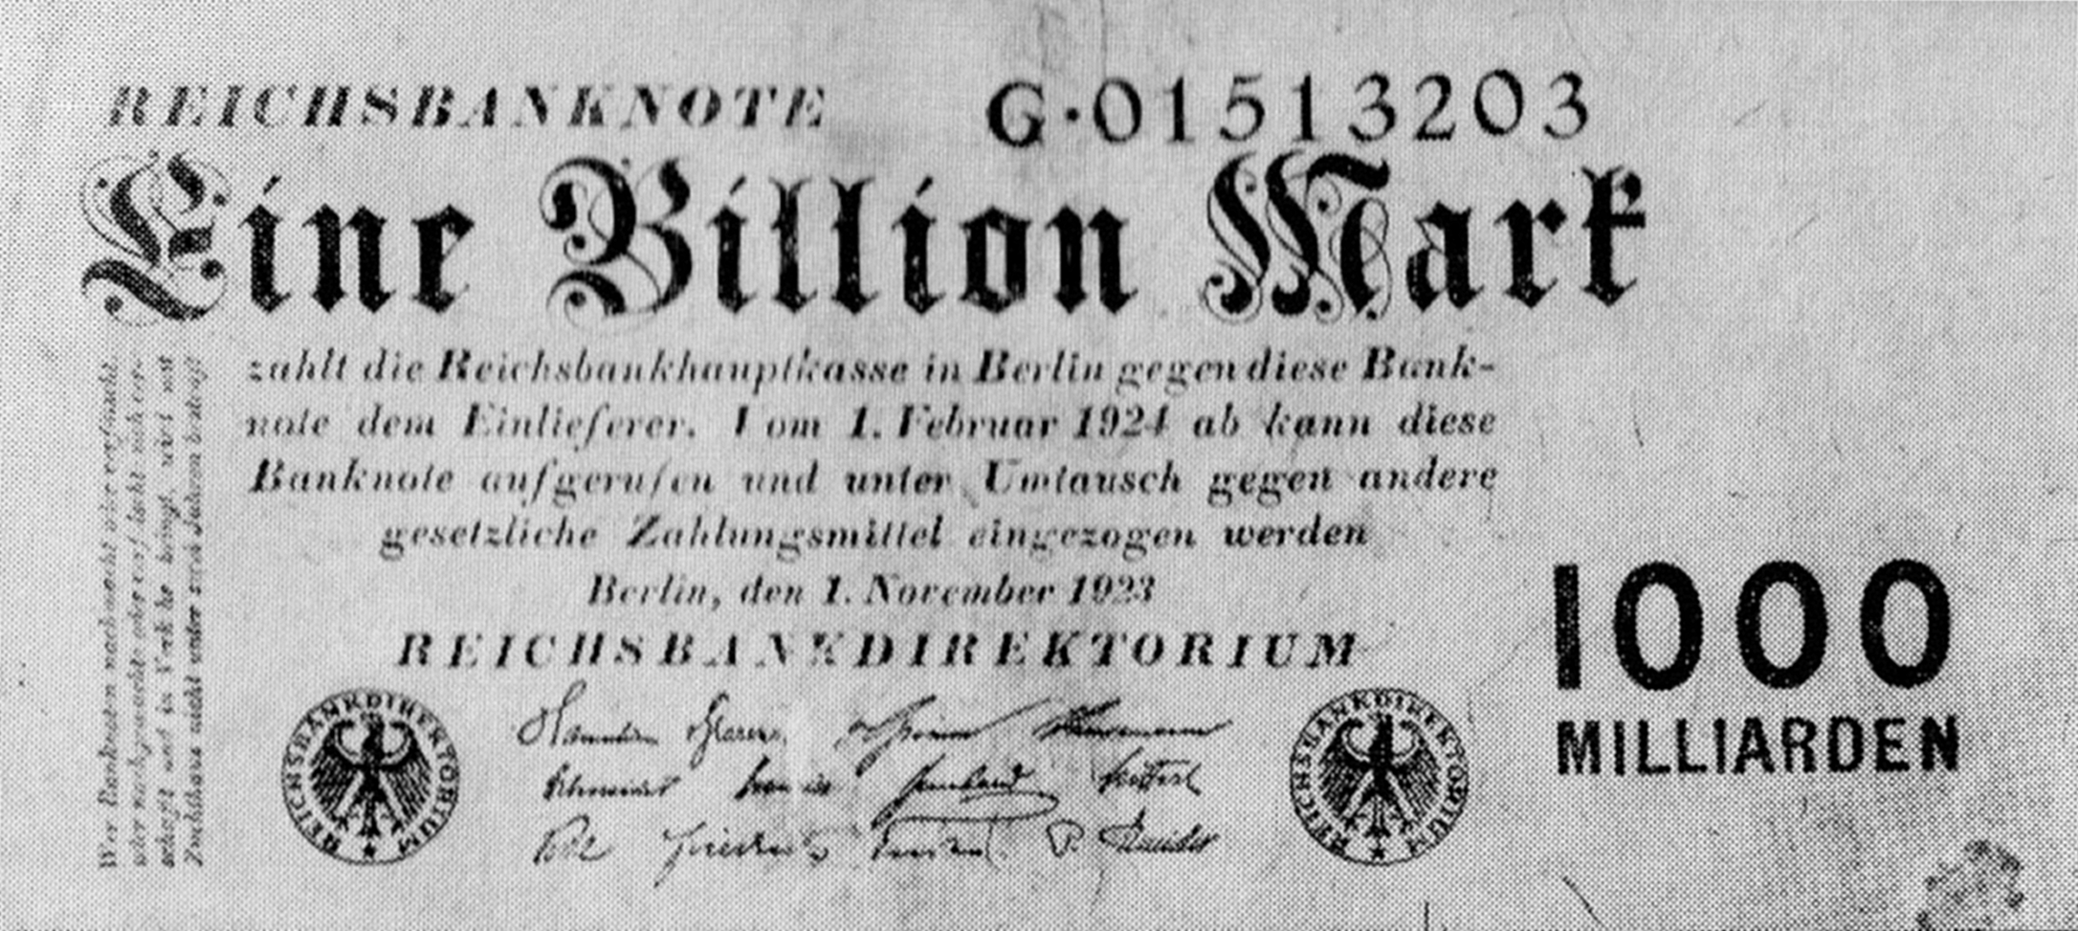

The cost of a loaf of bread in Weimar Germany
 |  | Price in Marks | Price in British pounds
1918 |  | .63 marks | 63p
1922 |  | 160 marks | £1.60
1923 | January | 250 marks
1923 | July | 3 500 marks
1923 | September | 1 500 000 marks
1923 | November | 200 000 000 000 marks

6
The Great Inflation
Source 1 A long line of unemployed men on the streets of Berlin, 1930

Read and consider the sources below. Use all of the sources and your own knowledge to explain how Hitler and the Nazis came to power in 1933.
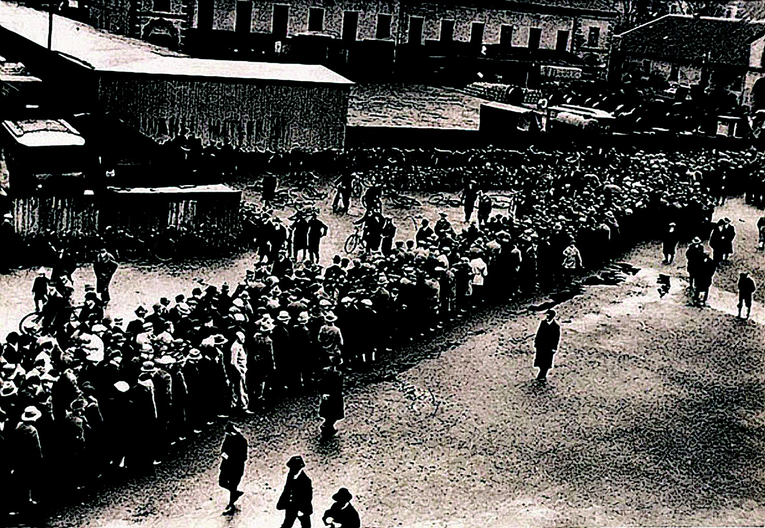

Source 2 Gregor Strasser, a Nazi, speaking in 1931

‘All that serves to bring about catastrophe…is good, very good for us and our German revolution.’

7
The rise of the Nazis
Source 3 Nazi election poster, 1933
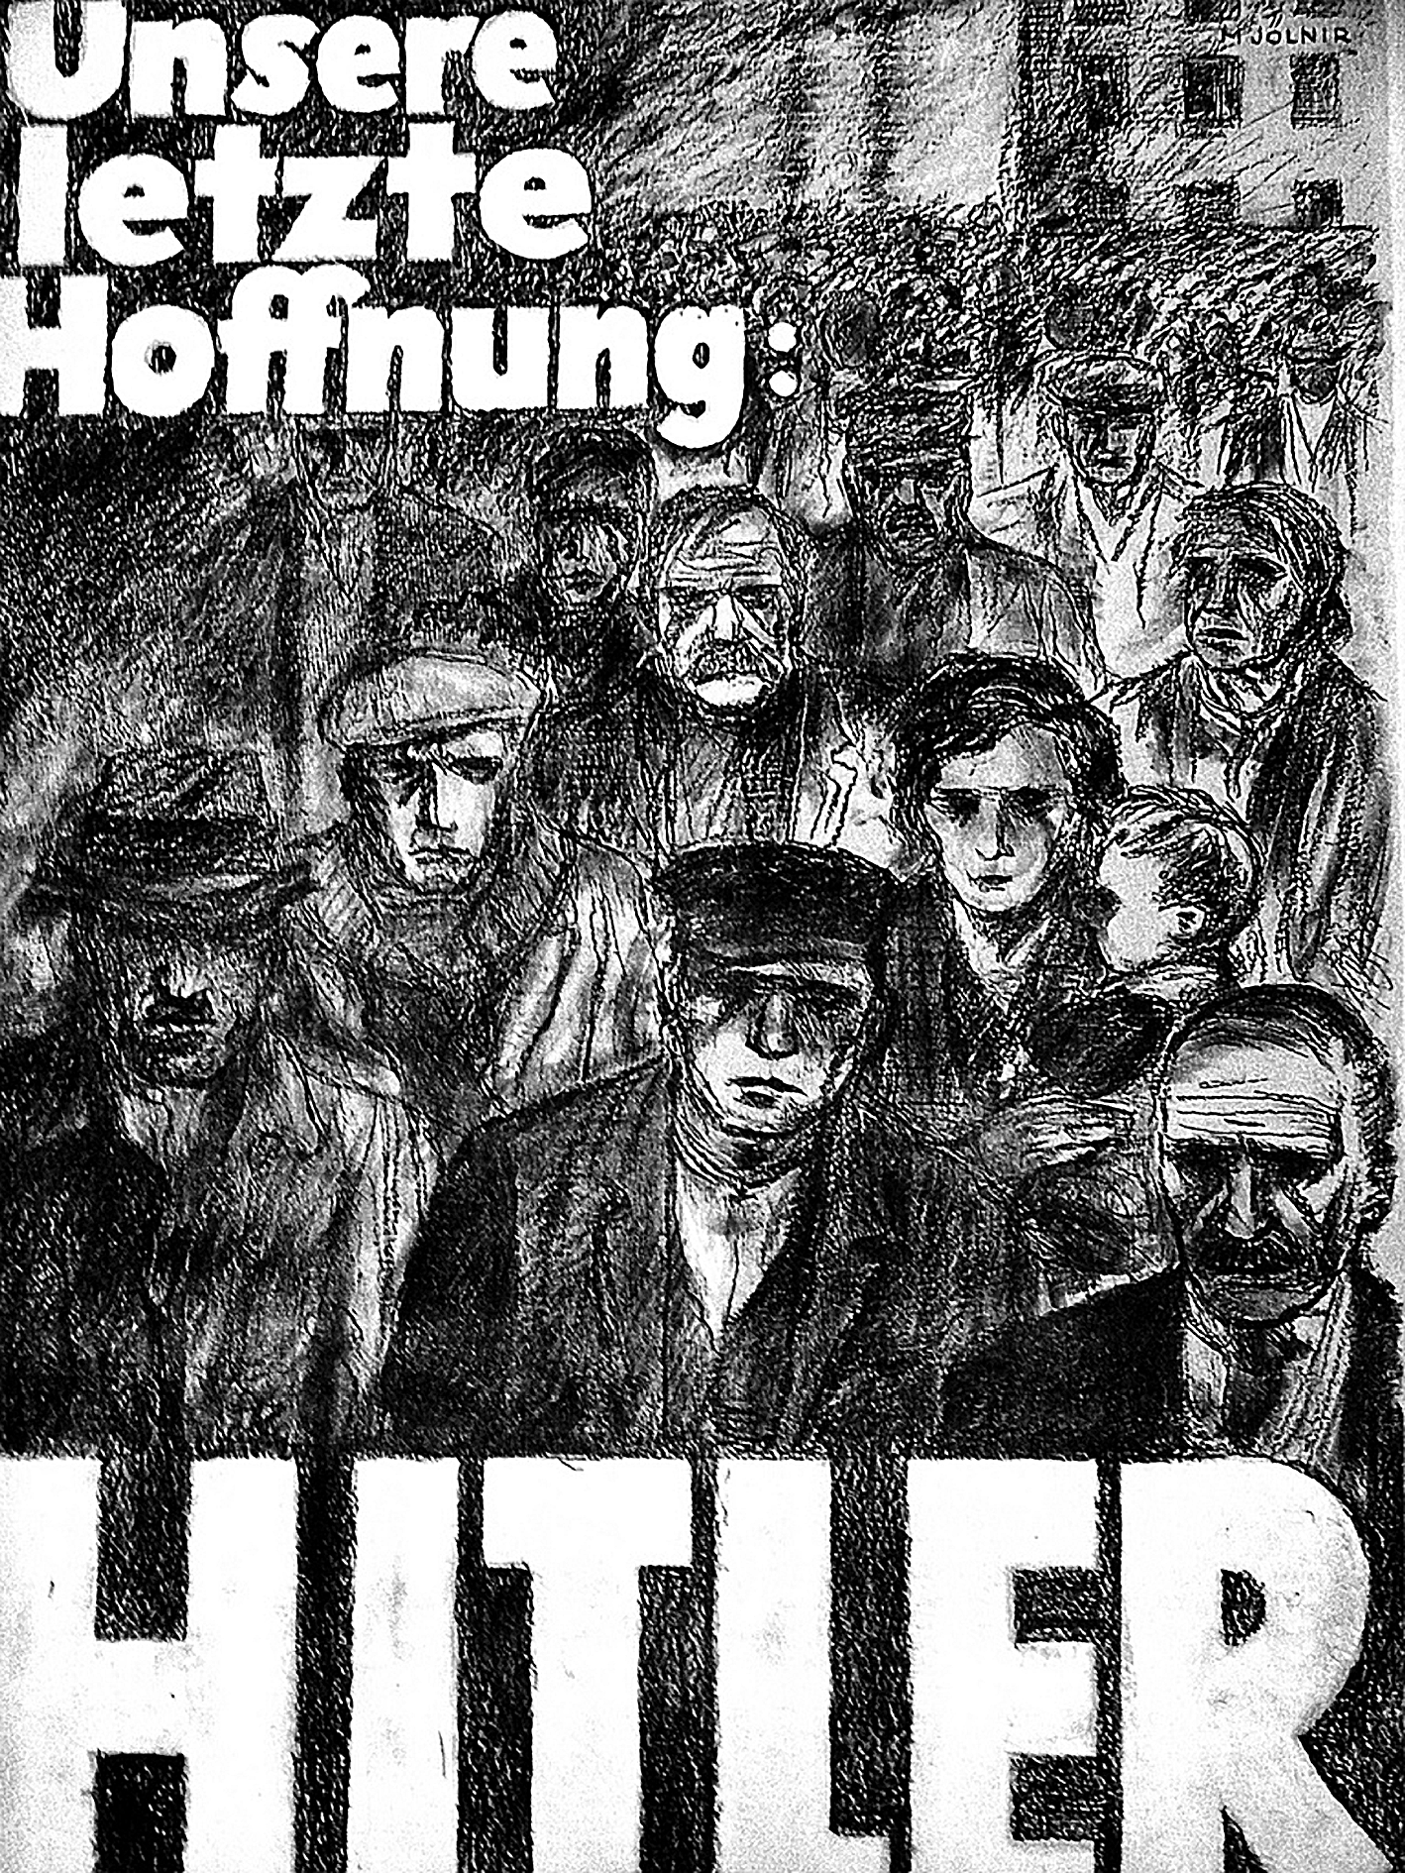

Source 4 Statement issued by Hitler on 28 February 1933, the day after the Reichstag fire

‘This act of arson is the most outrageous act yet committed by Communism in Germany. The burning of the Reichstag was to have been the signal for a bloody uprising and civil war…’

7

1 True or false? Rosa Luxemburg was a Spartacist leader, killed in 1919.
2 True or false? Joseph Goebbels was Hitler’s Foreign Minister.
3 True or false? Hitler came to power in Germany in 1934.
4 True or false? The SA was led by Ernst Rohm.
5 True or false? The Munich Putsch took place in 1923.
6 Which is the odd one out: North Schleswig, West Prussia, Alsace, Bavaria?
7 Which is the odd one out: Stresemann, Hindenburg, Hitler, von Papen?
8 Which is the odd one out: 1928, 1930, 1931, 1932, 1933?
9 Which is the odd one out: Rhineland 1936, Sudetenland 1938, Poland 1939?
10 Which is the odd one out: the Spartacist rising, the Kapp Putsch, the Munich Putsch?
11 Who was the first President of Weimar Germany?
12 What was the Free Corps?
13 Who or what were the November Criminals?
14 Why was the Republic based in the small town of Weimar?
15 What was the Rentenmark?
16 What was the correct name of the Nazi party, re-named by Hitler in 1920?
17 What was the book written by Hitler whilst he was imprisoned?
18 Approximately, how many workers were unemployed in Germany in January 1933?
19 What was Kristallnacht?
8
Quiz 2 Germany
9
Overview of international relations 1919 – 45
Source A Map of Europe, August 1939
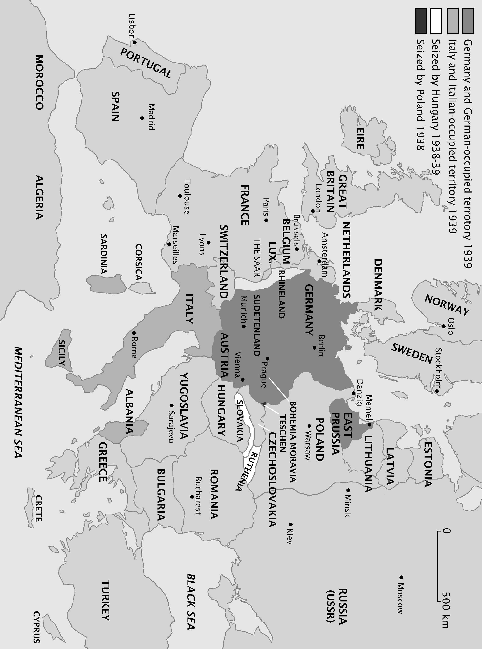

11
Germany goes to war
Cartoon from the Daily Sketch, a British newspaper, April 1940
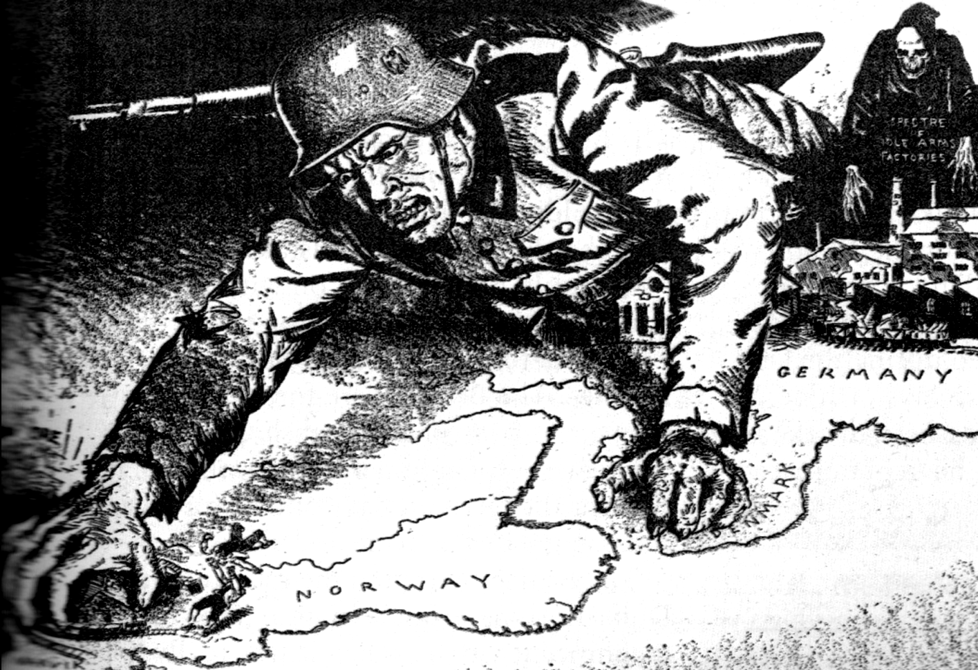

Chronology of German gains 1939–41

Prague | Czechoslovakia | Invaded March 1939
 |  | Invaded September 1939
Oslo | Norway | Invaded April 1940
Amsterdam | Netherlands | Invaded May 1940
Brussels | Belgium | Invaded May 1940
Paris | France | France sign armistice with Germany June 1940
Bucharest | Romania | Romania joined the Axis Alliance in November 1940
Libya | North Africa | German soldiers sent to North Africa, February 1941
Russia | East Europe/Asia | Operation Barbarossa began, June 1941

Questions

1 How is Germany shown in the cartoon?
2 Scandinavia was rich in raw materials, especially iron, how does the cartoonist draw your attention to this?
3 What do you think this cartoon is telling British newspaper readers about Germany?
11

US Presidents in this period:

Dates | Name | Party | Unemployment
1913–21 | Woodrow Wilson | Democrat
1921–23 | Warren Harding | Republican
1923–29 | Calvin Coolidge | Republican | 1929 = 1.5 million
1929–33 | Herbert Hoover | Republican | 1933 = 12 million
1933–45 | Franklin Roosevelt | Democrat

The years 1918–29 are often referred to as the boom years. Then, in 1929, came the collapse of the US Stock Exchange on Wall Street – the Wall Street Crash. Many people had borrowed heavily to invest in stocks and shares, assuming they would continue to grow. As selling took place in 1929 panic set in and thousands of shares were sold forcing down the price of shares. Some banks became bankrupt, having lost peoples’ savings. Many people lost life-savings and were forced into debt. Many businesses closed and so lots of people lost their jobs and had no money to spend. More businesses close, in a downward moving spiral of debt and despair. Between 1929–32 US industrial production fell by 47%. This was known as the ‘Great Depression’.

Poor agricultural practices and years of sustained drought in the early 1930s caused the ‘Dust Bowl’. This was most severe on the southern plains, but drought, windblown dust and agricultural decline were common in the north too. Many people moved away from the plains to cities where there were no jobs for them. Agricultural devastation caused by the dust bowls helped to lengthen the depression.

In 1933, F. D. Roosevelt was elected President. Roosevelt believed that the government had to spend money to stimulate the economy. He called this the ‘New Deal’. There were many projects to stimulate growth, such as the Tennessee Valley Authority and the Works Projects Administration. Many opposed Roosevelt because they believed his policies too socialist and against the freedom of individuals.

The New Deal was only a partial success. In 1938, unemployment was still over 10 million. In 1939, the war in Europe began and re-armament meant a demand for US manufactures. As a result of the New Deal and the war, the USA came out of the Great Depression.
18
Pupils’ overview of USA 1919 – 41
Source 1 Woody Guthrie (1961) Do Re Mi, a popular folk song

NB The ‘do re mi’ is a metaphor for dough, cash, money.

Source 2 From John Steinbeck (1939) The Grapes of Wrath, a popular novel

‘And then the dispossessed were drawn west- from Kansas, Oklahoma, Texas, New Mexico; from Nevada and Arkansas, families, tribes, dusted out, tractored out. Car-loads, caravans, homeless and hungry; twenty thousand and fifty thousand and a hundred thousand and two hundred thousand. They streamed over the mountains, hungry and restless - restless as ants, scurrying to find work to do - to lift, to push, to pull, to pick, to cut - anything, any burden to bear, for food. The kids are hungry. We got no place to live. Like ants scurrying for work, for food, and most of all for land.’

Questions

1 Why was California such a popular destination for people fleeing the Dust Bowl?
2 Did the Californian authorities have the right to stop people at the border and demand to see proof of income?
3 Are these sources an accurate portrayal of the Great Depression in the USA?
4 John Steinbeck’s The Grapes of Wrath was published in 1939 and Woody Guthrie’s song Do Re Mi was released in 1961. How do the terms ‘primary source’ and ‘secondary source’ apply to these sources?
5 Can either sources be considered a reliable account of what happened in the dust bowls of the early 1930s? Explain your answer.
19
Boom and Bust:
sources and questions
1 True or false? In the late 1920s the USA was the wealthiest country in the world.
2 True or false? The Wall Street Crash was in 1929.
3 True or false? The Wall Street Crash only affected the USA.
4 True or false? Dust bowls were worse in the northern plains.
5 True or false? Teddy Roosevelt was elected President in 1933.
6 True or false? President Harding introduced the New Deal.
7 True or false? The New Deal was welcome news to all Americans.
8 Which is the odd one out: Harding, Coolidge, Hoover, Roosevelt?
9 Which is the odd one out: Arkansas, Nevada, New Hampshire, Oklahoma?
10 Which is the odd one out: TVA, WPA, AAA, RAC?
11 Why did the US economy boom in the period 1919–29?
12 Why did the Wall Street Crash affect so many people?
13 What was a Hooverville?
14 What was a Hobo?
15 What was a dust bowl?
16 What was the New Deal?
17 What was the Tennessee Valley Authority?
18 Why did so many US citizens oppose the New Deal?
19 How did the Second World War help the USA to come out of the Great Depression?
21
Quiz 5 The USA

